Nibedita Banerjee 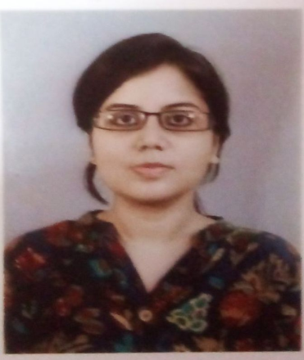

 General Information

| **Department** | Psychology |
| --- | --- |
| **Designation** | State Aided College Teacher-II |
| **Qualification** | M.A. in Psychology 2014(C.U),Fundamental Psychology and Applied Counselling and Body language course from Psychogenesis Research Foundation. |
| **Specialization**  **(Masters)** | Social Psychology |
| **Email** | banerjeenibedita2016@gmail.com |

Teaching Experience

8 years of teaching experience

Colleges Served

RKSMVV -2015 to till date

Head of the Department- 2015 to 2021

Research

* Masters Dissertation- Personality profile of high achievement motivators in terms of certain

Selected correlates:An in-depth exploration.

Teaching experiences in other Institutions

Deputed School Teacher,Dept.of Psychology,Ushangini Balika Vidyalaya(November,2014-June,2015).

Administrative Responsibilities in College

* Member,GRC

Others Responsibilities in College

* Faculty of Psychological Counselling course
* Faculty of Certificate Counselling course
* Faculty of PG Diploma in Certificate Counselling Course
* Faculty of Eligibility test coaching
* One year teaches AECC