DEBRUPA DAS

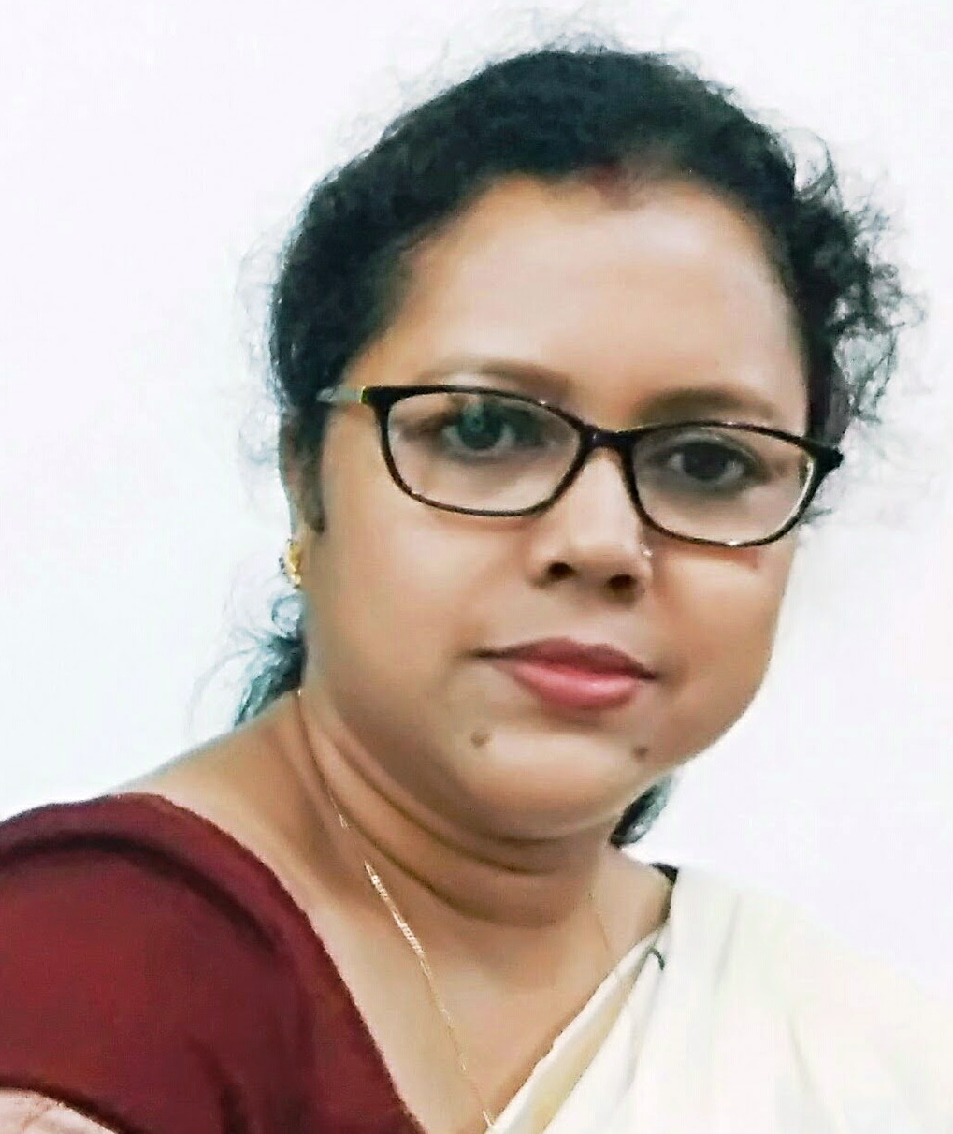

 General Information

|  |  |
| --- | --- |
| **Department** | [Bengali](http://www.bethunecollege.ac.in/departments/EnglishDepartment.htm) |
| **Designation** | Associate Professor |
| **Qualification** | M.A. in Bengali Literature 1998 (J.U.) UGC- NET- December1998  B Ed |
| **Specialization** | Modern Bengali Literature |
| **Email** | dasdebrupa@yahoo.co.in |

Teaching Experience

21 years of teaching experience

Colleges Served

1. Ramakrishna Sarada Mission Vivekananda Vidyabhavan (6th January,2003 till date)

Research

1. PhD (Continuing): “JIBANANANDA DASHER CHHOTOGALPO: SAMAJIK O MANASTATWIK BISHLESHAN”

* UGC Minor Research Project: Title: “Palli Punargathane Rabindra Bhavna – Ajkerjuge tar prasangikata”, Duration: 2012-14

Publication

**Book Chapters/Articles in Edited Volumes**

1. Title of Book: “**Shakta Padabali Chinta Charchar Nanadik”,** Editor: **Gargi Bandyopadhay** Publisher: Akshar Prakashani (National Level), ISBN No.-978-93-82041-12-2, Title of the Chapter: “**Manaka O Uma: Bangladesher Ma O Meye**” , August,2013, Pg no. 296-301

**2.** Title of Book: “**Samayik Patra: unish-bish Shatak”** Edited: Jayanta Mistri, Publisher: Ekush shatak, Kolkata**,** (National Level), ISBN No.-978-93-83521-60-9, Title of the Chapter: “**Patrapatrikay thakurbarir meyeder Bhraman katha**” , December,2015, Pg no. 79-86

**Articles in Journals/ E - journals**

1. Title: “***Mrinalini Devi: Thakurbarir ek Analokito AntohPurika*”,** RKSMVV Journal of Human Sciences, November, 2016, Pg no.106-112
2. Title: “***Jibananander Chhoto Galpo: Samayer Darpan o Byaktimoner Sankat*”, ESCRA,** Vol-23, No.-3, ISSN No.- 2348-6279, February, 2017, Pg no.41-50
3. Title: “***Mrityur Manastwattwa O tar akasmikota: Jibananander Tinti Galpo***”, **TABU EKALAVYA** (An International Peer-reviewed Refereed Research Journal On Arts & Humanities), Vol-27, Issue 4, No.-47,

ISSN No.0976-9463, July 2022, pg. 318-329

1. Title: ***‘Byaktimoner sankote prokritir ashroy:Jibanananda Daser koyekti chhotogolpo’***, **Nibodhata** Patrika, Vol-37, No.1, May-June 2023, ISSN No. 0972– 4877, https://ugccare.unipune.ac.in/apps1/home/index
2. Title: ‘Jamidarir Uttaradhikar O Uttaran: Tarashankarer koyekti Galpo’, **Nibodhata** Patrika, Vil. 37, No. 3, September-October 2023, ISSN No. 0972-4877, UGC care listed Journal.

**Seminar/ Conference Proceedings**

1. Title: “***Gananatya Andoloner Sharik Bijan Bhattacharya*”,** Conference title: “JanmaShatabarshe Bijan Bhattachaya” (National Level), dated 02-03/05/2015, published on January, 2016, Pg no.-121-127, ISBN: 978-81-924388-5-6
2. Title: “***Rabindranatya : Shuvo Ichchhashaktir Joygan*”,** Conference title: “Rabindra natyacharcha: Sampratik Abhimukh” (National Level), dated 20-21/08/2015, published on December, 2015, Pg no.-105-109, ISBN: 81-7864-194-1
3. Title: “***Sukanta Bhattacharyay: Chiratarun Ek Pratibadi Kabi*”,** Conference title: “Pratibader O Pratibadi Kabita : Prekshit Hazar Bachhorer Bangla Kabita” (National Level), dated 15-16/09/2016, published on January, 2017, Pg no.-80-84, ISBN: 978-81-80930-65-2

Invited Lectures/ Paper Presentations

1. Presented a research paper, Topic: “**Palli Punargathane Rabindra Bhavna – Ajkerjuge tar prasangikata**” in the UGC sponsored National level conference, Title: Rabindranath O Samakalin Prasango, dated 09-10/02/2012, organized by Dept. of Bengali, Bidhannagar College & Chittaranjan College.
2. Presented a research paper, Topic: “**Bartaman Bharat Chintay Rabindra Bhavna- Samakalin Prasango**” in the UGC sponsored State level conference, Title: Sahitya O Sanskriti-te Rabindra Bhavnar Prasango, dated 16/02/2012, organized by Dept. of Bengali, Maulana Azad College
3. Presented a research paper, Topic: “**Amar Chetana: Kabir Biswas**” in the UGC sponsored State level conference, Title: Ami in Rabindranath, dated 02/03/2012, Organized by Dept. of Bengali, English & Sanskrit of New Alipore College, Sahitya Academy, Kolkata.
4. Presented a research paper, Topic: “**Bhasha o tar bibidho madhyam**” in the National level conference, Title: **Language, Communication and Society**, dated 19/12/2014, organized by Dept. of Philosophy, West Bengal State University.
5. Presented a research paper, Topic: “**Gananatya Andoloner Sharik Bijan Bhattacharya**” in the UGC sponsored National level conference, Title: **JanmaShatabarshe Bijan Bhattachaya**, dated 02-03/05/2015, organized by Dept. of Bengali, Dwijendralal College, Krishnagar.
6. Presented a research paper, Topic: “**Rabindranatya : Shuvo Ichchhashaktir Joygan**” in the UGC sponsored National level conference, Title: Rabindra natyacharcha: Sampratik Abhimukh, dated 20-21/08/2015, Organized by Dept. of Bengali & English, Mahadevananda Mahavidyalaya, Barrackpore.
7. Presented a research paper, Topic: “**Bish Satoker tirish challish dashoker bangla chhoto galpo: Kaler matray ekti samikshya**” in the UGC sponsored International conference, Title: **Bangla Katha shahityo: Unish-Bish**, dated 15-16/03/2016, Organized by Dept. of Bengali, Rabindra Bharati University & Centre for studies on Indigenous People.
8. Presented a research paper, Topic: “**Panchovuter Pathantar: Kichhu Tathya**” in the UGC sponsored International conference, Title: **Rabindta Sahityer Pathantar**, dated 29/03/2016, Organized by Centre for studied & Research on Tagore, Rabindra Bharati Universty, Kolkata.
9. Presented a research paper, Topic: “**Sukanta Bhattacharyay: Chiratarun Ek Pratibadi Kabi**” in the UGC sponsored National level conference, Title: Pratibader O Pratibadi Kabita : Prekshit Hazar Bachhorer Bangla Kabita, dated 15-16/09/2016, organized by Dept. of Bengali, Sri Gopal Banerjee College, Mogra, Hooghly.
10. Presented a research paper, Topic: “**Adda Sanskritir ekal o sekal**” in the UGC sponsored State conference, Title: **Bangalee Culture: Past & Present**, dated 15/09/2016, Organized by Dept. of Bengali, Barasat Govt. College in collaboration with District information & cultural affairs, North-24 PGS.
11. Presented a research paper, Topic: “**Janoganer Natyakar Bijan: Vabnay Bishista**” in the UGC sponsored National level conference, Title: **Bijan Bhattacharyay: Ekush Shatake Phire Dekha**, dated 26-27/09/2016, Organized by Dept. of Bengali, Fakir Chand College in collaboration with Dept. Of Bengali, Dhruba Chand Halder College.
12. Presented a research paper, Topic: “**Bangla Bhramonsahitye Narider Bhumika: Sekal O Ekal**” in the UGC sponsored National level conference, Title: **Nari Pragatir Sekal O Eka**l, dated 15-16/12/2016, Organized by Dept. of Bengali & Education, Sonarpur Mahavidyalaya.
13. Presented a research paper, Topic: “**Bish shataker Tiner Dashker Artho-Samajik Prekkhapot O Jibanananda Dasher Kayekti Galpo**” in the UGC,DRS-SAP,Phase2 sponsored National seminar dated 27-28.12.2021, Organized by Department of Bengali, Jadavpur University.
14. Presented a research paper, Topic: “**Jibananander kayekti Galpe Samakalin Artha-samajik Paristhiti O Byaktimanaser sangkat: Ekti samikkha**” in a Two day International Webinar on “Bharatbarsha’s freedom Movement in a Socio-economic, Political and Cultural Perspective” dated 16-17th March, 2022, organized by Department of Bengali, Tripura University.

Awards/ Fellowships/ Grants

* 1. UGC Minor Research Project from U.G.C (2012).

Teaching experiences in other Institutions

* 2019 Guest Lecturer, Shri Shikshayatan College, Kolkata (From 2000-2002)
* Guest Lecturer, Bijoygarh Jyotish Roy College (2001-2002)
* Guest Lecturer, Sonarpur Mahavidyalaya (2001-2002)

Administrative Responsibilities in College

* Joint Convener, College office sub-committee (From 2019 till date)
* Member, Examination sub-committee (From 2019 till date)
* Nodal officer for uploading data in Banglar Uchchashiksha Portal (From 2020 till date)
* Convener, Admission Committee
* HOD, Department of Bengali
* Member, Academic Sub-committee
* Member, Library committee

Honorary Posts/Positions Held