1. A College Level webinar on “Training on online class and e-content” was organised by the Departments of Geography and Journalism & Mass Communication, in collaboration with IQAC on 14.07.2020 from 11:00 am - 01:00 pm at Google Meet platform. Total number of participants was 90. The Resource Person/s were -
a) Dr. Tapan Kumar Das, Assistant Professor of Geography, Cooch Behar College.
b) Prosenjit Dawn, Assistant Professor of Zoology, Shyampur Siddheswari Mahavidyalaya.
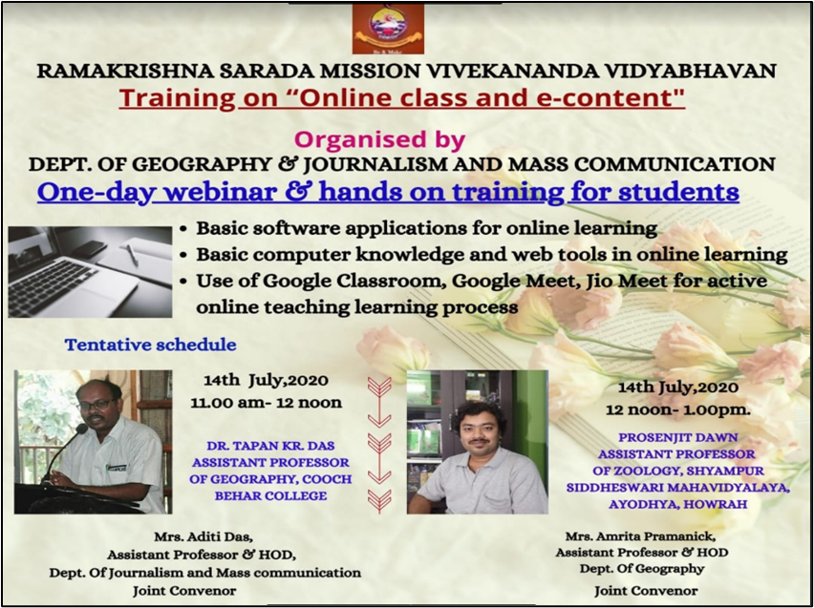
Programme Outcome : As the COVID-19 condition was prevailing, there was no scope for classroom teaching. Both teachers and students were not so familiar with the online teaching-learning process. All of us came to know about the Google classroom teaching, how to use Google meet platform and basic software applications for online learning.
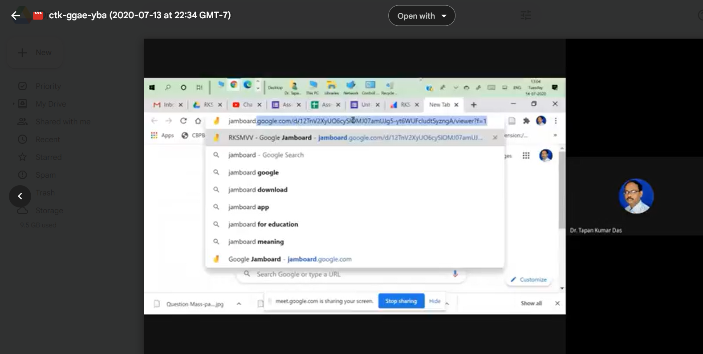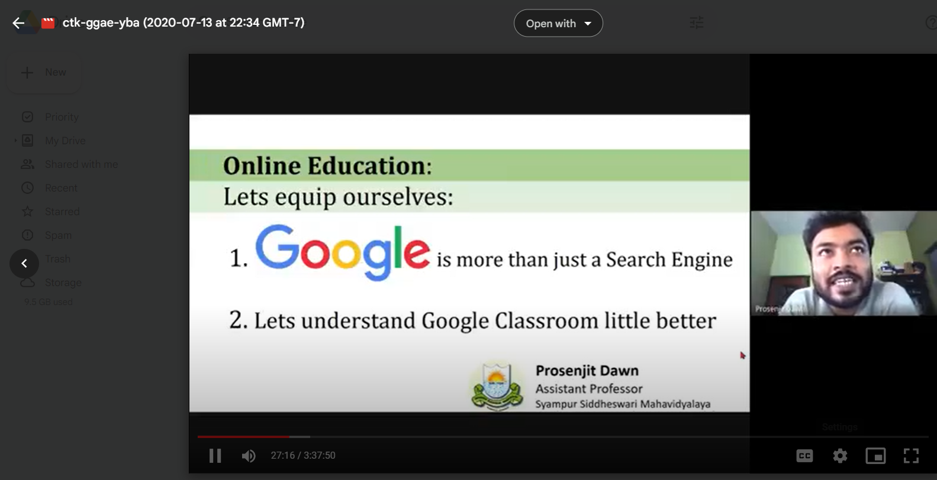
Dr. Tapan Kr. Das was presenting Prosenjit Dawn was presenting
-------------------------------
2. A National Level Webinar on “Disaster Management & Communication: Challenges & Opportunities” was organised by the Departments of Geography and Journalism & Mass Communication in collaboration with IQAC, RKSMVV on 10.08.2020 from 10:30 am – 01:30 pm at Google Meet platform. Total number of participants was 310. The Resource Persons were-
a) Dr. Sourav Gupta, Senior Assistant Professor of JMC, Central University, Odisha.
b) Ajit Kumar Sil, Associate Professor of Geography, Bhairab Ganguly College.
c) Dr. Tapan Kumar Das, Assistant Professor of Geography, Cooch Behar College.
d) Biswajit Mondal, Assistant Professor of Geography, Nahata JNMS Mahavidyalaya.
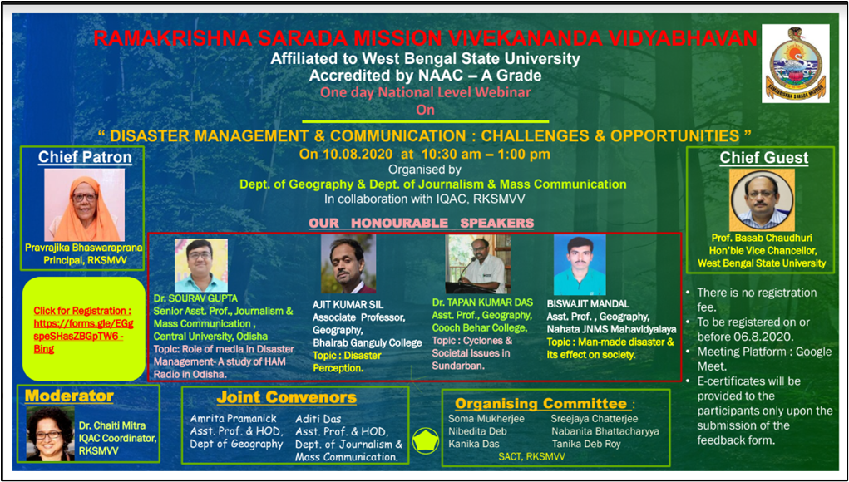
Programme Outcome : Participants gained knowledge about nature and types of disaster, the deadly effects of disaster on our society, how media can help in the management of disaster, how one of the most important world heritage site sundarban was frequently affected by intense cyclonic storm like Amphan, Aila etc. and its effect on the livelihood of local people, the process of management of all these disasters to some extent etc.
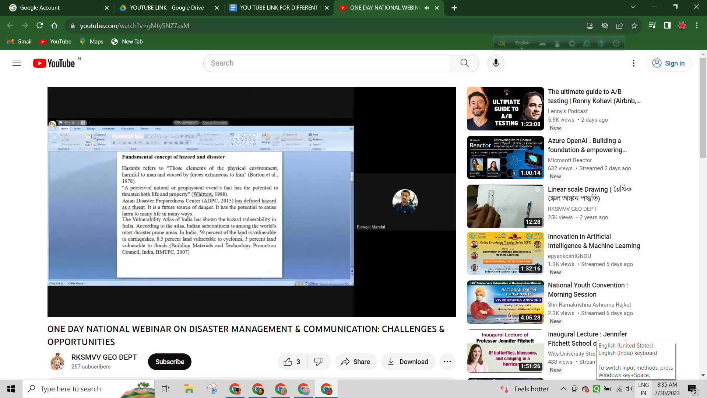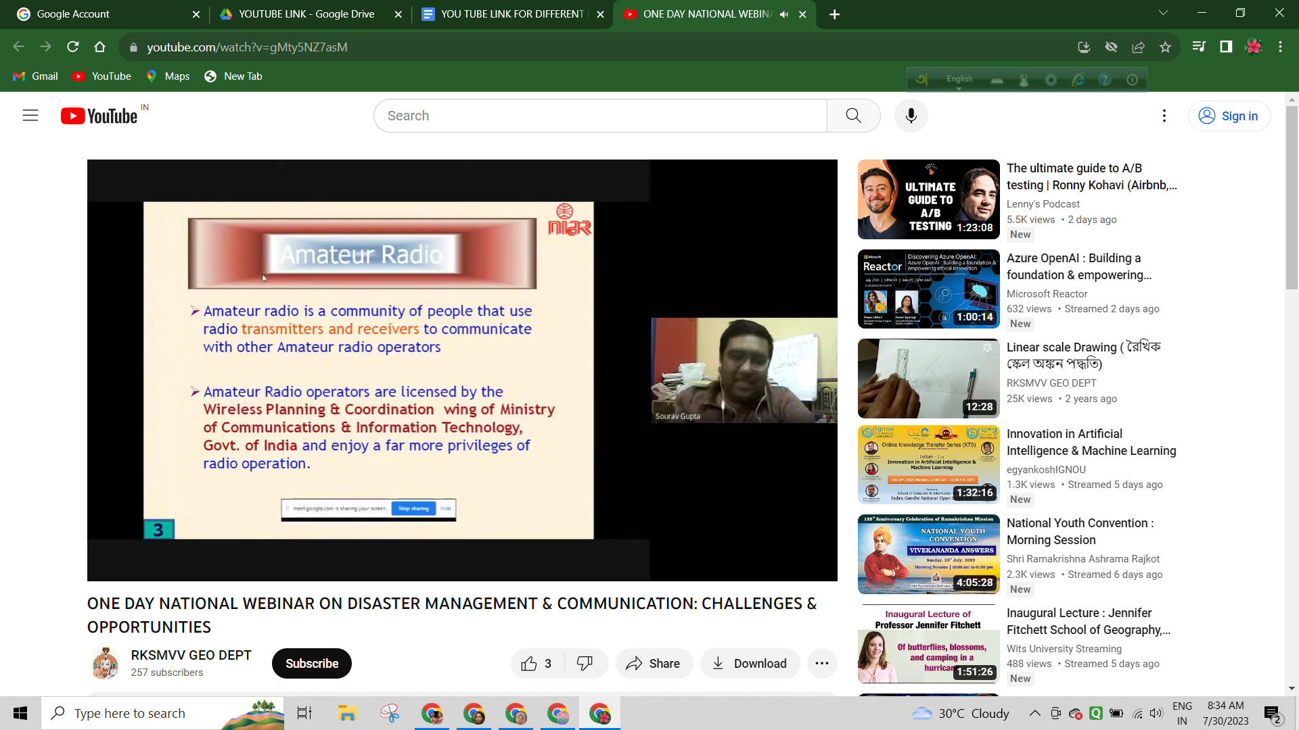
Biswajit Mondal was presenting Dr. Sourav Gupta was presenting
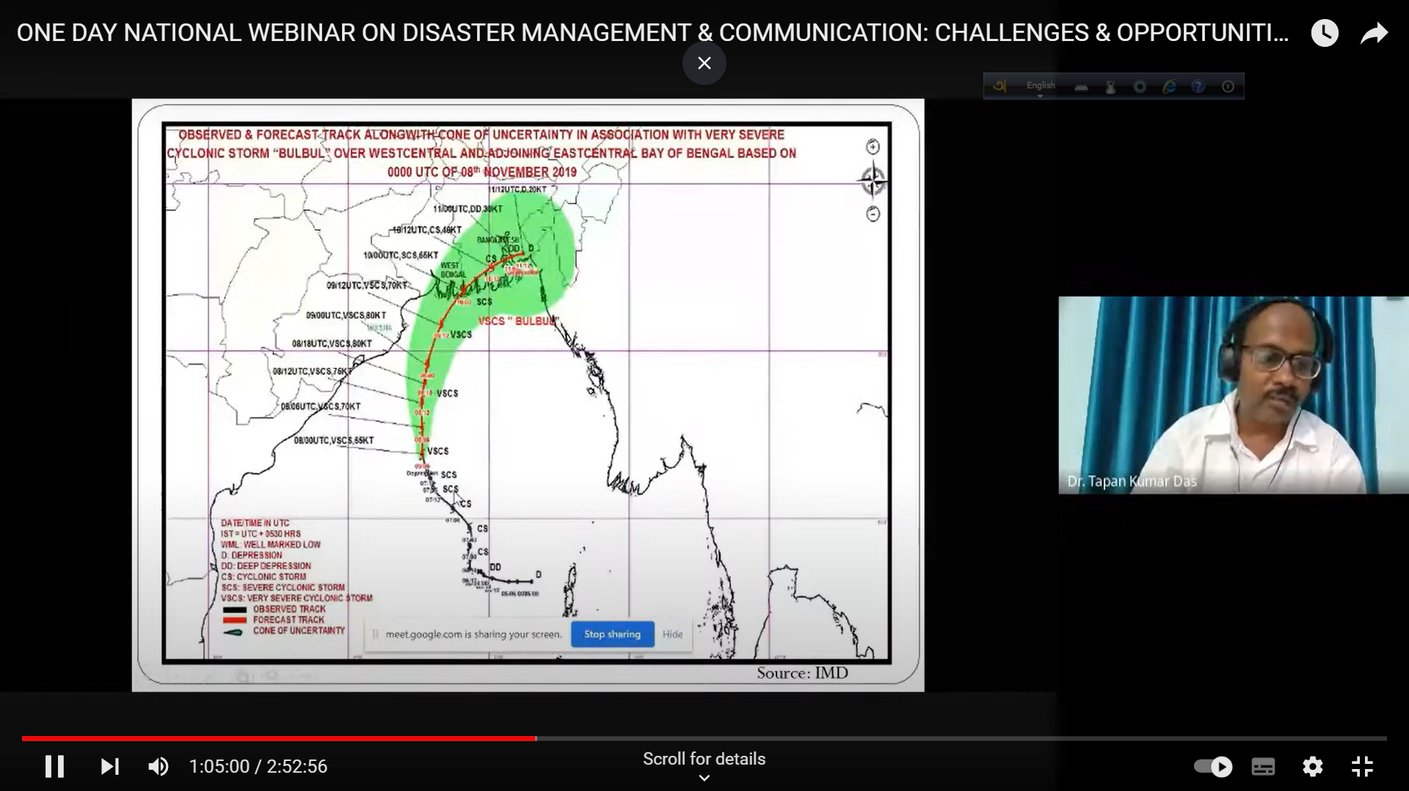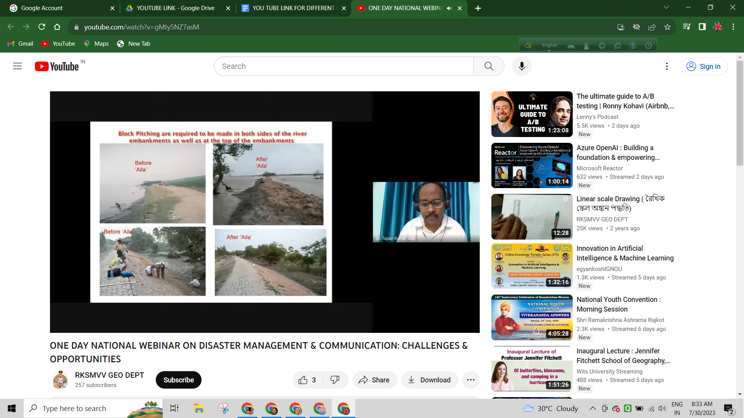
Dr. Tapan Kumar Das was presenting
…………………………………………..
3. A State Level Webinar on “ Research Methodology & Field Work” was organised by the Dept. of Geography of RKSMVV & Dept. of Geography of Syamaprasad College, in collaboration with IQAC, Syamaprasad College on 30.08.2020 & 31.08.2020 at Zoom Meeting platform. Total number of participants was 229. The Resource Person/s were -
a) Dr. Pranam Dhar, Associate Professor of Commerce & Management, WBSU.
b) Prof. Shasanka Kumar Gayen, Prof. & Head of the Dept., Dept. of Geography, Cooch Behar Panchanan Barma University.
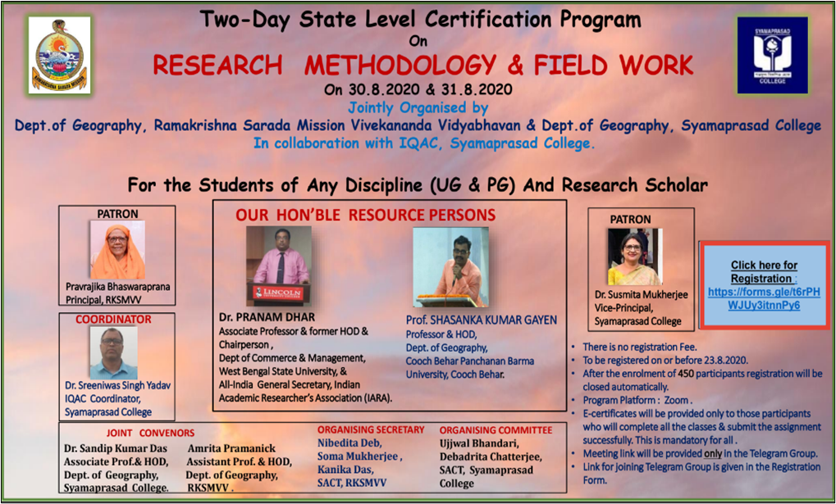
Programme Outcome : The participants gained detailed knowledge about different types of research methods required for different purposes, various components of research methodology like abstract writing, introduction, review of literature, methods, results, conclusions & discussions and references etc. They also came to know about the importance of field study in geographical research, different techniques of field study, process of data collection for research work, and the advantages of field study in different research purposes.
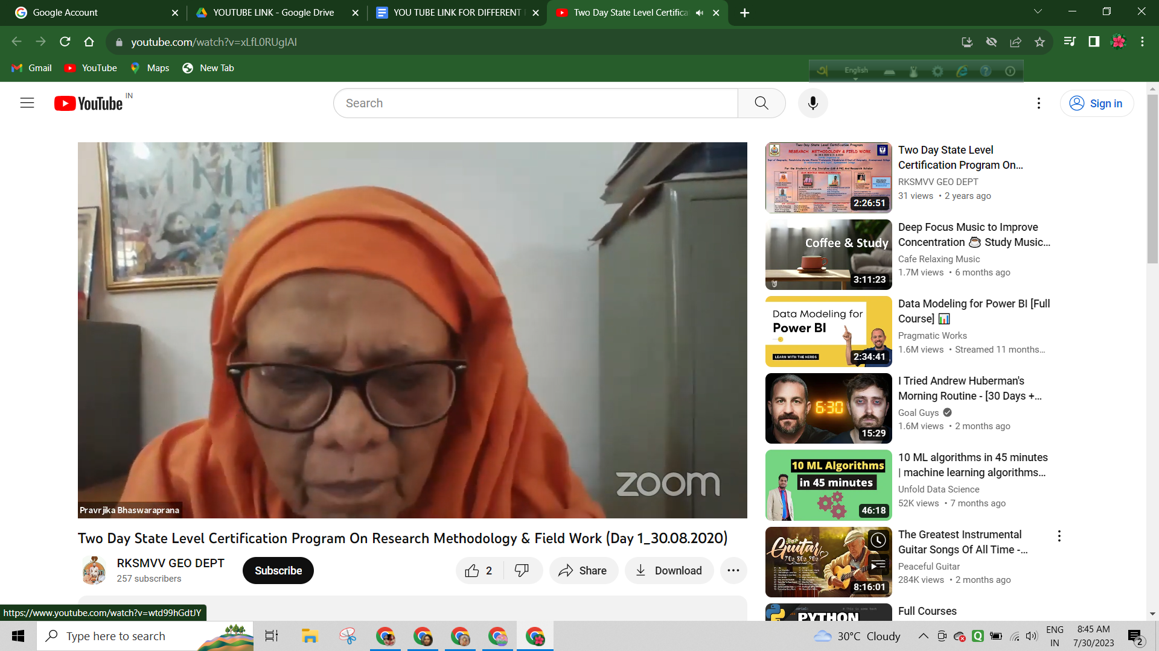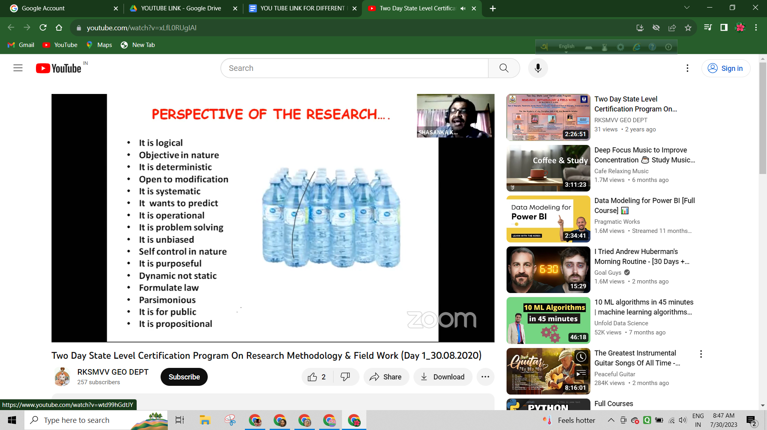
Principal Mataji was in zoom meeting Prof. Gayen was presenting on Day 1
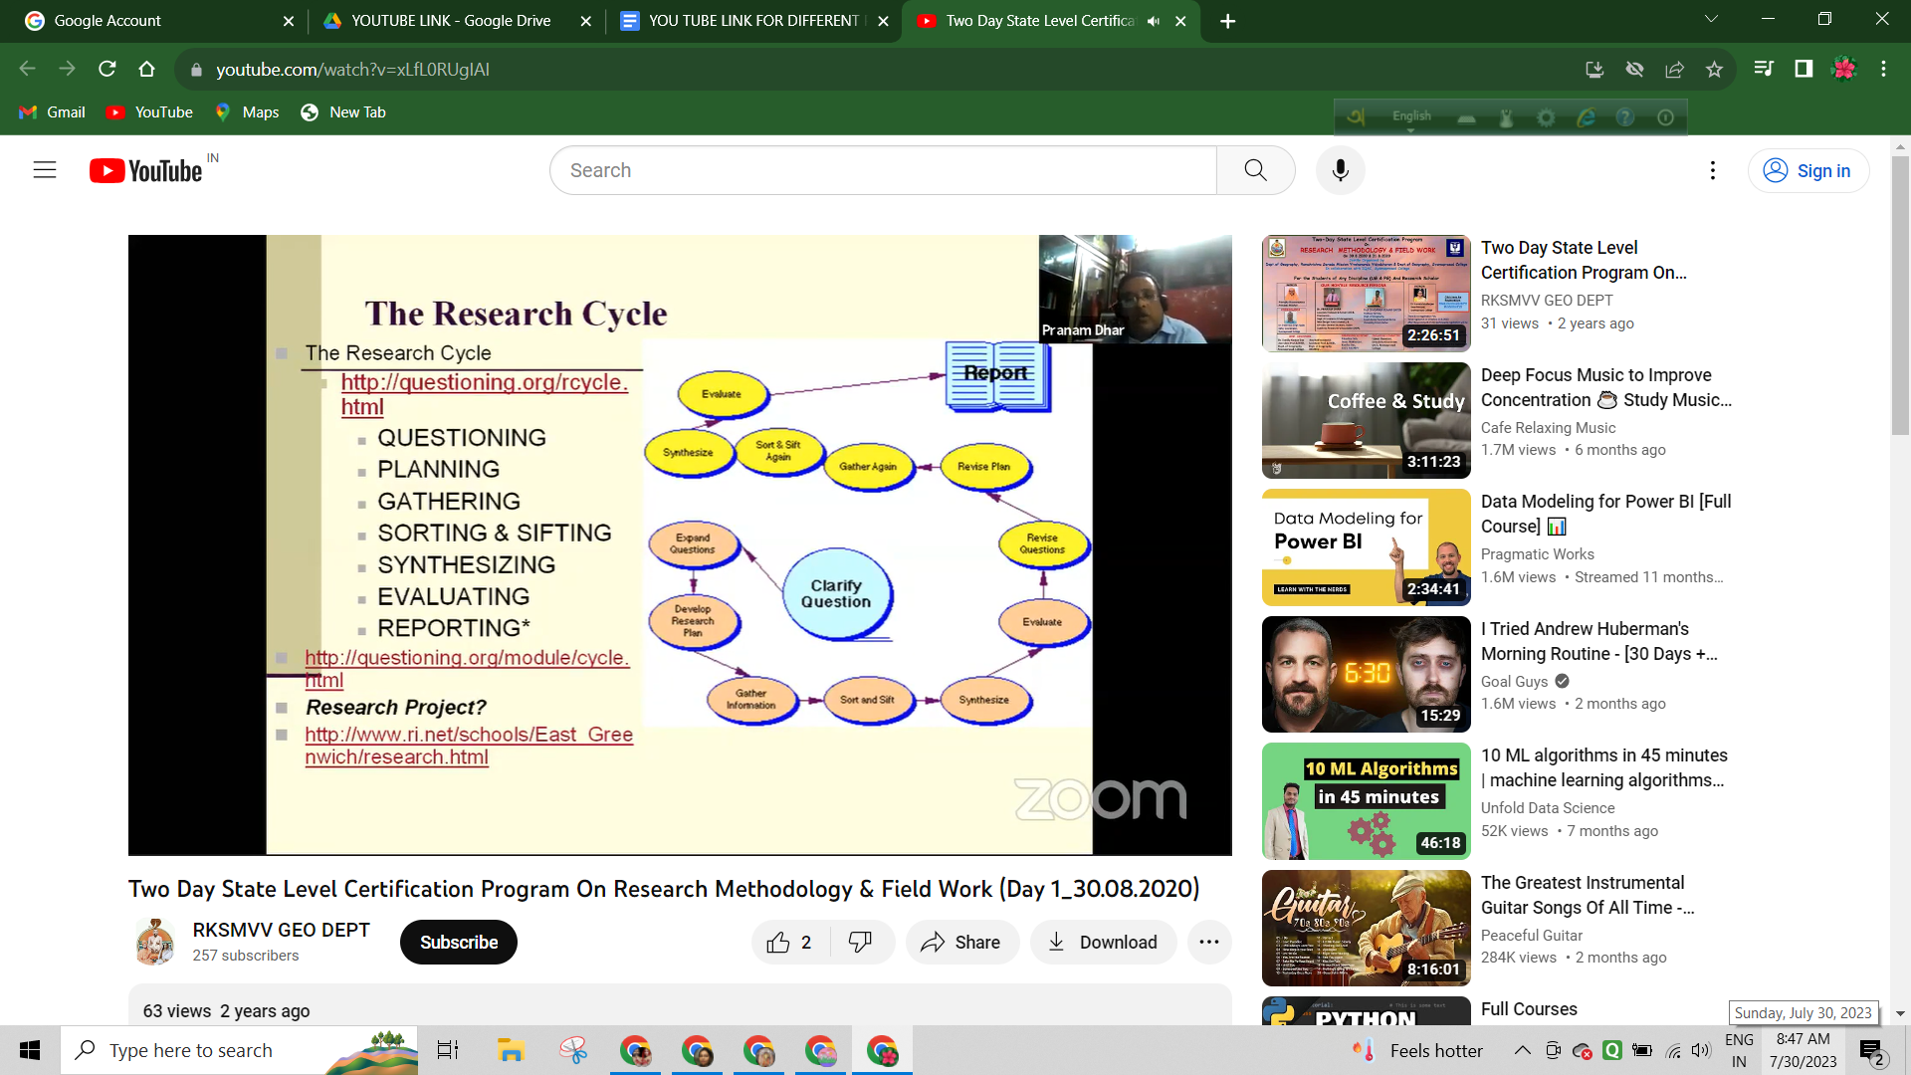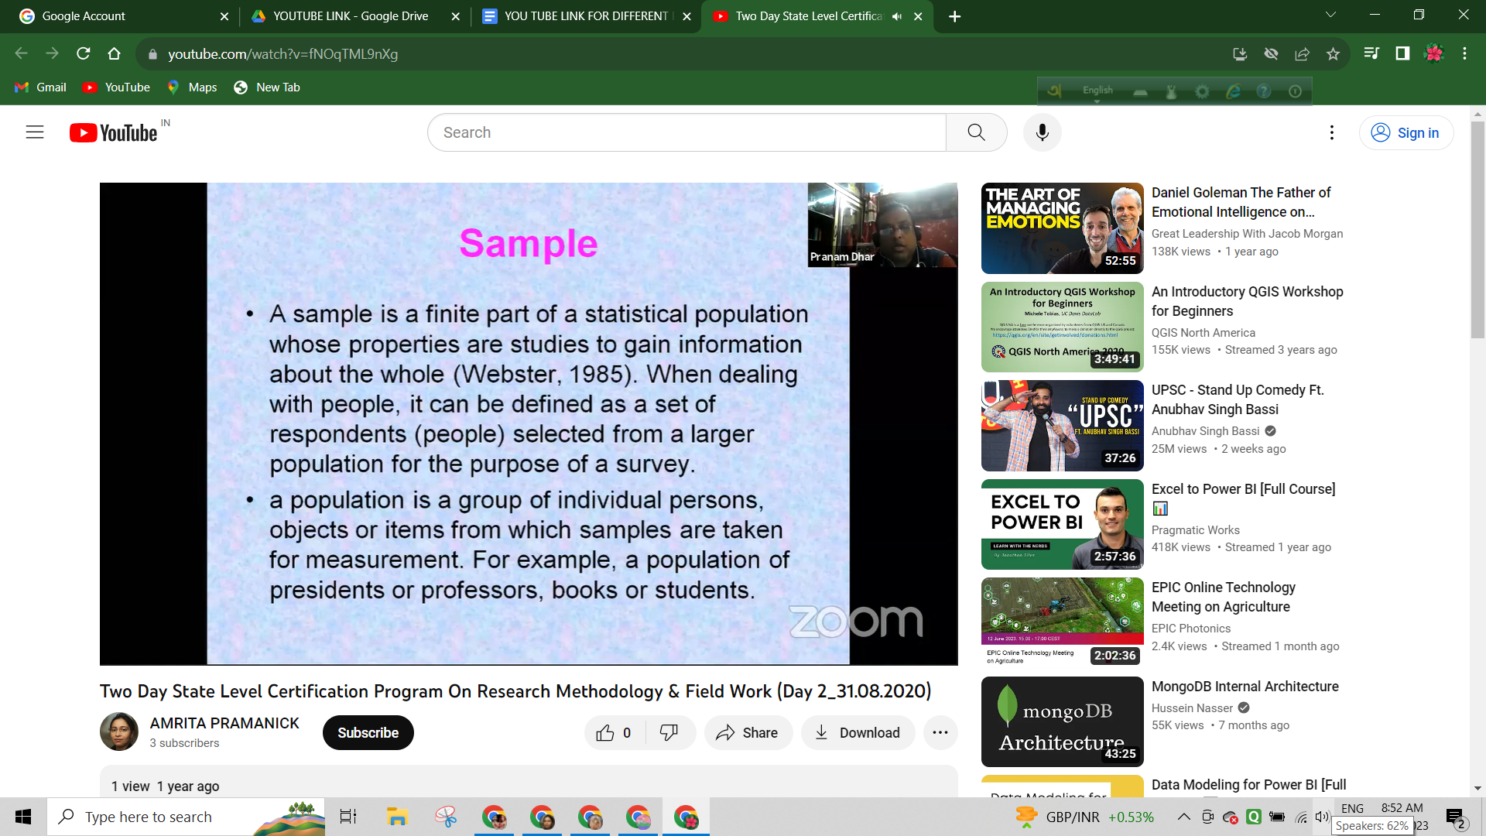
Dr. Pranam Dhar was presenting on Day 1 Dr. Dhar was presenting on Day 2
‌‌ …………………………………………………………………….
4. A National Level Online Workshop on “Learning Content Management System” was organised by Dept of Geography, RKSMVV and PG Dept of English & Geography of Cooch Behar College, Cooch Behar, from 02.09.2020 to 08.09.2020 at Google Meet platform. Total number of participants was 108. The Resource Persons were -
a) Prof. Uma Kanjilal, Prof. & Head of the Dept., Library & Information Science, IGNOU, and Director of Centre for Online Education (COE), National Swayam Coordinator, India.
b) Prof. Parthasarathi Mukhopadhya, Professor, Dept of Library & Information Science,
University of Kalyani.
c) Dr. Manas Kumar Baia, Principal, Malda College.
d) Dr. Biswanath Dutta, Associate Professor, Documentation Research and Training Centre, Indian Statistical Institute, Bangalore, India.
e) Md. Rafiqul Alam, Librarian, Malda College.
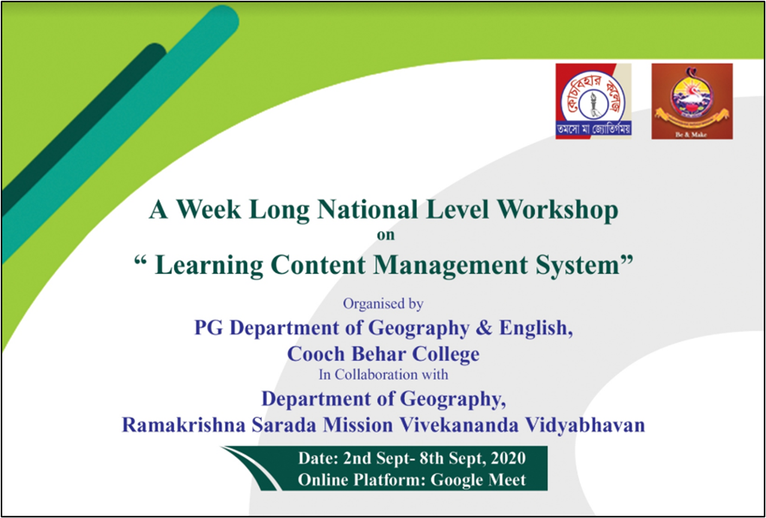
Programme Outcome : Infact, moodle is a learning management system used to manage, deliver and measure training and learning online. It is a widely used and most well-known LMS platform. The 4 quadrant system i.e Tutorials, content development, Discussion forum and Assessment provides us a better opportunity to manage and continue the teaching-learning process very efficiently.
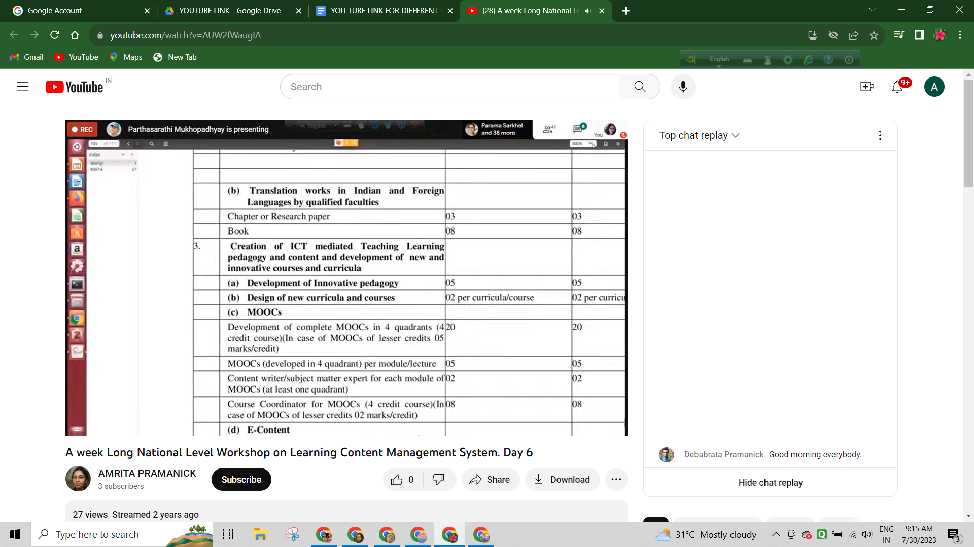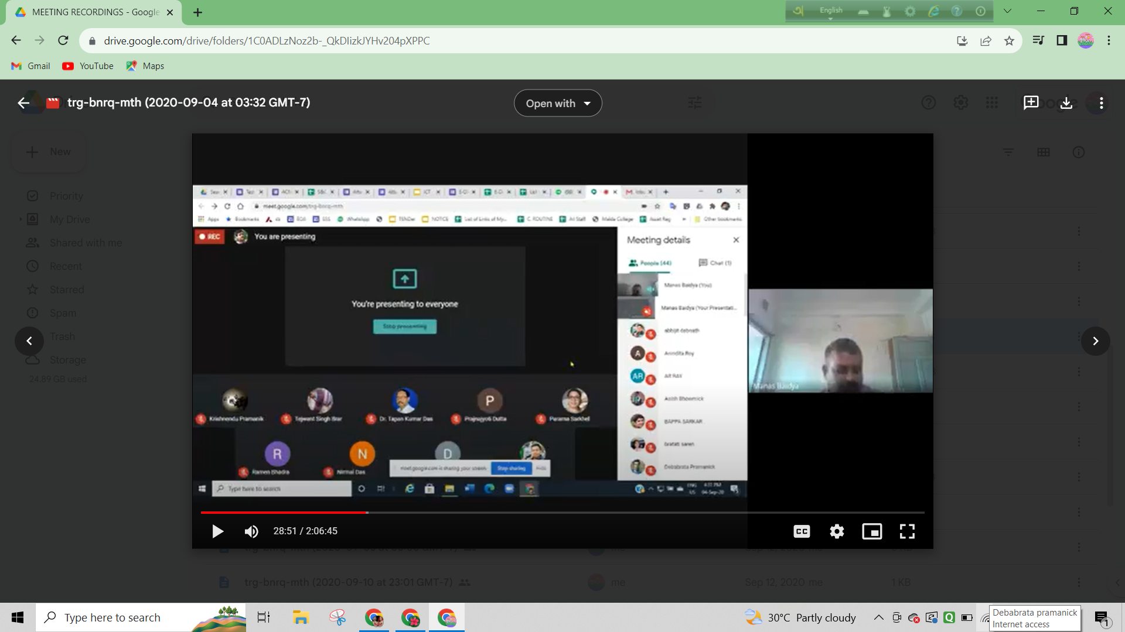
Prof. Mukhopadhyay was presenting Dr. Baidya was presenting
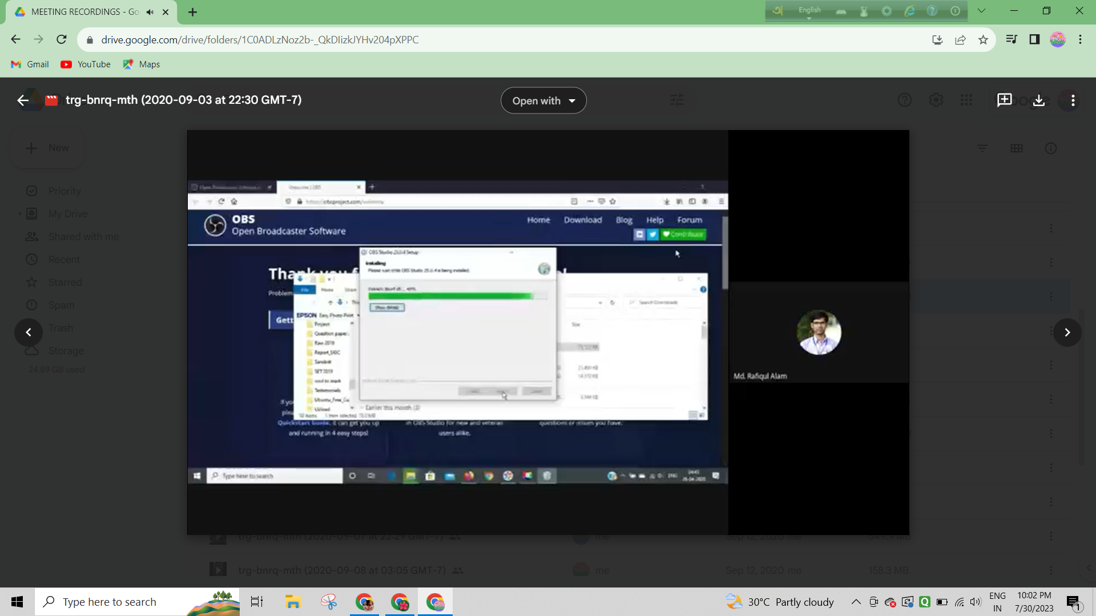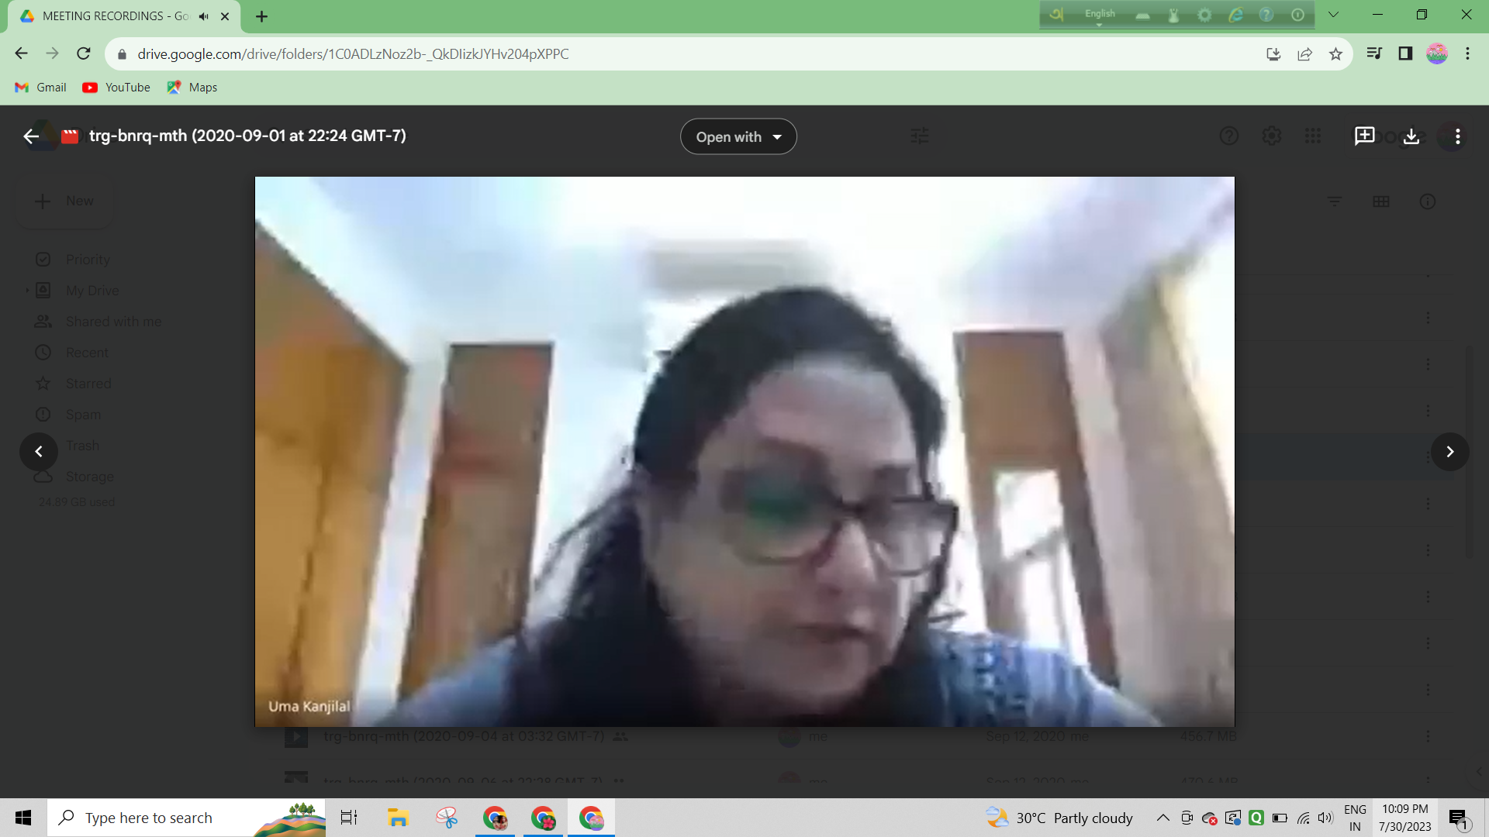
Md. Rafiqul Alam was presenting Prof. Uma Kanjilal was presenting
…………………………………………………………………….
5. A State Level Webinar on “Multidisciplinary on-line lecture series on Gender Studies” was organised by Department of Geography & GRC of RKSMVV on 31.01.2021 from 04:00 pm to 06:00 pm at Google Meet platform. The Resource Persons were -
a) Prof. Dulal Chandra Das, Associate Professor, Dept. of Geography, BidhanNagar Govt. College.
b) Mrs. Yogia Dutta, Assistant Professor, Dept. of Geography, Haldia Govt. College. Total participants were 95, including students and faculty members.
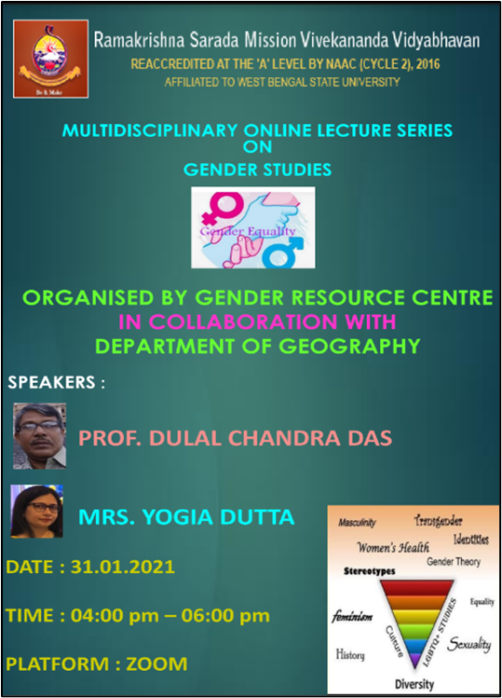
Programme Outcome : Gender Studies is an academic discipline with deep roots and an enormous resonance in the contemporary world. The field is constantly developing, and new research themes, journals and programs keep emerging, testifying to the profound and far-reaching significance of the knowledge produced. The interdisciplinary nature of the topic and the variety of areas from which gender analysis has emerged means that there are multiple and at times conflicting streams of thought about gender and its meaning and origins.
…………………………………..…………………………………..
6. A State Level Webinar on “Drone Technology : Its Relevance in the Modern Era” was organised by the Department of Geography & IQAC, RKSMVV on 26.03.2022 from 12 noon to 3 pm at RKSMVV College campus. The participants were all the teaching, non-teaching staff, students of all departments of RKSMVV. The Resource Persons were -
a) Bidhan Nanda, Senior Business Development Executive, CSS Geospatial, Kolkata.
b) Hemant Kr. Yadav, Assistant Manager, CSS Geospatial, Kolkata.
c) Satyen Prasanna Achar, Drone Consultant, CSS Geospatial, Kolkata.
d) Soumyadip Chandra, Drone Consultant, CSS Geospatial, Kolkata.
e) Ayan Ghosh, IT Personnel, GIS Special Investigation Division, CAD GIS Centre, Public Health & Engineering Dept, Govt. Of WB.
Programme Outcome : Increasing work efficiency and productivity, decreasing workload and production costs, improving accuracy, refining service and customer relations, and resolving security issues on a vast scale are a few of the top uses drones offer industries globally. Adoption of drone technology across industries leapt from the fad stage to the mega-trend stage fairly quickly as more and more businesses started to realise its potential, scope, and scale of global reach.
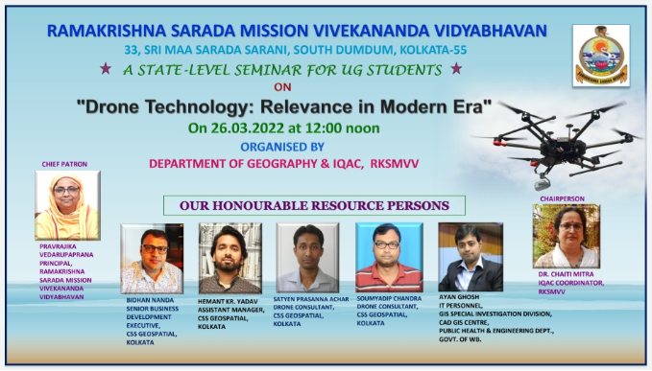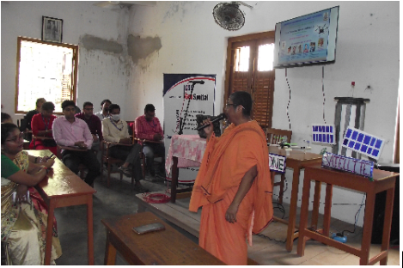
Flyer of the program Inaugural speech of Principal Mataji

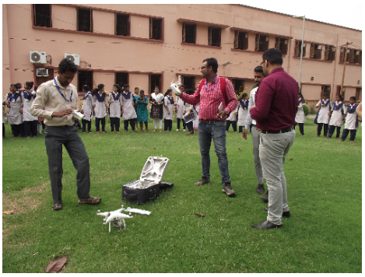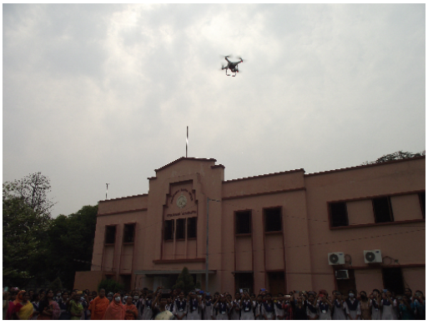
Preparation for Drone flying Flying of Drone in the sky of college campus
………………………………………
7. An educational field work was organised by the Department of Geography from 02.05.2022 to 06.05.2022 for “Socio-Economic Study of Mangalbari Mouza, Chalsa, Jalpaiguri, West Bengal”. Total number of participants was 42 .
Programme Outcome : Field work is the collection of raw data outside a laboratory, library or workplace setting in order to achieve specific objectives. The main objective of conducting this field trip is to reinforce experimental and contextual learning, to enrich the students and to take learning beyond the walls of a classroom. This field work enables students to examine the interrelationship between the social and natural environment.
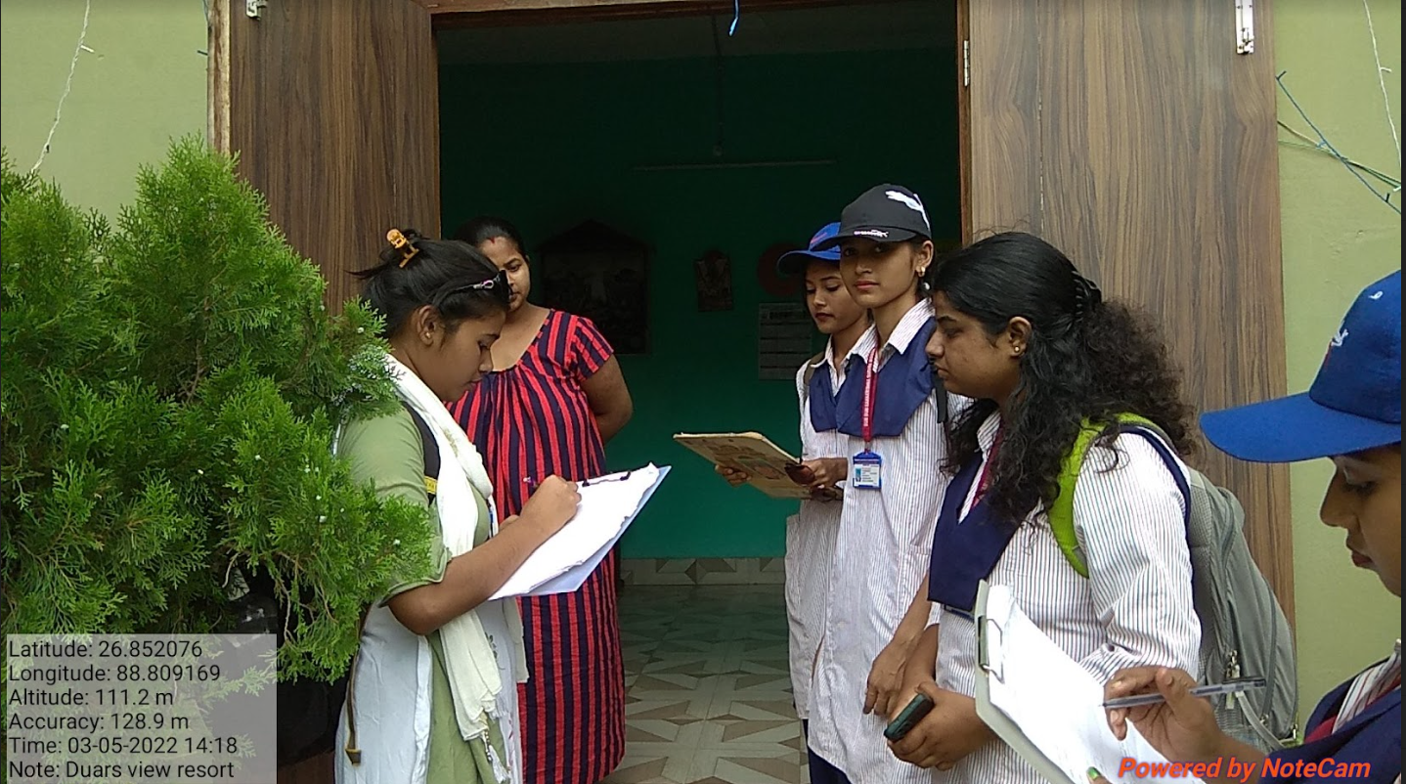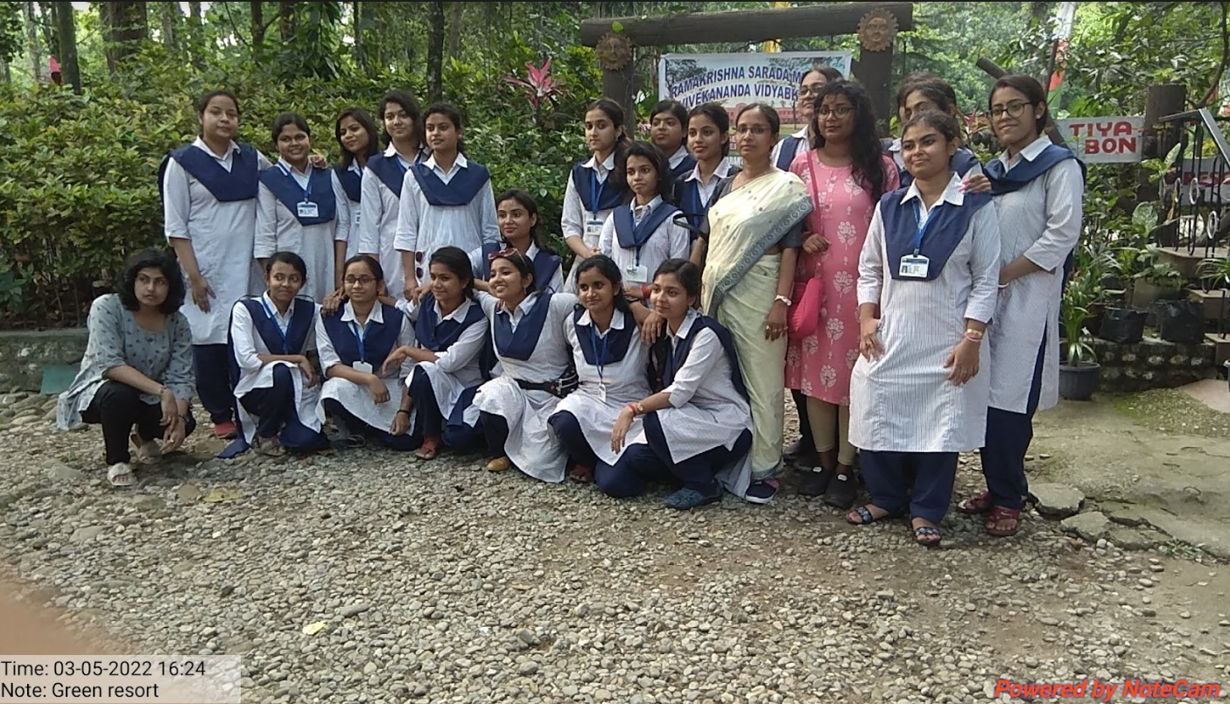
Home-stay survey Team at our Resort
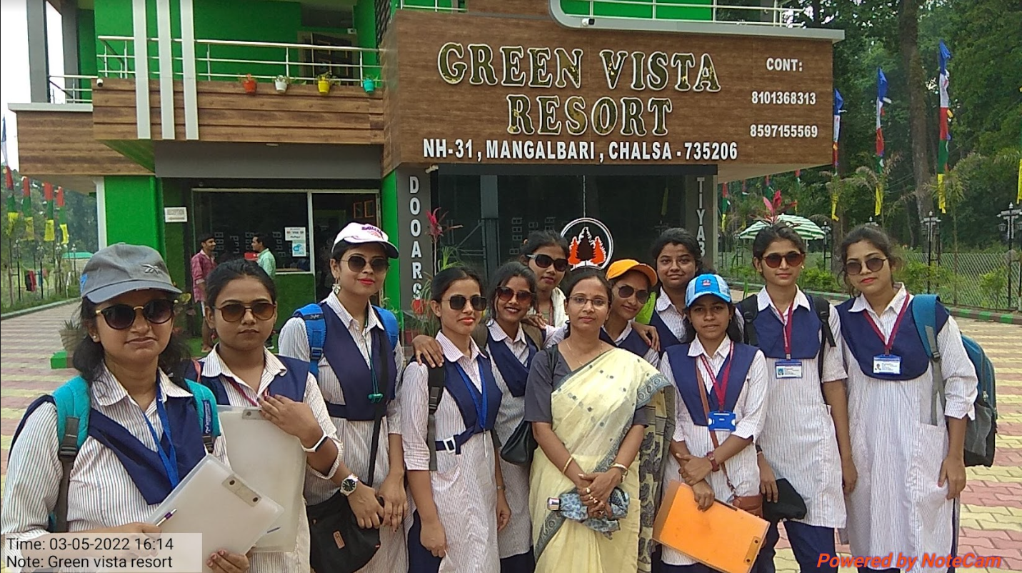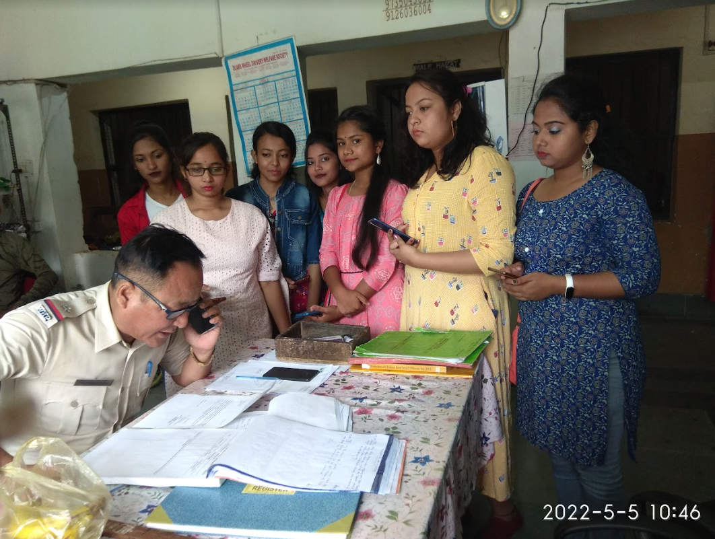
Hotel Resort survey Police station survey
………………………………………
8. A study Visit to Geological Survey of India, Eastern Region Headquarters, Bhu-Bijnan Bhavan, Block DK-6, Sector II, Salt Lake, Kolkata-91 was organised on 15.07.2022 with 12 Students of SEM-4 & 6 and 3 faculty members from 10 am to 4 pm.
Programme Outcome - Students visited and keenly observed the geological instruments like Abney level, compass and clinometers etc. which are used in different purposes, demonstrations and presentations of the different items organised by staffs of this institution, various kinds of corals and igneous, sedimentary and metamorphic rocks, a no. of GSI publications etc. They gathered knowledge about all these to a great extent. Students also participated in the quiz on the ICONIC DAY celebration of “Azadi ka Amrit Mahotsav”, a Government of India initiative to commemorate 75 years of India’s Independence and took the 2nd runner up position.
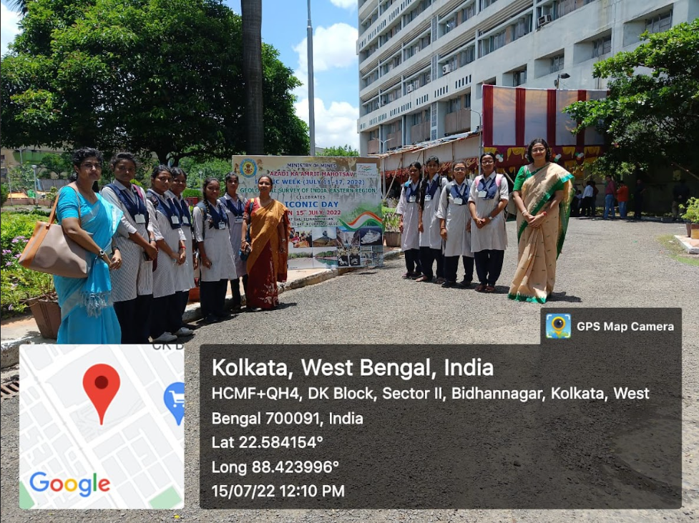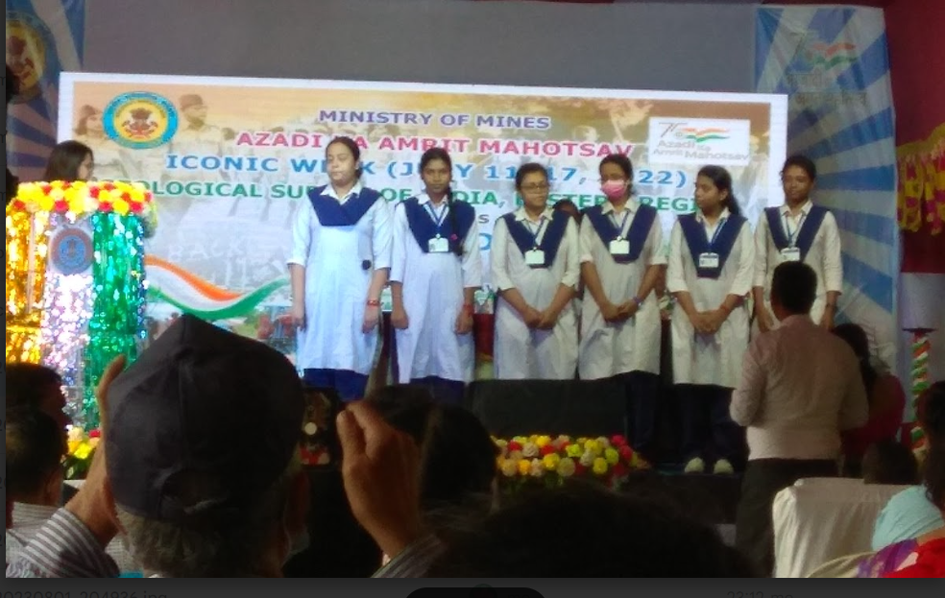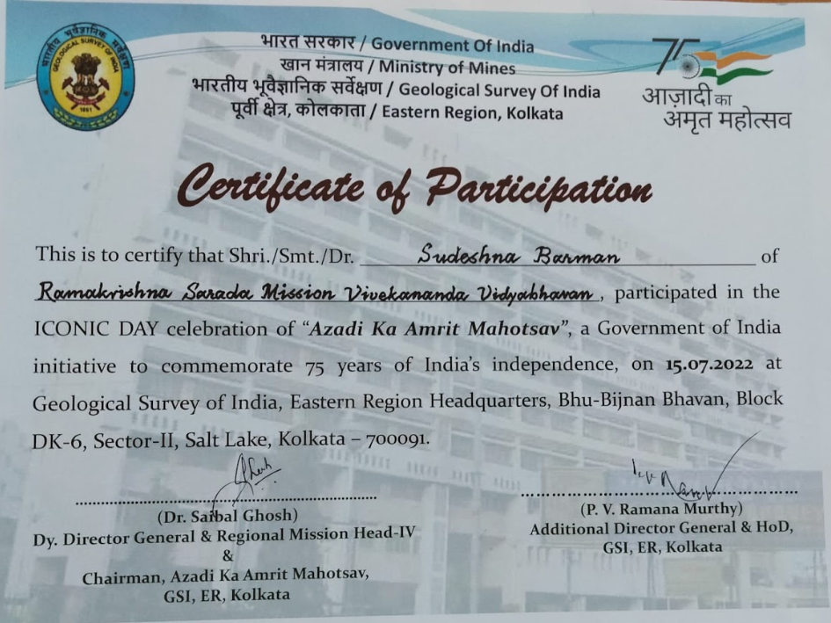
In front of GIS building 2nd Runner up in Quiz Participation certificate
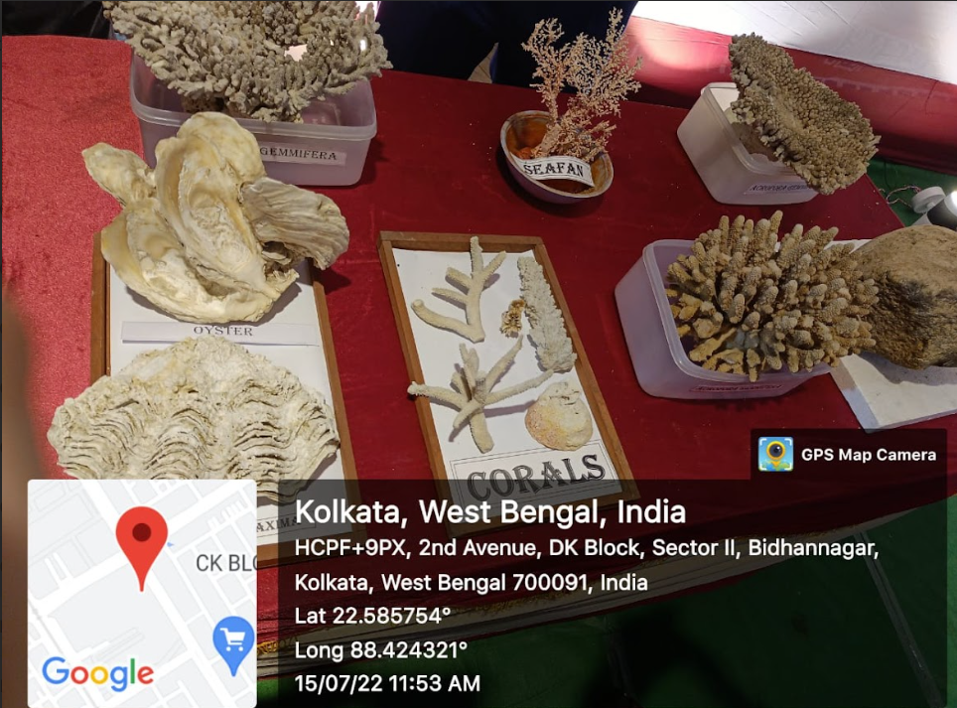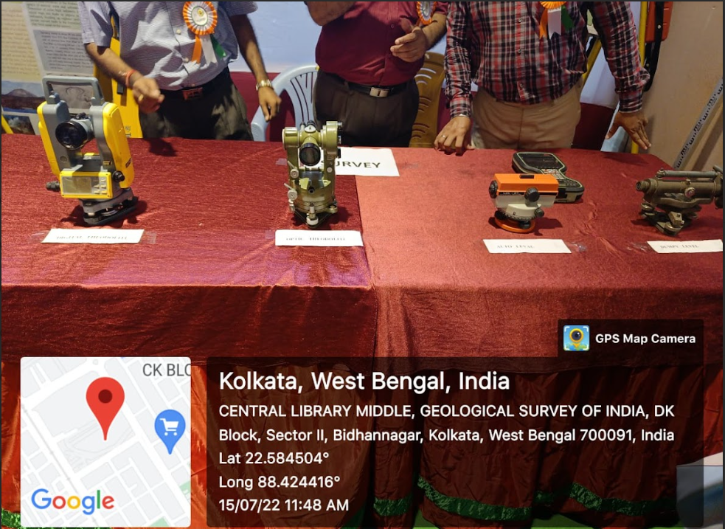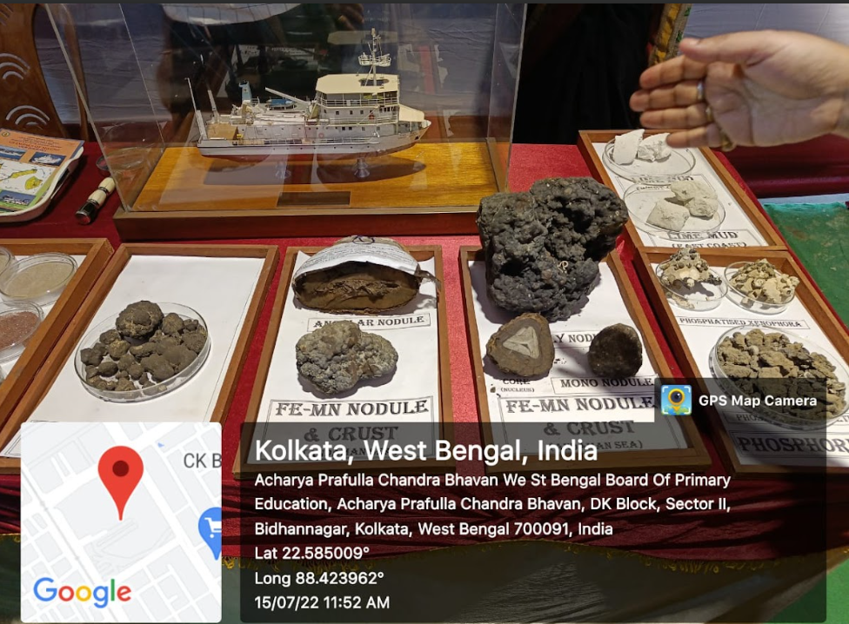
Different types of Corals Geological instruments Various types of Nodules
…………………………………………………
9. Annual Excursion was organised by the Dept on 23.12.2022 to M. P. Birla Planetarium, St. Paul’s Cathedral & Victoria Memorial Hall, Kolkata with 32 students and 2 faculty members.
Programme Outcome : We experienced the cosmic collision at MP Birla Planetarium. Cosmic collision launches visitors on an awe-inspiring trip through space and time to explore the hypersonic impacts that drive the dynamic and continuing evaluation of the universe. We witnessed collisions of past, present and future including the creation of our moon some 5 billion years ago, a re-creation of the meteorite impact that has hastened the end of the age of Dinosaurs 65 million years ago and a nail-biting future scenario where humanity desperately attempts to divert the path of an oncoming in asteroid on a collision course with the earth.
Students visited the St. Paul’s Cathedral, located beside Birla Planetarium. Its solemn atmosphere and peaceful environment influenced us a lot. We also visited the campus of Victoria Memorial Hall and the museum dome inside it and saw many historical things preserved with care.
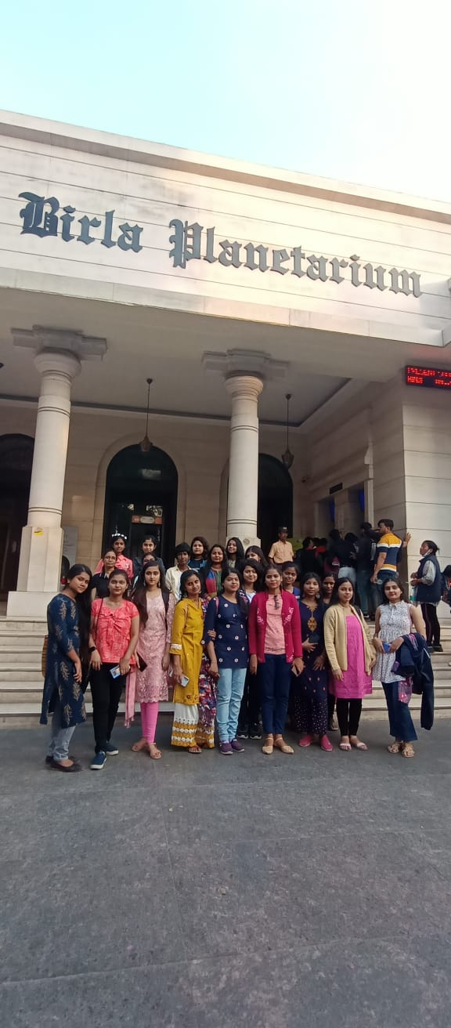
…………………………………………………..
10. The Department of Geography of RKSMVV organised a study visit to Jadavpur University on 15.02.2023 on Occasion Of Blended Capacity Building Program For Stakeholders Of River Ganga - FIFTH COLLOQUY : GANGA SAMVAD at Dr. Triguna Sen Hall of Jadavpur University with 10 students of SEM-4. This program was sponsored by National Mission for Clean Ganga, Ministry of Jal Shakti, Government Of India. This project was led by Indian Institute of Public Administration, New Delhi, in collaboration with South Asian Institute of Advanced Research & Development.
Programme Outcome : Students became familiar with the stakeholders of the holy River Ganga, various projects and a blended capacity building program for stakeholders to keep Ganga clean, the initiatives taken by the Department of Water Resources of Govt. of India to maintain cleanliness of River Ganga flowing besides the different cities of India. It was a very knowledgeable program for us to know the united efforts of different organisations to clean Ganga river from source to mouth.
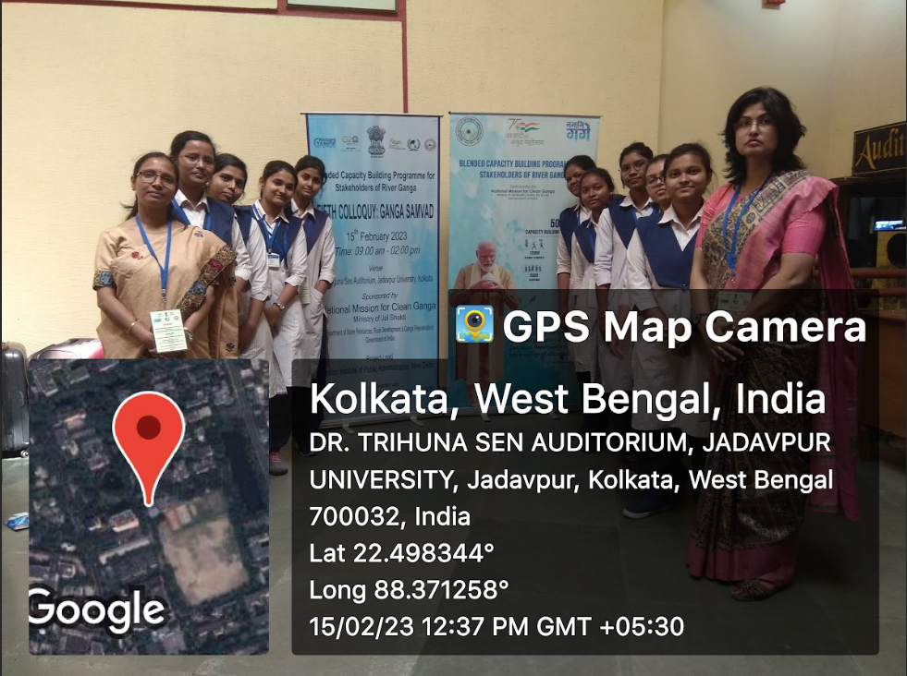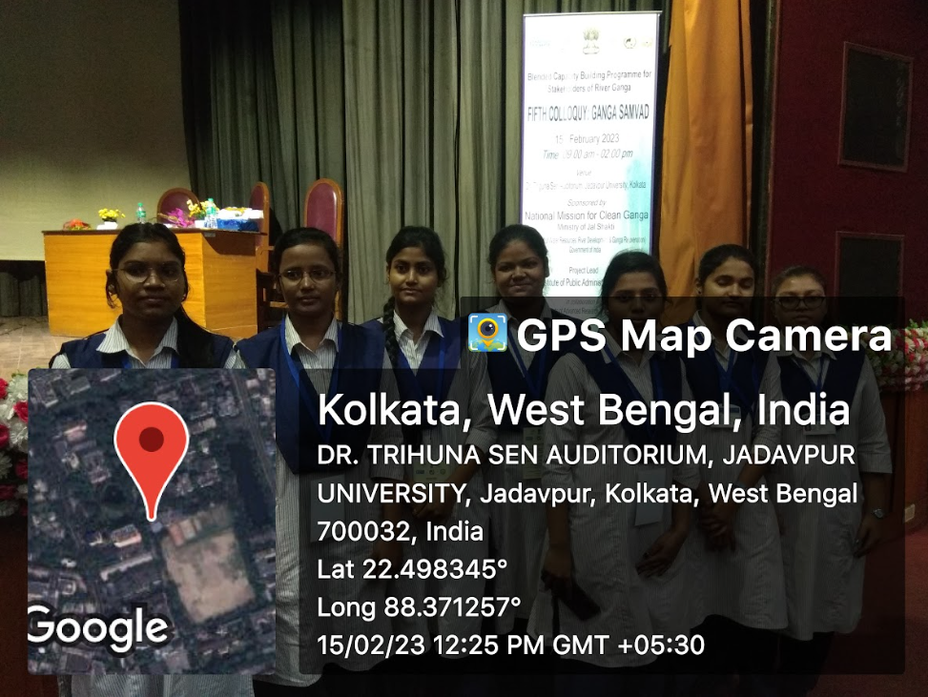
In front of Dr. Triguna Sen Hall, JU Students inside the hall
…………………………………………………………………….
11. The Department of Geography of RKSMVV organised a study visit to Regional Meteorological Centre, Alipore, Kolkata on 23.03.2023 on the occasion of Celebration of "World Meteorological Day" with 15 students of SEM-4.
Programme Outcome : The students got acquainted with the use and working of different meteorological instruments like max-min thermometer, wet-dry bulb thermometer, rain gauge, automatic weather station, automatic rain gauge, wind vane, anemometer, air balloon, theodolite etc. and collection and tabulation of weather data. The students also got familiar with the working of radar and its use in transmission and reception of information about the clouds and collection and analysis of that information.
An interactive session was also held within the office, where the students are asked questions related to monsoon and other climatic phenomena. Also our students had participated in the quiz section and got prizes.

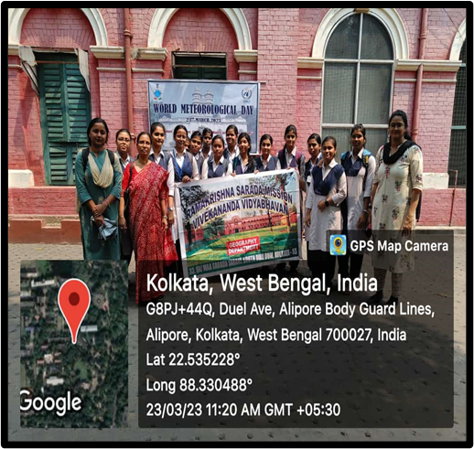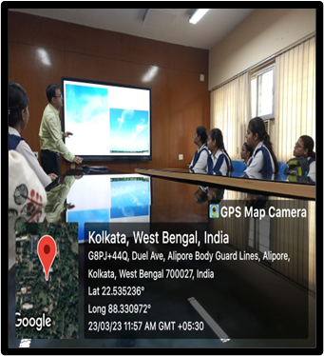
Students in front of RMC, Alipore Demonstration of clouds by a member
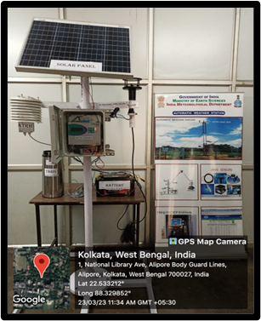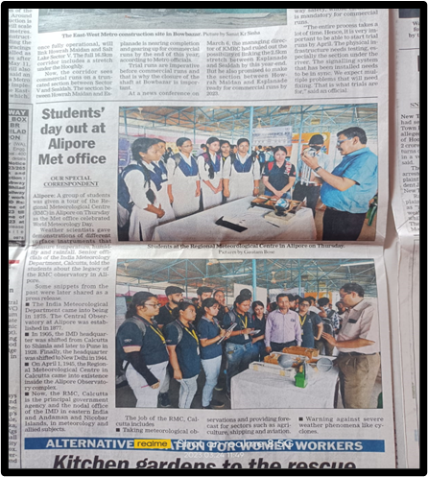
Meteorological instrument Source: Telegraph paper, Date:24/3/2023
………………………………………………………..
12. World Environment Day was celebrated by the Geography Department & NSS Unit of RKSMVV on 05/06/2023 from 2pm-3pm at Muktiprana Auditorium. Number of students present was 120 .
Program Outcome : The theme of World Environment Day of 2023 was ‘Plastic Pollution’. Through this work, the students tried to explain how conscious we need to be about the environment. This activity made other students very motivated. Use of Plastics in different forms is very much detrimental for our sustainable survival and also for future generations as it does a lot of harm to us and also our environment. All the students & teachers became aware of these bad effects of plastics and they took a pledge for a plastic free environment.

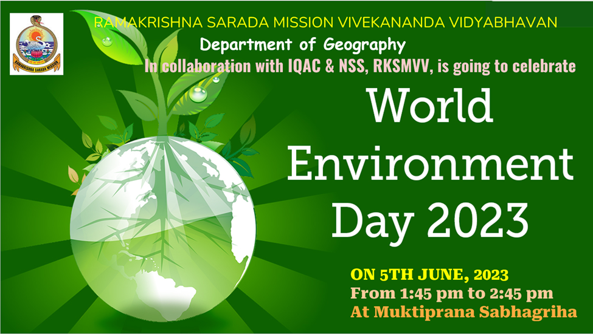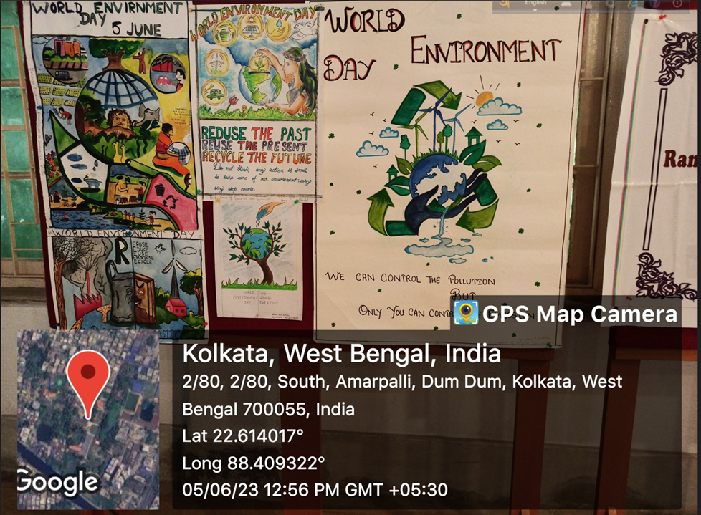 Flyer of the program Posters made by students
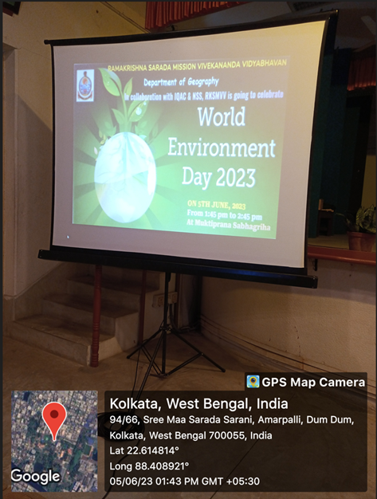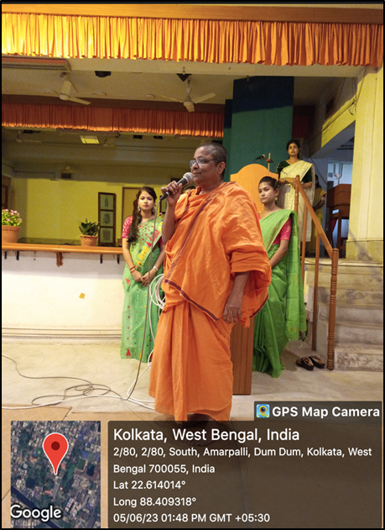
Inaugural speech of Principal Mataji on 5th June
…………………………………………..
13. A State-Level Seminar on “Application of RS / GIS & Its Career Prospects” was organised by the Department of Geography & IQAC, RKSMVV in collaboration with Department of Earth Sciences & Remote Sensing, JIS University, Kolkata on 12.06.2023 from 2 pm to 4 pm. Number of Participants was 62. The Resource Persons were :
a) Dr. Anatu Bhattacharya, Associate Professor, Dept. of Earth Sciences & Remote Sensing, JIS University, Kolkata.
b) Dr. Ratnadeep Ray, Assistant Professor, Dept. of Earth Sciences & Remote Sensing, JIS University, Kolkata.
Programme Outcome : Infact, we can’t imagine our day-to-day life without the help of GIS. It has become a part and parcel of our lives. The Seminar was very fruitful particularly for the students who are interested in Remote Sensing and GIS. Every year after completion of graduation in Geography Honours, many students take admission for Post-graduation in GIS and Remote Sensing in West Bengal and other States of India as the job opportunity is better, & the popularity of the subject is increasing day by day. So, students are largely motivated to continue their career with GIS as its prospects are growing gradually to a great extent.
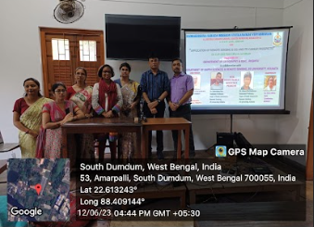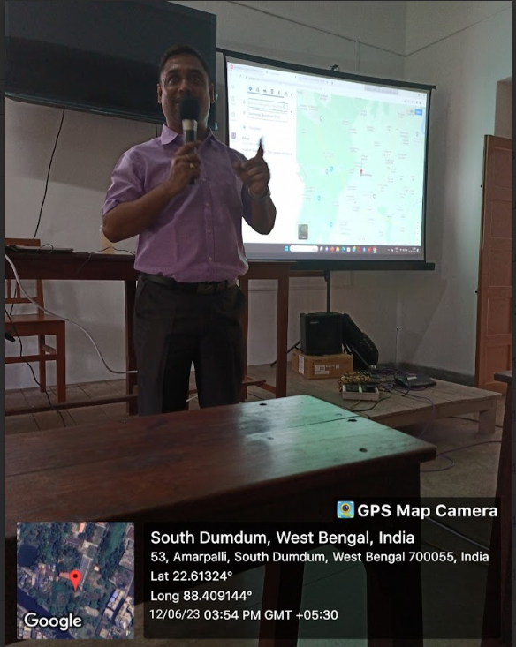
Faculties with the resource persons Speech of Dr. Ratnadeep Ray
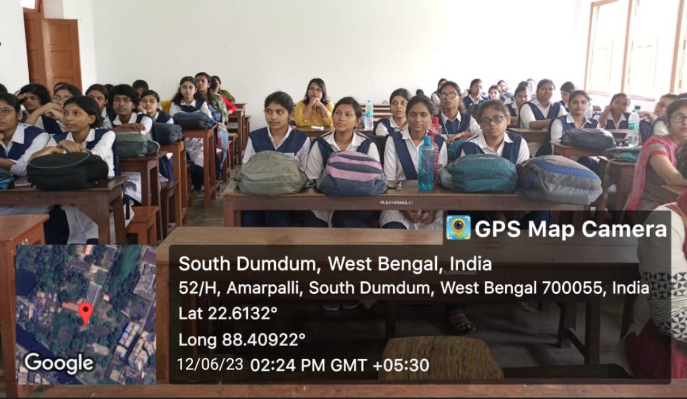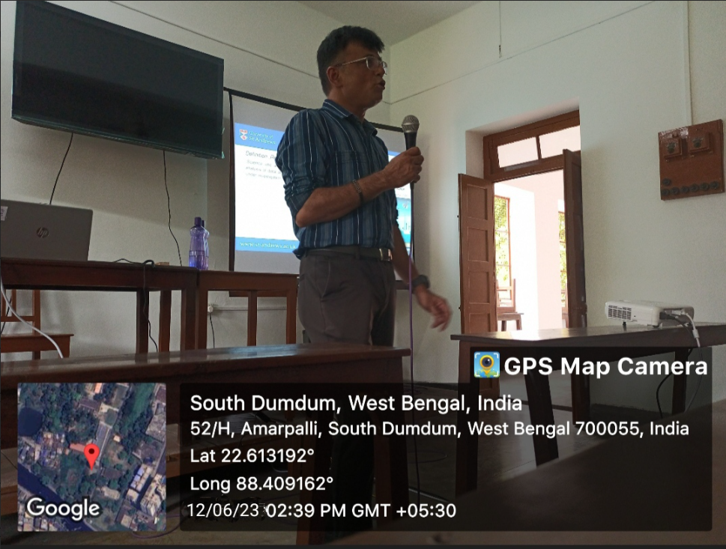
Speech of Dr. Atanu Bhattacharya
……………………………….
14. A Field Trip was arranged for SEM-5 to Ghatsila for Socio-Economic Study on Ghatsila & its surroundings from 03.10.2023 - 6.10.2023 with 16 students and 2 Faculties and 1 Non-Teaching staff.
Programme Outcome : An excursion is an opportunity for all to get a good geographical exposure and learn how management and marketing principles are applied by businessmen in tourist areas. Excursion was also a platform for them to get a taste of local food, understand the culture and appreciate the beauty of these cities and develop a strong bonding between each other. Excursion gave students a refreshing, enlightening, adventurous, nostalgic and tremendous learning experience through visits to some of the prominent places in these destinations like Burudi dam, Subarnarekha River, Jamshedpur, Jubli park etc.
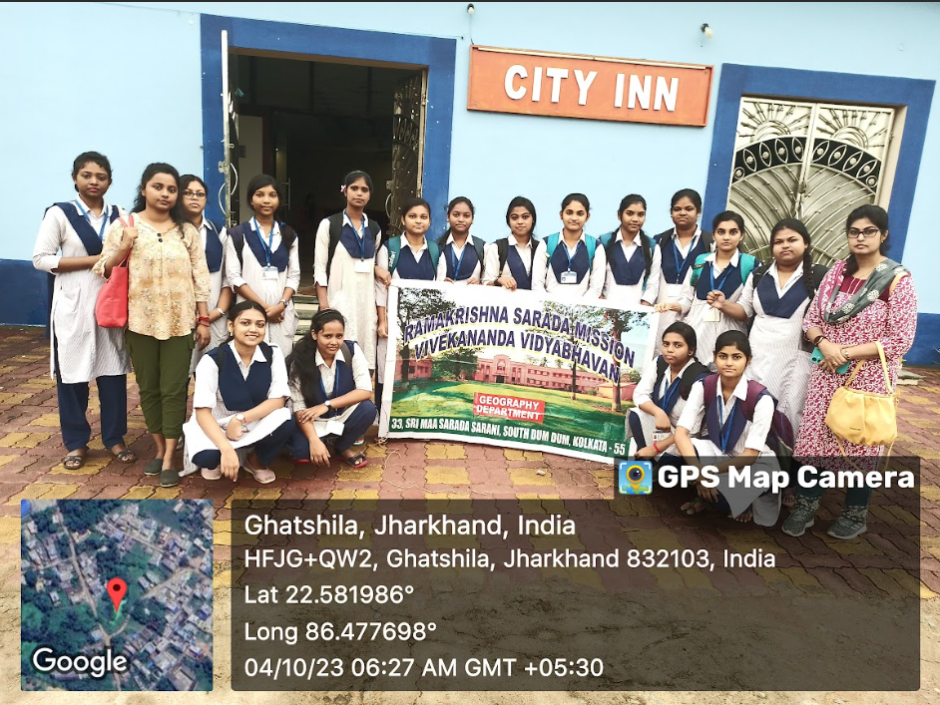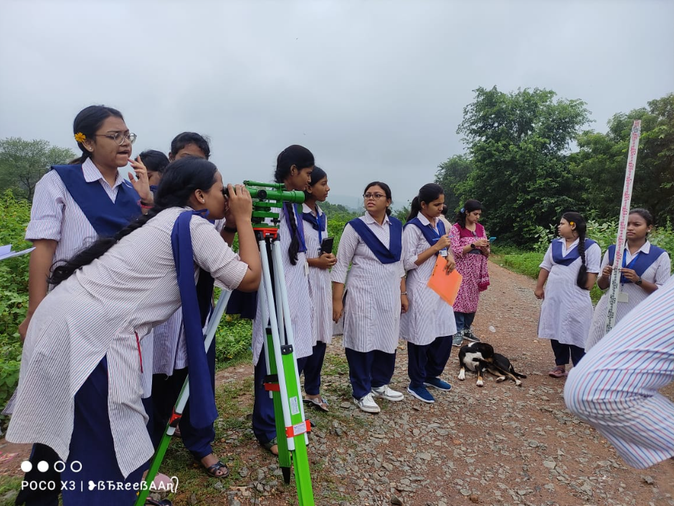
Hotel Survey Profile Survey

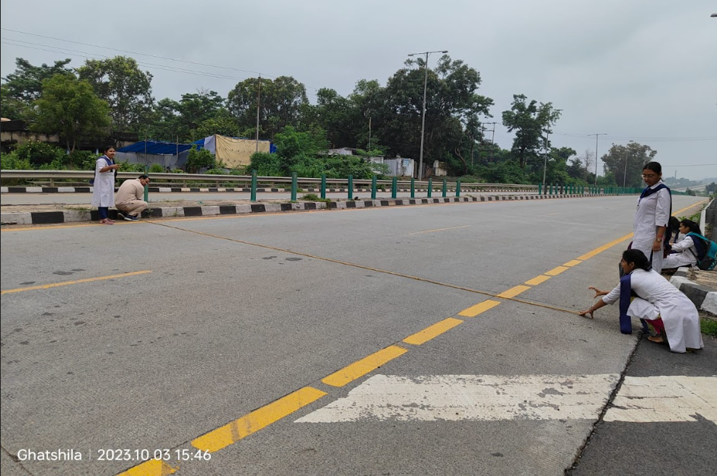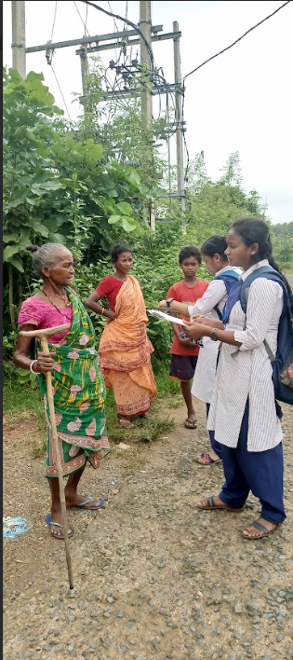
Road Survey Household survey
……………………………….
15. An orientation program on “Fundamentals of Remote Sensing & GIS & its career opportunities” was organised by the Geography department and IQAC, RKSMVV on 06.12.2023 from 12.30 p.m - 3:00 pm at Swamiji Bhavan. Total participants were 54 students of the department. The resource person was Mr. Ayan Ghosh, IT Personnel, GIS Special Investigation Divisions, CAD GIS Centre, Public Health and Engineering Department, Govt. of West Bengal.
Programme Outcome : The Orientation Program serves the course outline about remote sensing and its application in the real field. The aim of the program is a comprehensive and sequential educational concept designed to provide a brief description about remote sensing and how students will further proceed with the subject and in which colleges and universities they can further move ahead. Our speaker also lightens upon various forms of employment opportunities and to develop job retention skills.
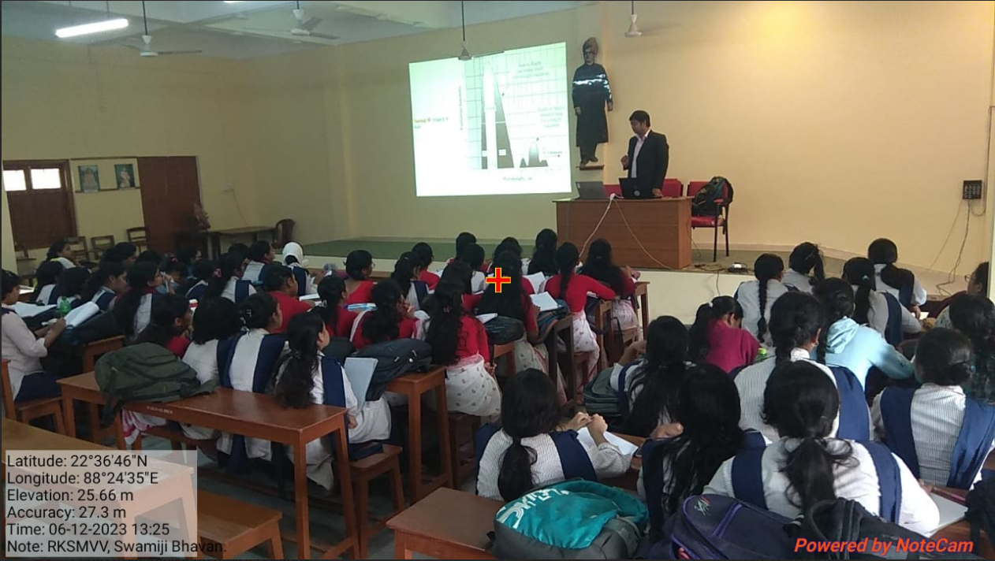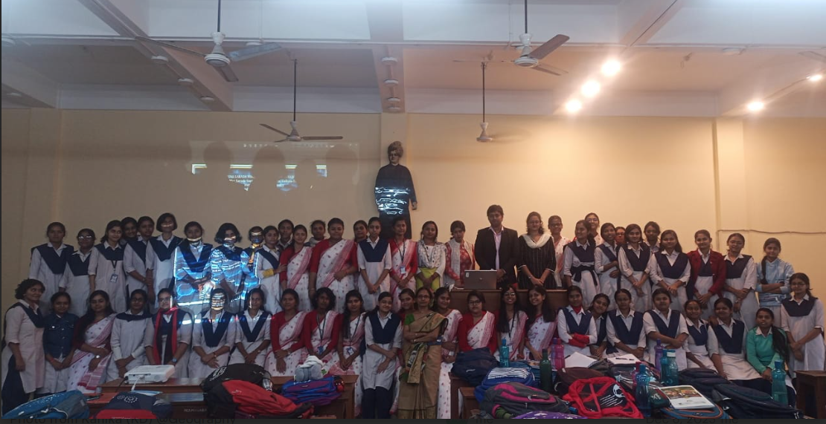
Program is going on Geography Dept. With Resource Person
…………………………………………………………..
16. A Visit to Kolkata Book Fair was organised by the Department on 22.01.2024 with 15 students of SEM-1 & 3 faculty of the dept.
Programme Outcome - A book fair is an excellent opportunity to build students’ home libraries. Book fairs often showcase more than just books. Audiobooks, electronic books, and other forms of digital media are often featured at book fairs. Some book fairs also incorporate performances, screenings and other types of entertainment also.
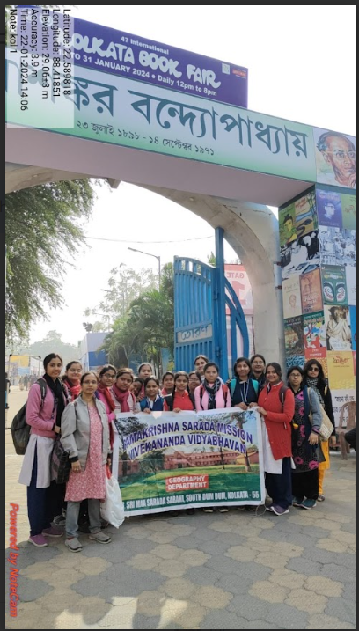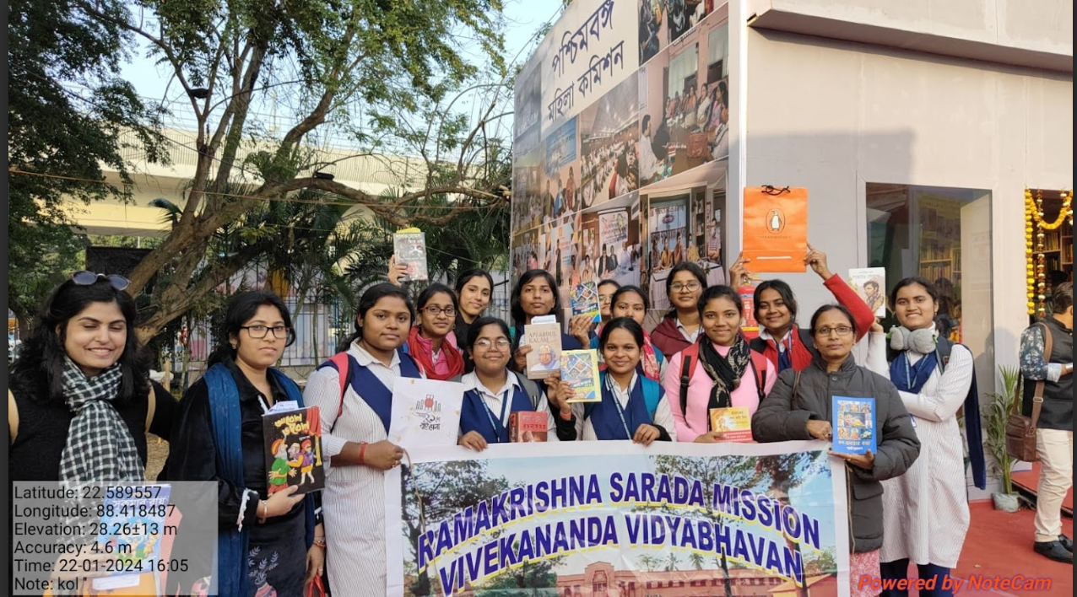
Group of us at Gate no. 1 In front of Womens’ Commission stall
…………………………………………………………..
17. A State-Level Seminar on “Role of Mangrove Army in Plantation, Protection & Conservation, Sundarban” was organised by the Dept. of Geography & Human Rights in Collaboration with IQAC, RKSMVV on 22/05/2024 from 11 am - 1 pm.
Programme Outcome - Students came to know about the name, locational characteristics of various endangered species in Sundarban Mangrove forest. It also provides us the overall knowledge about how Sundarban Mangrove singly holds an unique ecological system and how this wildlife habitat makes it one of the best natural beauty in the world. The seminar was very informative and motivational.
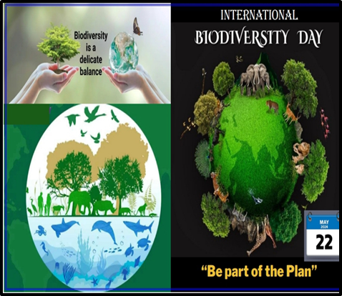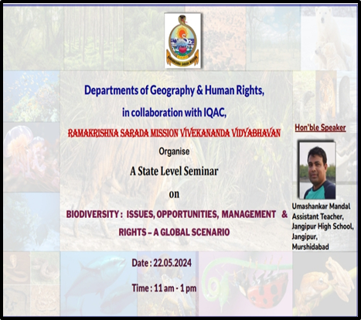
Flyer of the programme
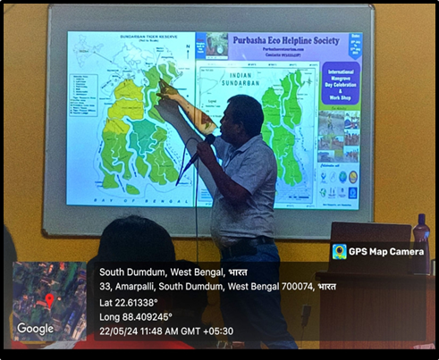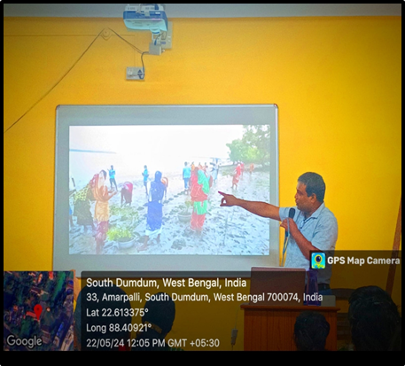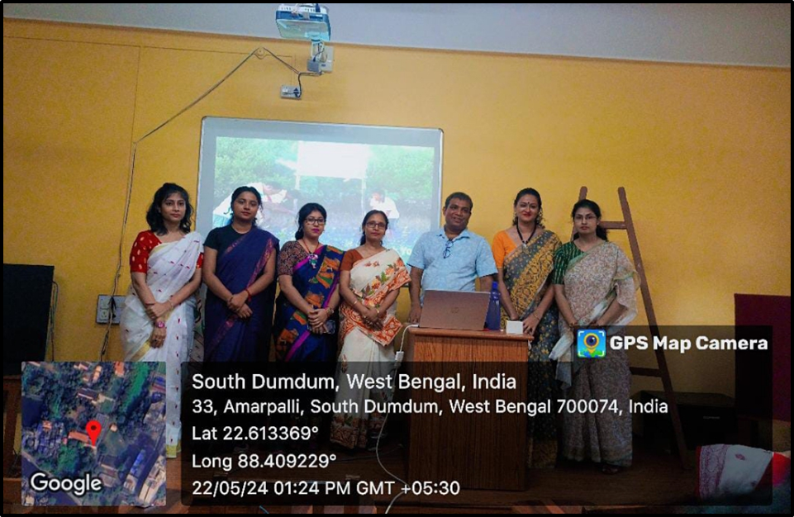
Presentation of the resource person
…………………………………………………………..
18. Celebration of World Environment Day was organised by the Department of Geography & NSS Unit, in collaboration with IQAC, RKSMVV on 05/06/2024.
Programme Outcome : The theme of World Environment Day of 2024 was ‘Land Restoration, Desertification and Drought Resilience’ under the slogan “Our land. Our future. We are #GenerationRestoration.” Through this celebration the students acquired a clear concept regarding land restoration, and desertification and how drought situations can be managed and the cause-effect relationship of climate change, desertification and drought with the potential of ecosystem restoration. This activity made other students very motivated and again conscious about our environment.
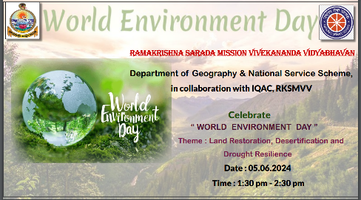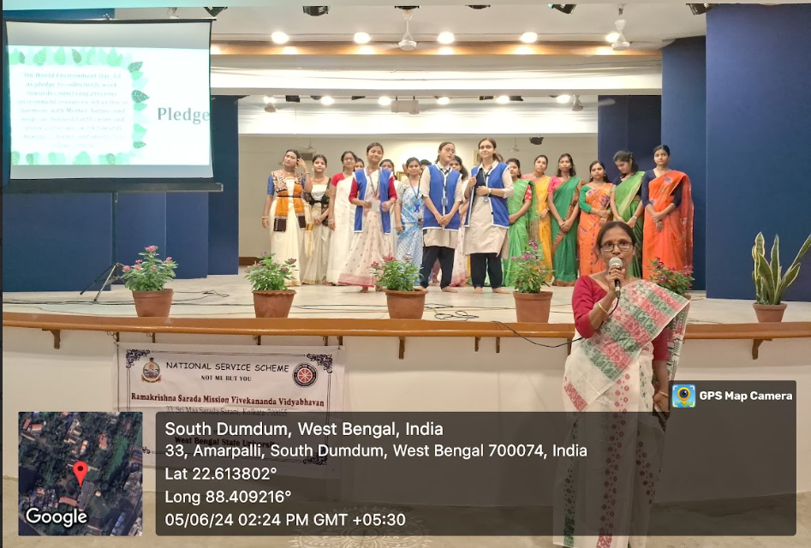
Flyer of the programme Pledge reading by students
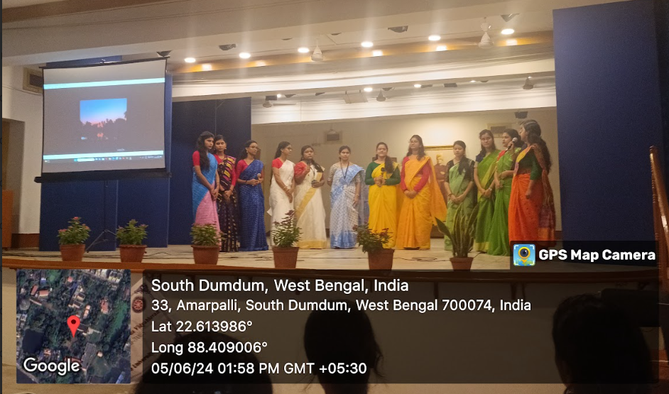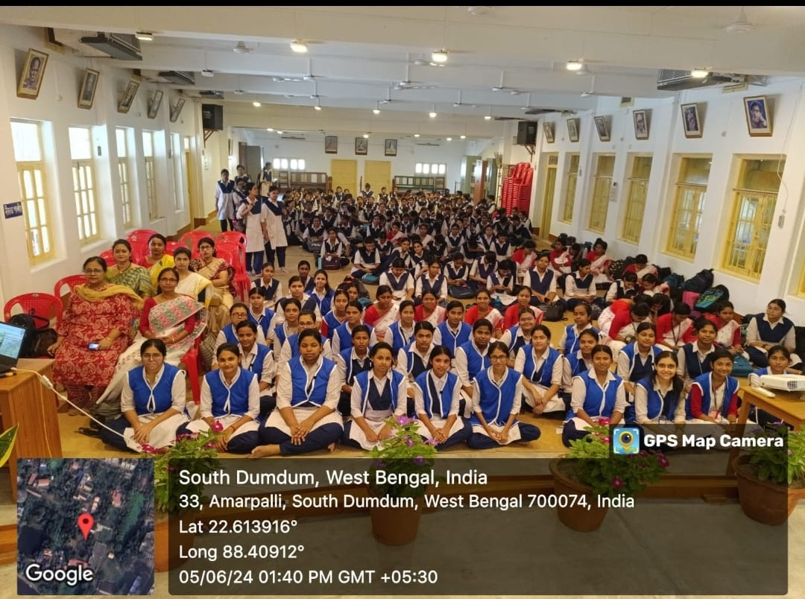
Students’ performance Muktiprana Auditorium
………………………………………………..
19. A National Seminar in Commemoration of "World Environment Day" was organised by the Departments of Geography, History & Human Rights, in collaboration with IQAC, RKSMVV on 10.08.2024
Programme Outcome :
Students gain a deeper understanding of the impacts of climate change on ecosystems, human health, economies, and global weather patterns. Practical knowledge about adaptation strategies for dealing with climate change, such as sustainable agriculture, water conservation, renewable energy, and disaster preparedness was also gained. Encouraging individuals to adopt more sustainable lifestyles, such as reducing carbon footprints, switching to renewable energy, conserving water, and reducing waste.
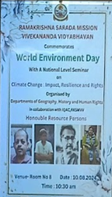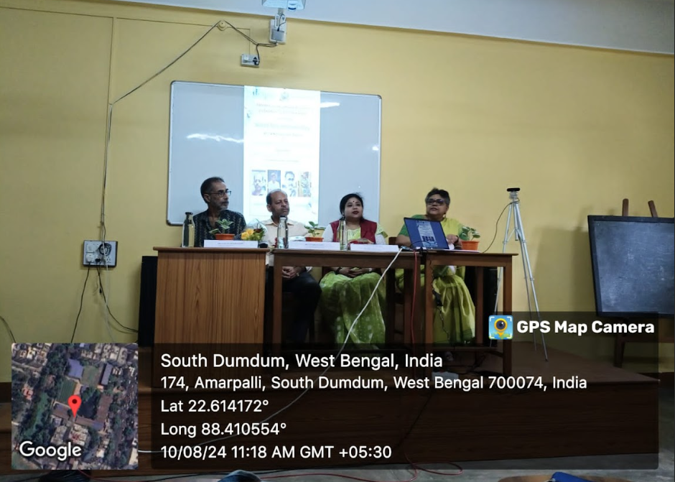
………………………………………………………………………………….
20. A Compulsory Educational Field Trip was organised by the Dept. of Geography, RKSMVV to Ballavpur mouza in Bolpur-Sriniketan C.D Block, Birbhum, West Bengal from 18.09.2024 to 20.09.2024 with 20 Students of 5th semester.
Programme Outcome - Shantiniketan, a neighbourhood of Bolpur town, demonstrates an experimental settlement in education and communal life in a rural setting. The students carried out dumpy level surveys at khoai to know the physical setting along with household survey, market survey, traffic survey, hotel survey, tourist survey, hospital survey and environment survey for better understanding of socio-economic conditions of inhabitants of Ballavpur mouza. Land Use data collected from the Land reform office of Bolpur-Shantiniketan represented, in an outstanding way, the emergence of Post-colonial centres of cultural, philosophical and spiritual exploration. The trip helps the students to learn about the real world, develop geographical thinking, understand human adaptation, collect primary data and improve reasoning abilities.
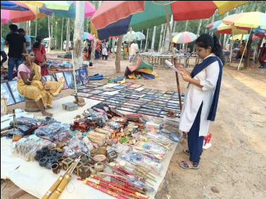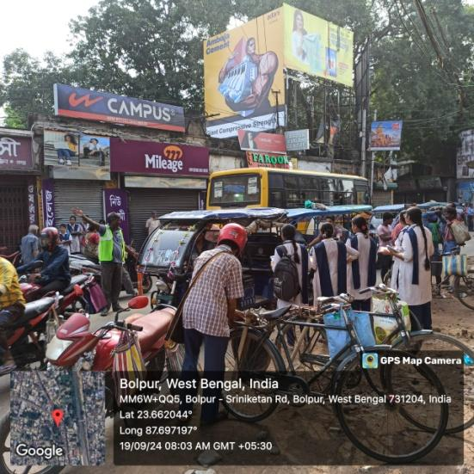
Market Survey Transport Survey
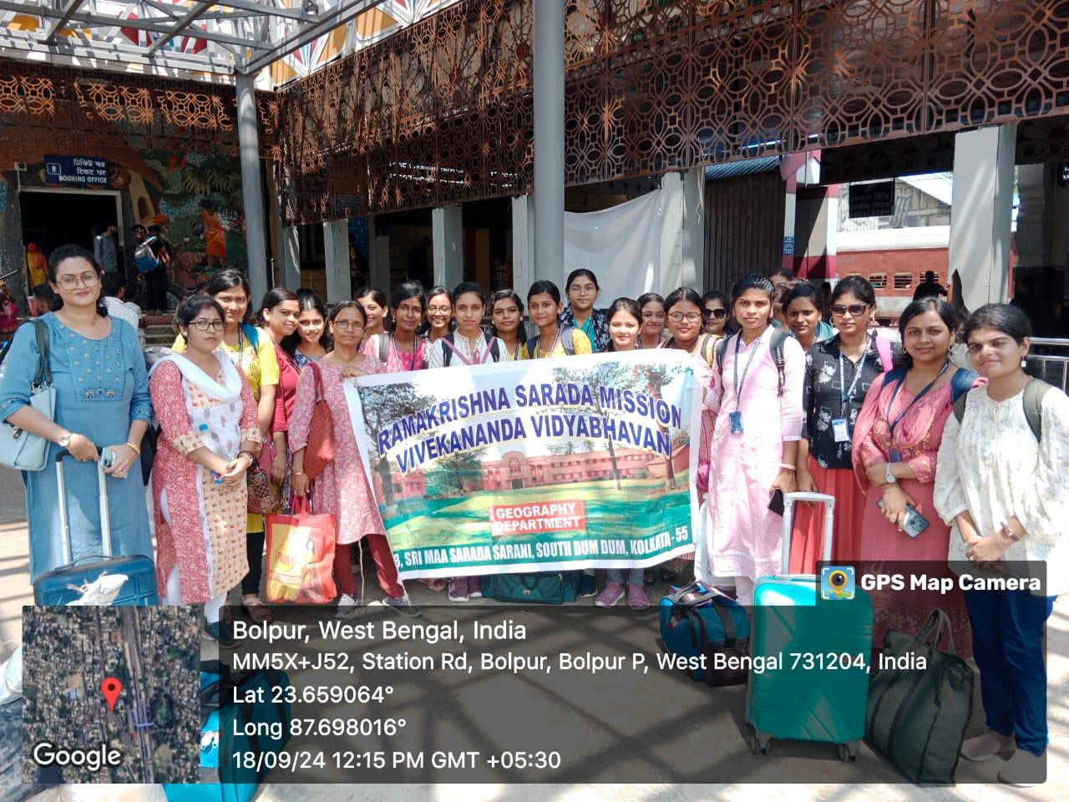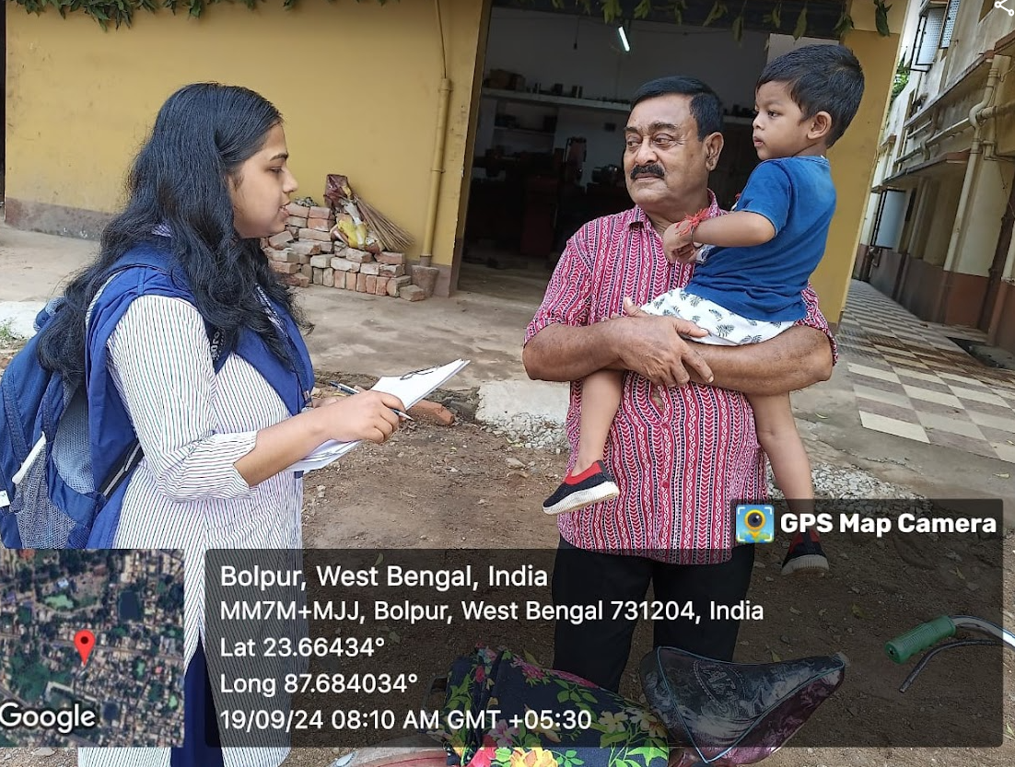
Team of SEM-5 students at Bolpur stn. Household survey
………………………………………………………………………………………………………...

