1. **Name of Activity:** Invited Lecture

**Category:** Faculty Exchange

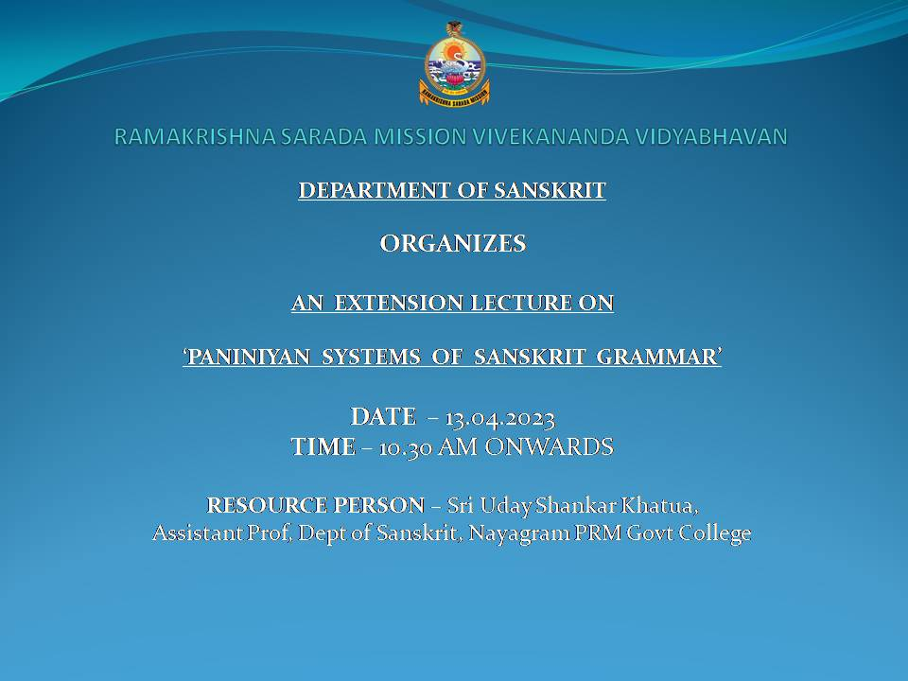

**Date: 13.04.23**

**Time:** 10.30 am onwards

**Venue:** RKSMVV

**Name of Resource Persons:** Uday Shankar Khatua, Ass Prof, Dept of Sanskrit, Nayagram PRM Govt College

**Number of Participants:** 25

**Programme Outcome:** Students enjoyed the talk on ‘Paniniyan Systems of Sanskrit Grammar’.

**\*\*\* *** \*\*\***

1. **Name of Activity:** Faculty Exchange (Department of Sanskrit)

**Category:** Class Lecture

**Topic: Śabdaśakti  
Date: 12th June, 2023**  
**Time:** 12 noon to 01:00 pm  
**Venue:** Room no-34, Ramakrishna Sarada Mission Vivekananda Vidyabhavan

**Name of Resource Person:**

Poulomi Saha, Assistant Professor, Department of Sanskrit, Barasat Government College

**Number of Participants:** 15 students

**Programme Outcome:** The students were happy as they could get a comprehensive idea about the topic.

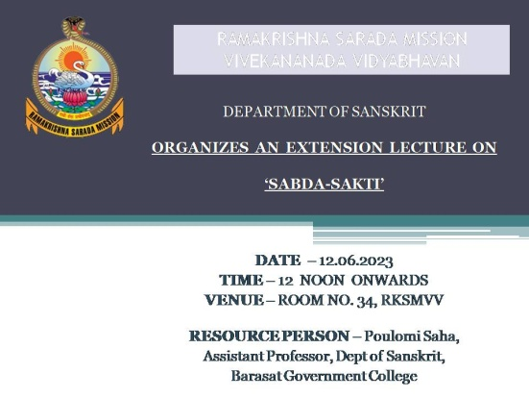

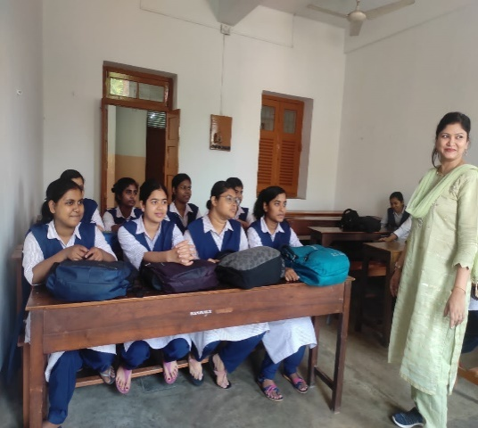

**\*\*\* *** \*\*\***

1. **Name of Activity:** Faculty Exchange (Department of Sanskrit)

**Category:** Class Lecture

**Topic:** General Idea of Sanskrit Poetics

**Date: 12th June, 2023**

**Time:** 1.30 pm to 2.30 pm

**Venue:** Room no-34, Ramakrishna Sarada Mission Vivekananda Vidyabhavan

**Name of Resource Person:**

Poulomi Saha, Assistant Professor, Department of Sanskrit, Barasat Government. College

**Number of Participants:** 15 students

**Programme Outcome:**   
The students were happy as they could get a comprehensive idea about the topic.

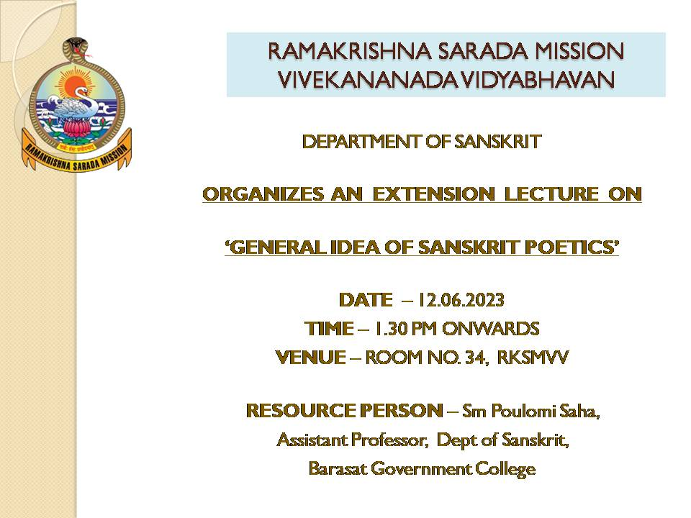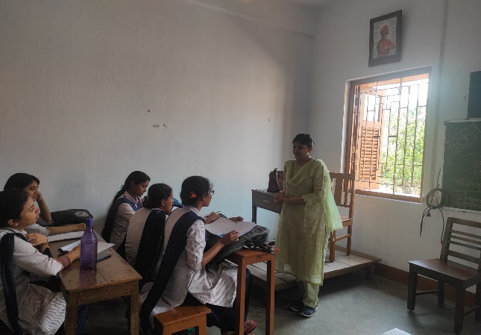

*** *** ***

1. **Name of the Activity:** Extension Lecture

**Organising Unit:** Department of Sanskrit, RKSMVV

**Date:** 15 March and 12 April 2023

**Time:** 12.30pm

**Venue:** Room No. 24

**Name of the Resource Person:** Dr. Dipankar Patra, Associate Professor, Dept of Sanskrit, APC College

**Name of the participants:** Students of Semester 4

**Brief description of the event:**

Dr. Dipankar Patra delivered a resourceful lecture on the Indian Epigraphy, Paleography and Chronology with vivid description and example of various Inscriptions.

**Programme Outcome:** Students were benefited with his various inputs about Indian epigraphy.

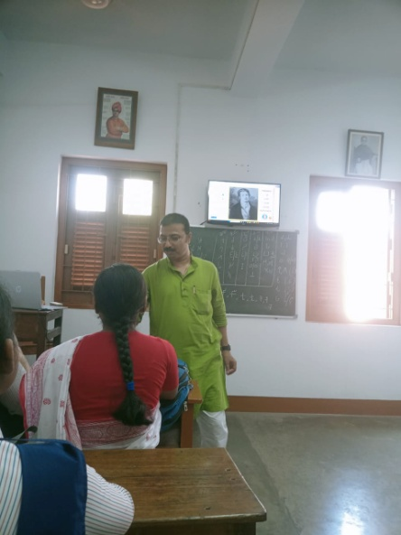

*** *** ***

1. **Name of the Activity:** International Mother Language Day

**Organising Unit:** Departments of Sanskrit and Bengali along with IQAC, RKSMVV

**Date:** 21.2.2024

**Time:** 1 - 3.30 pm

**Venue:** Swamiji Bhavan

**Name of the Resource Person**: Sm Isha Dev Pal (Associate Professor, Head of Department, Bengali, Srirampur College) and

Dr. Vivek Karmakar (Assistant Professor, Department of Sanskrit, Scottish Church College)

**Number of participants:** All students of RKSMVV

**Brief description of the Event:** Students and teachers of RKSMVV celebrated this auspicious day with the lectures by Dr. Isha Dev Pal. She explained how the Bengali language evolved through Bengali fables and fairy tales. Dr. Vivek Karmakar described vividly how to spell correctly words with Murdhanya na and Murdhanya Sha.

**Programme Outcome:** Participants were benefited to know the appropriate pronunciation of the words with grammatical explanations.

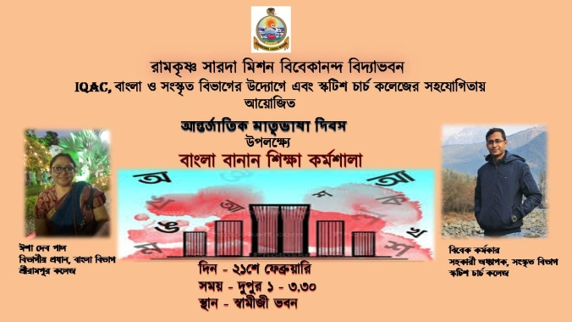 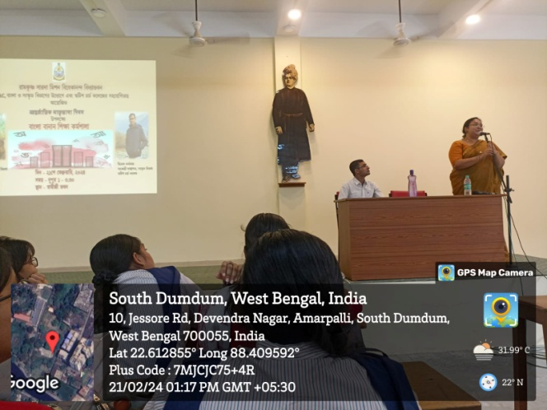

*** *** ***

1. **Name of the Activity:** Prativaad O Protirodhe Nari: Se-kaal O e-kaaler kolome

**Category:** Interdisciplinary Lecture

**Organising Unit:** Departments of Sanskrit and Bengali along with IQAC, RKSMVV.

**Date:** 24.5.2024

**Time:** 1pm

**Venue:** Room No.8

**Name of the Resource Persons**:

Dr. Sudakshina Ghosh, Associate Professor (Department of Bengali), Kishore Bharati Bhagini Nivedita College and

Dr. Antara Banerjee, Associate Professor (Department of Sanskrit), Barasat Govt College.

**Number of the participants:** All students of Bengali and Sanskrit Departments.

**Brief description of the Event:** Dr. Sudakshina Ghosh discussed some Middle-age and Modern Bengali literary works and explained that inspite of tremendous pressure and social suppression women could protest or revolt vocally or silently to establish their viewpoint.

Dr. Antara Banerjee described the struggle and revolt of women in the light of mythological anecdotes.

**Programme Outcome:** Students with ultramodern technological facilities came to know about the situations of suppressed women and their struggle to break the barricade. They learnt how to empower oneself and stand against the patriarchal domination.

