DEPARTMENT OF HUMAN RIGHTS

Name: Changes of Women’s Role in Society
Category: Extension Lecture
Organizing Unit: Department of Human Rights and Department of Psychology, RKSMVV
Date: 12:03:2019
Time: 11:15am
Number of Students: 15
Number of Teachers: 4
Speaker: Dr. Homprabha Barua
Assistant Professor, Department of Human Rights, Vivekananda Thakurpukur, University of Calcutta.

Brief Description of the Event: Speaker has been invited for delivering an Extension lecture on “Changes of Women’s Role in Society” organized by the Department of Human Rights and Department of Psychology, RKSMVV College on 12th March 2019 at 11:15am.

Outcome: Societal norms and expectations have shifted, allowing women to pursue careers and break the traditional gender roles that previously defined their roles in society. Women are now being seen as equals to men, and their contributions to society are being recognized and valued.
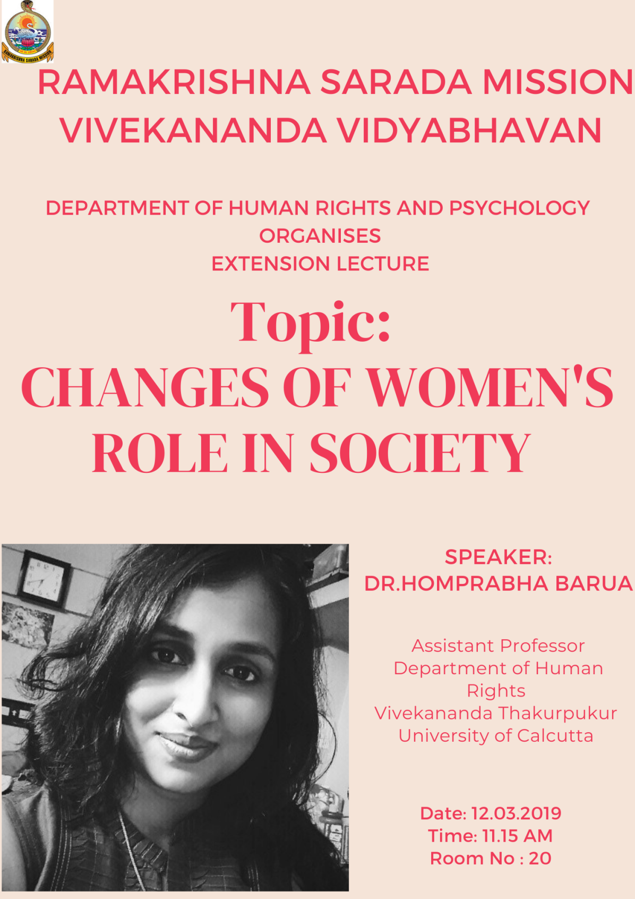

DEPARTMENT OF HUMAN RIGHTS

Name: National and State Human Rights Commission
Category: Extension Lecture
Organizing Unit: Department of Human Rights, RKSMVV
Date: 23:03:2019
Time: 11:15am
Number of Students: 9
Number of Teachers: 1
Speaker: Dr. Payel Rai Chowdhury Dutt
Coordinator and Assistant Professor, Department of Human Rights and Human Development, Rabindra Bharati University, Emerald Bower Campus.

Brief Description of the Event: Speaker has been invited for delivering an Extension lecture on “National and State Human Rights Commission” organized by the Department of Human Rights, RKSMVV College on 23th March 2019 at 11:15am.

Outcome: The Commission is responsible for spreading of human rights awareness amongst the masses and encouraging the efforts of all stake holders in the field of human rights literacy not only at the National level and State Level but at international level too.

