DEPARTMENT OF HUMAN RIGHTS
Online Series and Extension Lectures
2021

Name: Online Lecture Series
Category: Multidisciplinary Research and Gender Studies
Organizing Unit: Department of Human Rights in collaboration with Gender Resource Centre, RKSMVV
Date: 05:01:2021
Time: 04:00 to 6:00 pm
Number of Students: 40
Number of Teachers: 10
Speaker: Dr. Debdatta Chowdhury
Assistant Professor in Gender Studies, Centre for Studies in Social Sciences, Kolkata
Brief Description of the Event: The Gender Resource Centre, RKSMVV is holding a lecture series on Multidisciplinary Research and Gender Studies in January 2021.As a part of programme, the Department of Human Rights, in collaboration with Gender Resource Centre, is organizing an online lecture on 5th January 2021 from 4:00 to 6:00pm and in this regard Speaker is cordially invited to speak on “Of Consensus, Contentions and continuities: Feminist Legal Jurisprudence in India”
Outcome: Feminism jurisprudence or feminist legal theory claims that law should be equal for all, without any social prejudice or male domination. It carries the study of standards and application of different issues that have developed and emerged within feminists' thoughts and eventually became a theory.
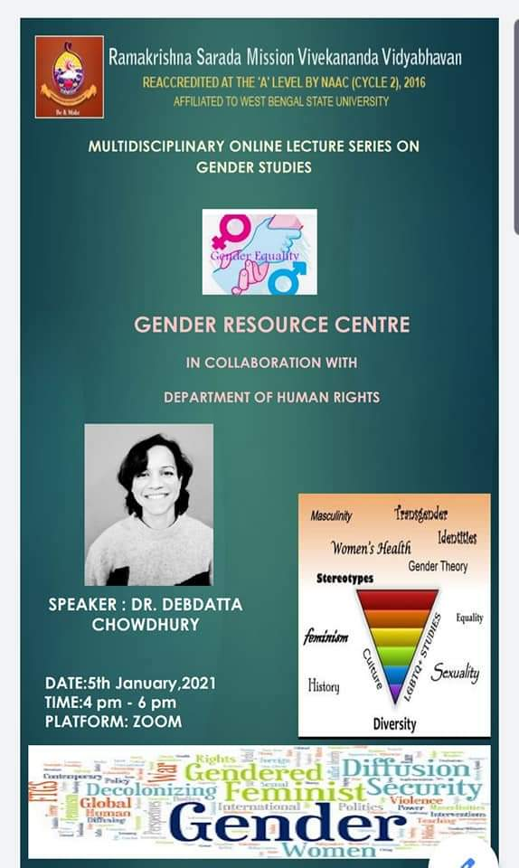
DEPARTMENT OF HUMAN RIGHTS

Name: Right to Education as a Fundamental Rights: With special reference on Articles 14, 15, 17, 21A, 28,30,45,56,350.
Category: Extension Lecture
Organizing Unit: Department of Human Rights, RKSMVV
Date: 15:01:2021
Time: 11:15am
Number of Students: 25
Number of Teachers: 2
Speaker: Dr. Soma Nandi
Associate Professor, Department of Education, East Calcutta Girls’ College West Bengal State University

Brief Description of the Event: Speaker has been invited for delivering an Extension lecture on “Right to Education as a Fundamental Rights: with Special emphasis on Articles 14,15,17,21A,28,30,45,46,350” organized by the Department of Human Rights, RKSMVV College on 15th January 2021 at Google Meet.
Outcome: The Act has ensured that every child, regardless of their socio-economic background, has access to quality education. The Act has led to an increase in enrolment rates, a reduction in drop-out rates, an improvement in infrastructure, and a better quality of education.

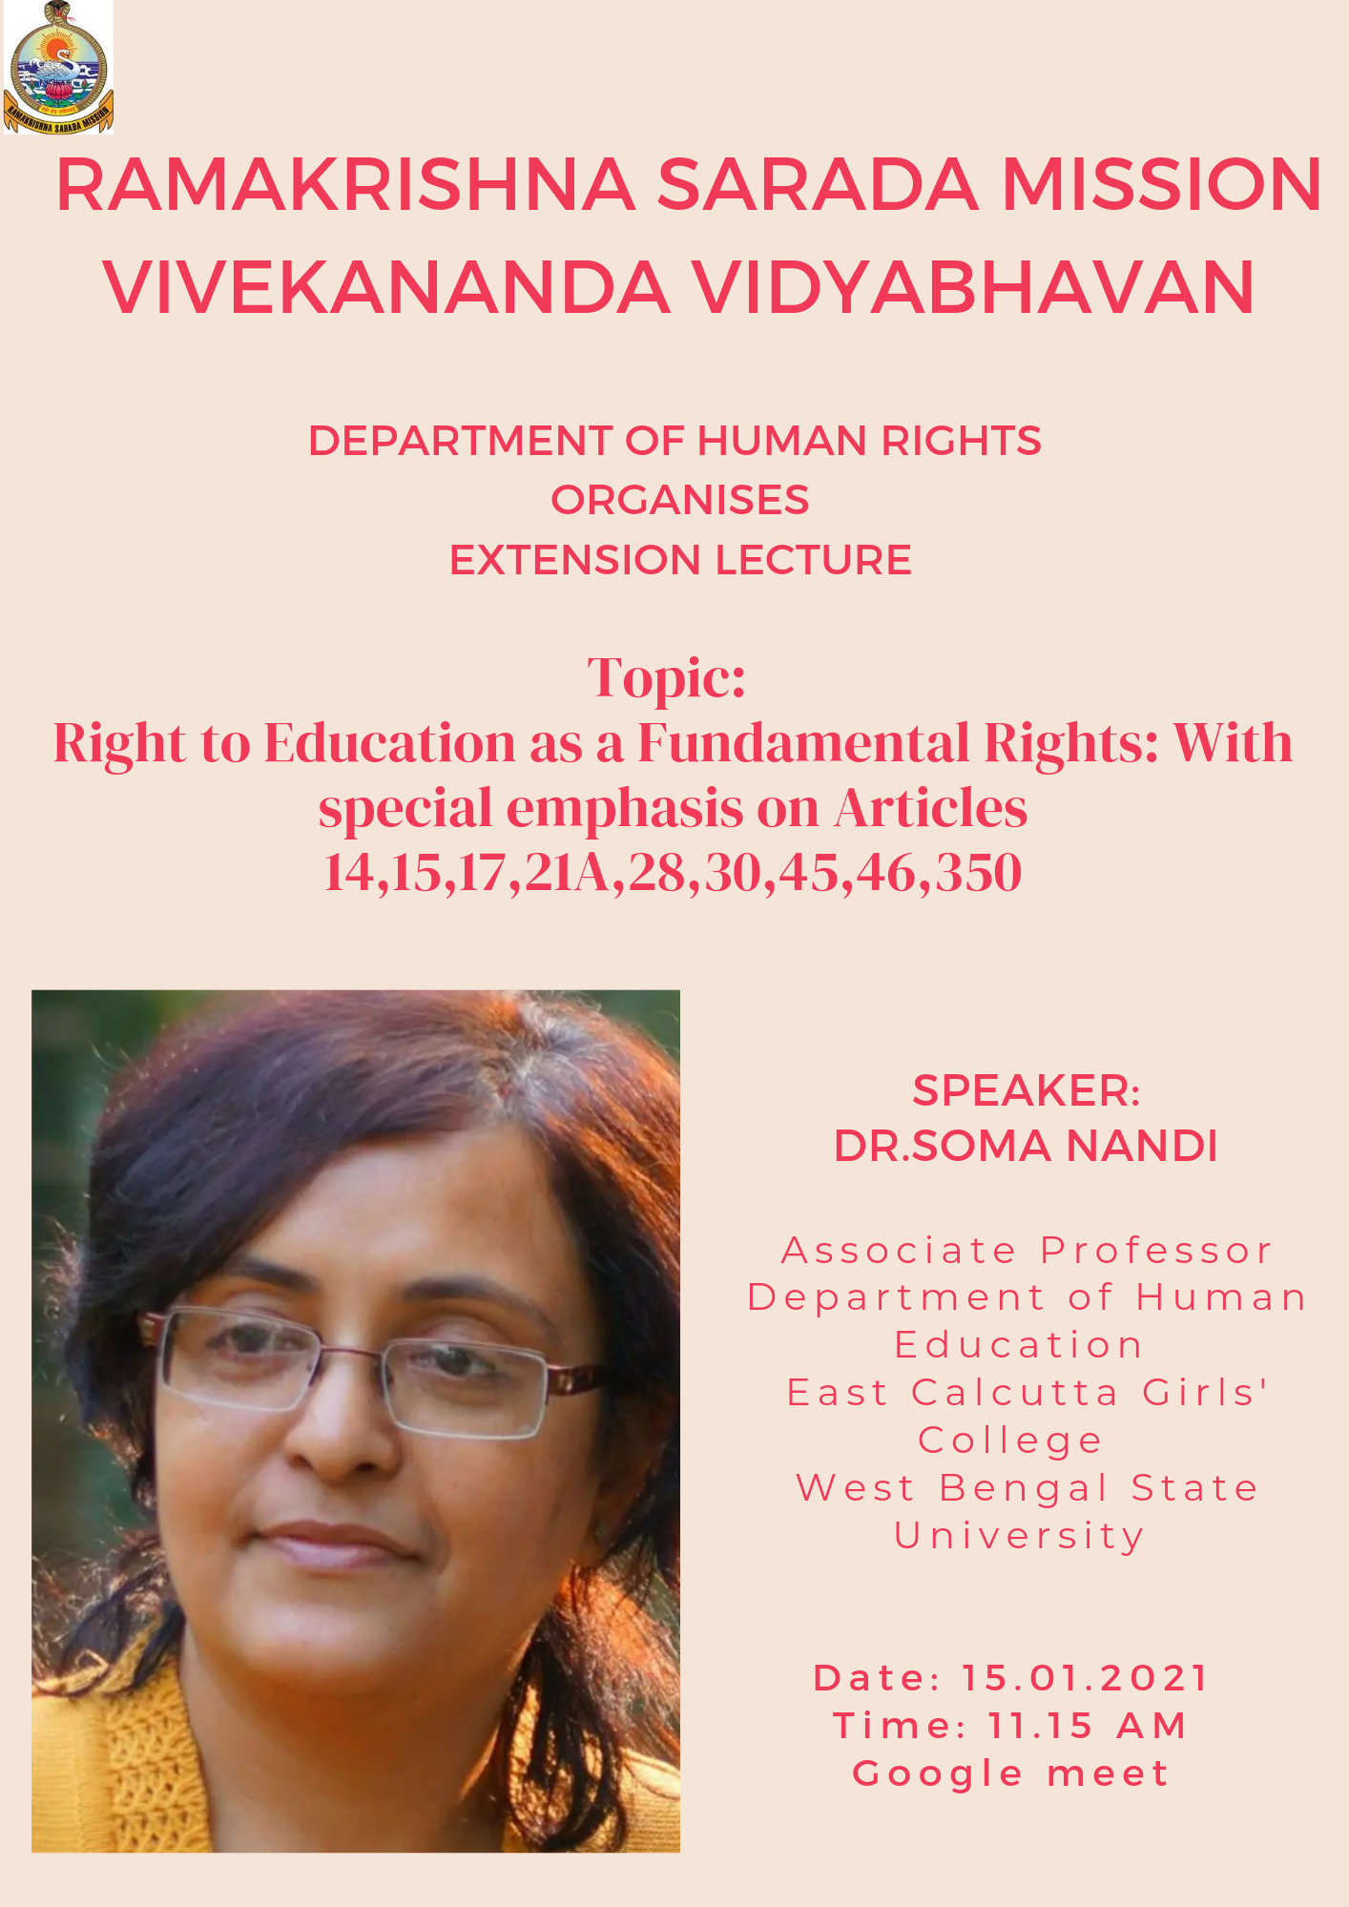
DEPARTMENT OF HUMAN RIGHTS

Name: United Nations and its Principal Organs.
Category: Extension Lecture
Organizing Unit: Department of Human Rights, RKSMVV
Date: 27:01:2021
Time: 11:15am
Number of Students: 25
Number of Teachers: 2
Speaker: Dr. Swatilekha Bhattacharya
Assistant Professor, Department of Political Science, Vidyasagar University Midnapore

Brief Description of the Event: Speaker has been invited for delivering an Extension lecture on “United Nations and its Principal Organs” organized by the Department of Human Rights, RKSMVV College on 27th January 2021 at Google Meet.

Outcome: The main objectives of the United Nations are the maintenance of international peace and security, the promotion of the well-being of the peoples of the world, and international cooperation to these ends.

