EVENT REPORT-2022
DEPARTMENT OF HUMAN RIGHTS

- Name: Historical Background of Human Rights
Category: Extension Lecture
Organizing Unit: Department of Human Rights, RKSMVV
Date: 11.1.2022
Time: 11.00 am
Number of Students: 08
Number of Teachers: 2
Speaker: Dr. Atrayee Banerjee
State Aided College Teacher, Department of Human Rights, Basanti Devi College, University of Calcutta.

Brief Description & Outcome of the Event: Speaker has been invited for delivering an Extension lecture on “Historical Background of Human Rights” organized by the Department of Human Rights, RKSMVV College on 11th January, 2022 at 11:00am. Students will be able to understand the importance of Historical Background of Human Rights.

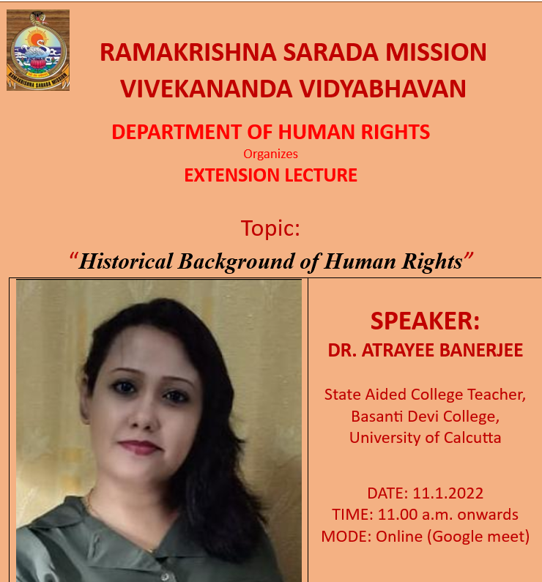

DEPARTMENT OF HUMAN RIGHTS

2)Name: Convention on The Elimination of All Forms of Discrimination Against Women (CEDAW)
Category: Extension Lecture
Organizing Unit: Department of Human Rights, RKSMVV
Date: 20.01.2022
Time: 3:00 pm
Number of Students: 10
Number of Teachers: 2
Speaker: Dr. Disari Roy
Assistant Professor, Department of Women’s Studies, Diamond Harbour Women’s University

Brief Description & Outcome of the Event: Speaker has been invited for delivering an Extension lecture on “Convention on The Elimination of All Forms of Discrimination Against Women (CEDAW)” organized by the Department of Human Rights, RKSMVV College on 20th January,2022 at 3:00pm. Students will be able to: Identify the emancipation or elevation of women, i.e., modifying social practices to enable women to play a more vital and constructive role in society; and equal rights for men and women, i.e., expansion of civil, political and cultural rights.

3)Report-SEXUAL HARASSMENT AT WORKPLACE AND EDUCATIONAL INSTITUTIONS: RIGHT TO MENTAL HEALTH

Name: sexual harassment at workplace and educational institutions: right to mental health
Category: Seminar
Organizing unit: Department of Human Rights, Psychology and Internal Complaints Committee (ICC).
Date: 2.03.2022
Time:1.45 pm – 4.15 pm
Number of Students: 100
From RKSMVV: 100
Number of Speakers: 2
- Prof. Pushpa Misra, President of Indian Psycho analytical Society, Kolkata
- Dr. Payel Rai Chowdhury Dutt, Assistant Professor, Department of Human Rights and Human Development Studies, Rabindra Bharati University, Kolkata
Number of beneficiaries: 100 students are the beneficiaries
Brief description of the event: Firstly, the program was started with a poster exhibition. After that a welcome address was delivered by the honorable Principal Pravajika Vedarupaprana, RKSMVV. Then the chairperson of ICC, Dr. Soma Marik explained the importance of the issue. Then Prof. Pushpa Misra delivered lecture on Sexual Harassment: Taboos and Therapy. After that Dr. Payel Rai Chowdhury Dutt delivered her speech on Human Rights and how to Combat Sexual Harassment. Lastly a small discussion was also done which was followed by the vote of thanks.
Outcome: Students will be able to justify the importance of right to mental health .They also able to Identify violations to the rights to equality and freedom in the workplace and educational institutions. They clearly understood different taboos and therapy regarding sexual harassment and realized the importance of Human Rights to combat sexual harassment.

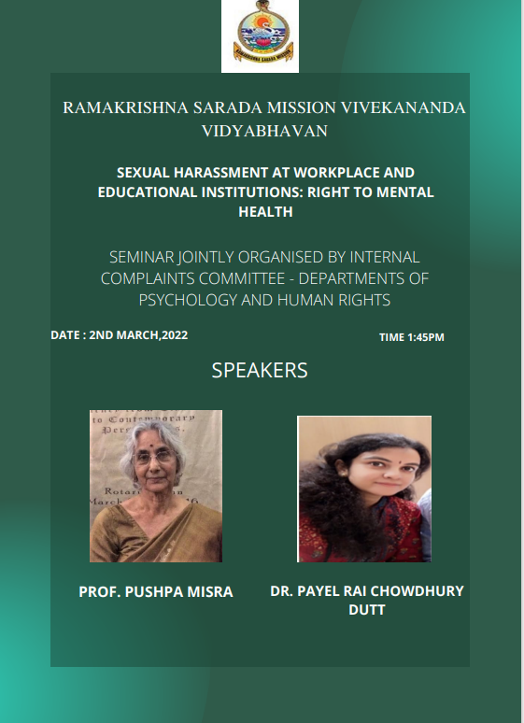

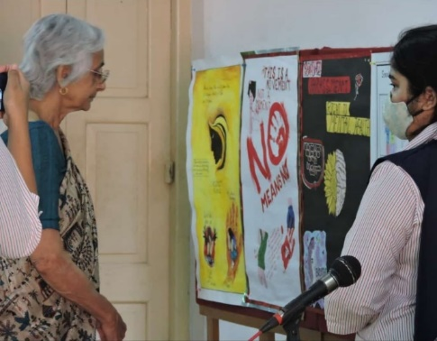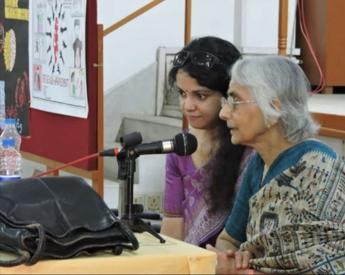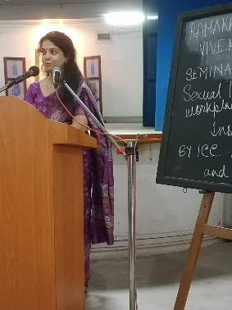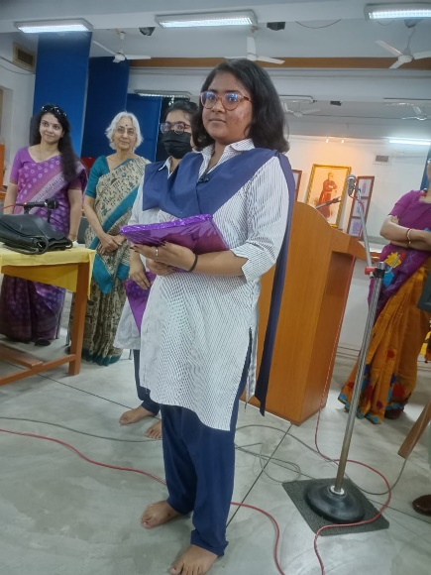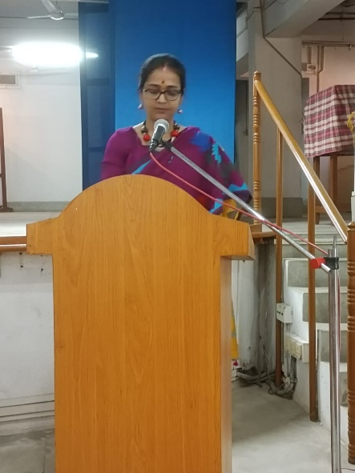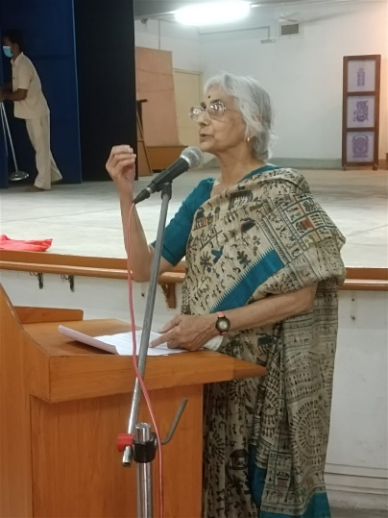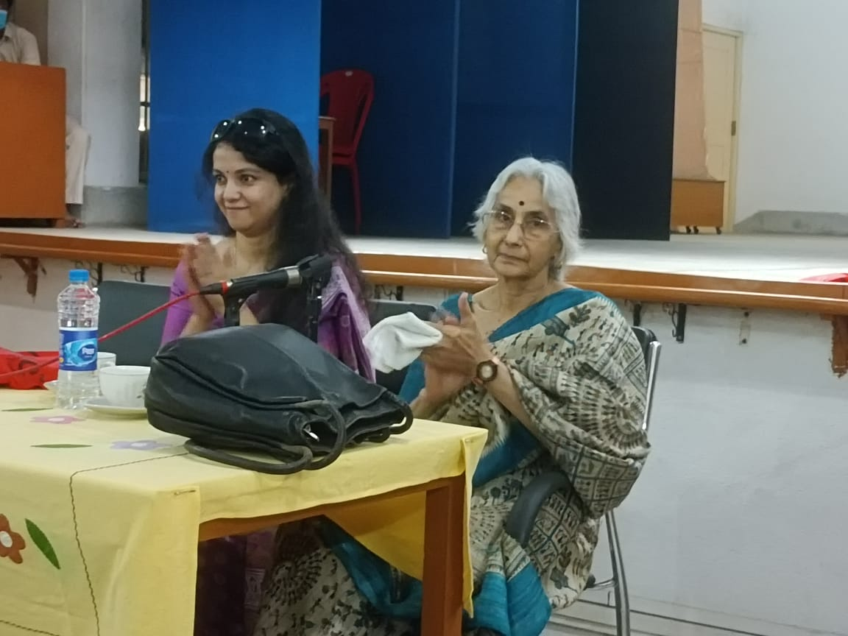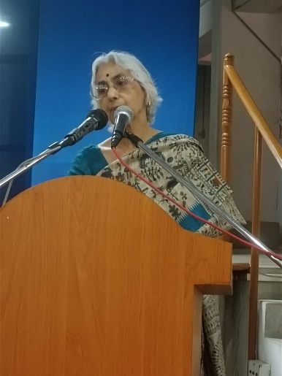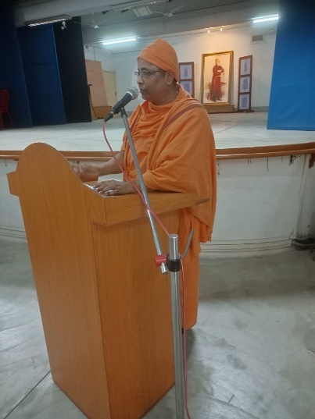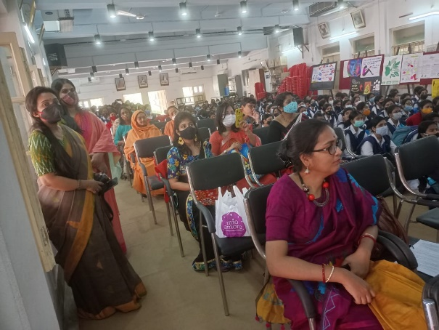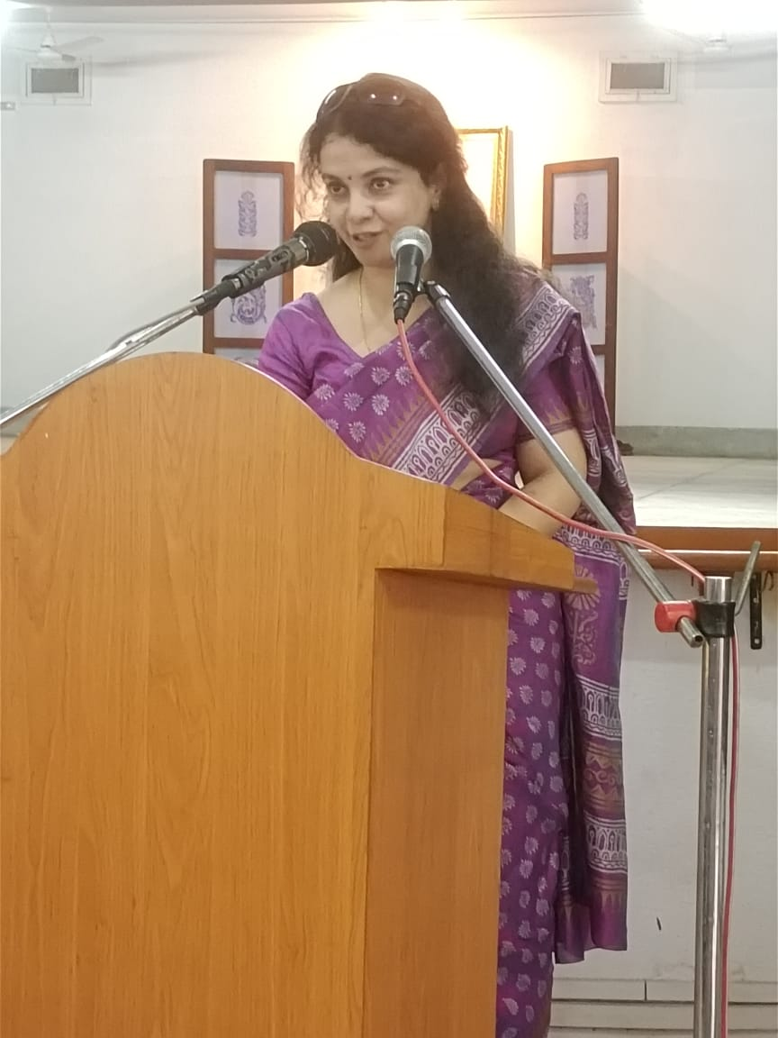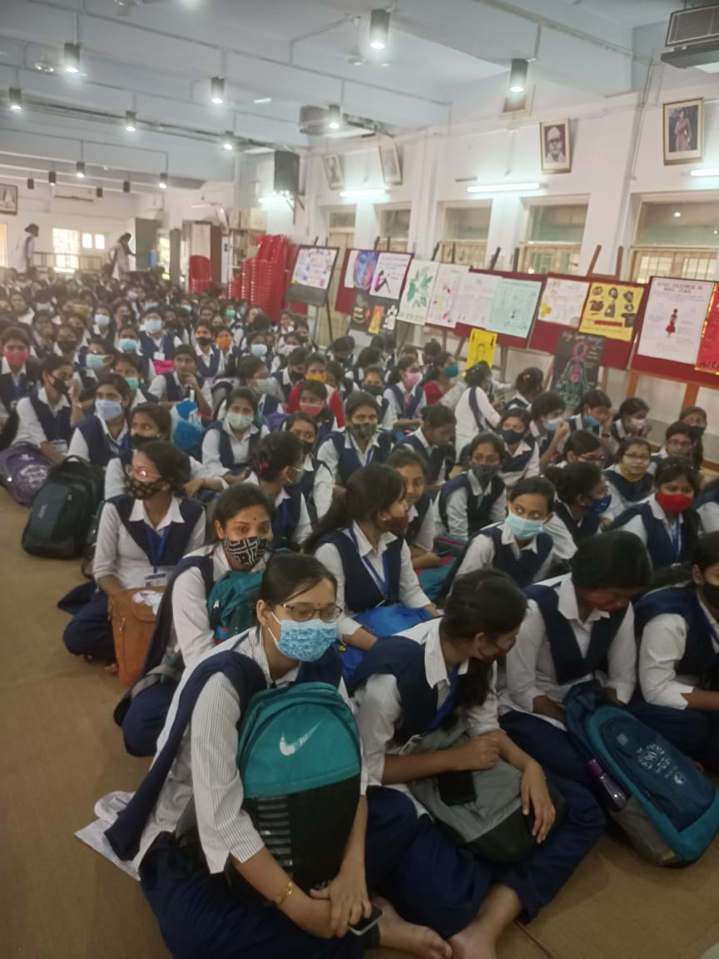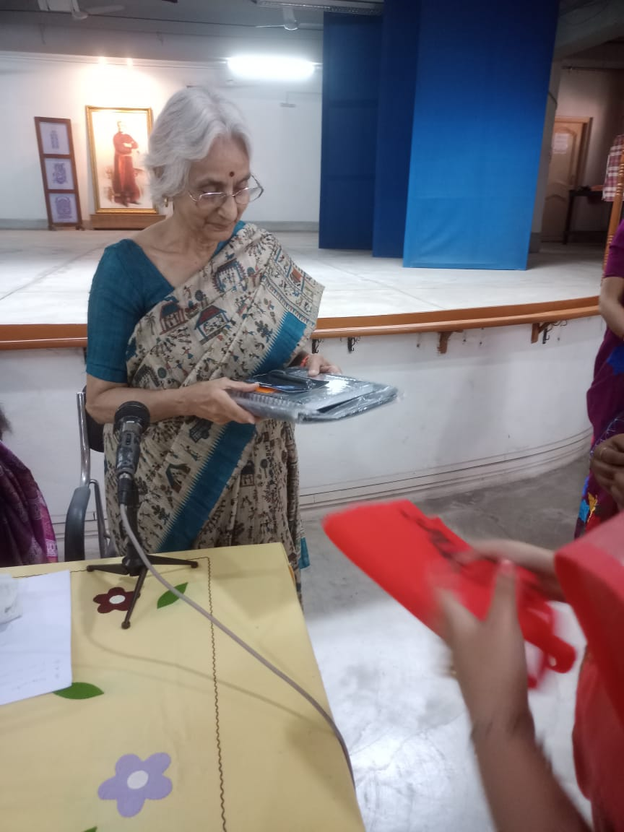

4)Report-Some Observations on Human Rights and Violence on Women.

Name: some observations on Human Rights and violence on women.
Organizing unit: Department of Human Rights, Philosophy, History and IQAC, RKSMVV.
Date: 13.12.2022
Time:12.15 pm – 2.00 pm
Number of Students: 50
From RKSMVV: 50
Number of Speakers: 1
- Miss Mitali Biswas, Film Maker, Social Activist and Journalist.
Number of beneficiaries: 50 students are the beneficiaries
Brief description & Outcome of the event: A Seminar on some observations on Human Rights and Violence on women was jointly organized by the department of Human Rights, Philosophy, History and IQAC of RKSMVV.
Students were able to identify the importance of some observations on Human Rights and violence on women.
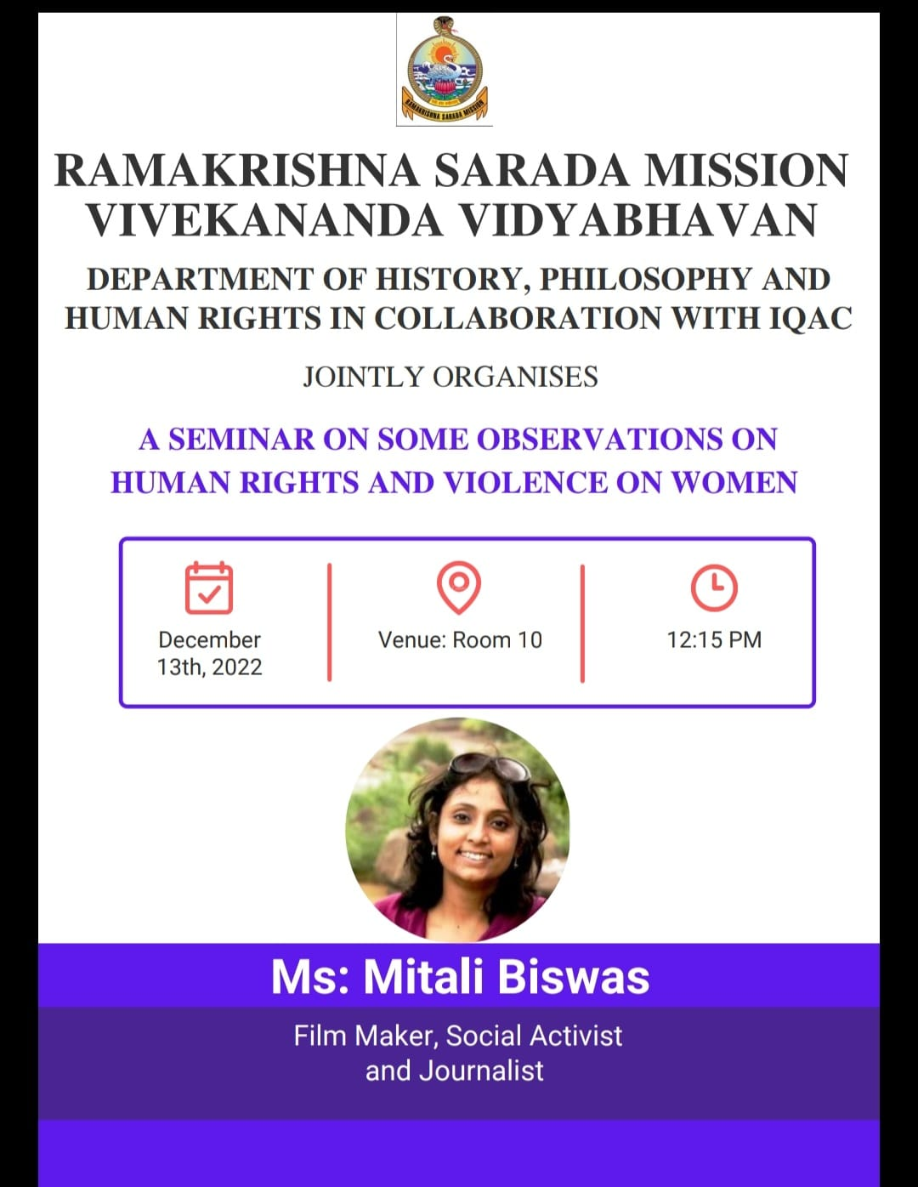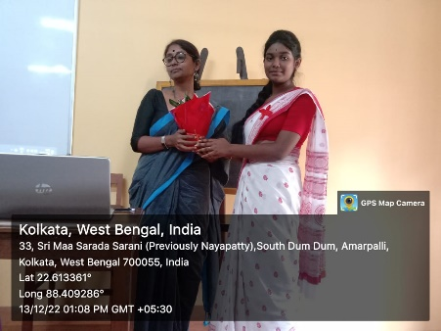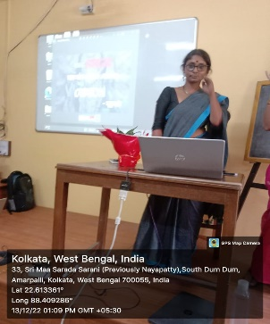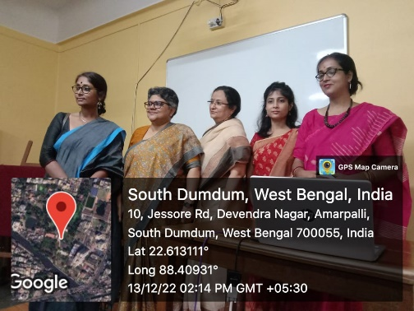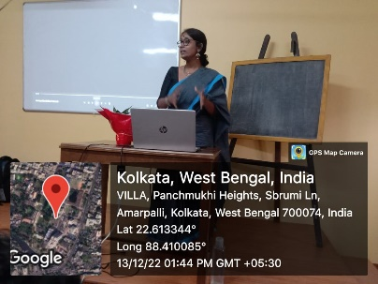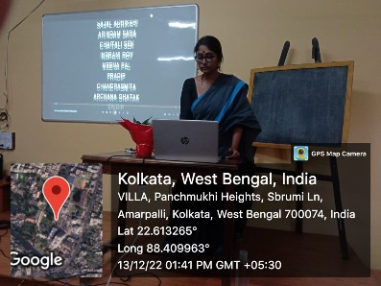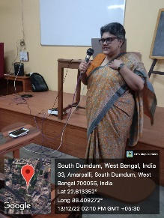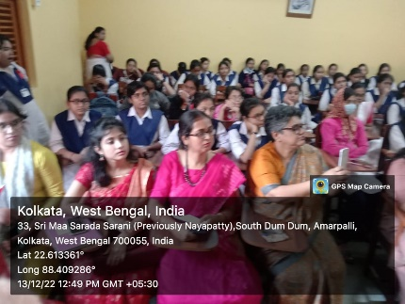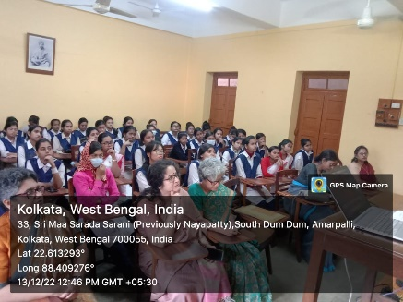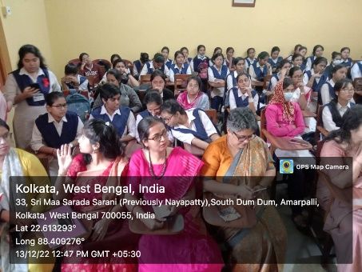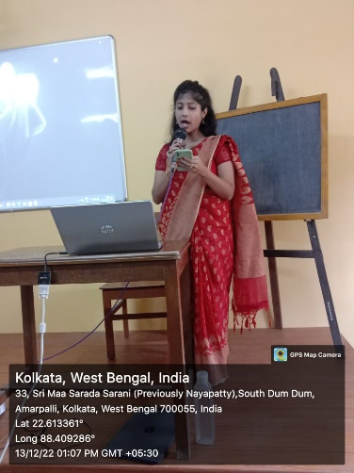

DEPARTMENT OF HUMAN RIGHTS

5)Name: United Nations and its Specialized agencies
Category: Extension Lecture
Organizing Unit: Department of Human Rights, RKSMVV
Date: 20.12.2022
Time: 12:15 pm
Number of Students: 08
Number of Teachers: 2
Speaker: Dr. Atrayee Banerjee
State Aided College Teacher, Department of Human Rights, Basanti Devi College, University of Calcutta.

Brief Description & Outcome of the Event: Speaker has been invited for delivering an Extension lecture on “United Nations and its Specialized agencies” organized by the Department of Human Rights, RKSMVV College on 20th December, 2022 at 11:00am. Students will be able to: understand the world wide importance of United Nations and it’s specialized agencies.

