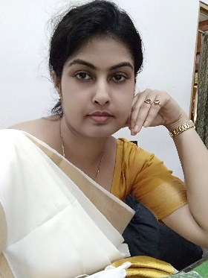

Dr. Soma Mukhopadhyay

General Information

Teaching Experience

1. In Krishnagar Women’s College (2008-2013) & Dwijendralal College (2009-2012)

5years teaching experience under Kalyani University as a Guest Lecturer.

1. In Syamaprasad College (2013-2020) 7 years teaching experience under Calcutta University as a Contractual College Teacher.
2. In Ramakrishna Sarada Mission Vivekananda Vidyabhavan Girl’s College (8th August,2018 to till date) 6 years teaching experience under West Bengal State University as a State-Aided-College-Teacher.

Research Interests

Population

Settlement

Environment

Landuse

Geographical Information System

Publication

**Articles in Journals/ E – journals**

1. Improper Transformation of Natural Land use pattern to growing New Satellite Commercial Town, analysis with GIS application, at Rajarhat and adjoining area, Kolkata, West Bengal (Science, Technology and Development, ISSN: 0950-0707, July-2020)- International.
2. Unsystematic Urban Land Use and Water Logging problems along Maniktala and adjoining areas of Kolkata, analysis with the help of GIS evidence (JAAC, ISSN: 0731-6755, December-2019)-International.

|  |
| --- |
| **Department: Geography** |
| **Designation: SACT I** |
| **Qualification: M.Sc in Geography; B.Ed; M.A in Education; Ph.D in Geography(2021)** |
| **Specialization: Cartography; Tourism** |
| **Email:** [**lect.soma@gmail.com**](mailto:lect.soma@gmail.com)**; soma.mukherjee@rksmvv.ac.in** |

## Seminar/ Conference Proceedings

1. Presented paper on Beyond Kolkata: Rajarhat and the Dystopia of Urban Imagination (IJRPB Academic Conferences, ICRAESTHM-2019)
2. Presented paper on Urbanization, Land Alienation and Proletarianization: A study of Rajarhat and adjoining area in West Bengal.(IJAMSR Research Foundation, ICEAEPMSH- 2020).

# Invited Lectures/ Paper Presentations

1. Paper presentation about my Research area “Improper Urbanization on Inspirational Wetland of East-Calcutta, West Bengal, analysis by GIS” at Ramakrishna Sarada Mission Vivekananda Vidyabhavan, Kolkata, West Bengal-2021

# Administrative Responsibilities in College

1. Course Co-Coordinator of “Application of RS & GIS Diploma Course” from 2021
2. Member, Environment Committee (from July, 2022 to till date)
3. Member, Office Committee (2021)
4. Member, Documentation Committee (2024)
5. Member, cultural Committee (2024)