EVENT REPORT OF GRADUATE COURSE, DEPARTMENT OF
PHILOSOPHY, RKSMVV

WEBINAR/ SEMINAR
-2018-

Event: Seminar on ‘Ethics and Epistemology’ to observe World Philosophy Day
Organizer: Department of Philosophy.
Date: November 29, 2018.
Resource Persons:
- Dr. Sanjukta Basu , Professor, Rabindra Bharati University
- Dr. Ranjana Mukherjee, Retd. Professor, Rabindra Bharati University
- Pravrajika Bhaswarprana, Principal, Ramakrishna Sarada Mission Vivekananda Vidyabhaban
No. of Participants: 100
Brief Description: On the eve of celebration of World Philosophy Day, the department of Philosophy of RKSMVV organized a one day Seminar to discuss epistemological issues and debates in philosophy as well as the importance of studying ethics and its relevance in present situation.
Programme Outcome: Apart from the excellent lectures delivered by esteemed speakers, the sessions were inter-active and several philosophical issues were critically discussed.
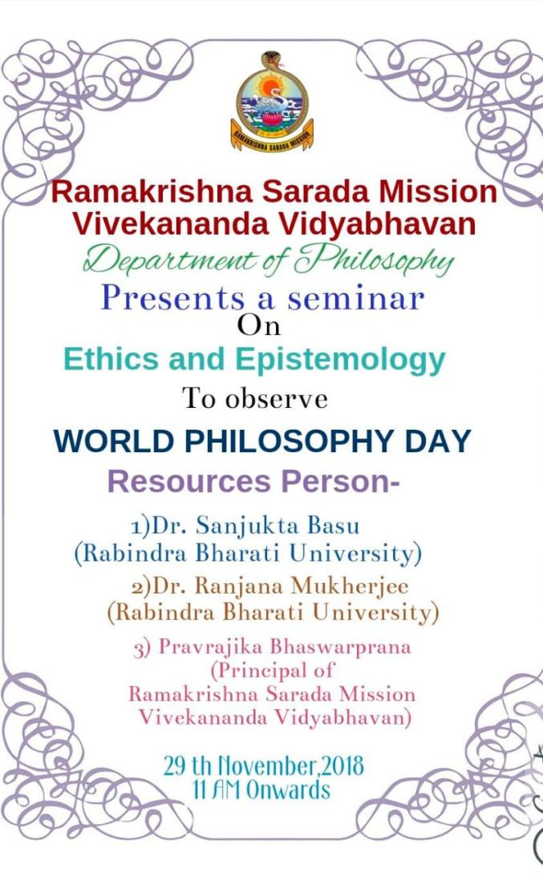

SEMINARS/WEBINARS 2019
Event: State Level Seminar on the eve of World Philosophy Day Celebration
Title : Philosophy - East and West
Date: 26.11.19
Venue: Muktiprana Sabhagriha
Participants: 50 (UG & PG Students)
Brief Description: A State Level seminar was organized by the department of Philosophy of RKSMVV on the eve of World Philosophy Day Celebration. In the first half of the seminar, the speakers were Pravrajika Bhaswaraprana, Professor Ranjana Mukherjee and Professor Ratna Datta Sharma. The second half witnessed the presentation of the Post Graduate students of the department of philosophy on various philosophical issues of East and West.
Programme Outcome: It was a very thought-provoking seminar as the first session of it had an inter-active session with the speakers. The post lunch session was also very interesting as the young Pst Graduate scholars of RKSMVV presented very well researched papers.

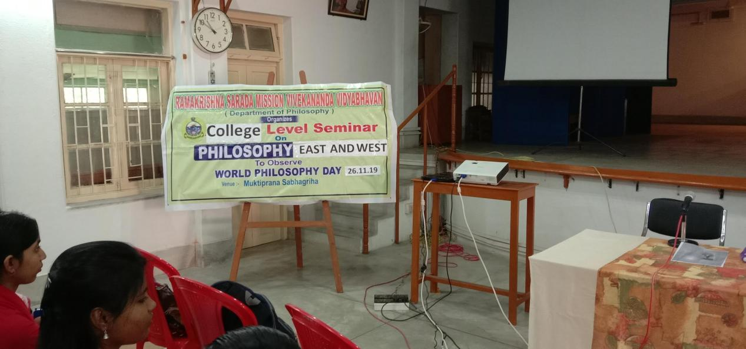

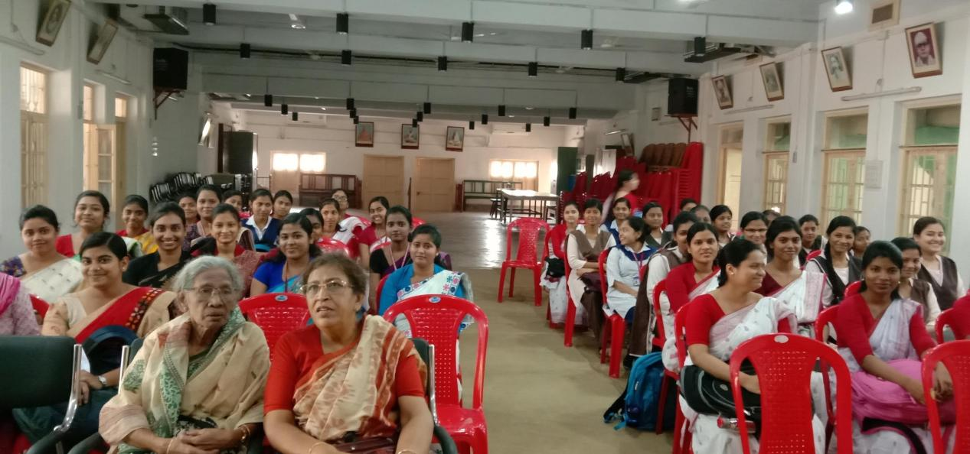

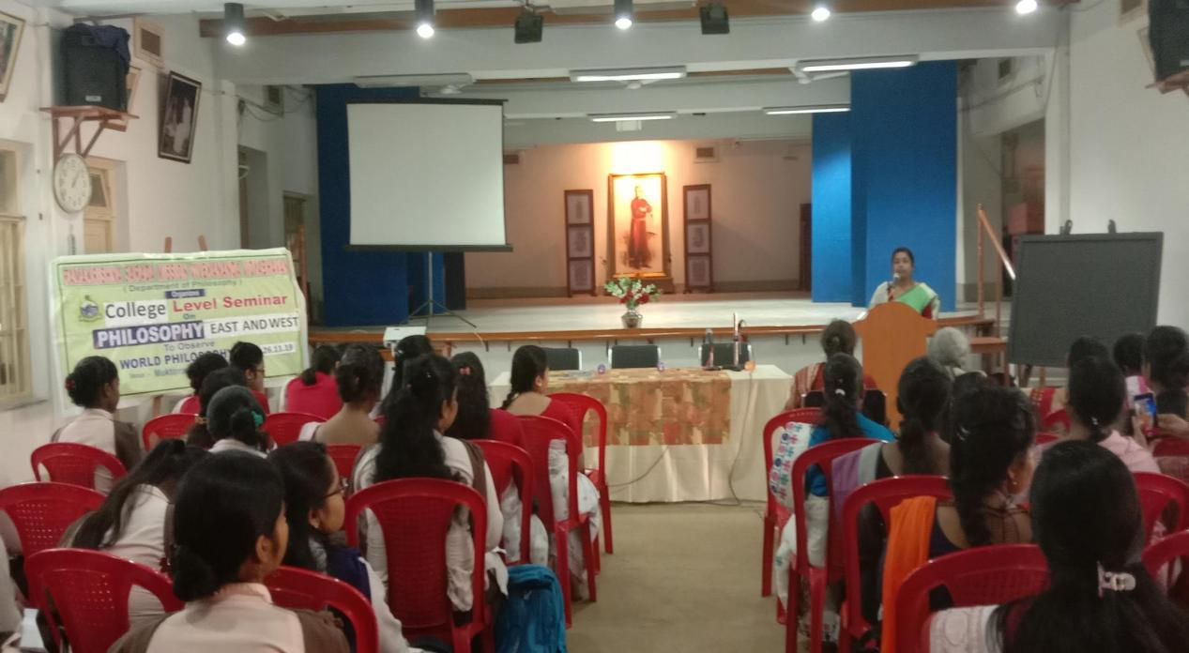

WORLD PHILOSOPHY DAY CELEBRATION 2019

SEMINARS /WEBINARS 2020

Event: National Webinar on YOGA: IN THEORY AND IN PRACTICE
Organizer: Department of Philosophy, RKSMVV
Sponsored by: ICPR
Date: 5th July, 2020.
Venue: zoom platform
Participants: Both UG and PG Students of Philosophy
Resource Persons:
- Dr. Ranjana Mukherjee, Retd. Professor, Rabindra Bharati University
- Pravrajika Divyanandaprana, Editor of ‘Samvit’, Sri Sarada Math, New Delhi
- Sm. Anjana Acharya Banerjee, Retd. Yoga Instructor, Burdwan University
- Sri Malay Mukhopadhay, Asst.Prof.PG.G.I.P.E, Banipur, N24Pgs.
- Sm.Taniya Nag, Physical Instructor, Serampore College.
Brief Description: It was an online Webinar where the speakers talked about the importance of yoga in keeping a balance between mind and body. Apart from theoretical lectures there was physical demonstration also about different asanas that will keep our mind and body fit and stress free during the covid time,
Outcome: Yoga is not a religion it is a way of life. The mental trauma and physical helplessness that we all faced during the Covid-19 outbreak, was really stressful. The Webinar, “Yoga: Theory and in Practice” – was an appropriate attempt to rejuvenate our distressed mind and body.

Event: One-Day International Symposium on Medical Ethics
Organized by: Ex-students of Department of Philosophy.
Date: August 29, 2020.
Venue: Zoom meet
Number of Participants: 90
Resource Persons:
Prof. Ratna Dutta Sharma, Jadavpur University, Kolkata
Dr. Dhiman Ganguly, Consultant Pulmonologist, Retd Prof. Vivekanana Institute of Medical Sciences, Kolkata, Ex-President, Indian Chest Society.
Dr Sambrita Mukherjee, Speciality Registrar, Dept of Anaesthetics and Critical care, Epsom and St Helier University Hospitals, NHS Trust, UK.
Brief Description: The Department of Philosophy organized a Webinar reflecting a very relevant medical issue during pandemic situation. The Webinar was attended by students and faculty members from other departments also. Dr Dhiman Ganguly, Dr, Sambrita Mukherjee, from the medical background and Dr. Ratna Datta Sharma from the department of Philosophy delivered very well structured lectures in their own field.
Outcome: During the covid situation everyone was suffering from the anxieties of the pandemic and they were having various questions regarding the coping strategies of the situation the suggestions and do’s and don’t’s from the physician’s side helped them to understand and face the situation in a more dynamic ways.

Seminar/Webinar/workshops 2022
Event: An Inter-Disciplinary Seminar
Organized by: Department of Philosophy, Education and Sociology
Topic: ‘Research Methodology’
Date: 8.3.22,
Venue Muktiprana Sabhagriha.
Brief Description:
An Interdisciplinary Seminar was organized jointly by Departments of Education, Philosophy and Sociology, on ‘Research Methodology” for all the 5th Semester Students and Post Graduate students of Philosophy. Professor Maushumi Guha of Department of Philosophy, Jadavpur University and Professor Prarthita Biswas of Department of Education, Adamas University, were the distinguished speakers who delivered excellent speech on the basic facts about Research Methodology. Professor Guha introduced the topic by explain the need to have a very focused yet clear view about the Research topic and Professor Guha explained in details both the Qualitative and the Quantitative Methodology and their applications.

Outcome: It was a very insightful session as the students got few basic ideas regarding research methods. Dr Guha introduced the need for us to do research and how we will be able to identify the issues that we will choose as our research topic. Dr Prarthita Biswas discussed about the particularities that we need to remember and follow while doing any research. The entire session enriched the students about the basics of research method which was the main intention of the workshop.
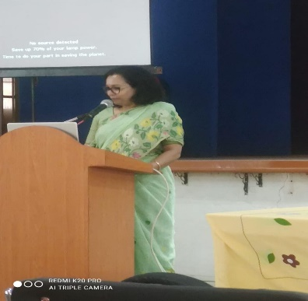
ology 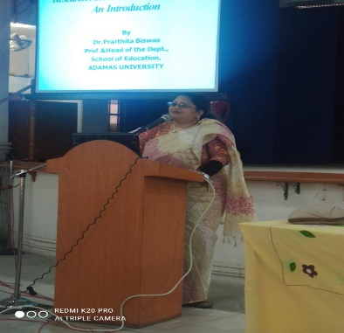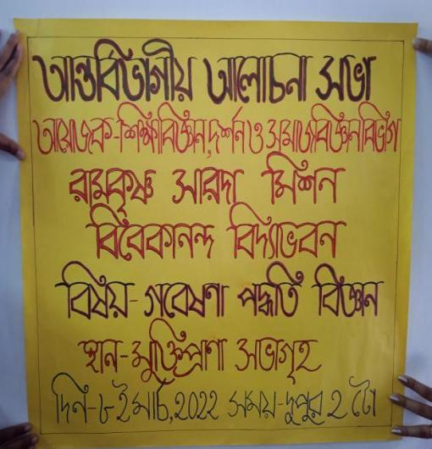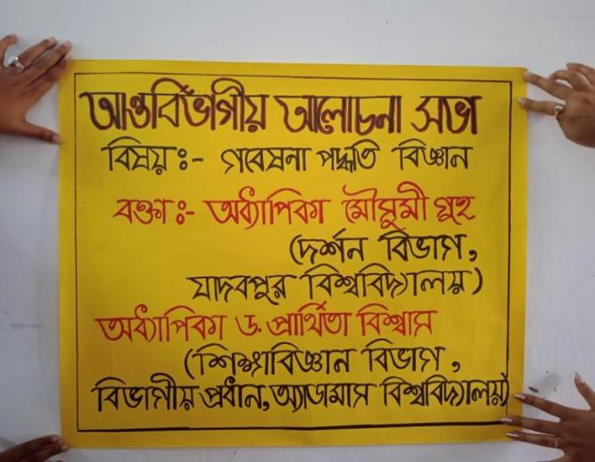

Event: An Inter-Disciplinary One- Day Workshop on ‘Research Methodology’
Organized by: Department of Philosophy, Education and Sanskrit
Date: 1.12.22.
Venue: Muktiprana Sabhagriha & Swamiji Bhavan
Speakers: Dr. Maushumi Guha,
Brief Description: An inter-disciplinary seminar was held on Research Methodology where students of all the semesters of Philosophy, Education and Sanskrit participated. Dr. Maushumi Guha, professor of Philosophy, Department of Philosophy, Jadavpur University, introduced the basics of Research Methodology. The speaker from the department of Education delivered lecture on the quantitative approach of research and Dr. of Department of Sanskrit gave elaborate demonstration on the referencing part of research.

Outcome: The one –day inter-disciplinary workshop benefited the student in understanding the basics of research methodology and this will help them in their future research oriented projects.

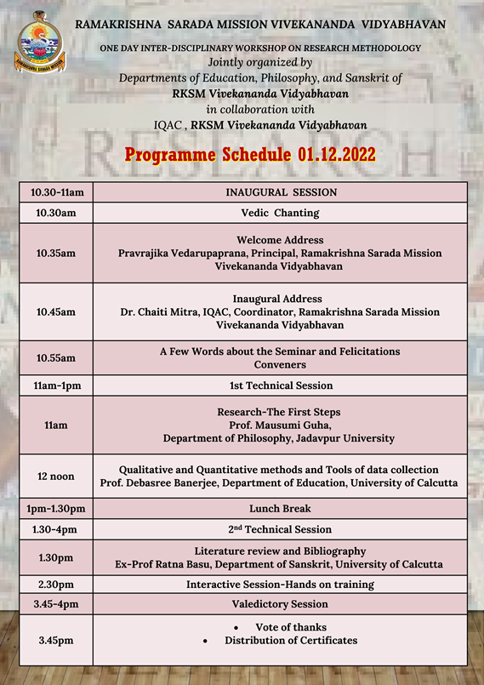

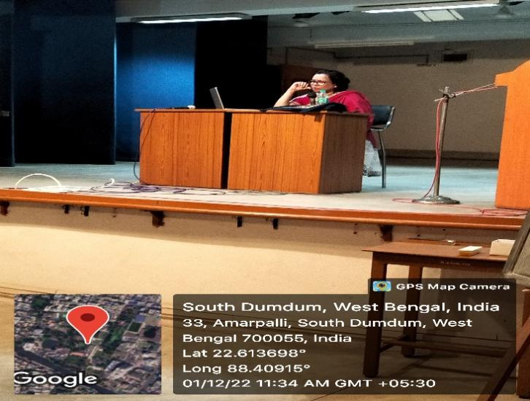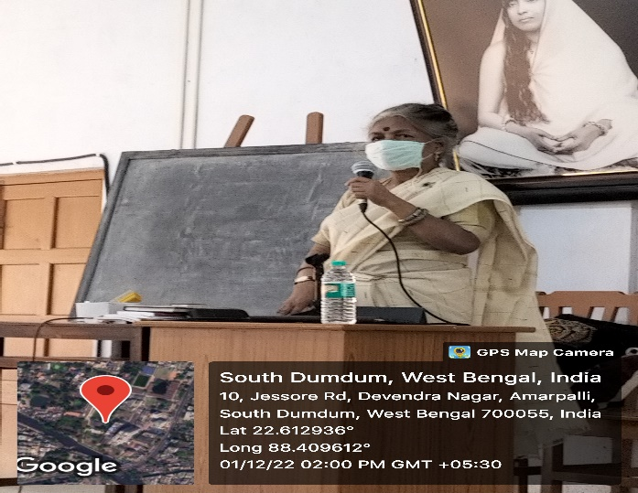

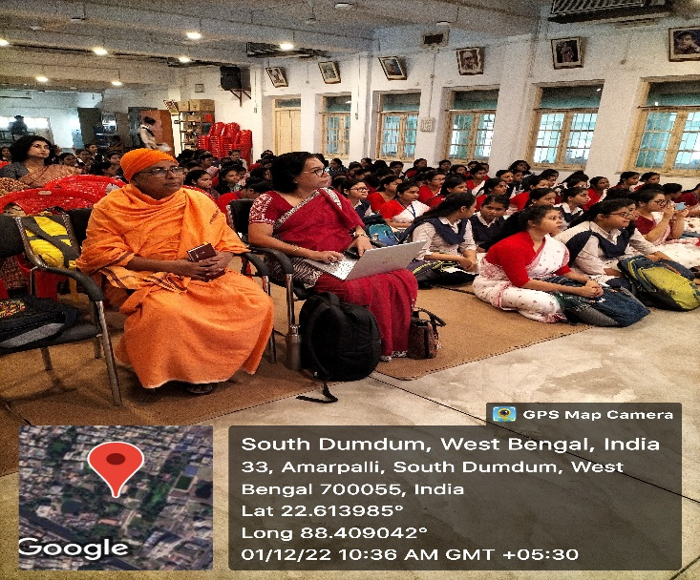

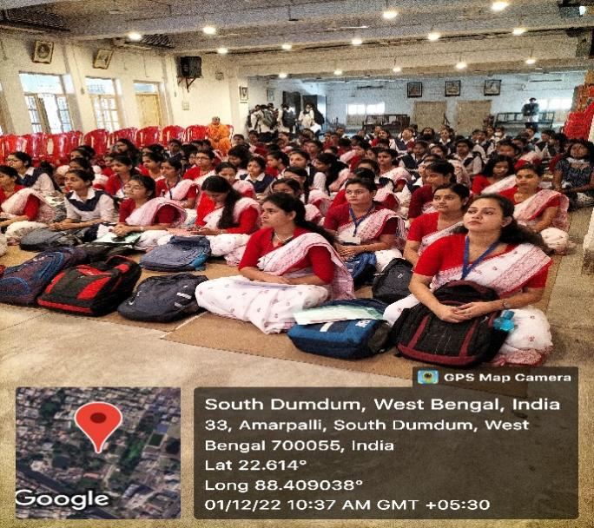

Event: Two Days’ International Seminar on ‘ROLE OF TECHNOLOGY IN THE NEW NORMAL: SOCIAL ETHICAL AND PSYCHOLOGICAL CHALLENGES’
Organizer: Department of Philosophy
Date: 5th &6th December 2022
Resource Persons:
Dr Nirmalya Narayan Chakraborty, Professor, department of Philosophy, Rabindra Bharati University, as our key note speaker.
Dr. Sucheta Ghosh– ‘Humanity Towards Opulence Using AI ’
Dr. Shubhranil Som. – ‘Cyber Security: Role of User Behaviour, Social and Psychological Impact.
Paper Presentations by UG & PG Students
No. of Participants: 5.12.22 - 122 participants, 6.12.22 - 102 participants
Brief Description : On the eve of celebration of World Philosophy Day, the Department of Philosophy of Ramakrishna Sarada Mission Vivekananda Vidyabhavan and Scottish Church College, jointly organized an International Seminar on - ‘ROLE OF TECHNOLOGY IN THE NEW NORMAL: SOCIAL ETHICAL AND PSYCHOLOGICAL CHALLENGES’. Apart from invited lecturers there was a parallel session of Professors and Research Scholars who shared their views regarding technology, AI and relevant issues. Apart from this a separate section was there for the students to voice their opinion in this issue. It was really a very enriched two days International Seminar which witnessed development of new perspectives regarding impact of technology in our lives.
Outcome: Apart from the excellent lectures delivered by esteemed speakers, the sessions were inter-active and several philosophical issues were critically discussed.

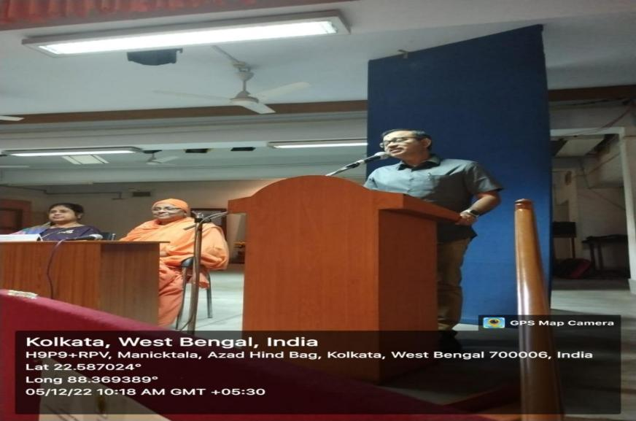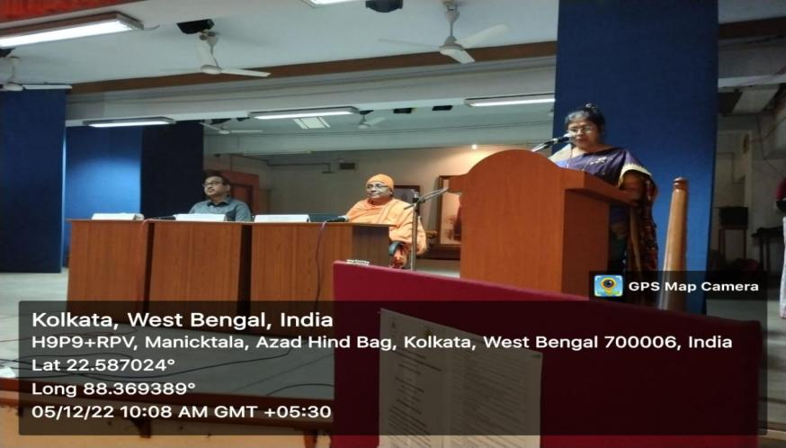
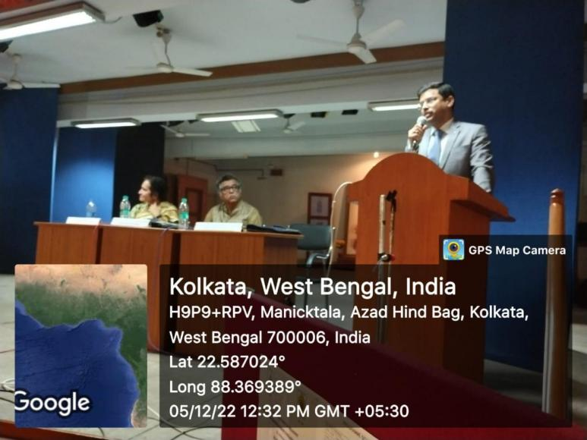
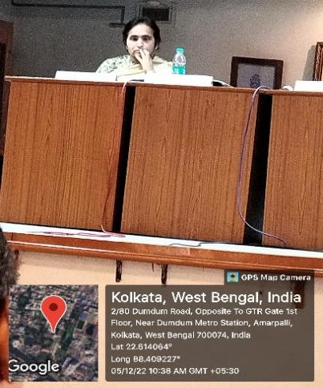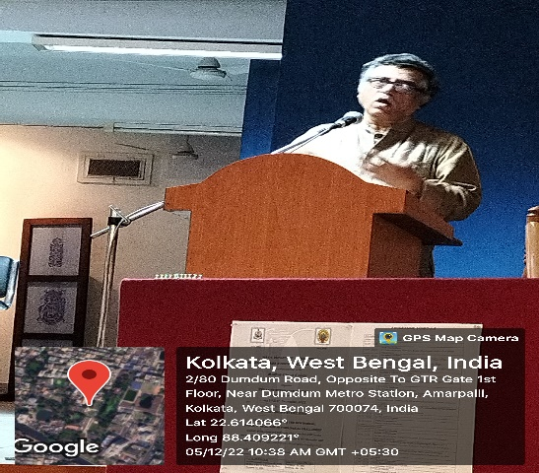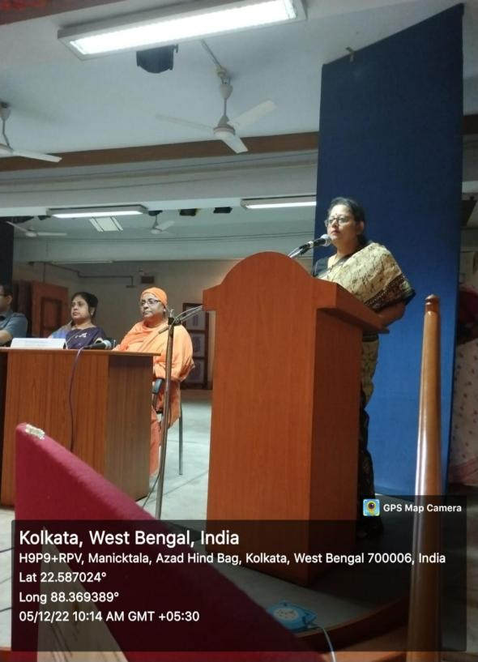
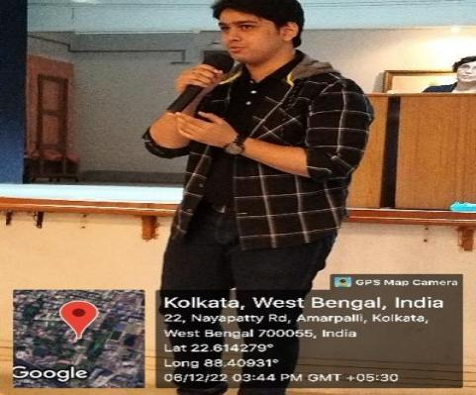
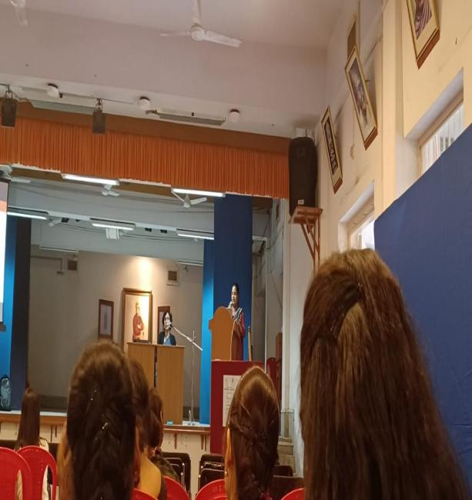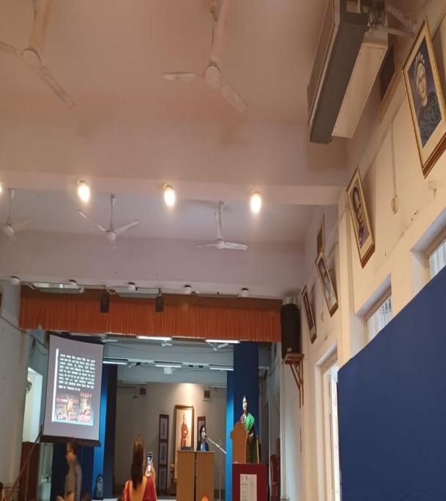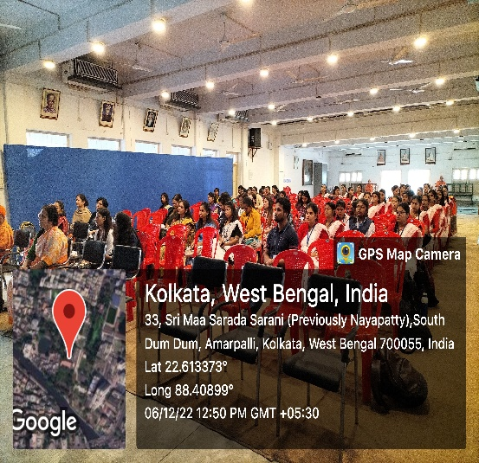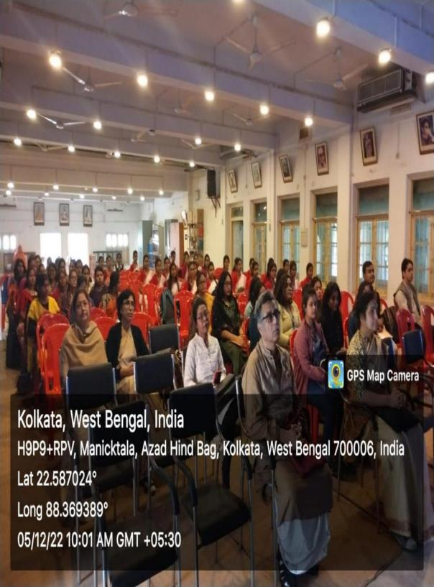
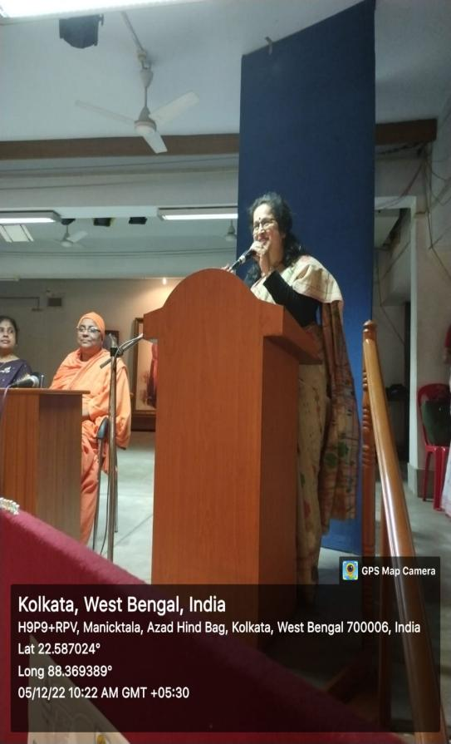
PPT PRESENTATIONS BY STUDENTS OF RKSMVV

Seminars/Webinars 2023
Event:Open House
Date: 10.3.23
Venue: Room No. 14
Organized by:Department of Philosophy
No. of Participants:
Brief Description:On 10.3.23, Open House of semesters IIIrd & VIth was organized by department of Philosophy. The students were given a feedback form to fill up regarding their academic and non-academic experiences of the department. They were also asked about their opinion regarding the way our departmental faculty members take classes and assessments.

Programme outcome: The Open House programme of the department is a very inter-active and open forum where the students reveal their views regarding the entire working of the department. They particularly appreciate the continuous assessment methods, the slow learner’s class, the mock test and the inter-active class methods.
Few 6th semester students - Piu Roy, Priyanka Guin and Chandrima Pondit, who took the training for joining corporate worlds expressed their gratitude to the initiative of the College authority to help our students to make their future on a strong footing, even though they are not in the academics. Many of them like Usha Hazari, Arpita Dalui and Meenakshi Mondal, expressed their willingness to join Post Graduate course offered by the College and pursue higher studies.

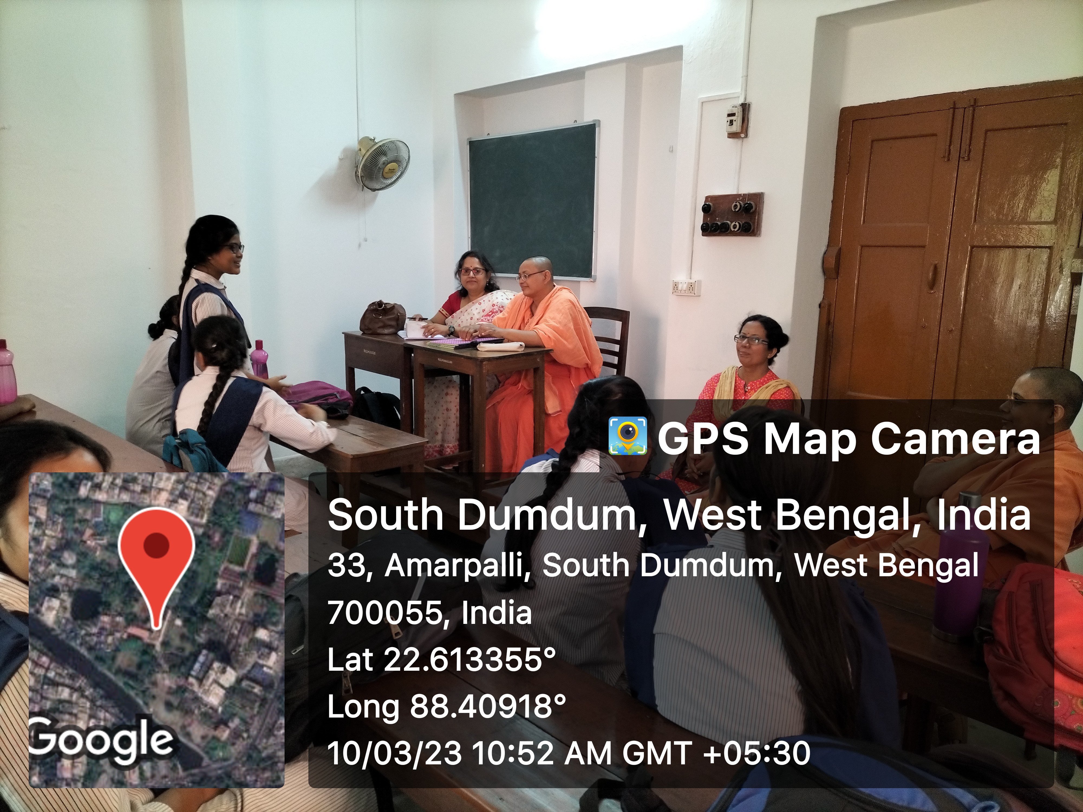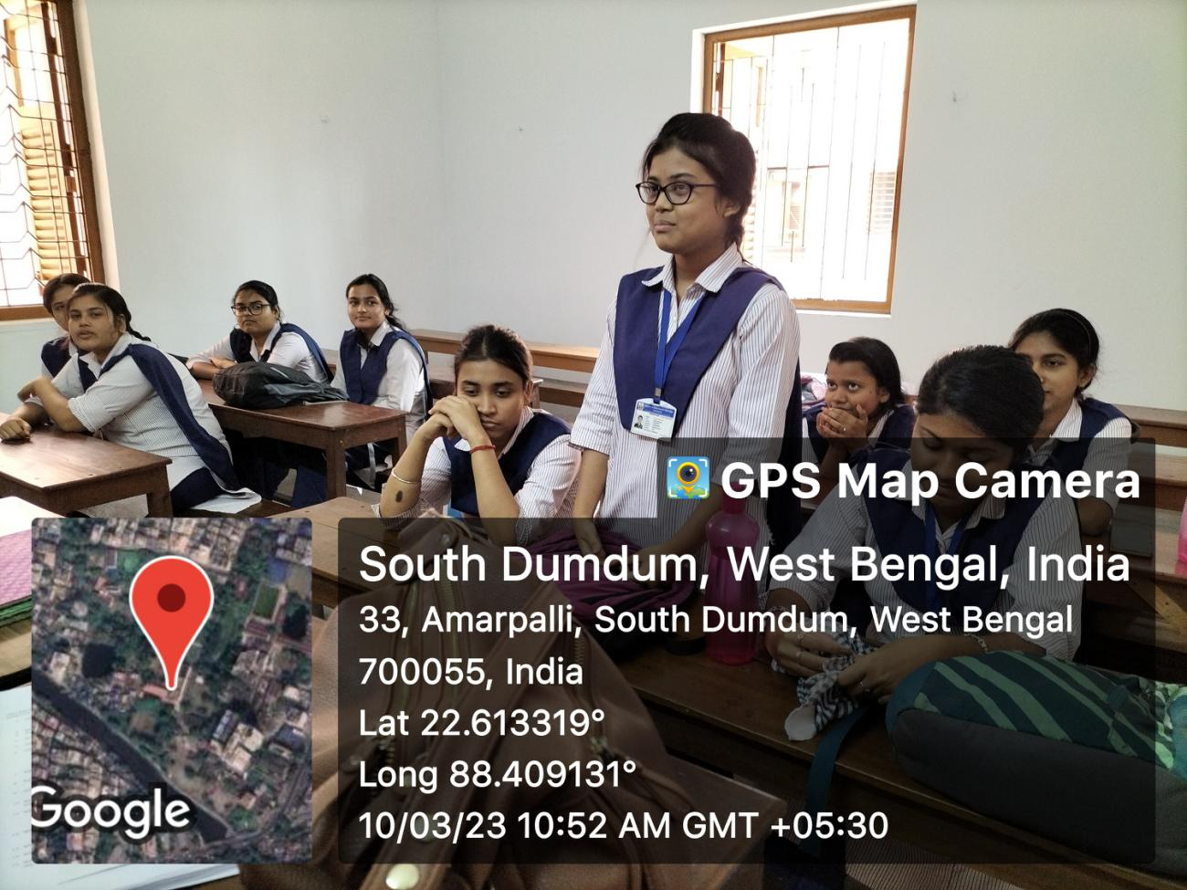
OPEN HOUSE: SEM III & VI

Event:Open House
Date: 11.4..23
Venue: Room No. 14
Organized by: Department of Philosophy
No. of Participants: 14
Brief Description:
On 11.4.23, the department of Philosophy arranged for an Open House session for the 2nd Semester students to get a feedback from them about their experience of the previous academic session. They gave their opinion about their academic experience in the college. They openly discussed their views regarding the benefits of mock tests, regular tutorial classes and the slow learner and advanced learner classes. They repeatedly expressed their gratitude towards all the faculty members for their excellent teaching.
Programme Outcome:
Open House session organized by the department of Philosophy gives an opportunity to the students to reveal their opinion regarding the academic and teaching method of the department. There remains a transparency between the students and the teachers regarding the strength and weakness of the department.

Event: Value Added Course on Bhagavad Gita
Venue: Room No.8
Organized by: Department of Philosophy
No. of Participants: 35
Speaker: Pravrajika Vedarupaprana
Brief Description :
Programme Outcome:
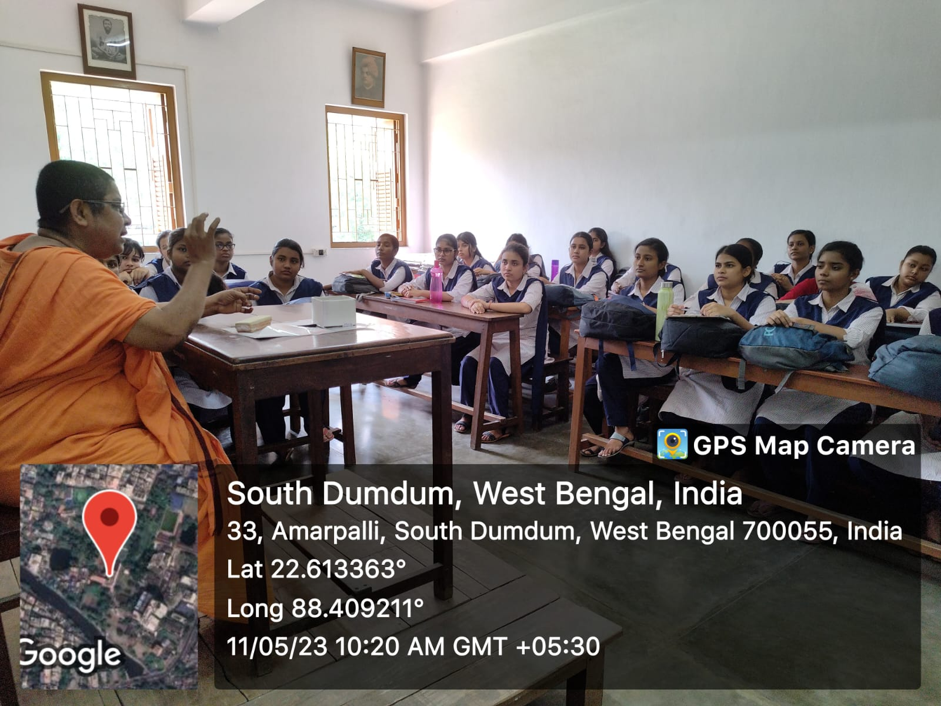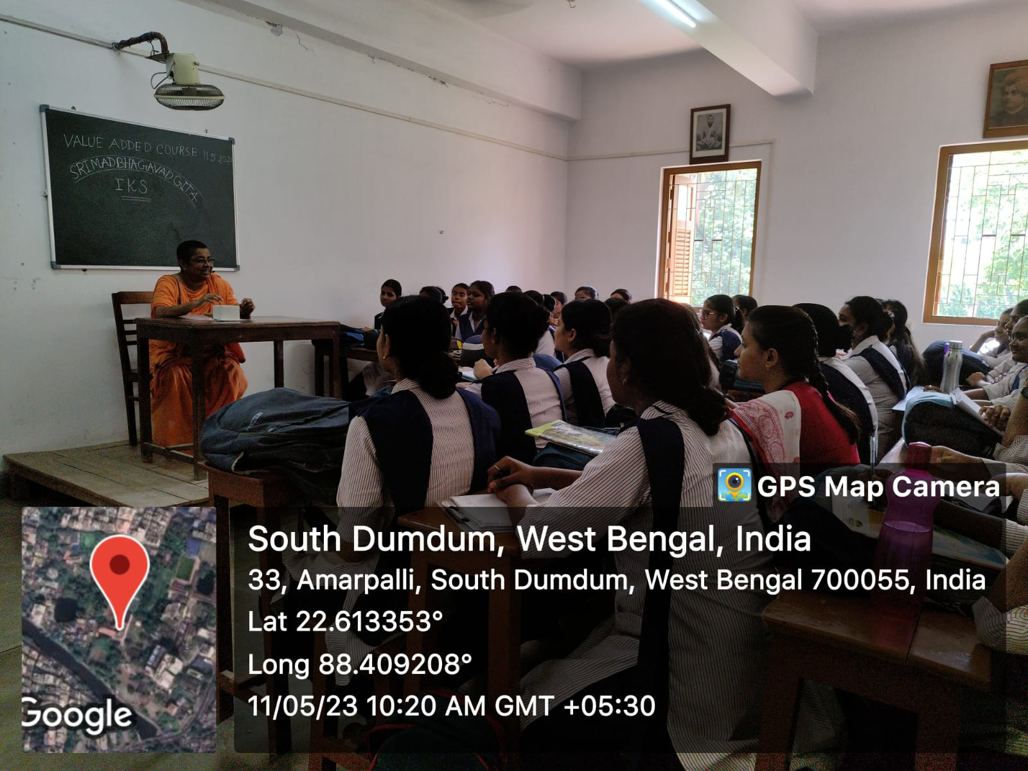

Event: Annual Function & Prize Distribution Ceremony
Date: 27.5.23
Venue: Muktiprana Sabhagriha
Organized by:RKSMVV
No. of Participants: Students, Invited guests and parents
Brief Description: The students of department of Philosophy whosored outstanding result were fecilitated on Annual Prize day.
Outcome: It is a moment of pride for both the student and the department to give away prizes to the achievers. This day is celebrated to honour the hard work of the students and appreciate their achievements. It encourages them to do better.

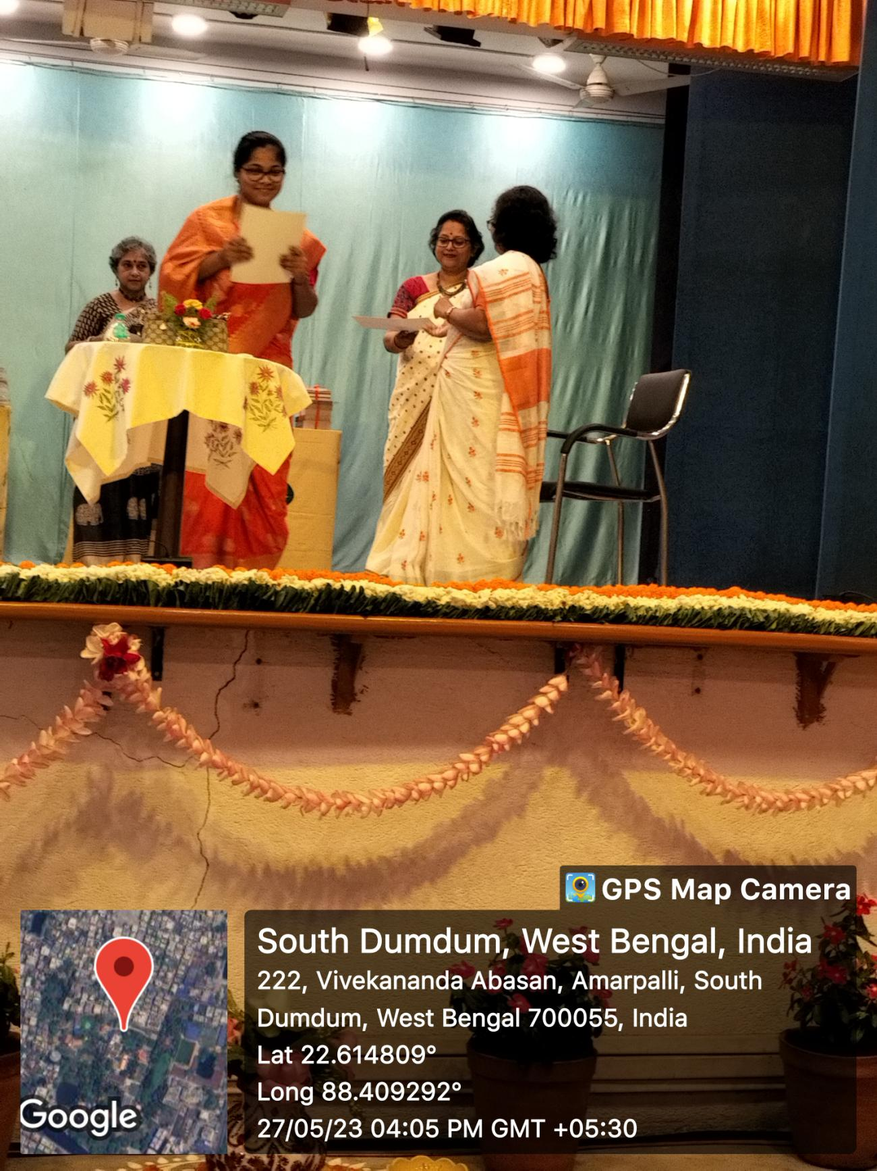

Event: Farewell
Date: 11 .7.23
Venue: Room No. 39
Organized by: IInd & IVth Semester Students
No. of Participants: 35
Brief Description:
The IInd & IVth semester students of Department of Philosophy gave a farewell to the outgoing Under graduate batch of semester VI.

Programme outcome: It was an emotional moment for the students to whom farewell was given as they are leaving the college as well as for the teachers and the junior students who will miss the outgoing batch.
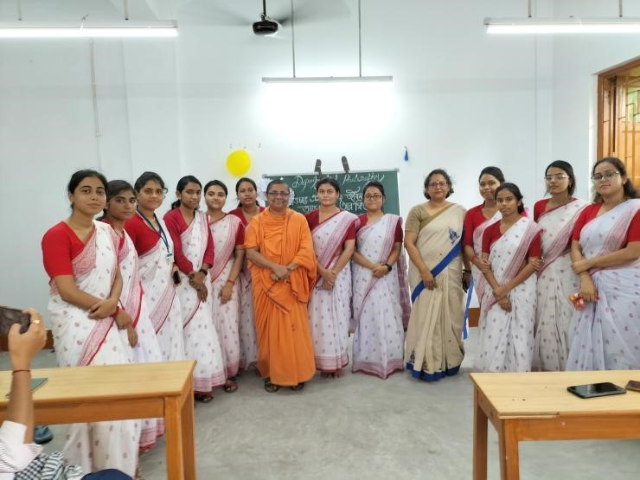
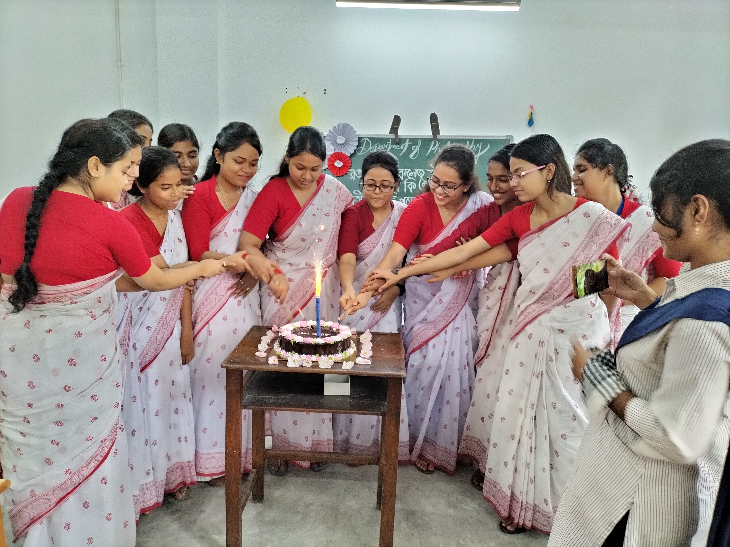
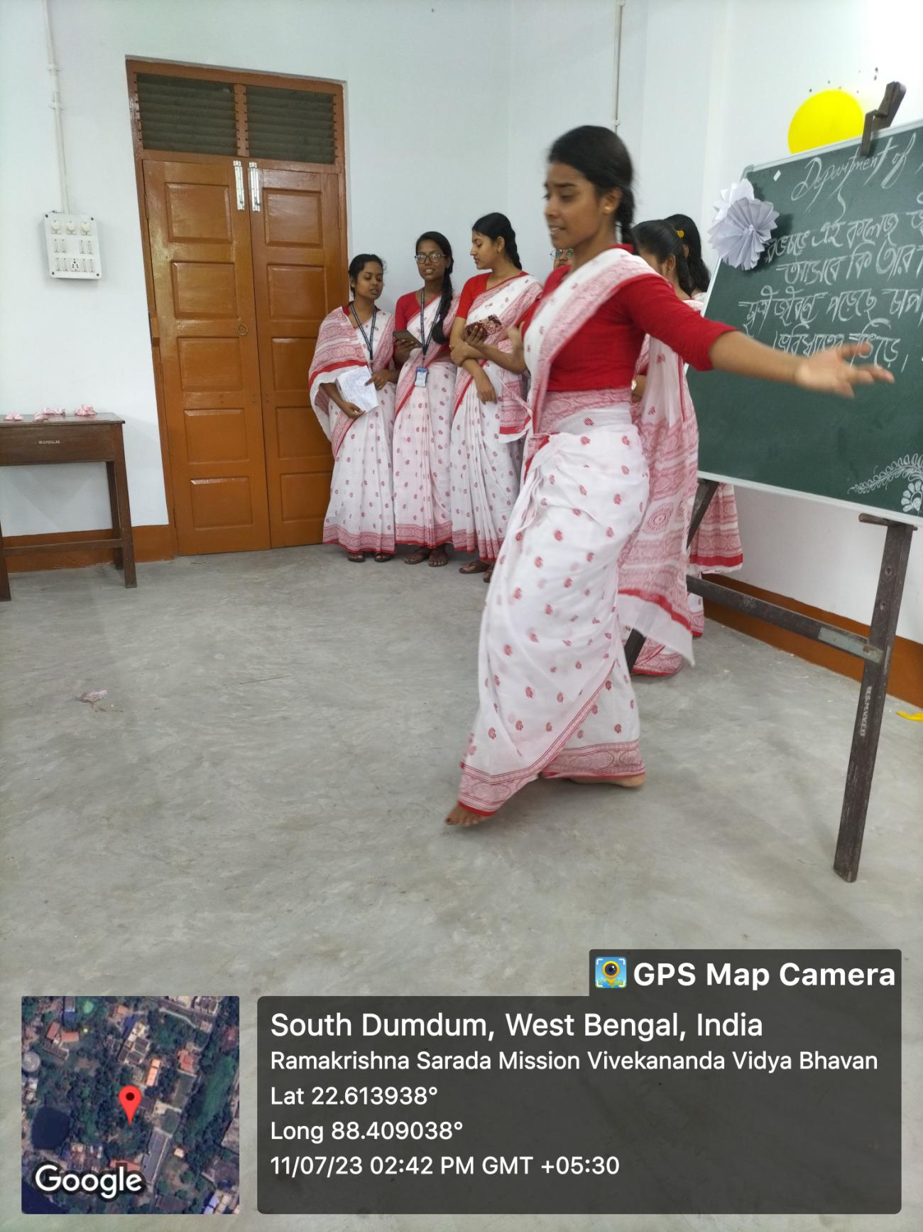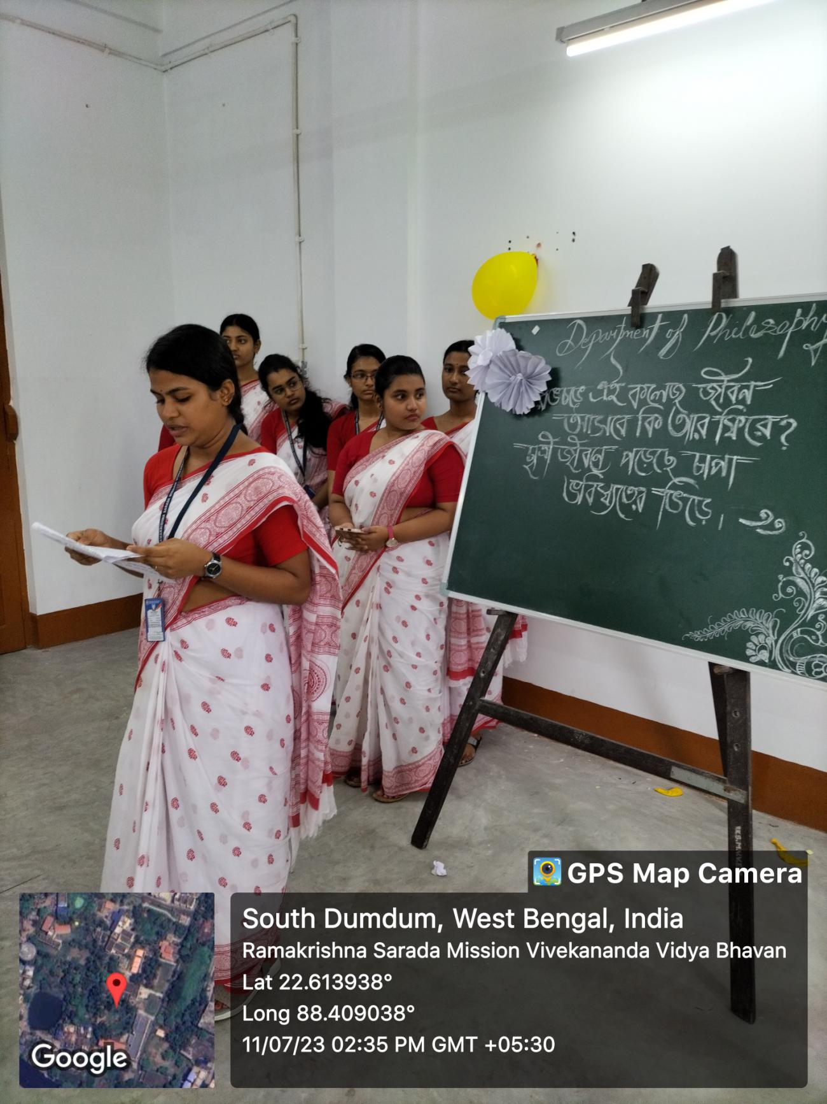
FAREWELL: 2023

EVENT: BANOMAHOTSAV - SUNDARVAN
DATE: 28.7.23
Description: On the eve of World Conservation Day, the students of Philosophy participated in the Vriksharopan Programme arranged by the college, where each of the teachers and the students have planted trees.
Outcome: Amidst songs and recitation, the students planted trees, which was an unique experience for them. The students got the opportunity to have a live experience of how to plant a tree and care for the environment.

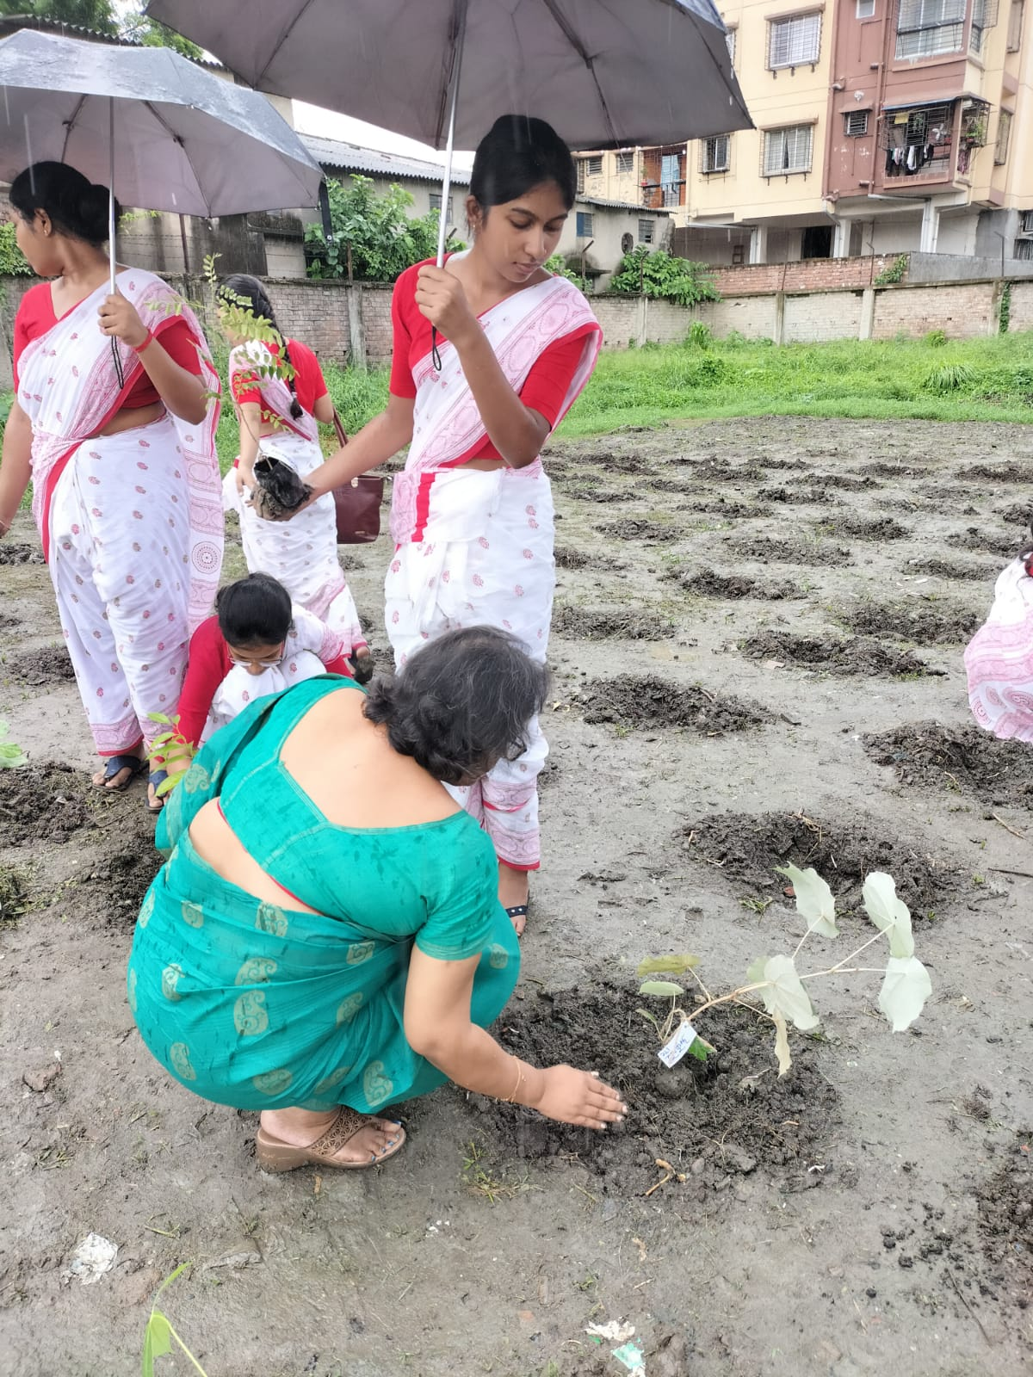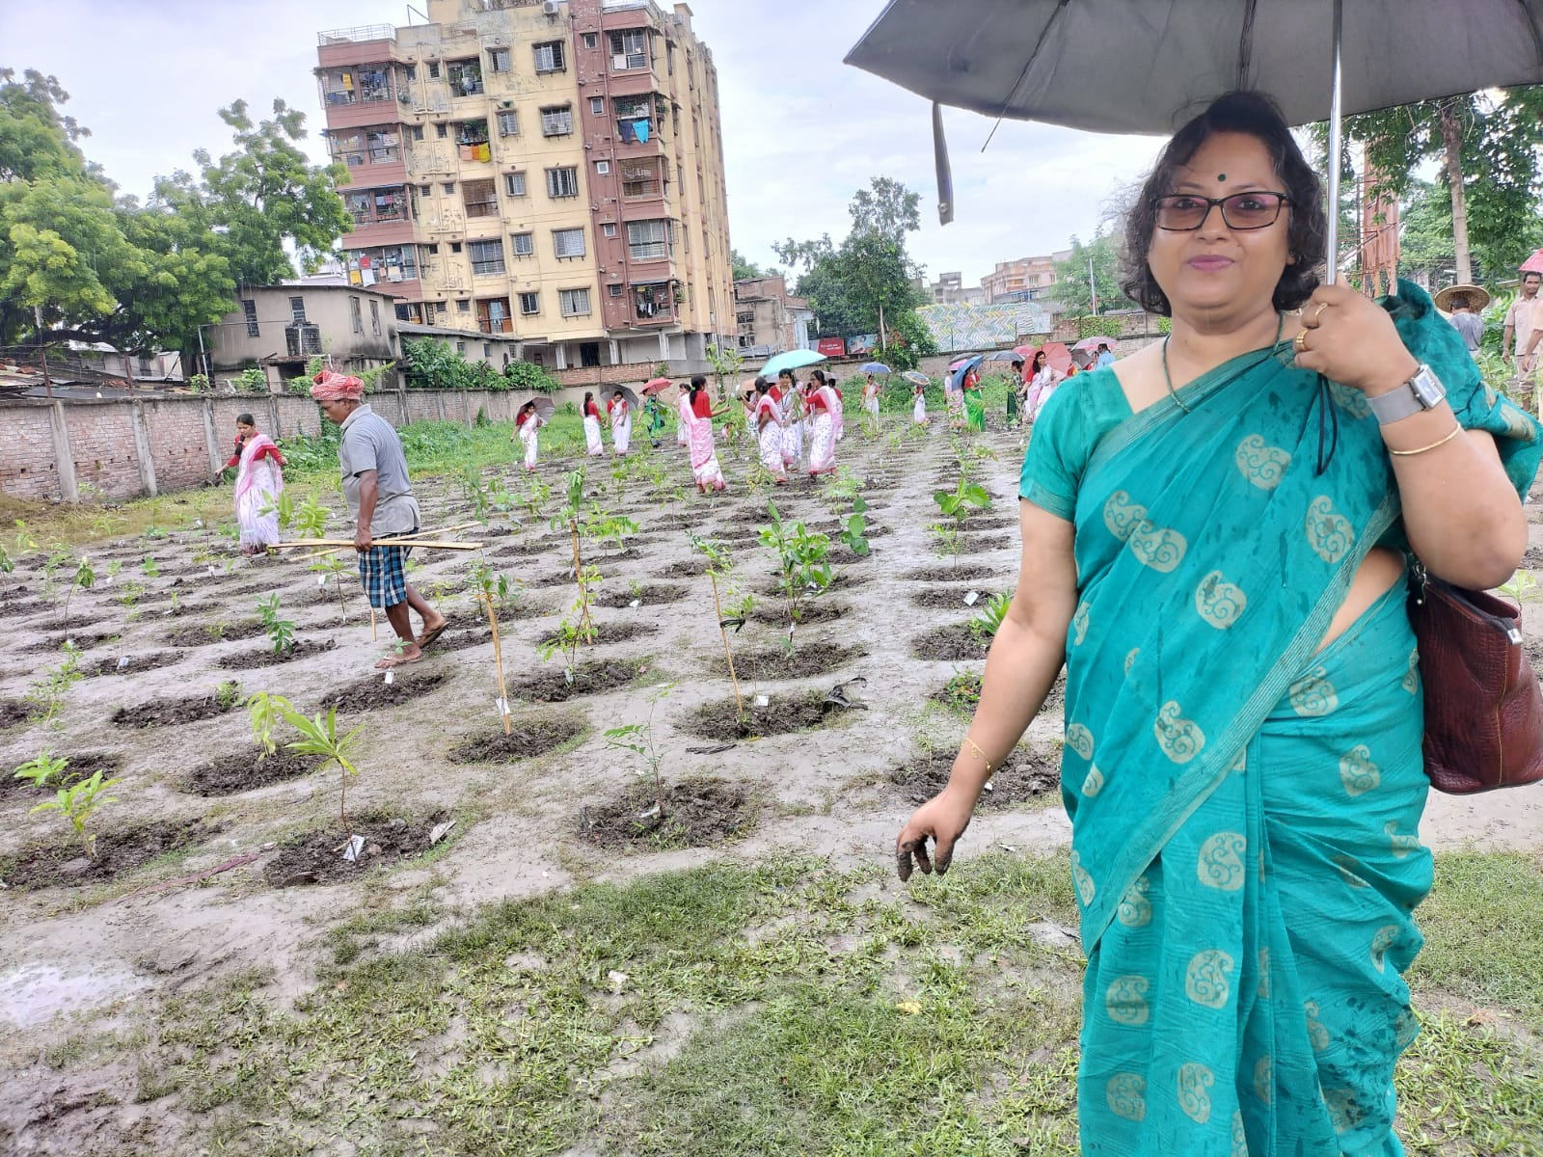

Event: Micro-teaching
Topic: Democracy - A philosophical analysis
Date: 31.7.23
Venue: Room No. 23
Resource Person: 5th Semester Students
No. of Participants: 23
Brief Description:
The 5th semester students of Department of Philosophy delivered lecture on Democracy : A Philosophical Analysis, where they elaborately stated the notion of democracy -its various forms.
Programme outcome:
The presentation made jointly by the students of 5th Semester, helped them experience the way to present a paper, to face questions and to learn the benefits of group discussion. The other two junior semester students got encouraged from the Micro-teaching programme and participated actively in the session.

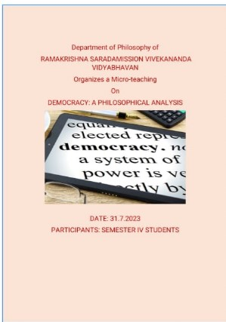
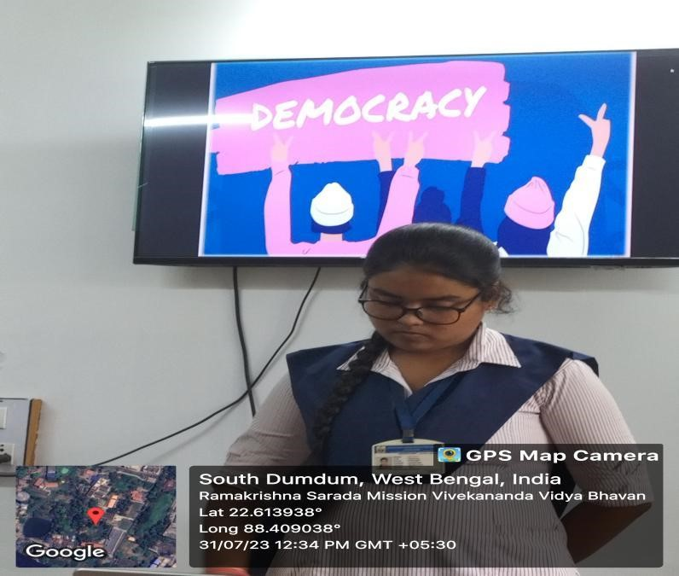

MICRO-TEACHING/SEMESTER V

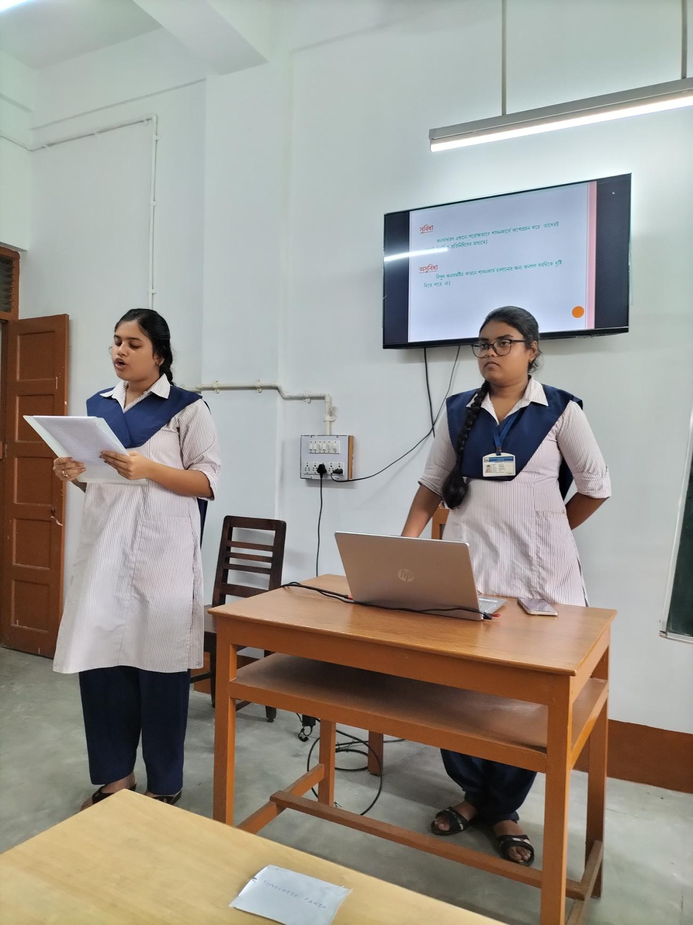

Event: Orientation Programme of Semester I
Date: 01.08.23
Description: An orientation programme has been organized by department of philosophy for the first semester students, to have an informal talk with the students. They were told about the new NEP system and the exam structure.
Outcome: The students expressed their choices and preferences, their liking in both academic and non-academic field. The students had their queries about the NEP structure and the students tried their best to explain it in details. They were also informed about the mentor-ward system, the slow and the advanced learner system which are already there in the departmental working structure.

Event: Micro-teaching
Name of the Topic – Bharatiya Nastik Darshaner Atma
Date: 11.8.2023
Venue: Smart Classroom
Speaker:Students of Semester III (UG) Number of Participants: 42
Brief Description:
The Ist semester students of Department of Philosophy delivered lecture on Self from the Indian context. Each of the students prepares a brief paper on their topic of discussion where they elaborately stated and defended the various arguments that arise regarding acceptance of atma.
Programme outcome:
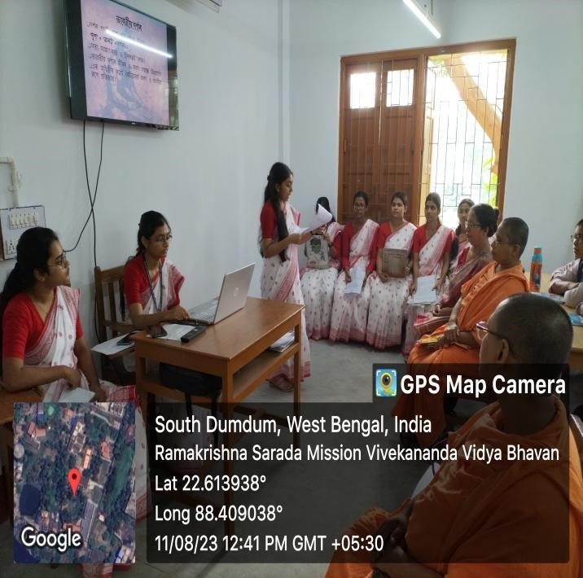
The presentation made jointly by the students of III rd Semester, helped them experience the way to present a paper, to face questions and to learn the benefits of group discussion. The other two semester students and participated actively in the session. The students from other departments like English and Sanskrit also joined the discussion.
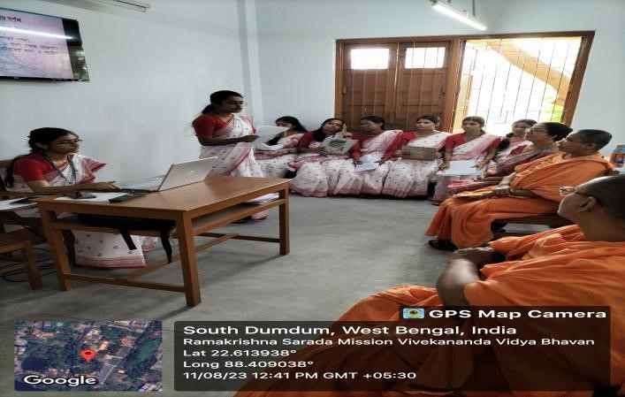

MICRO-TEACHING / SEMESTER III

Event: PARAMPARA

Name of the Topic – Descartes’ Method of Doubt

Date: 1.9.23

Venue: Smart Classroom

Speaker: Arifa Khatun (Ex-student of RKSMVV)

Number of Participants: 25

Brief Description:
The Department Of Philosophy introduced Parampara session from 1st September, 2023 . In the inaugural session, our Principal, Pr. Vedarupaprana delivered a thoughtful speech on the vision of ‘Parampara’ where our ex-students deliver lectures to spread their philosophical notions, outlook and understanding among the young learners. It was followed by an encouraging lecture by our IQAC coordinator,
Dr. Chaiti Mitra. Then, the co-convenor of the program, Dr. Bidisha Chatterjee, of the Department of Philosophy introduced the theme of Parampara. The speaker in the first session was Arifa Khatun, ex-student of RKSMVV delivered a lecture on
‘DescartesMethod of Doubt’.

Programme Outcome: The Semester I students and the Post Graduate Students were present in the session and they had an interactive session with the speaker.
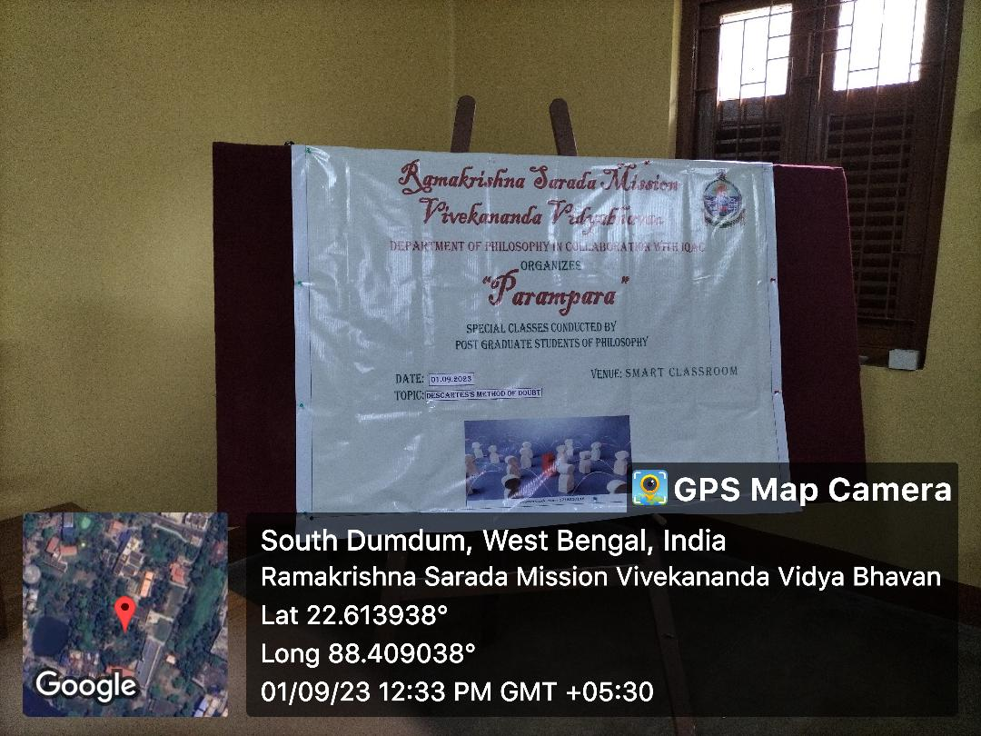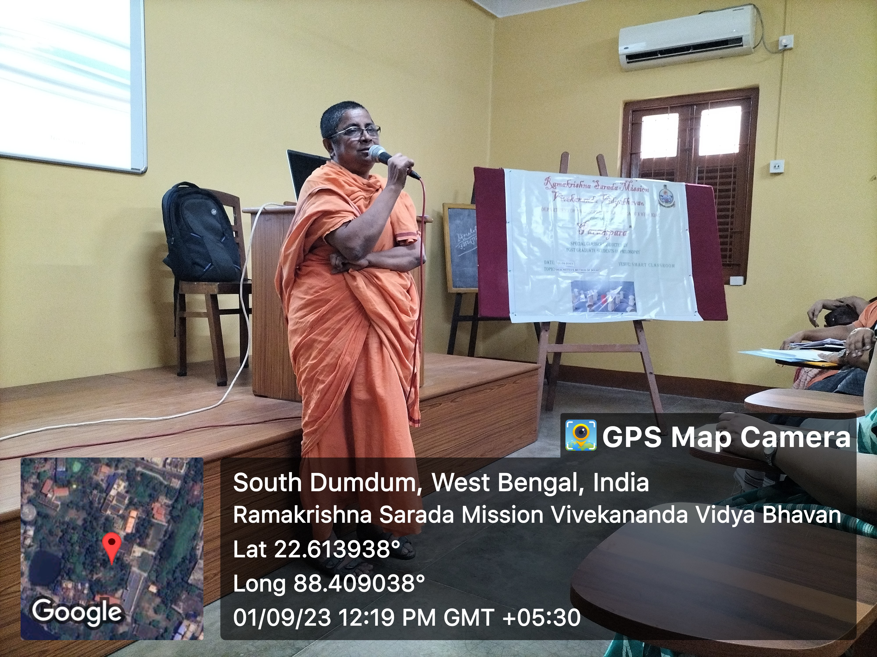

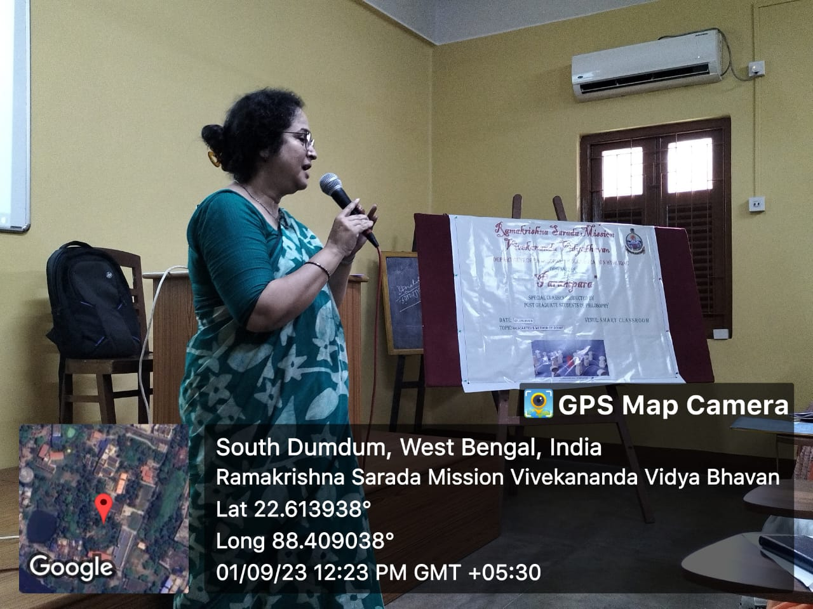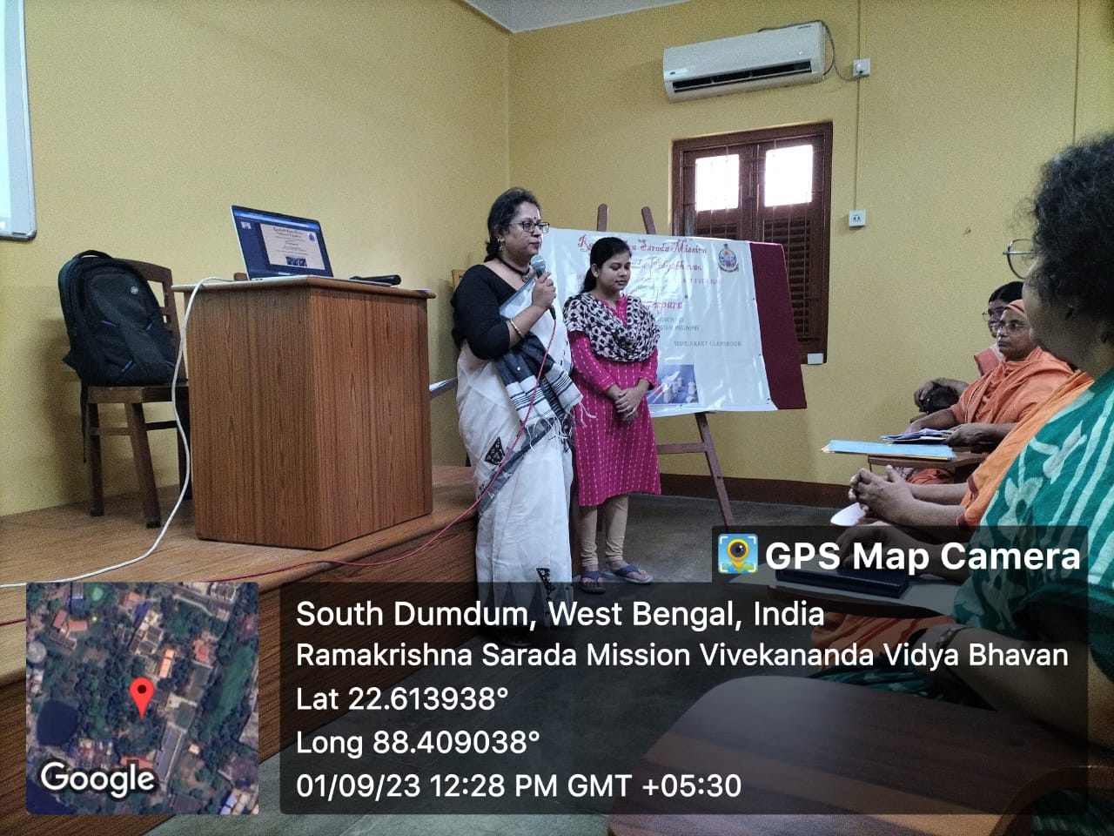
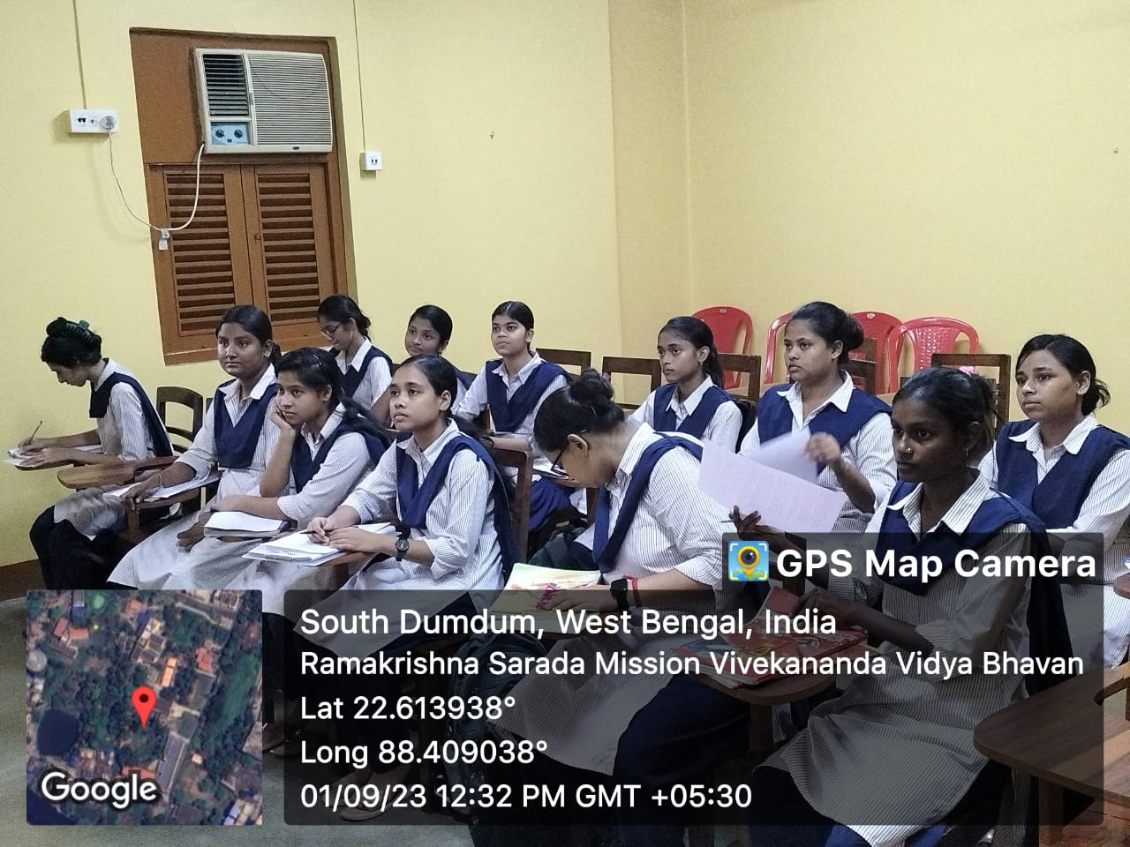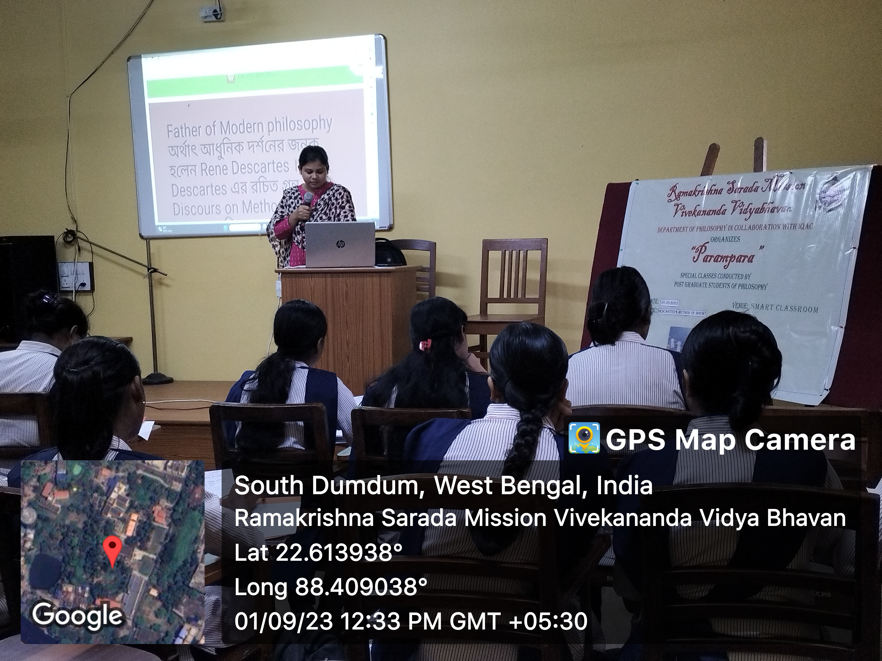

PARAMPARA - INAUGURAL SESSION , 1.9.23

Event: Introduction to Mentor-Ward System
Date: 15.9.23

Venue: Room No. 14

Teachers present: Pr. Ishtatmaprana, Anuradha Sadhukhan, Dr. Bidisha Chatterjee

Number of Participants: 16
The faculty members of Department of Philosophy introduced the Mentor-ward system to the Ist semester students. They were asked about their areas of interest apart from academics.

The students get the opportunity to share their views personally to the teachers if and when necessary.
Brief Description:

Programme outcome:

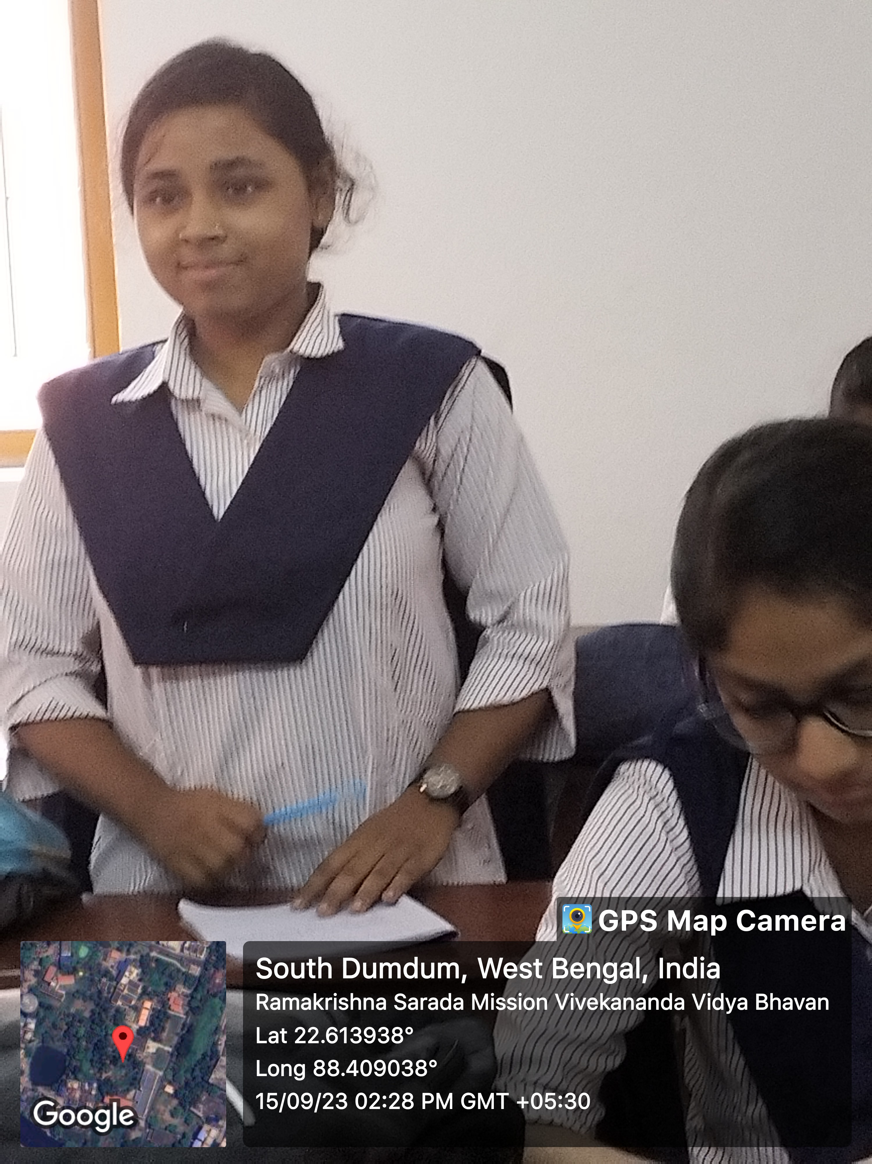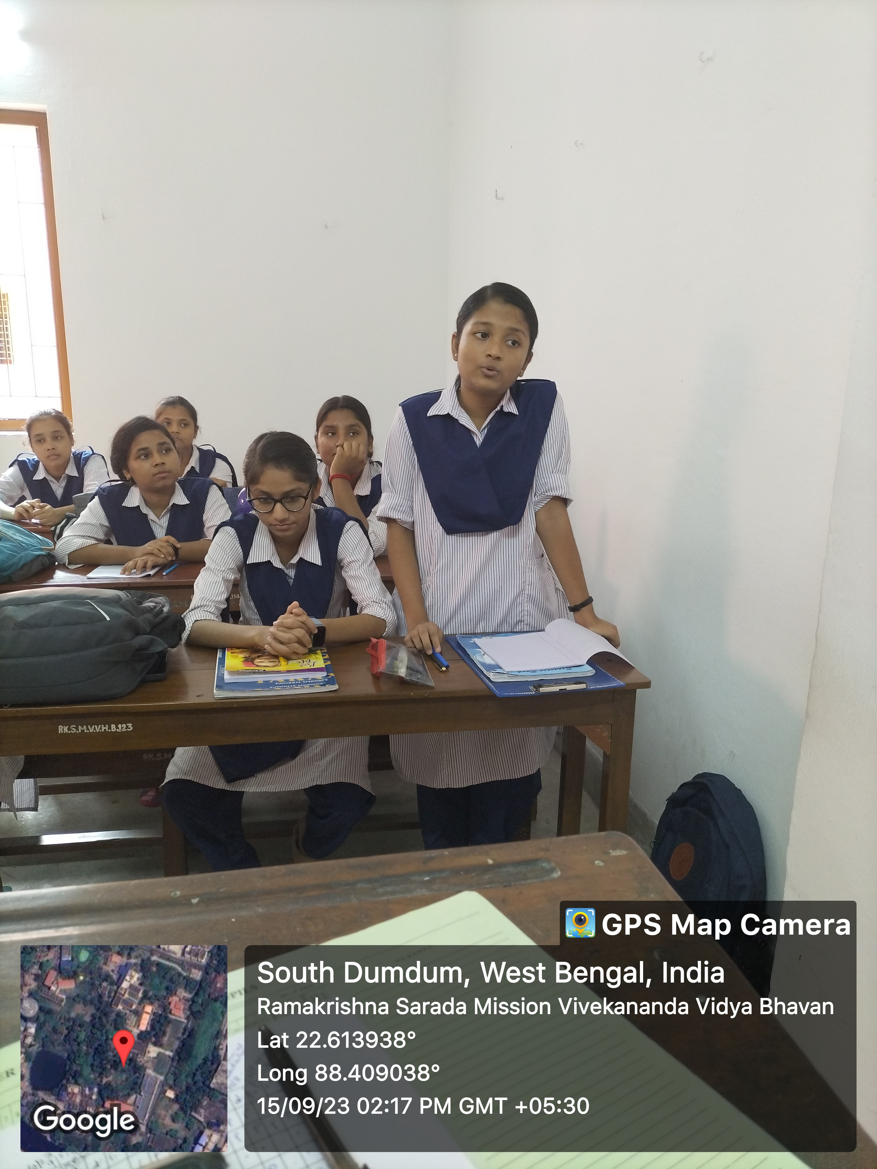

MENTOR-WARD SESSION

Event: Open House

Date: 26.9.23

Venue: Room No. 14

Organized By: Department of Philosophy
Number of Participants: 25

Brief Description: An Open house was arranged for Semester III & V to discuss about the experience of the students about their previous semester session. The students gave their feedback about their academic and non- academic facilities they got and the difficulties they faced in the previous semester. In broad, the issues they mentioned were:
- Completion of syllabus within time
- Repeated class tests and tutorials helped them to prepare themselves for the final semester.
- Mock tests before final semester helped them do better in exams.
Megha Chatterjee, Bidisha Halder, Neha Das and Megha Bahadur of Semester V, expressed their satisfaction regarding the discussions of issues in Practical Ethics and Religion. Third semester students like Ananya Ghosh, Sudeshna Pal, Antara Das expressed their satisfaction regarding the slow and the advanced learner classes and repeated class and home assignments.
Event: PARAMPARA (Lecture No. 2)
Topic: Indian Philosophy, Sankhya Darsana
Date: 29.9.23
Venue: Smart Classroom No. 8
Resource Person: Hritu Mukherjee
No. of Participants: 5th Semester Students
Brief Description:
The 5th semester students of Department of Philosophy attended the Parampara Class on 29.9.23. the speaker, Hritu Mukherjee delivered an excellent lecture on Sankhya Darsana. She explained the topics in details for clear understanding.
Programme outcome: The students were very much benefited from the inter-active session. They cleasrd their doubts regarding various issues and a brief notes was also given to them by the speaker.

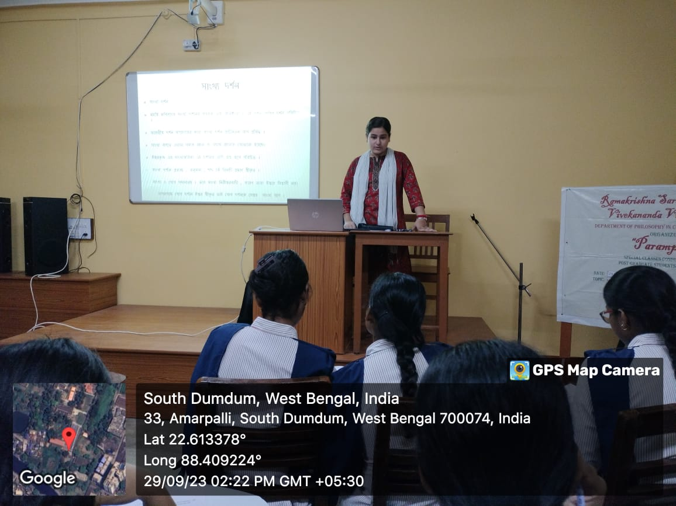

PARAMPARA LECTURE NO.:2

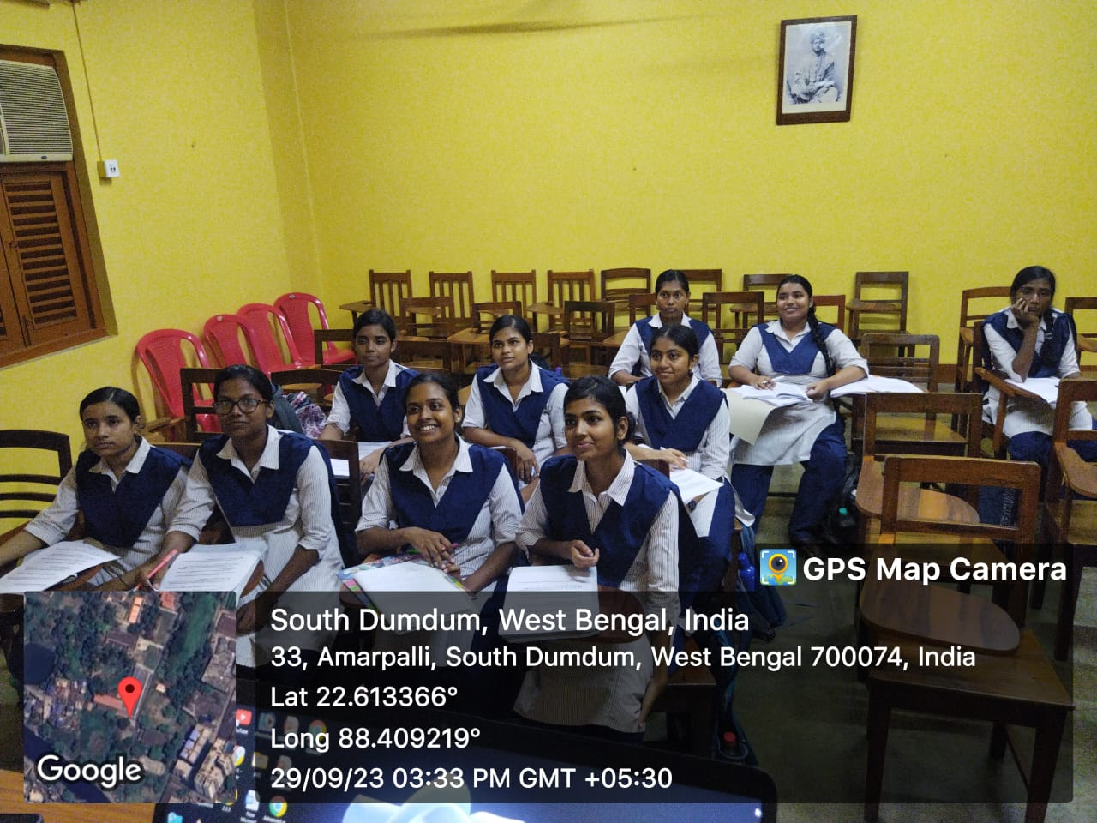

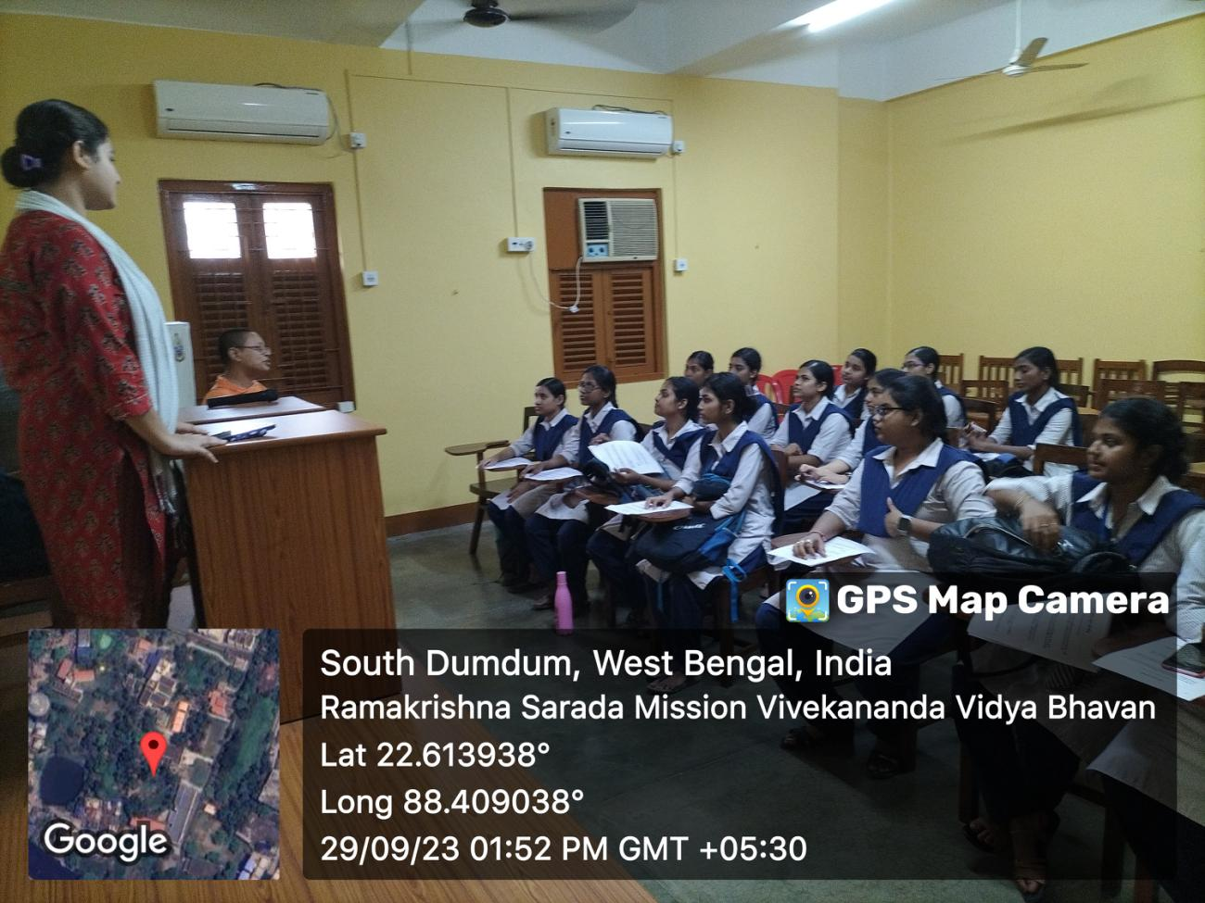

Event: Micro Teaching
Topic: Plato’s theory of Knowledge
Date: 17.10.23
Venue: Smart Classroom No. 8
Resource Person: 1stSemester Students.
No. of Participants: 3rd & 5th Semester Students
Brief Description:
The 1st semester students of Department of Philosophy presented an elaborate paper through the Micro-Teaching programme on 17.10.23. The class was attended by the under-graduate students of department of philosophy and the faculty members.
Programme outcome: The presentation made jointly by the students of Ist Semester, helped them experience the way to present a paper, to face questions and to learn the benefits of group discussion. The other two semester students attended and participated actively in the session.

MICRO-TEACHING/ SEMESTER I

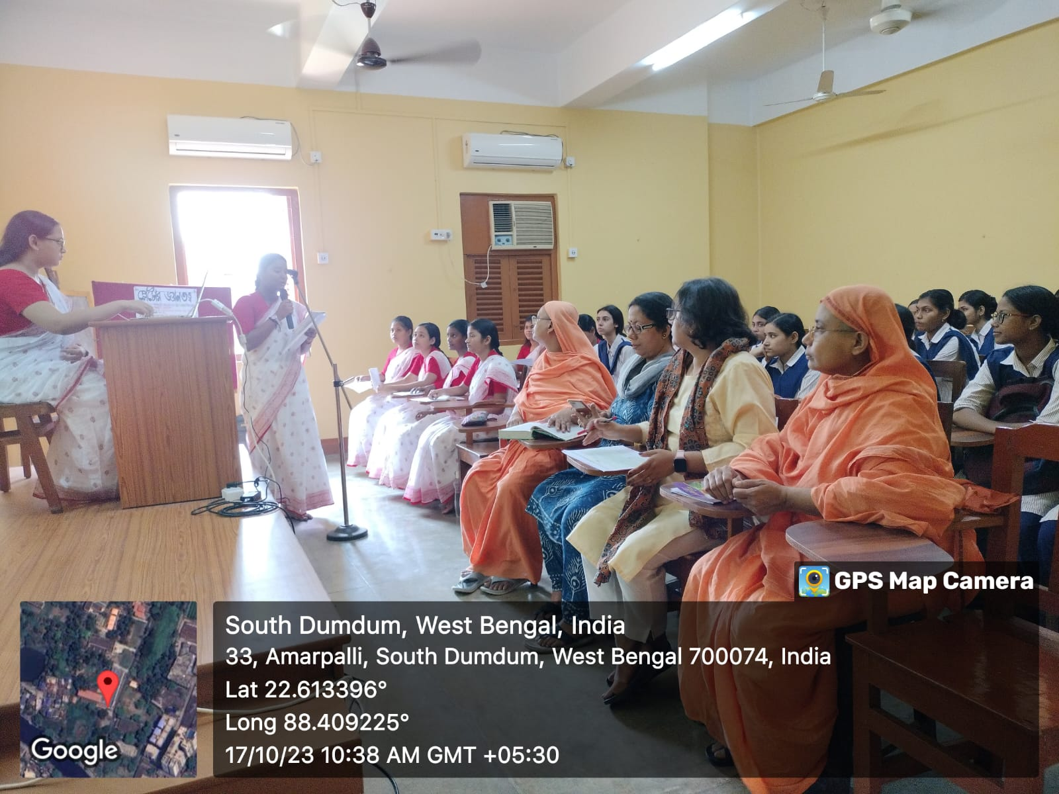

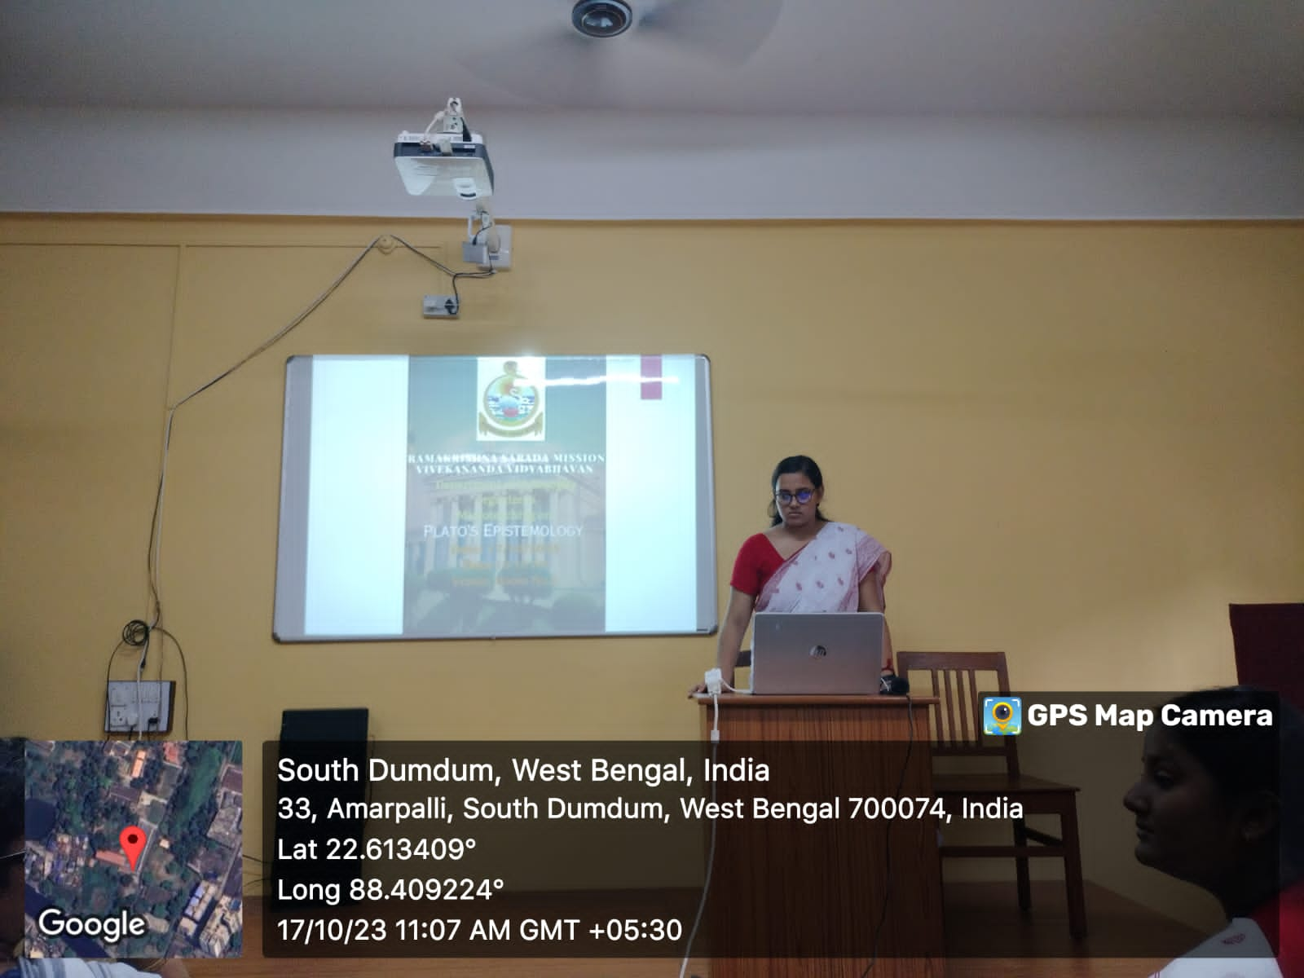

MICRO-TEACHING

Event: RKSMVV BOOK FAIR
Date: 6.10.23
Participants: Students of Philosophy
Brief Description: The students of Philosophy visited the college library premise to be a part of the Book Fair organized by the College authority.
Programme outcome: The students enjoyed buying books at college premise.
RKSMVV COLLEGE BOOK FAIR

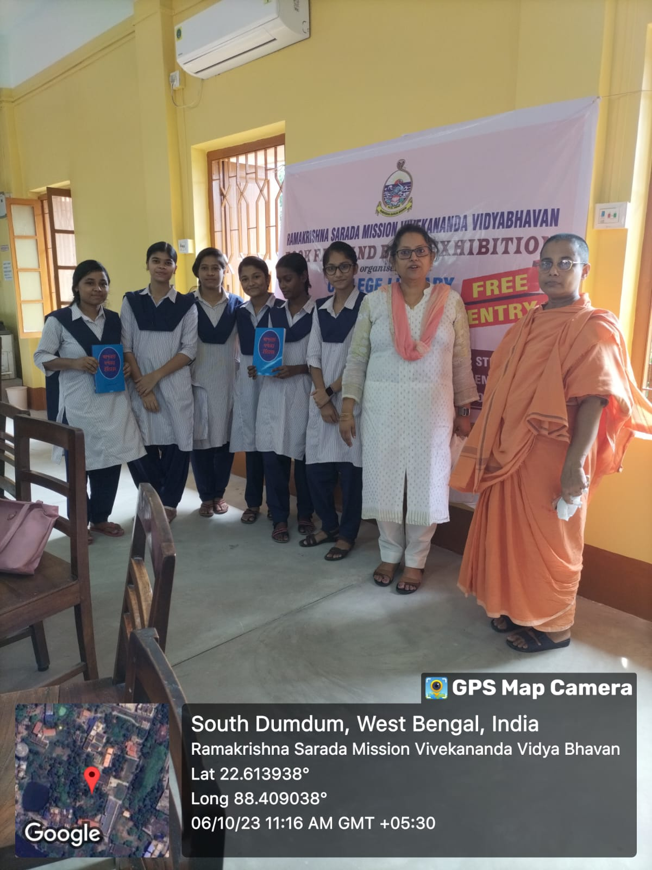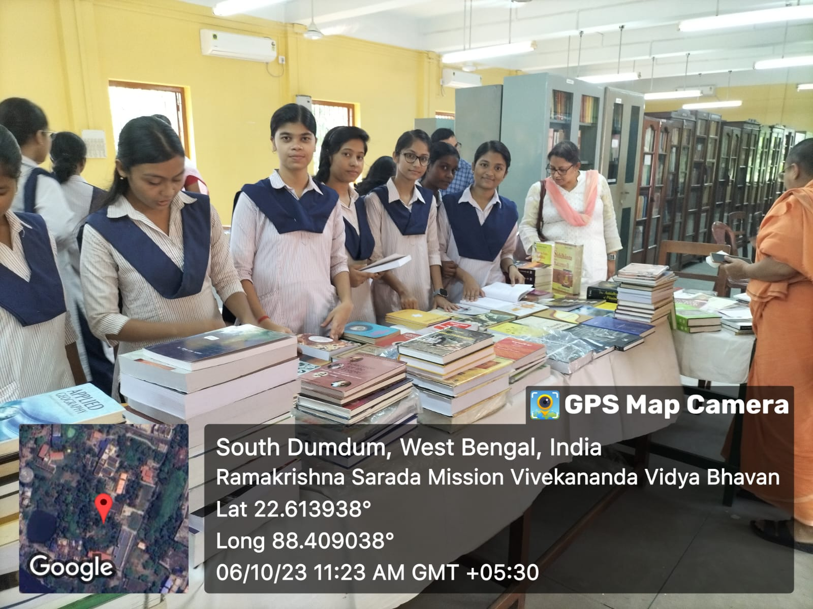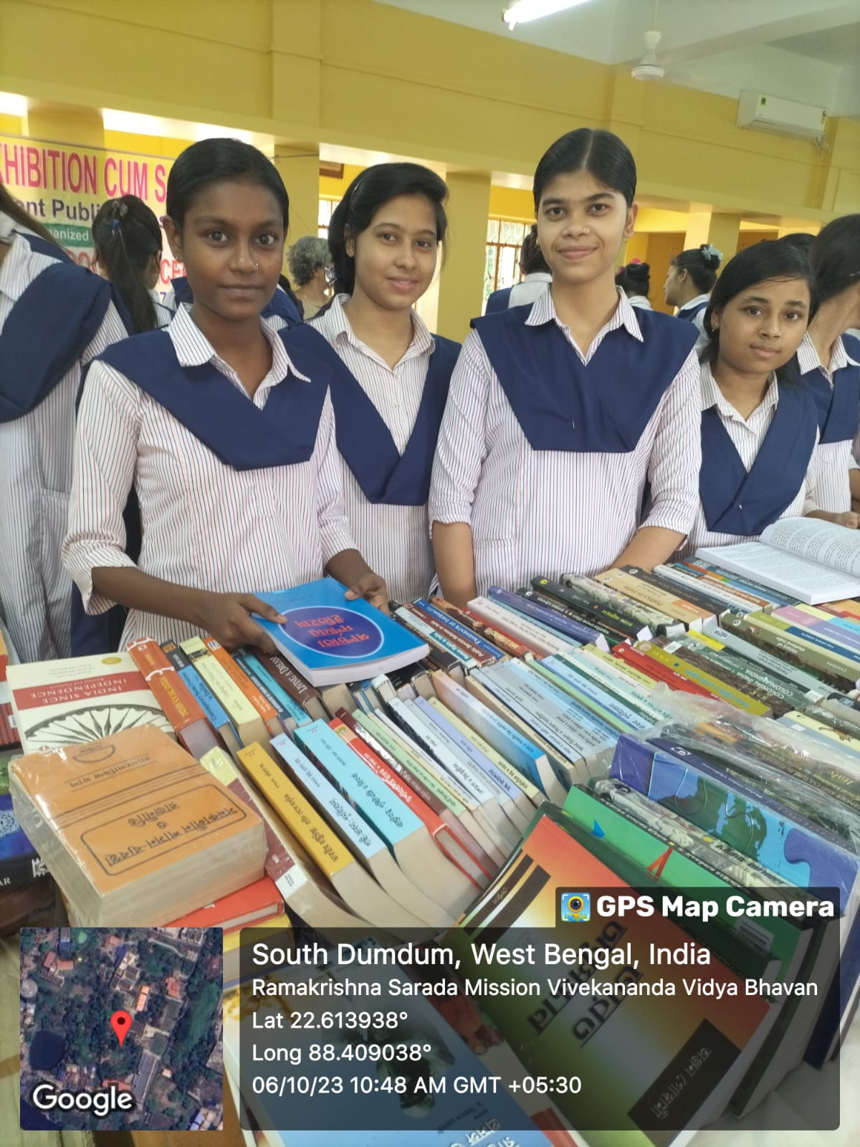

Event: PARAMPARA (Lecture No. 3)
Topic: Hospers on Ambiguity
Date: 24.11.23
Venue: Smart Classroom No. 8
Resource Person: Hritu Mukherjee
No. of Participants: 5th Semester Students
Brief Description:
The 5th semester students of Department of Philosophy attended the Parampara Class on 29.9.23. the speaker, Hritu Mukherjee deliverde an excellent lecture on the critical concept of ambiguity as depicted by Hospers and its different implications.
Programme outcome: The students were very much benefited from the inter-active session as they were asked to solve few words of ambiguity and give proper explanation against it.

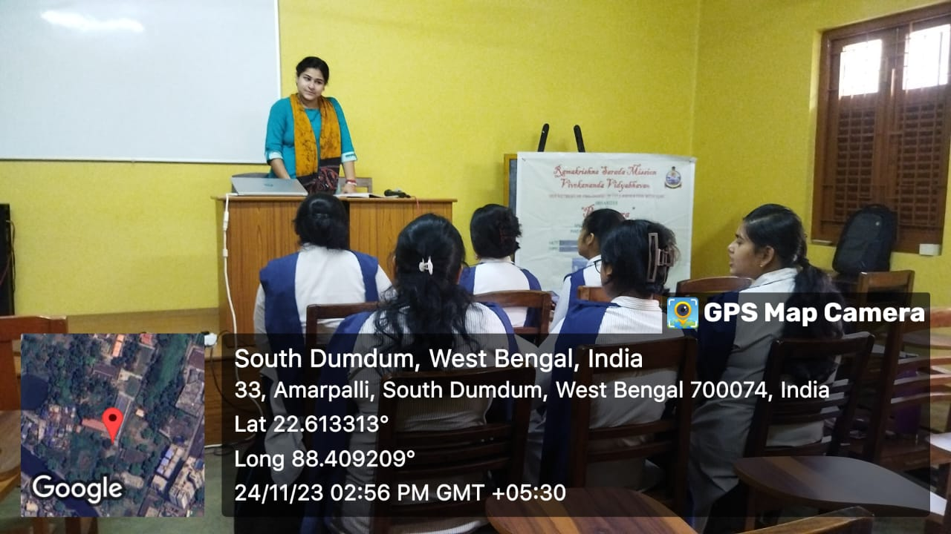

PARAMPARA - LECTURE

Event: Seminar

Event: Seminar on World Philosophy Day
Name of the Topic – Revisiting Environmental issues From the Perspective of Indian Knowledge System
Date: 30.11.2023
Venue: Muktiprana SabhaGriha
Speaker:Dr. Priyambada sarkar and Dr. Sanghamitra Mukherjee
Number of Participants: 85 UG and PG Students
Brief Description:
TheDepartment of Philosophy organized World Philosophy Day in collaboration with Gurudas College, East Calcutta Girl’s College, Sammilani Mahavidyalaya, Shyampur Siddheshwari Mahavidyalaya, and Ananda Mohan College and under the patronage of IQAC of Ramakrishna Sarada Mission Vivekananda Vidyabhavan. The students of the collaborating colleges were given the opportunity to deliver small talk on various issues related to Indian Knowledge system. Esteemed speakers were also invited to share their views on the topic.
Programme outcome:
The presentation made jointly by the students of 5th Semester, which helped them experience the way to present a paper, use ICT, to face questions and to learn the benefits of group discussion. The other two semester students participated actively in the session.

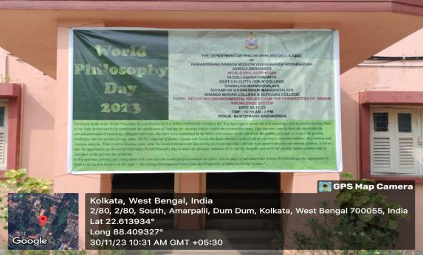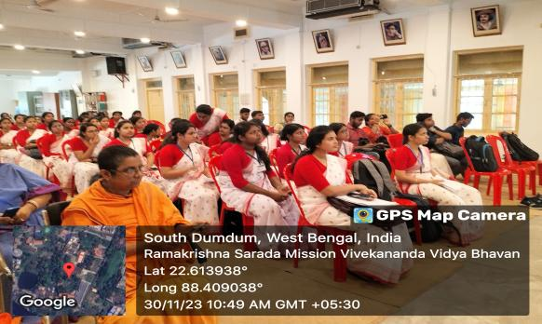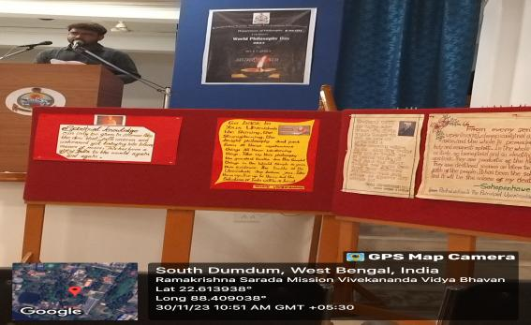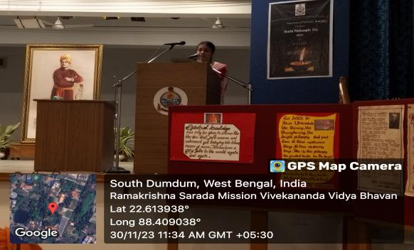
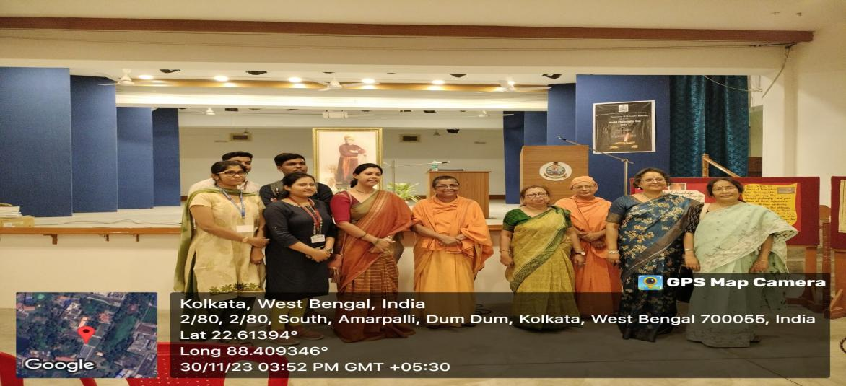

SEMINAR/WEBINAR 2024
Event: Parent-Teacher Meeting
Date: 4th & 6the January
Participants: Ist, 3rd and 5th Semester students
Brief Description: The department of Philosophy conducted Parent Teachers meeting on the above mentioned dates. The Internal assessment result was discussed along with the suggestions to the students who did not fare well in the IA exams.
Outcome: It is an open discussion forum where the parents are allowed to speak about anything regarding the academic aspect of their child. The teachers also get the opportunity to reveal their views regarding the progress of each and every students to the respective parent.

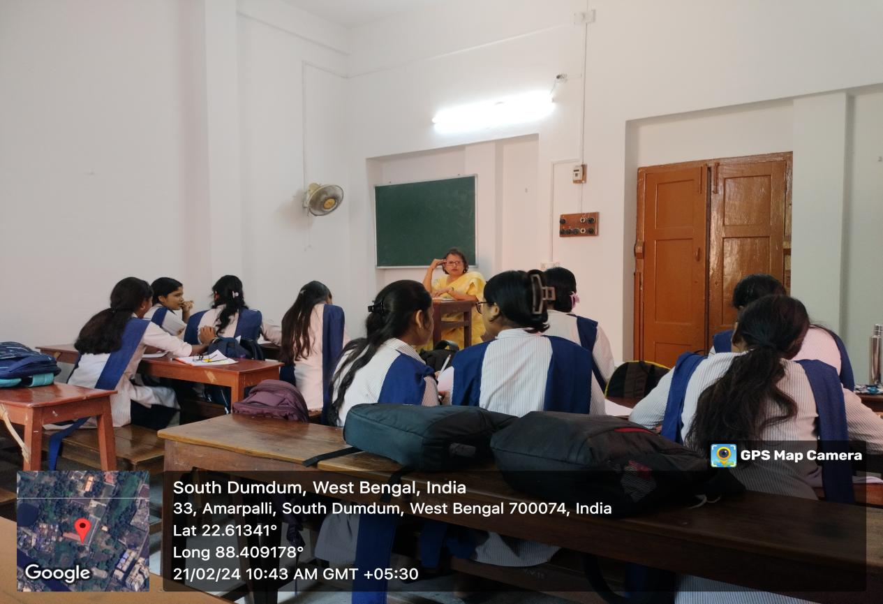:

Event: Philosophy Post Graduate Degree Award Ceremony
Date: 23.4. 2024
Organized By: Department of Philosophy in collaboration with IQAC of RKSMVV
Venue: Muktiprana Sabhagriha
Invited Guest: Prof. Basab Chaudhuri, Principal, Heritage Institute of Technology.
No.of Participants: 68
Description: The department of Philosophy organized the award ceremony of the Post Graduate students of Philosophy to give away the Master Degree Certificates to the students of batches 2018, 2019, 2020 and 2021. Professor Basab Chaudhuri was invited to grace the occasion. Our Principal Pr. Vedarupaprana gave the keynote address, followed by the briefing of the journey of the department of philosophy to materialize the opening of the PG Autonomous Course under the affiliation of WBSU in 2016, by IQAC member Dr. Bidisha Chatterjee who is also one of the faculties of the department. Prof. Chaudhuri gave away the certificates after delivering his brief but inspirational talk to the students. the highest scorer of each batch were awarded with special prizes also. The session ended with the words of experience of the students who got the MA degree from the institution and vote of thanks given by faculty member, pr. Ishtatmaprana.
Outcome: The students were overwhelmed by being a part of the ceremony and expressed their gratitude to the college and the faculty members to help them build up a bright future.

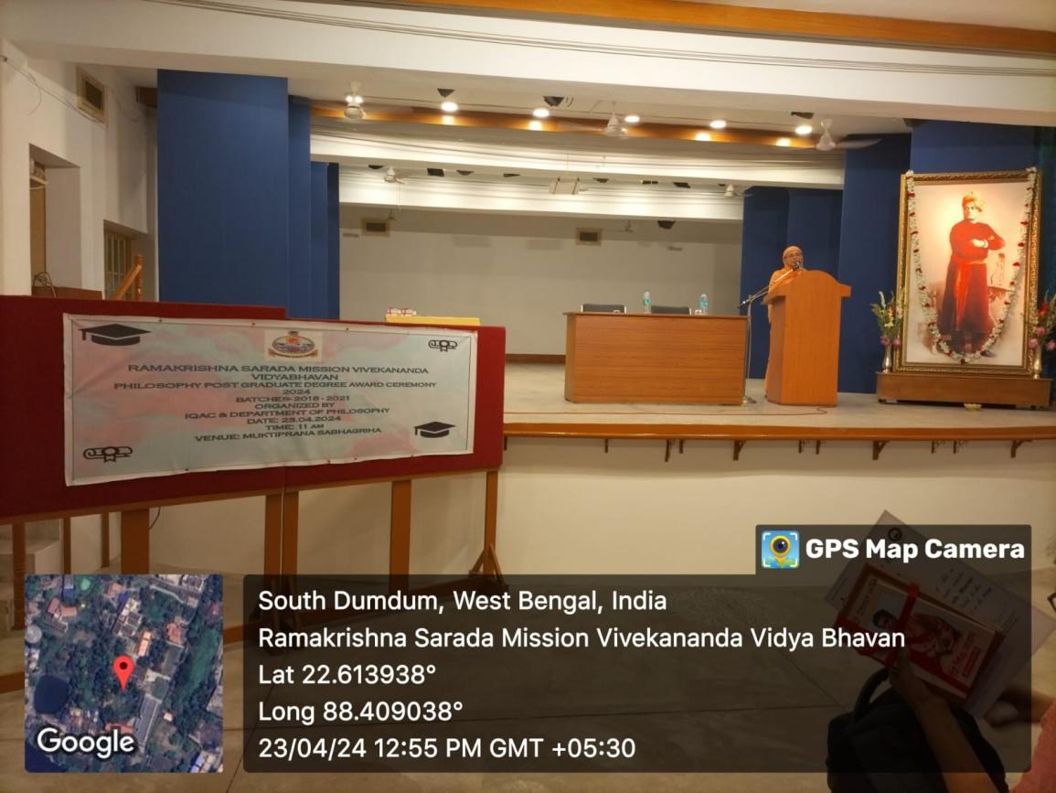

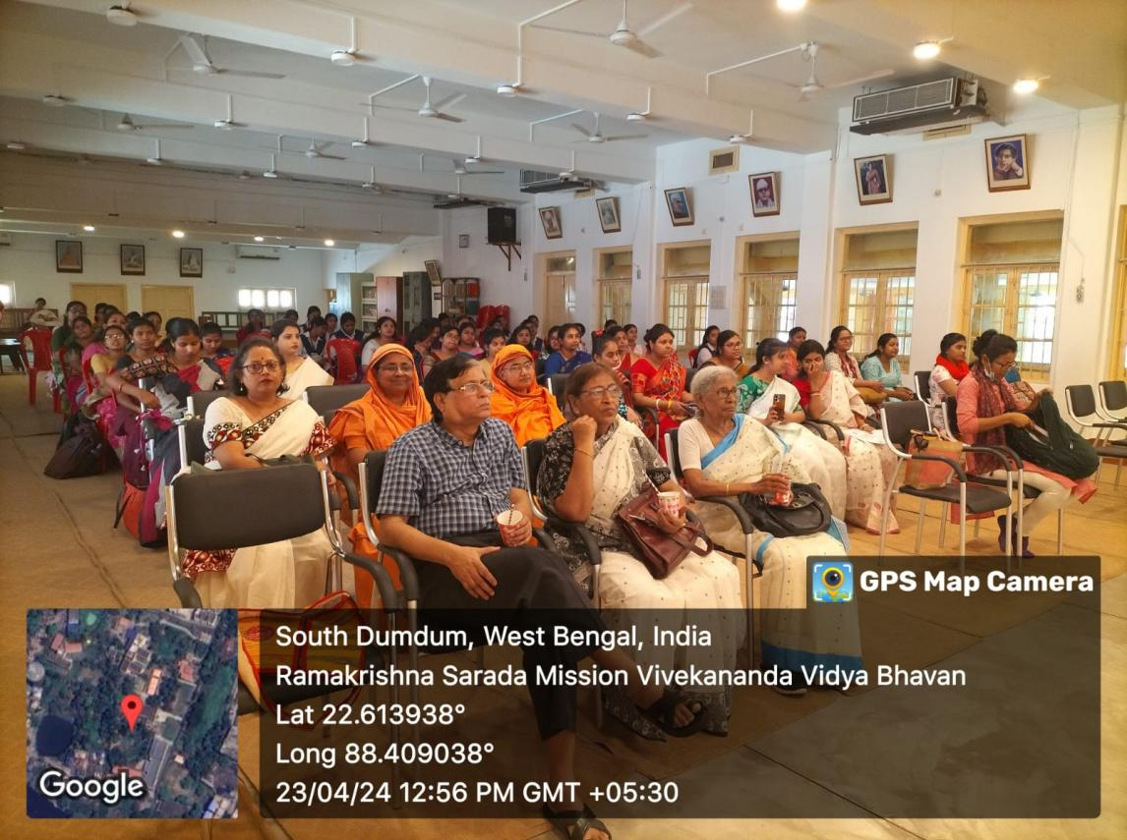

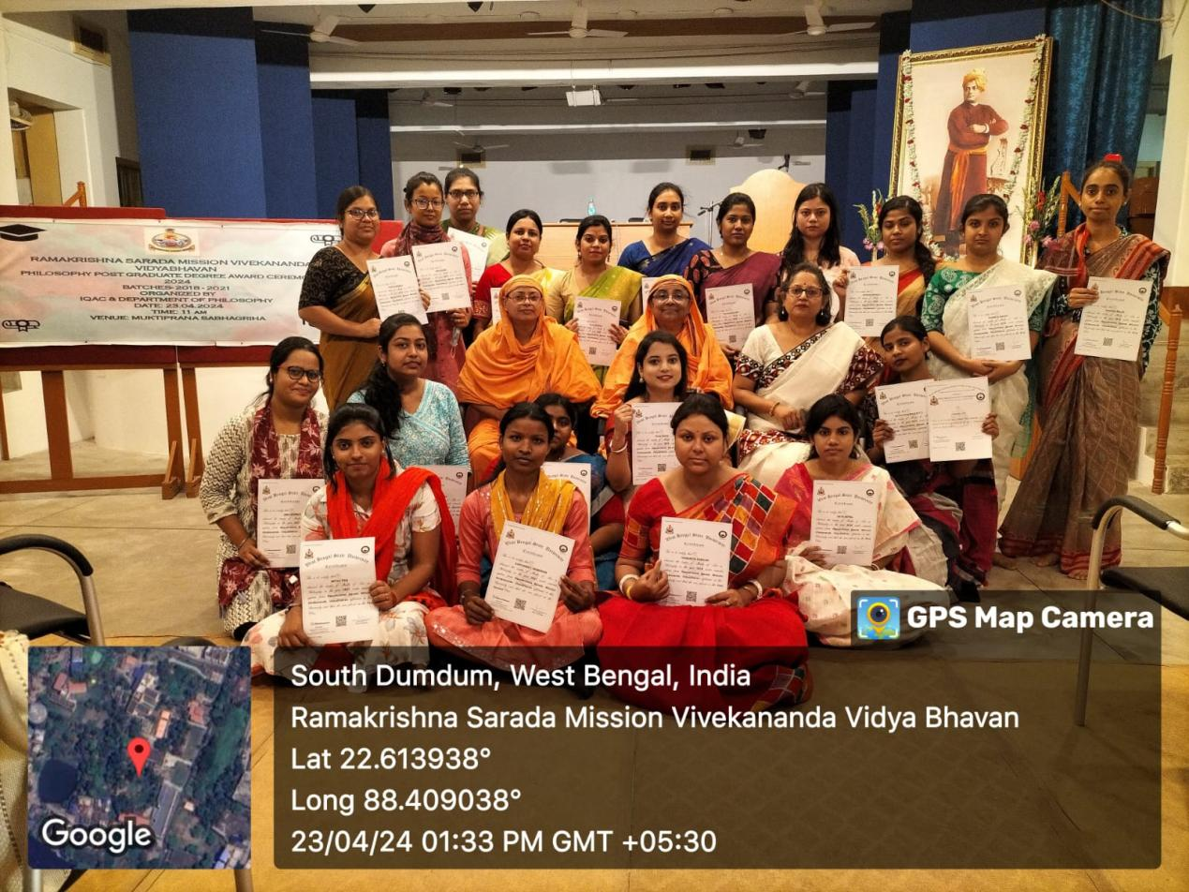

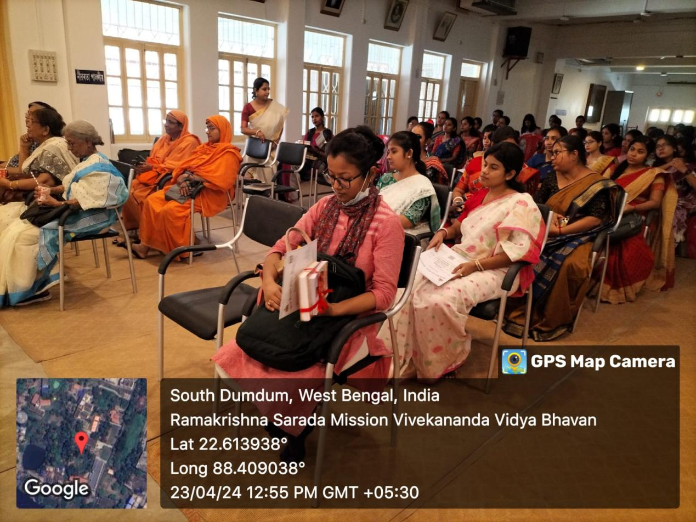

Event: State level Seminar
Date: 4.5.2024
Venue: Muktiprana Shabhagriha
Organized By: Department of Philosophy in collaboration with IQAC of RKSMVV and Sutradhar
Topic: Shri Ramakrishna and His Time
Speaker: Gautam Mukhopadhyay, Manabendra Mukhapadhyay & Dr. Arpita Mitra
No. Of Participants:
Brief Description: The Department of Philosophy organized a one day State Level Seminar on 4th May 2024. After the inaugural speech by our Principal, there was a book release session followed by three lectures.
Outcome: It was an interesting seminar where philosophy met with religion and gave us a few brilliant ideologies of Sri Ramakrishna Paramhansa and how we could accommodate his views to resolve our present scenario of social turmoil and unrest.
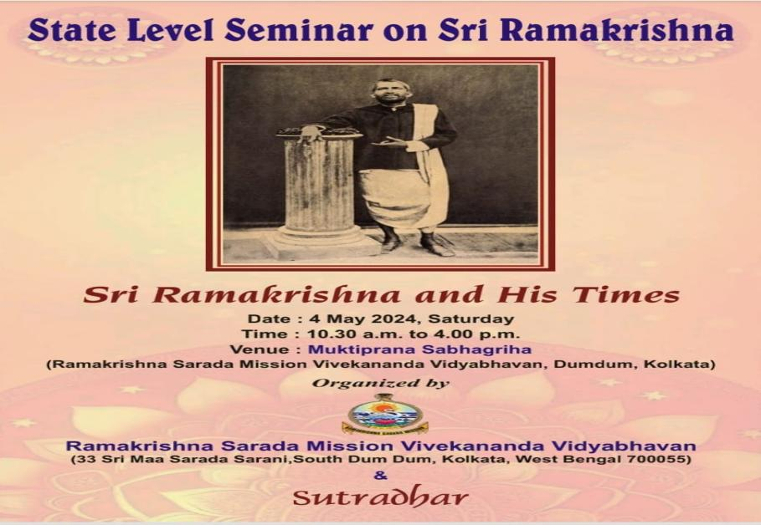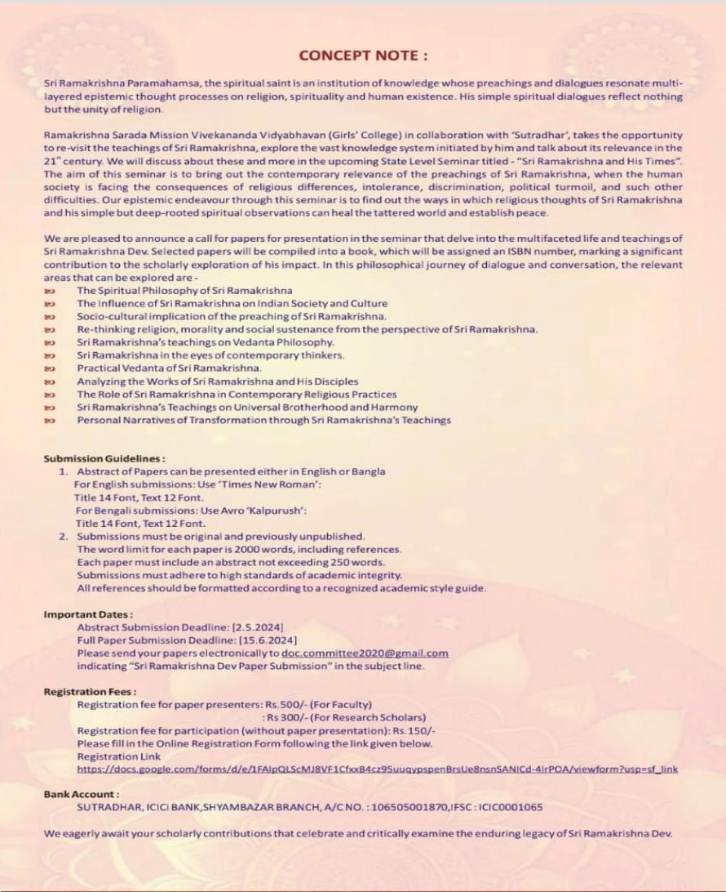

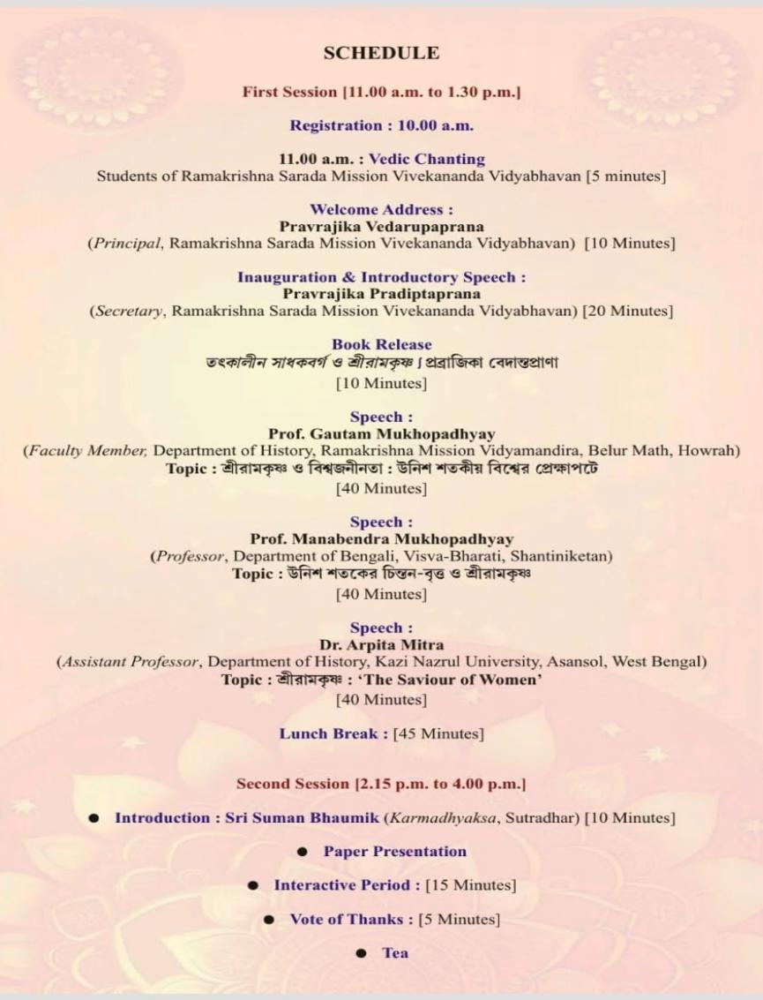

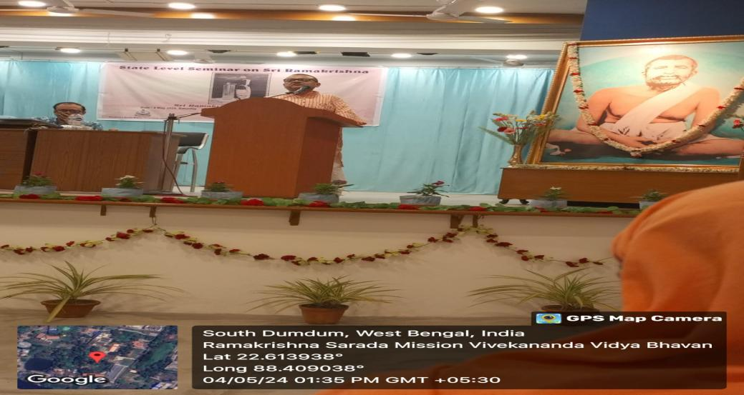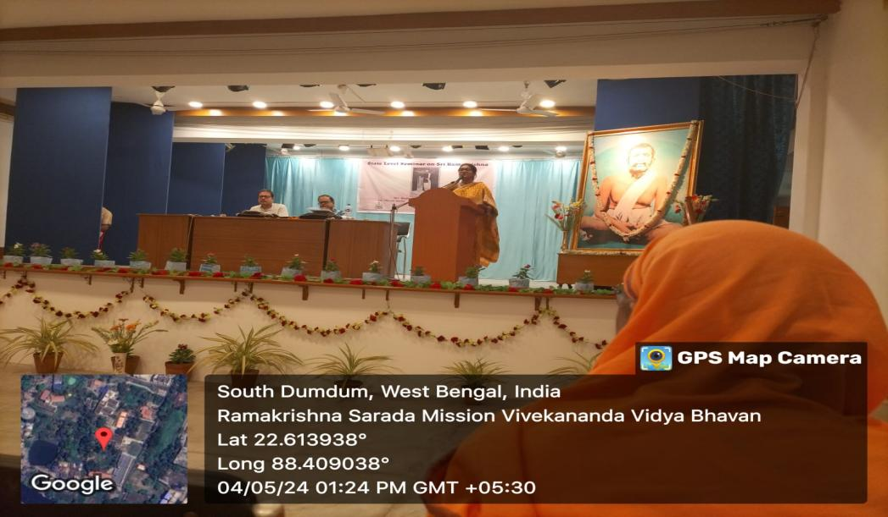
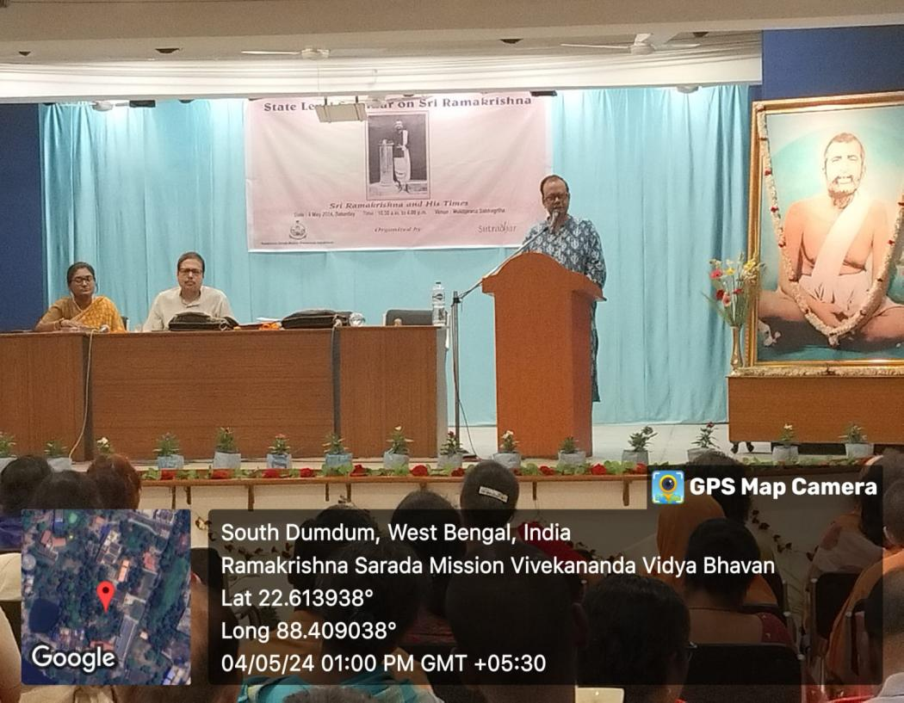
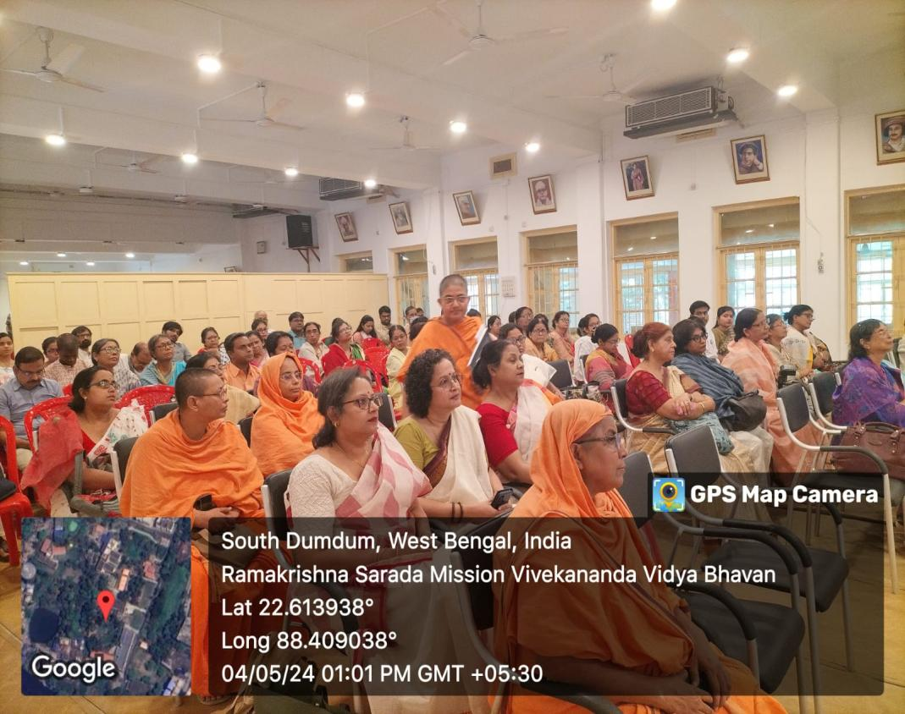

Event:Indian Philosopher’s Day
Date: 30.5.24
Organized By: Department of Philosophy in collaboration with IQAC of RKSMVV and Gurudas College
Topic: ‘The life and Teachings of Adi Shankaracharya’
‘Traditional Indian Philosophersand their
Contributions in Philosophy: An Overview’
Speaker: Pr. Vedarupaprana and Pr. Ishtatmaprana, Senior faculty members, department of Philosophy, RKSMVV.
Participants: Semester II, IV & VI students of RKSMVV , Semester II students of Gurudas College along with Smt. Paromita Majumder(Faculty, Department of Philosophy, Gurudas College)
Brief Description: Pr. Vedarupaprana and Pr. Ishtatmaprana, Senior faculty members, department of Philosophy, RKSMVV, delivered thought-provoking lectures on both the topics.
Outcome: As Schools of Indian Philosophy are taught in CBCS syllabus, both the lectures were informative for the students of both the institutions.

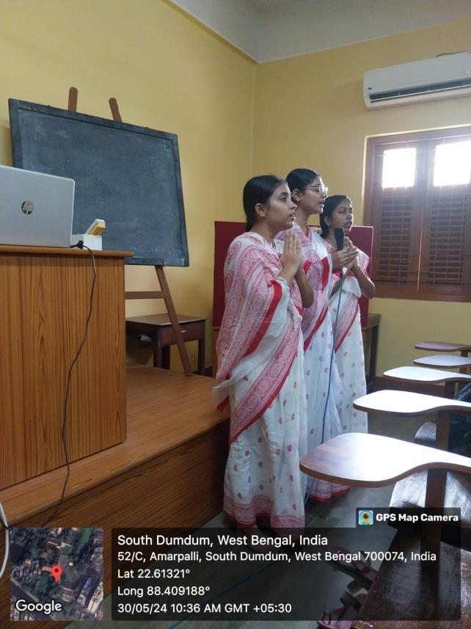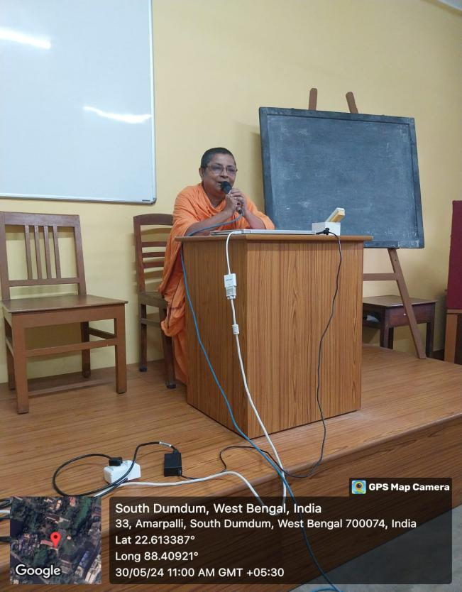

Event: Parent Teacher meeting
Date: 3. 7.24
Participants: Semester VI
Brief Description: A parent - teacher meeting of outgoing UG batch was held on 3rd July 2024 to discuss the Internal assessment result and career options of the students. The strength and weakness of each of the students were discussed with the parents. Few basic university exam related issues were also highlighted in the meeting. The career options were also revealed to the students and their parents( both Academic and non-academic).

Outcome:
Parent -teacher meet before the commencement of the Final Semester exam is a very fruitful meeting that gives both the teachers and the parents to talk freely about the progress or problems faced by the students. The teachers can communicate the strength and weakness of each of the students on one-to-one basis.

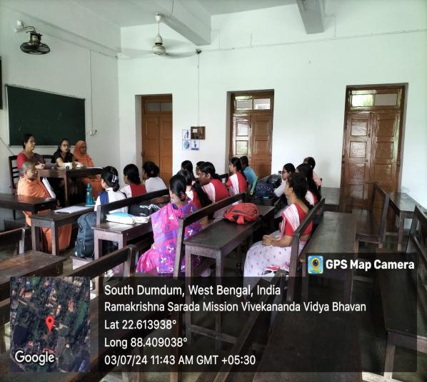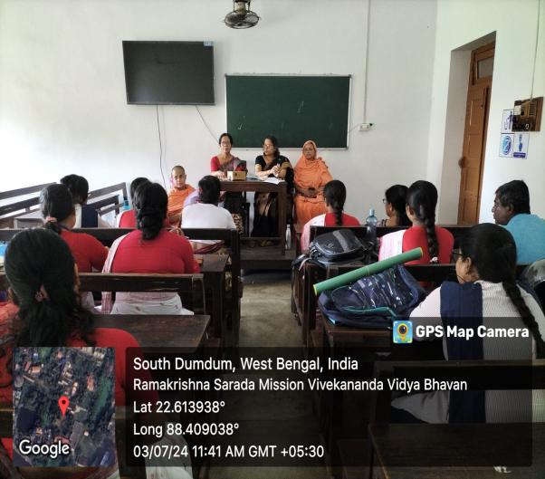

Event: International Seminar
Date: 24.8.2024
Venue: Muktiprana Shabhagriha
Organized By: Department of Philosophy in collaboration with IQAC of RKSMVV. And IKS Cell.
Topic: Towards an Epistemic Empowerment: Role of the New Avatar - AI in Philosophical Counselling.
Speakers: Prof. Priyambada Sarkar & Professor Sucheta Ghosh.
No. Of Participants:
Brief Description: The Department of Philosophy organized a one day International Seminar on 24th August 2024. to discuss the role of Artificial Intelligence in Philosophical Counselling
Outcome: It was an interesting seminar where philosophy met with science and technology. Both the lectures were very interesting and thought provoking and mesmerized the audience with new ideas of how AI will be able to influnce our thinking process in the near future.

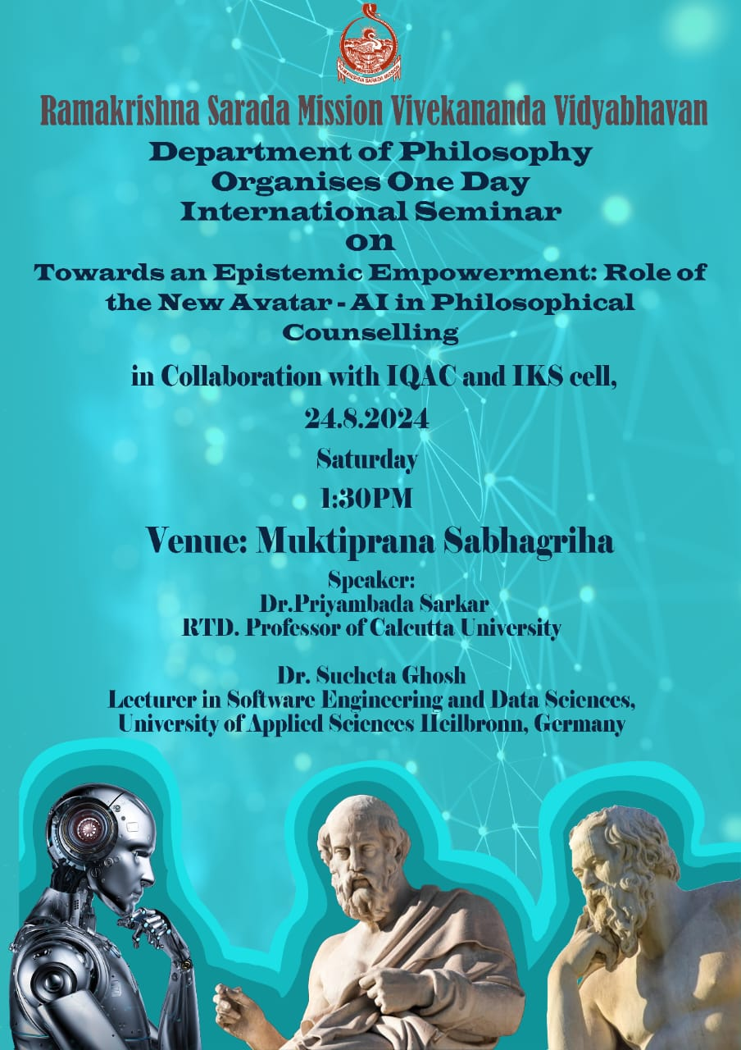

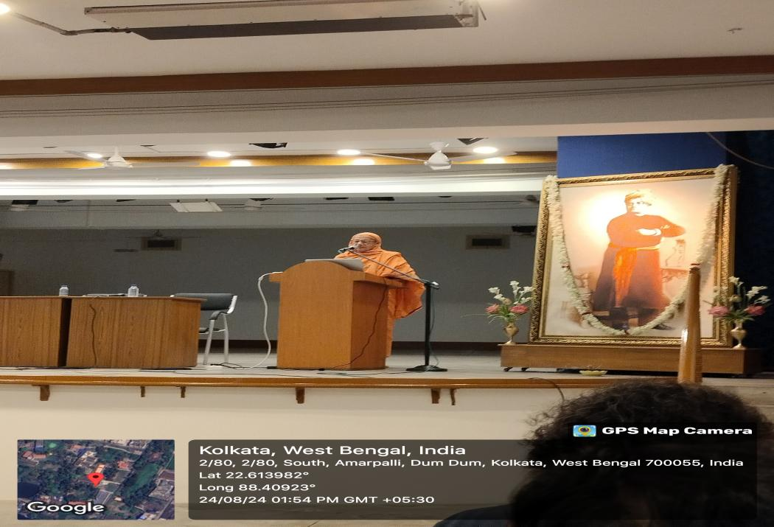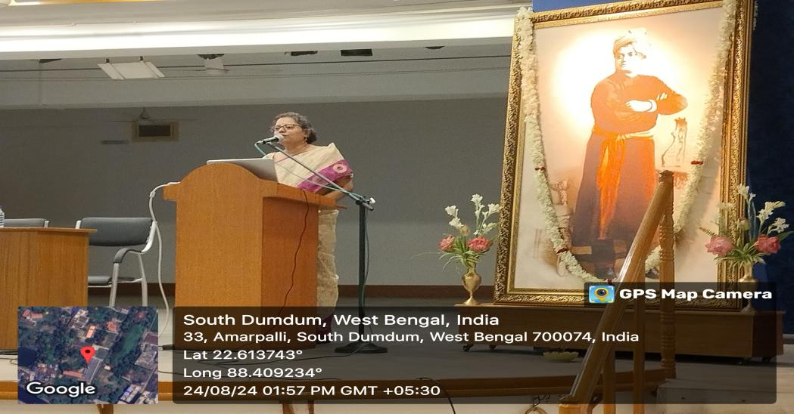
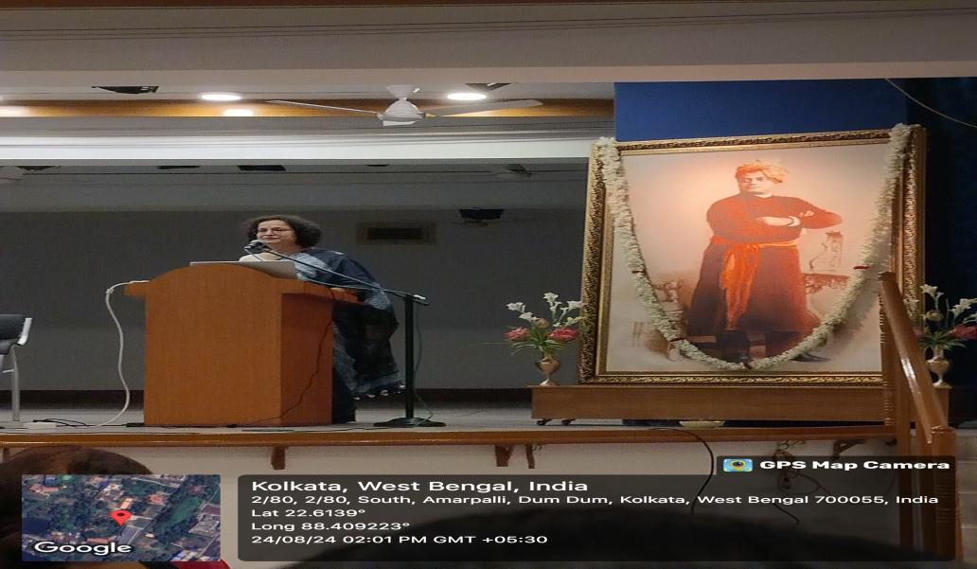
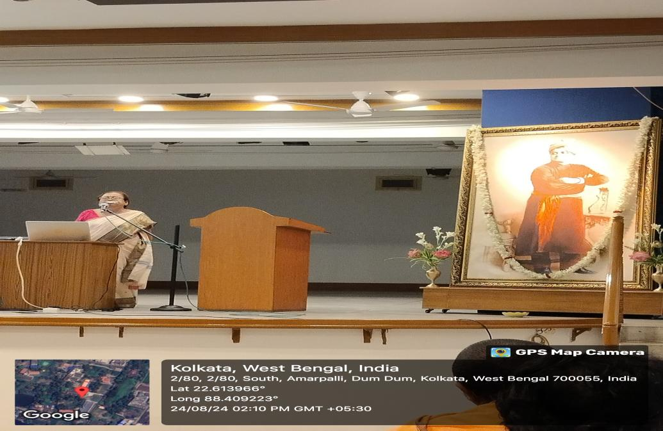
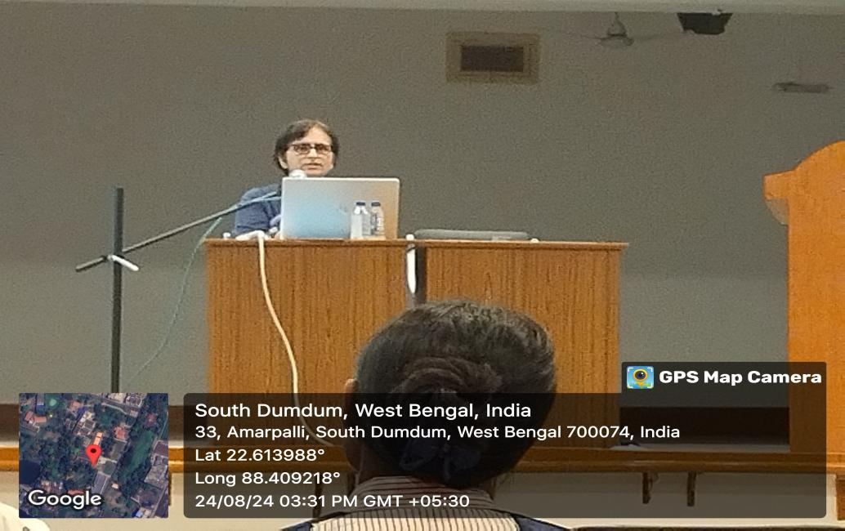

Event: Parent Teacher meeting
Date: 19.9.24
Participants: Semester VI
Brief Description: A parent - teacher meeting of Semester II UG batch was held on 19.9. 2024 to discuss the Internal assessment result and career options of the students. The strength and weakness of each of the students were discussed with the parents. Few basic university exam related issues were also highlighted in the meeting.
Outcome:
Parent -teacher meet before the commencement of the Final Semester exam is a very fruitful meeting that gives both the teachers and the parents to talk freely about the progress or problems faced by the students. The teachers can communicate the strength and weakness of each of the students on one-to-one basis.

