DEPARTMENT OF POLITICAL SCIENCE
2020-21 PROJECT REPORT

Name of the activity: Learning about Article 370
Organizing Unit: Political Science Department, RKSMVV
Brief Description of the Event:
Students of third-year honours did a project to learn about Article 370 of our Constitution related to the governance of Jammu and Kashmir. Each student made a project about the history and changes of this Article. They wrote reports on it. By doing this work, students studied deeply about Article 370.

Programme Outcome:
By making their own projects, students understood Article 370 better. They learned how-to do-good research and think carefully about delicate topics. This way of studying helped students form their own ideas about this important part of our Constitution. It also taught them how to look at big political issues in a fair way.

Name of the activity: Understanding Feminism in India
Organizing Unit: Political Science Department, RKSMVV
Brief Description of the Event:
Students of the third year did a project to learn about feminism in India. Each student researched and made a project in paper files about the history and current issues of Indian feminism. They gathered information from books and trusted sources. By doing this work and putting it all in files, students studied deeply about women's rights movements in India and the challenges women face today.

Programme Outcome:
By researching and making their own project files, students understood Indian feminism better. They learned how-to do-good research and think carefully about gender issues. This way of studying helped students form their own ideas about women's rights in India. It also taught them how to look at social issues in a fair way and think about how to make society more equal.

Name of the activity: Understanding Decentralization in India
Organizing Unit: Political Science Department, RKSMVV
Brief Description of the Event:
Students engaged in a project-based learning experience to understand decentralization in India. Each student conducted research and compiled their findings into a comprehensive project paper file. This hands-on approach allowed them to delve into the history, structure, and impact of decentralized governance in India.

Programme Outcome:
Through independent research and project development, students gained a deeper understanding of decentralization in India. The process fostered critical thinking, research skills, and the ability to analyze complex socio-political concepts. This experiential learning approach empowered students to form informed opinions on the role of decentralization in promoting good governance and citizen participation.

Name of the activity: Social Justice through Ambedkar
Organizing Unit: Political Science Department, RKSMVV
Brief Description of the Event:
Students learned about social justice by studying the ideas of Dr. B.R. Ambedkar. Each student did their own research and wrote a report about Ambedkar's life, his writings, and what he thought about making society fairer for everyone. They looked at how he helped write the Indian Constitution and how his ideas are still important today.

Programme Outcome:
By doing this project, students learned a lot about Dr. Ambedkar and his fight for social justice. They learned how to find information, think critically about it, and write about it in a clear way. This helped them understand the problems of inequality and discrimination that still exist in our society. They also learned how important it is to fight for a world where everyone is treated equally, just like Dr. Ambedkar believed.

POWER POINT PRESENTATION
Name of the activity: Netaji Subhash Chandra Jayanti Celebration 2020-21
Date:23rd January 2021
Brief Description of the Event:
Students commemorated Netaji Subash Chandra Bose's 125th birth anniversary by creating informative PowerPoint presentations on his life and contributions. The event culminated in the production of a YouTube video featuring the students' work, which was subsequently uploaded online. This initiative fostered active learning and digital content creation, allowing students to engage deeply with historical content while developing their presentation and technology skills.
Programme Outcome:
The celebration enhanced students' understanding of Netaji's role in India's freedom struggle while improving their research and presentation abilities. The creation and online sharing of the YouTube video expanded the event's reach, promoting digital literacy and collaborative learning. This innovative approach to historical commemoration fostered patriotism and technological competence among participants, aligning with modern educational goals.

Name of the activity: 200th Vidyasagar Jayanti Celebration 2020-21
Organizing Unit: Political Science Department, RKSMVV
Brief Description of the Event:
Students celebrated Ishwar Chandra Vidyasagar's 200th birthday by making PowerPoint presentations about his life and work. They focused on his efforts related to the improvement of the then society and women education. The students then turned their work into a YouTube video and shared it online.
Programme Outcome:
The celebration helped the students to learn more about Ishwar Chandra Vidyasagar. By making and sharing the YouTube video, they also learned about working with digital media. This new way of learning about history helped students to understand why social issues are important and how to use technology well.

2021-22
Name of the activity: Republic Day Celebration
Organizing Unit: Political Science Department, RKSMVV
Date:26th January 2021
Brief Description of the Event:
Students, on 26th day of January 2021 celebrated the Republic Day, the 26th January on digital platform. This online presentation with references to the Constitutional Articles of our Constitution explained the significance of the very Day as well as the pluralist characteristics of our country. They created a short video on the same which was uploaded in our departmental YouTube channel.

Programme Outcome:
The celebration helped students to understand the importance of the Indian Constitution and democracy better. By sharing their work on YouTube, students learned how to use digital media to spread knowledge. This hands-on approach to learning about Republic Day made students more aware of their rights and duties as citizens.

Name of the activity: Gandhi Jayanti Celebration 2020-21
Organizing Unit: Political Science Department, RKSMVV
Brief Description of the Event:
Students commemorated Gandhi Jayanti by creating educational videos about Mahatma Gandhi's life, philosophy, and impact on Indian independence. Working in small groups, they made a presentation focusing on different aspects of Gandhi's teachings and their relevance today. This presentation was compiled into a comprehensive YouTube video, which was subsequently uploaded and shared online. The event also included a symbolic cleanliness drive to honour Gandhi's emphasis on cleanliness.
Programme Outcome:
The celebration deepened students' understanding of Mahatma Gandhi's principles and their significance in contemporary society. Through the video-making process, students enhanced their research, collaboration, and digital presentation skills. Sharing their work on YouTube allowed them to reach a wider audience, promoting Gandhian values beyond the university. This interactive approach to commemorating Gandhi Jayanti fostered critical thinking about non-violence, social justice, and civic responsibility among participants.

2021-22
Name of the activity: Constitution Day Celebration 2020-21
Organizing Unit: Political Science Department, RKSMVV
Brief Description of the Event:
Students observed Constitution Day by creating informative videos about the Indian Constitution's key features and its relevance in modern India. Working collaboratively, they developed concise presentations explaining important articles and fundamental rights. These presentations were combined into a single YouTube video, which was later shared online. The event also included a reading of the Preamble to reinforce the Constitution's core principles.
Programme Outcome:
The celebration enhanced students' understanding of the Indian Constitution and its importance in shaping the nation's democratic framework. Through the video creation process, students improved their research, teamwork, and digital communication skills. By sharing their work on YouTube, they learned to use technology for civic education. This participatory approach to commemorating Constitution Day increased students' awareness of their constitutional rights and responsibilities as citizens.
YOU TUBE LINK: https://www.youtube.com/watch?v=df14WnAr_Ng
https://www.youtube.com/watch?v=bgF1pEwX-Us
https://www.youtube.com/watch?v=1ybN1dDPHso
https://www.youtube.com/watch?v=KoGmM1R4VEw
https://www.youtube.com/watch?v=MwJ3SWQYTH0
https://www.youtube.com/watch?v=7kOQSA6hwLo
https://youtu.be/-AYgZa_ns7g
https://youtu.be/6e9P__yCKtA
https://youtu.be/WHUUSlp5Imo
https://youtu.be/OF4FYrvs6Ng

2022-23
DEPARTMENTAL EVENTS:

DEPARTMENTAL EVENT - POSTER MAKING EVENT 25th May 2022

- Name of the activity: Poster Making Event
- Category: Departmental Activity
- Organizing Unit: Political science Department, RKSMVV
- Venue: Political science Department class room.

Brief description of the event: A successful poster making event was organized on the theme of 250th Anniversary of Raja Ram Mohan Roy, Students from every semester participated in this event.
The posters were drawn by the students of the department.

The event involved students making posters of relating to 250th Anniversary of Raja Ram Mohan Roy of India.

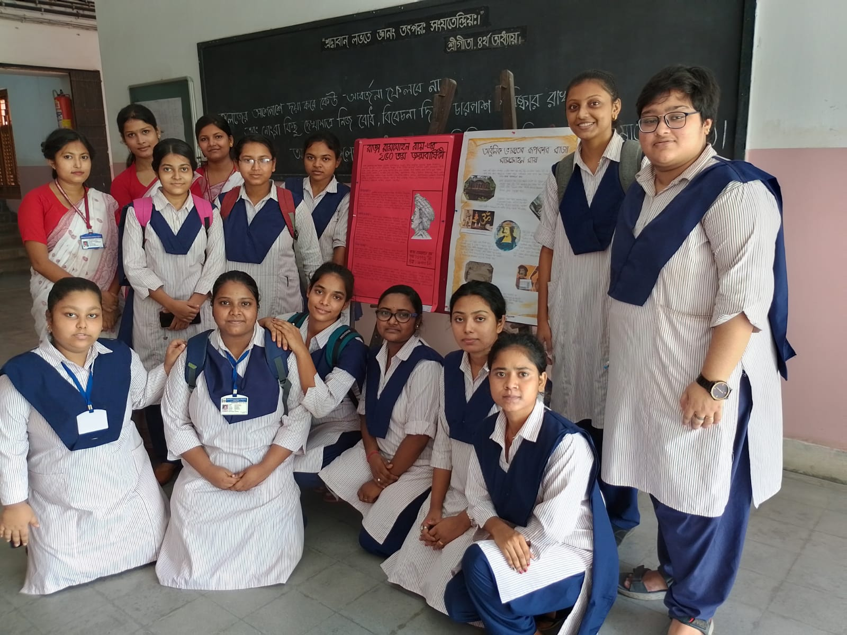
Programme Outcome: The students drew the portrait of relating to 250th Anniversary of Raja Ram Mohan Roy and his life events. The students were able to express their creativity and also came to know about the importance of Raja Ram Mohan Roy’s social reforms, events relating to his life and his important social contributions.
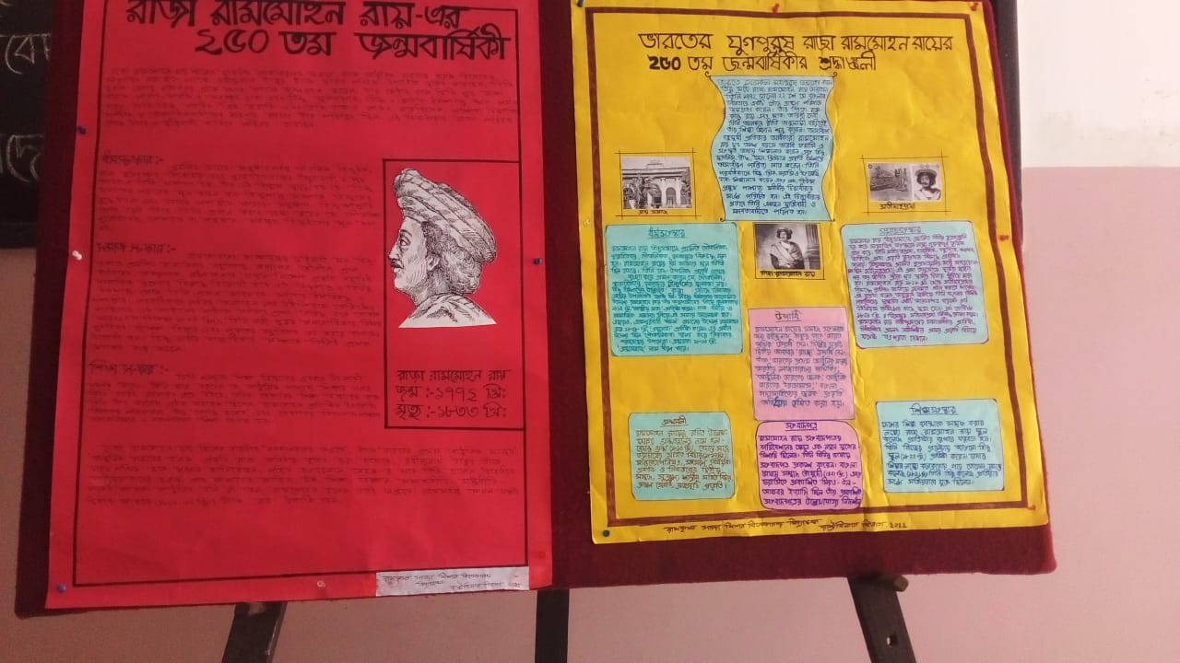

DEPARTMENTAL EVENT - CALENDAR MAKING EVENT 31st January 2023

- Name of the activity: Calendar Making Event
- Category: Departmental Activity
- Organizing Unit: Political science Department, RKSMVV
- Date: 31st January 2023
- Venue: Political science Department class room.

- Brief description of the event: A successful calendar making event was organized on the theme of important political and social events, remembering the birthday of eminent personalities relating to the particular discipline. Students from every semester participated in this event. The pictures were drawn by the students of the department.
The event involved students making pictures of various important political figures and social events.

- Programme Outcome: The students drew the portrait of various important political figures and also drew pictures relating to certain political and important social events of history. The students were able to express their creativity and also came to know about the importance of certain social and political events that happened in history.

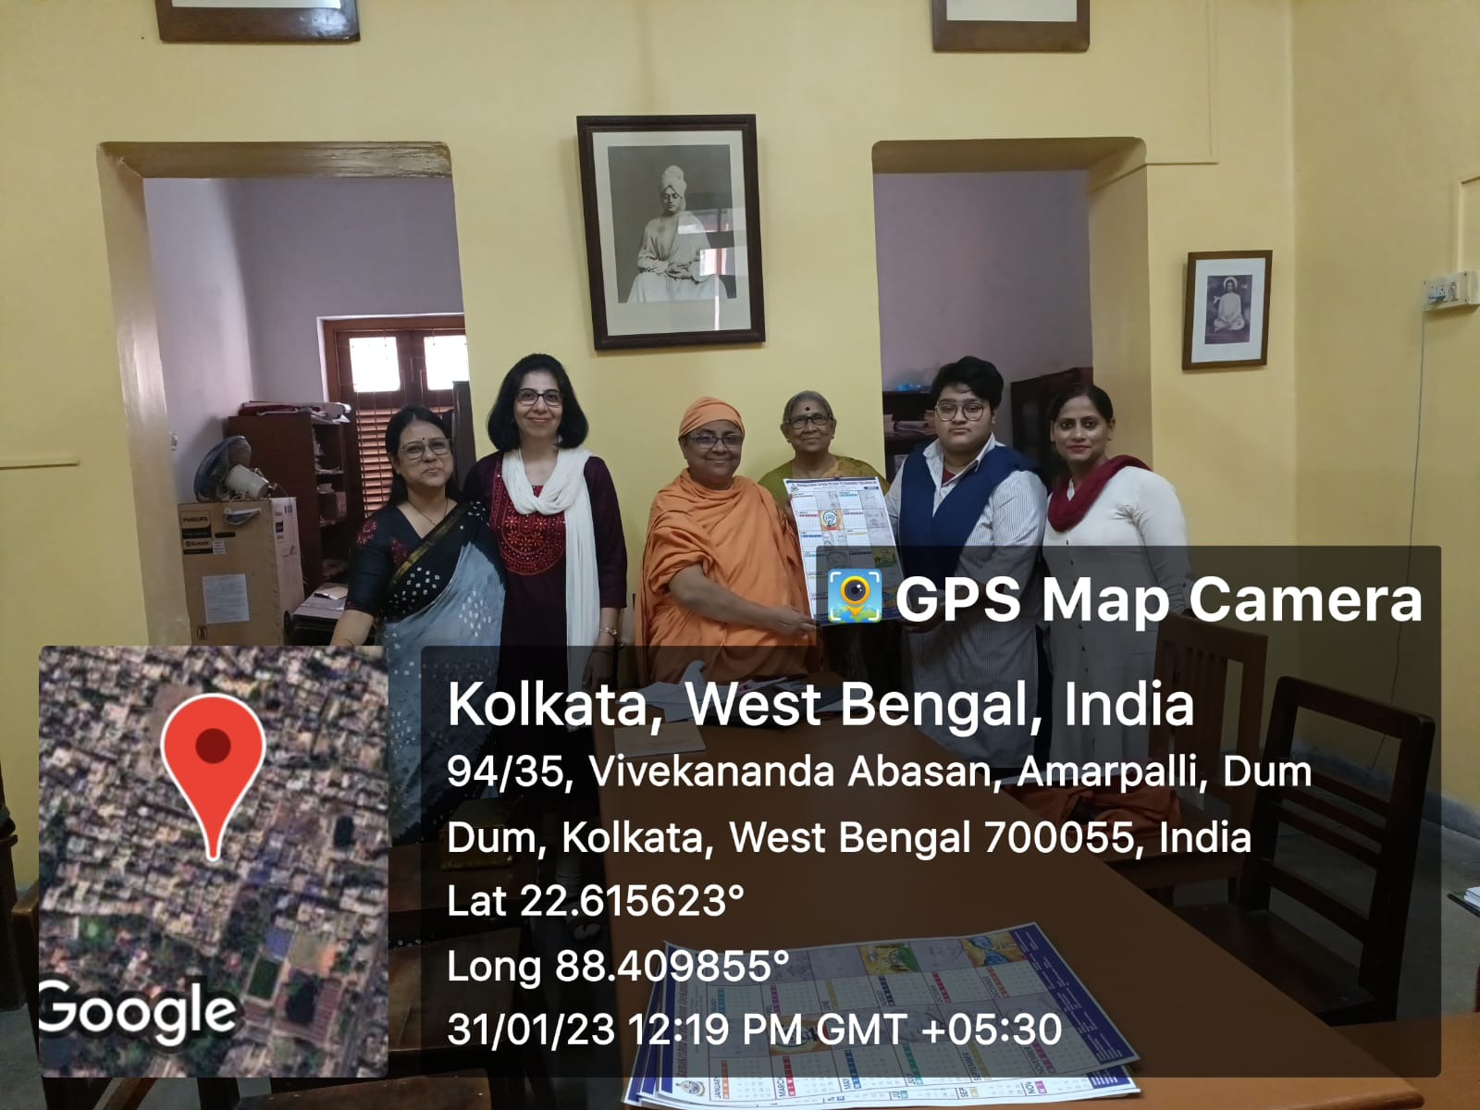

EXCURSION 2018-19

To study the political and social history, urban geography and cultural heritage of Kolkata. The trip helped sensitize the students about the imperial designs of the British.

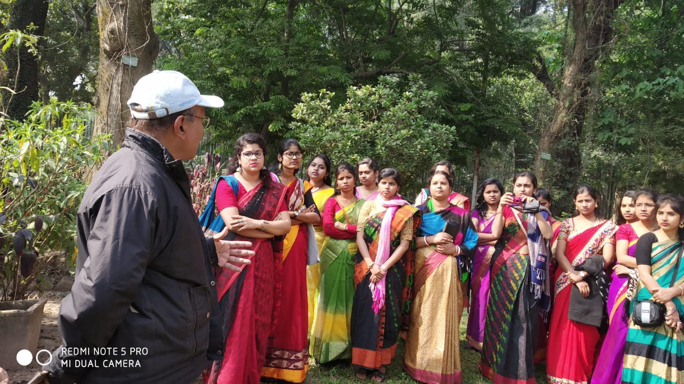
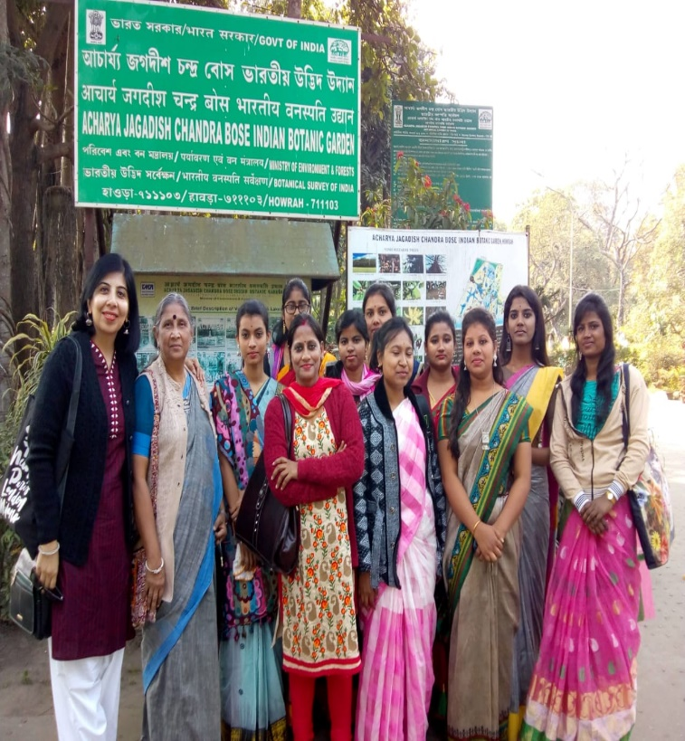

EXCURSION 2020

Category: Excursion
Topic: Educational Tour
Organizing Unit: Department of Political Science
Date: 23.12.2022
Time: Whole Day
Number of Students: 20
Number of Resource Person: 4
Number of Beneficiaries: 20

Brief Description: In 2020, we took our students on a tour to some of the landmarks of the city. This gave them an awareness about the importance of Kolkata as the colonial capital till 1911 and its continuing significance as the cultural capital of India.

Educational excursions not only enhance the knowledge of the students but also broaden their outlook towards the outside world. It is for this reason the department took the initiative to take the students for a day long study tour around the city on 16th January 2020. The places covered were Town hall, High court, New Market, Kolkata Municipal Corporation, Senapati Bhavan, Eden gardens, Akashvani Bhavan, National Museum, Nabanna, Vidyasagar Setu, Princep Ghat, Vivekananda House, College Street area. As most of the students of our department were from remote areas of Bengal, the tour helped them to know the city of Kolkata where they came for higher education.
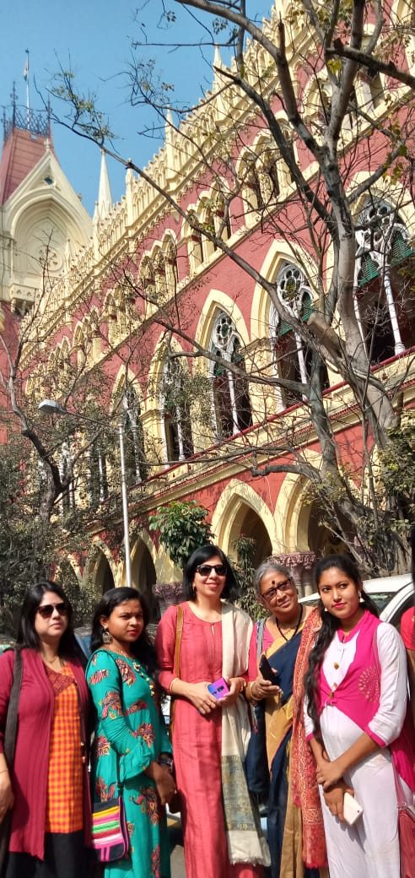
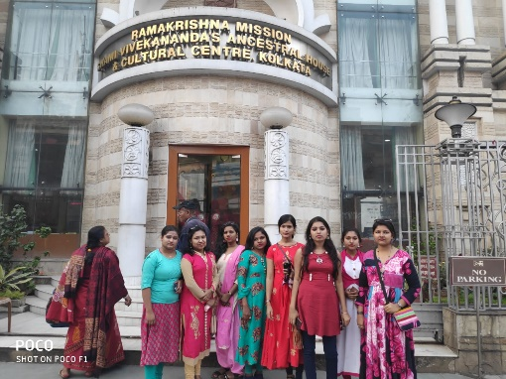
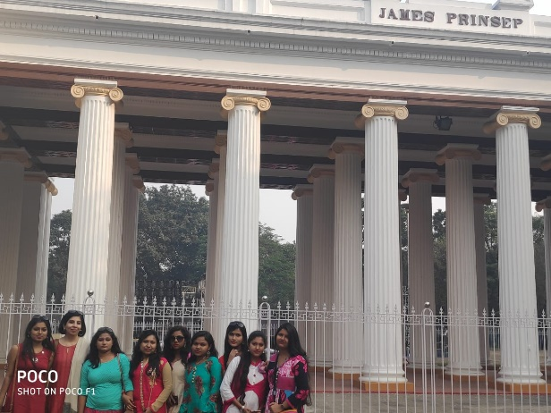

Excursion tour to Eco Park 2022

Category: Excursion
Topic: Educational Tour
Organizing Unit: Department of Political Science
Date: 23.12.2022
Time: Whole Day
Number of Students: 20
Number of Resource Person: 4
Number of Beneficiaries: 20

Brief description of the event: Every year the students are taken to a place of their interest both for educative and entertainment purposes. The places are not always located very far and since there are residential students who must return by a given time to the hostel, we take the students to nearby tourist destinations that have recently come up or old locations as per convenience.

The department, with students of three semesters and four full-time faculty members, went on its annual excursion on 23rd, December 2022. They were taken to New Town which is situated in the North Eastern Fringes of Kolkata and is fast emerging as one of India’s latest and fastest-growing planned new cities. It is situated adjacent to Salt Lake City and is close to the Netaji Subhas Chandra Bose International Airport, Kolkata. The students were first taken to the Indian Coffee House, which is built as a replica of the traditional Indian Coffee House of College Street where they had a cup of coffee to begin the day with. They were then taken on a tour of Mother's Wax Museum and the students were quite amused with the replica of eminent personalities in wax statues. The next stop was the Eco Park. This is a large recreational area for activities like picnics, boating, and cycling. This place also boasts of hosting the miniature formations of the Seven Wonders of the World. The students were given an extensive tour to develop exposure to what they are. This is also where the group sat for a hearty lunch. The new zoo of New Town - Harinalaya was the ultimate stop of the day. The students ended the day on a happy note sighting animals and went back home rejuvenated.
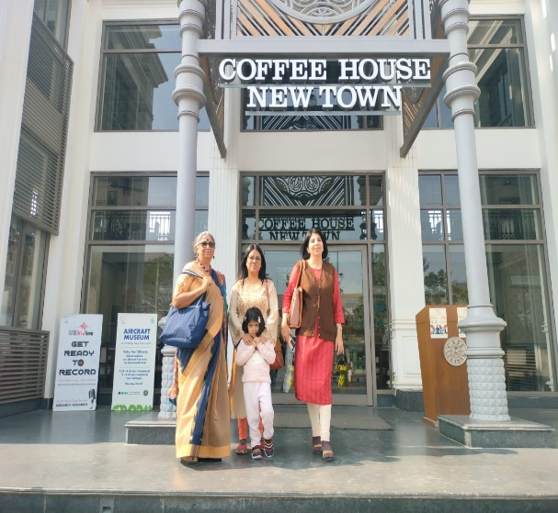
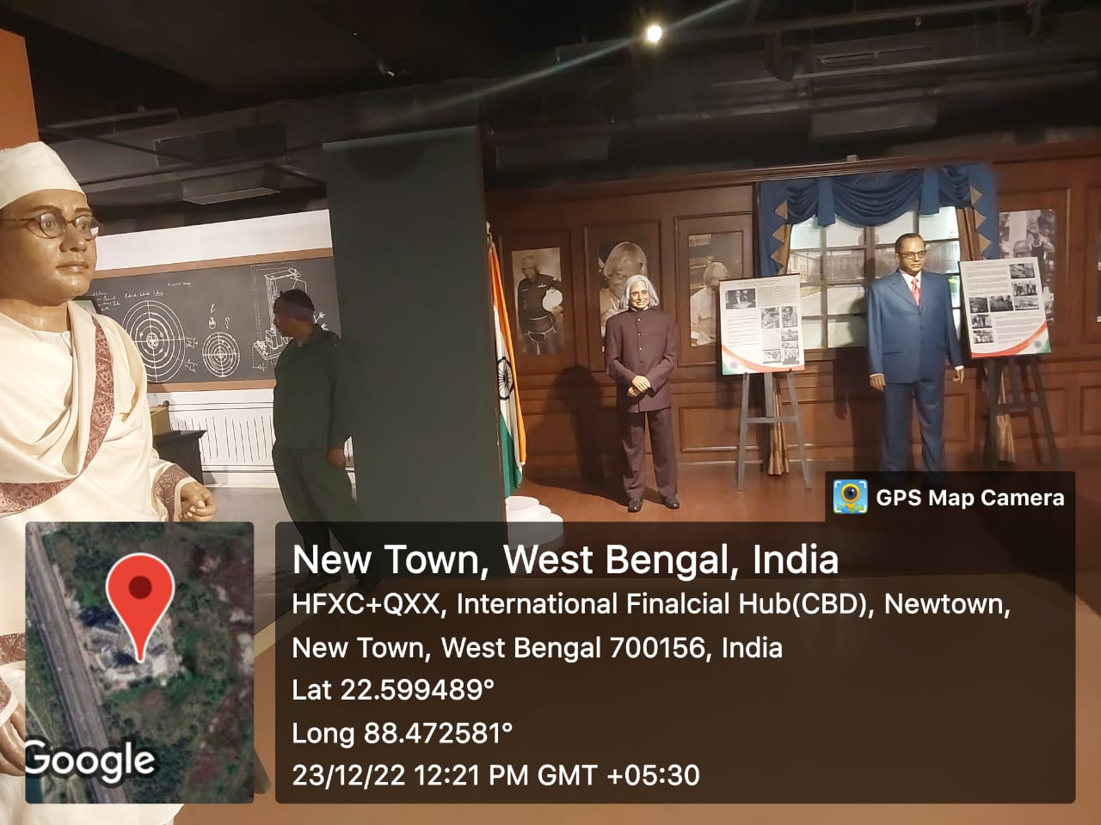

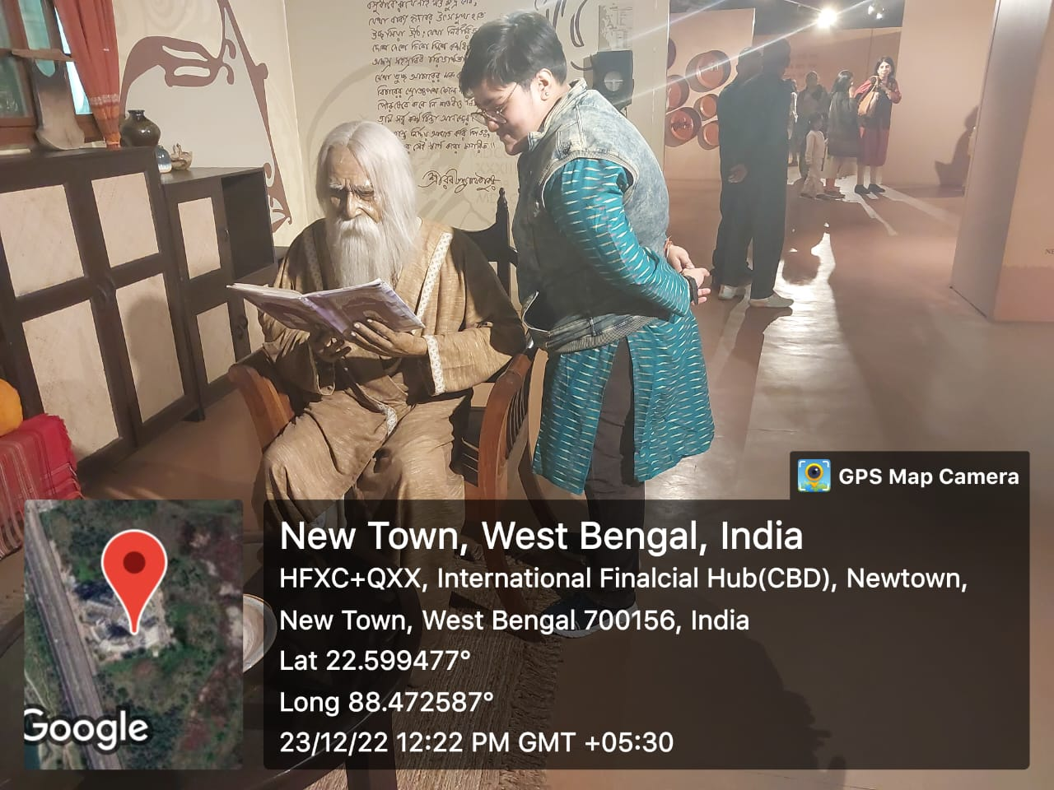

Excursion tour to Birla Planetarium, Victoria Memorial, Hogg (New Market) 2023

Category: Excursion
Topic: Educational Tour
Organizing Unit: Department of Political Science
Date: 19.12.2023
Time: Whole Day
Number of Students: 20
Number of Resource Person: 4
Number of Beneficiaries: 20
Brief description of the event:
Our recent excursion to Birla Planetarium, Hogg (The New Market), and Victoria Memorial was a mix of science and history. Birla Planetarium, like a space hub, taught us about the universe and made us curious about science. Hogg (The New Market) showed us Kolkata's old buildings and busy markets from the colonial times. Victoria Memorial, with its mix of Indian and British styles, had lots of old things and sights to see. We learned about Kolkata's past, how it changed, and connected with the city's history. This trip wasn't just about science—it also made us understand Kolkata's story better.

Programme Outcome:
This recent journey to Birla Planetarium, Hogg (The New Market), and Victoria Memorial proved transformative. Birla Planetarium sparked scientific curiosity, unraveling scientific wonders. Hogg, a colonial-era marketplace, showcased historical architecture and vibrant market life. Victoria Memorial, an architectural gem, narrated Kolkata's colonial past. This tour seamlessly merged scientific exploration with a deep dive into the city's history, significantly enriching students' knowledge. The immersive experience heightened awareness, fostering a holistic understanding of Kolkata's heritage—bridging the realms of science and history in a compact and impactful educational endeavour.

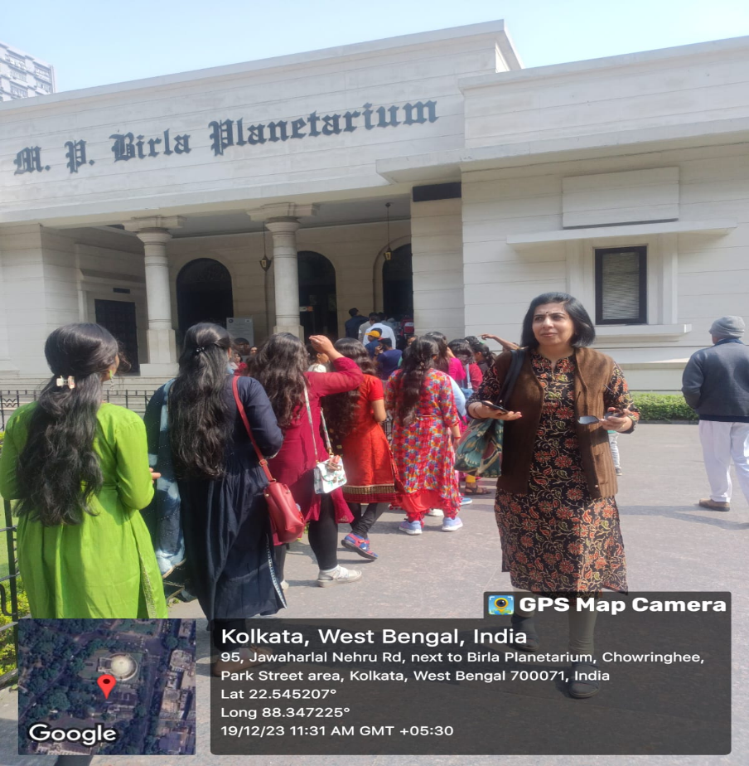

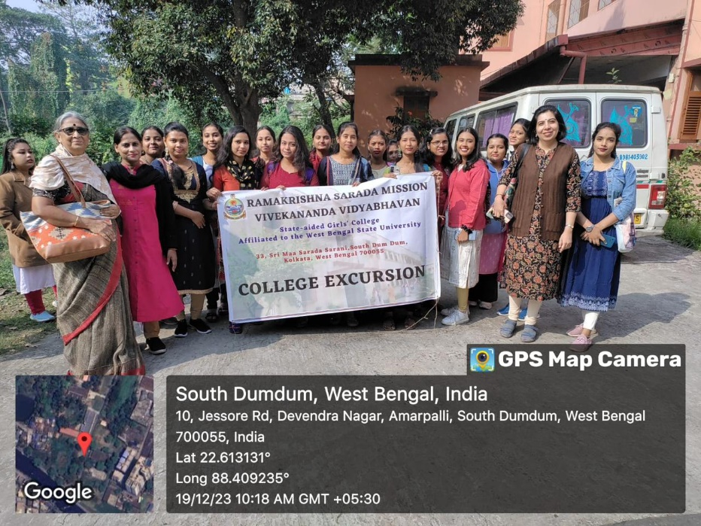

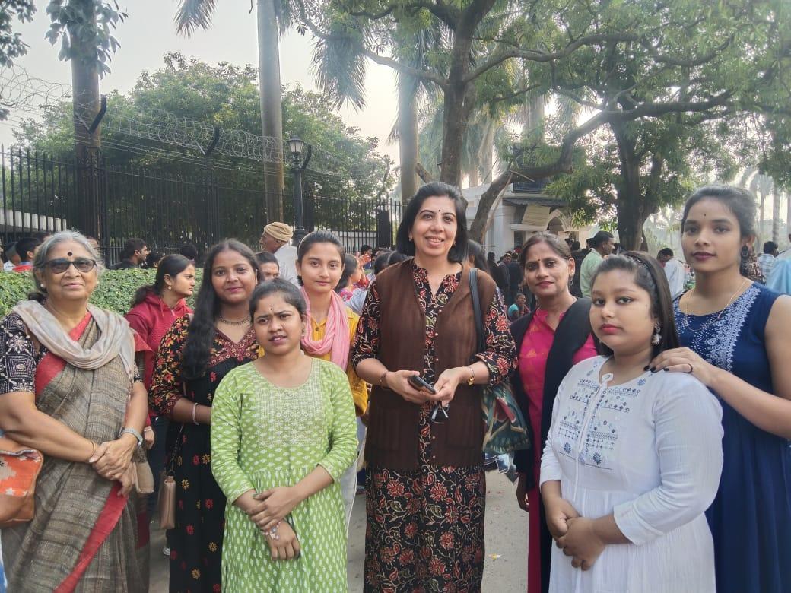

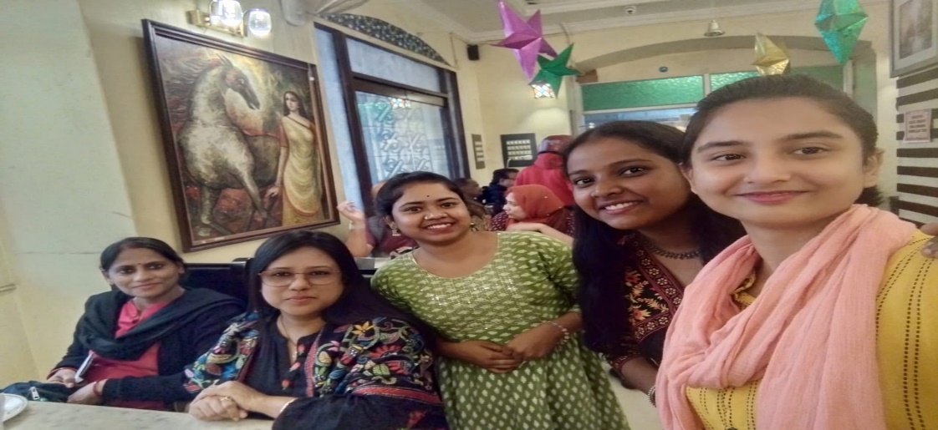
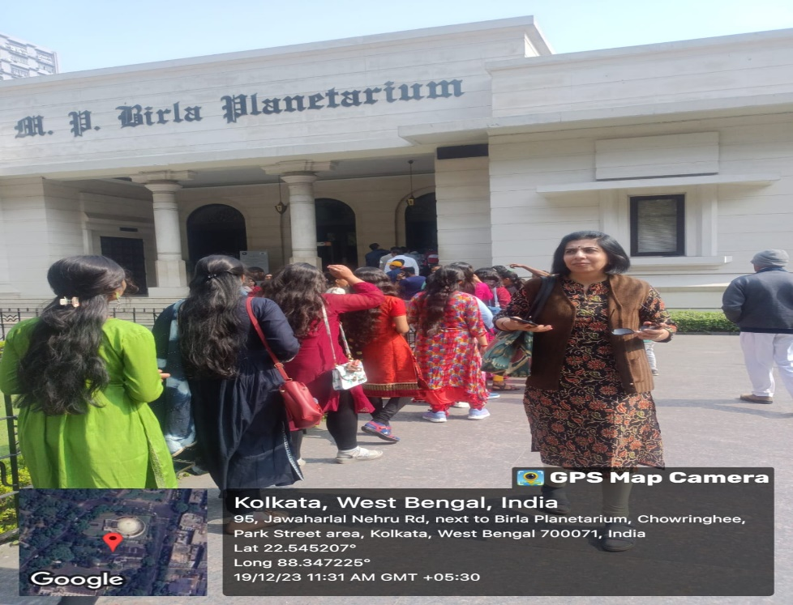

BOOK FAIR VISIT REPORT

Event: Book Fair Visit by College Students
Category: Educational/Cultural
Organizing Unit: Department of Political Science
Date: 31.01.24
Venue: Central Park, Salt Lake, Kolkata
Event Summary:
On 31.01.24, students from our college attended a meticulously organized visit to the esteemed International Book Fair at Central Park, Salt Lake, Kolkata. The outing aimed to cultivate a passion for literature, cultural appreciation, and intellectual exploration among the student body.

Outcomes:
The Book Fair visit facilitated a profound educational experience, broadening students' literary horizons and nurturing their cultural awareness. By engaging with diverse literature, students enhanced critical thinking skills and empathy, contributing to their overall intellectual growth.
The visit exemplified College's commitment to providing students with enriching experiences that open traditional classroom boundaries, preparing them to navigate a global society with insight and understanding.

