**Event Report**

**Department of English**

1. 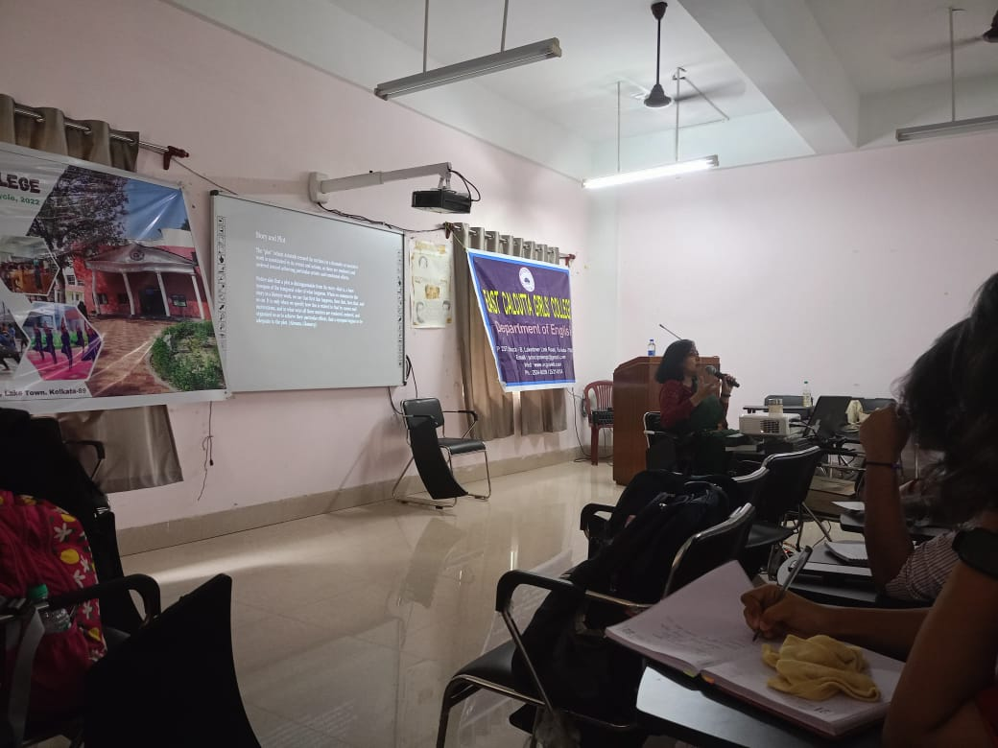**Name of the Event**- Seminar at East Calcutta College

**Organized by** – East Calcutta Girls’ College

**Category**- Seminar

**Date**- 30.07.2024

**Venue –** East Calcutta Girls’ College

**Resource Person**- Dr. Gargi Gangopadhayay, Assistant Professor RKSMVV

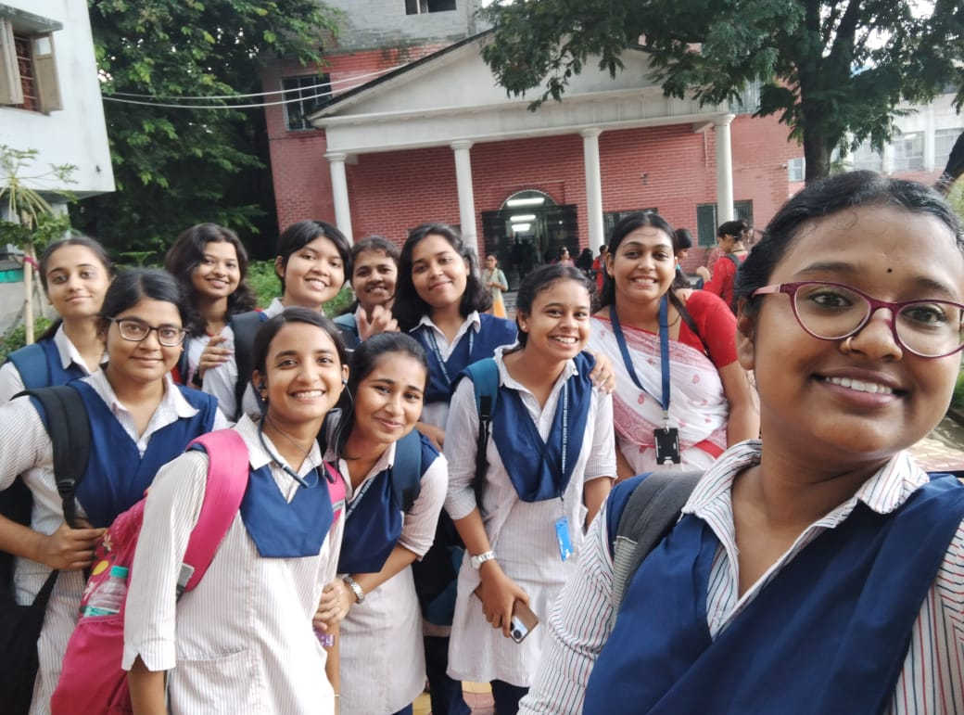**Brief Description of the Event** – On the occasion of celebrating Emily Brӧnte’s 206th birthday, the English department of East Calcutta Girls’ College invited Dr. Gargi Gangopadhyay, Assistant Professor, Ramakrishna Sarada Mission Vivekananda Vidyabhavan to deliver a lecture. Second semester students from the department of English, RKSMVV also attended this seminar. The Head of the Department from East Calcutta Girls’ College inaugurated the seminar with a brief introductory talk, addressing the literary significance and relevance of Emily Brӧnte. Students decorated a wall magazine for display. An academic paper was also presented by the student of the department of English, East Calcutta Girls’ College.

**Outcome**- Participation of the students in the seminar ensured their academic exposure. It encouraged them to be more academically resourceful.

**Number of Participants**- 13

**2. Name of the Event** - Farewell and Freshers’ Welcome

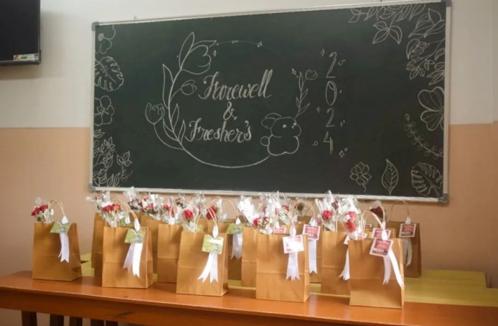**Organizing Unit** – Department of English

**Category** - Cultural

**Date** – 29.06.2024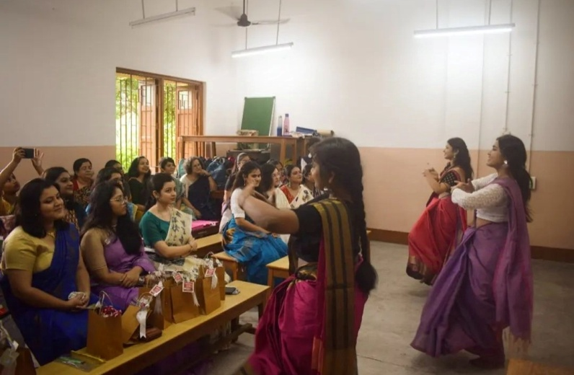

**Venue**- Room 16 **Brief Description of the Event** – On 29th June, students of the Department of English, RKSMVV, officially bade adieu to the third year students and welcomed the freshers, the first year students through a cultural event. The event was marked by some heartfelt moments and memorable cultural performances by the students. It featured solo and group dance performances as well as soulful musical renderings by the students. The event concluded with cutting cakes and having some refreshments. A photo session wrapped up the event, leaving everyone with memories to cherish.

**Outcome**- The event encourages students to present their co-curricular activities. This also helps in developing their creative, interactive and leadership skill set, as they are required in organizing an event.

**Number of Participants**- 30

**3. Title** - Strands and Waves of Feminism

**Category** – Extension Lecture

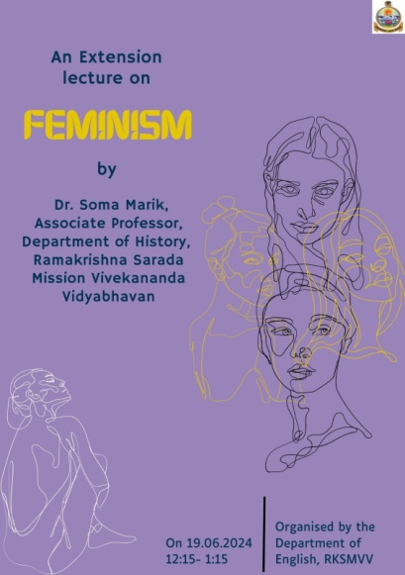**Organizing Unit**- Department of English, RKSMVV

**Resource Person** – Dr. Soma Marik, Associate professor, Department of History, RKSMVV

**Date** – 19.06.2024

**Time**- 12:15- 1:15 pm

**Venue** – Room no. 16

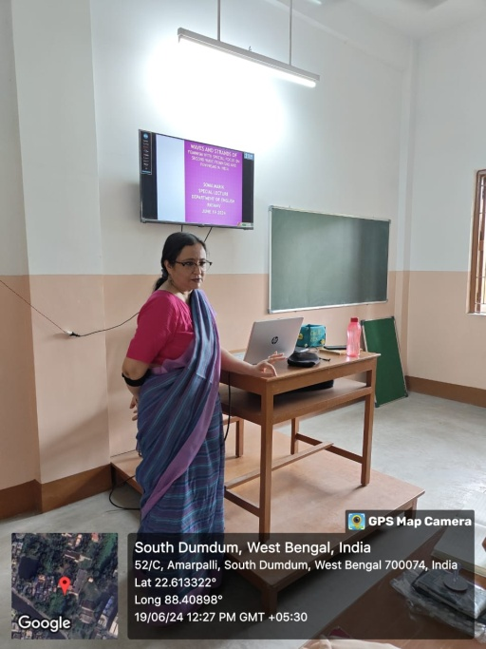**Brief Description of the Event** - Dr. Soma Marik began her lecture acquainting the students with the contributions of Mary Wollstonecraft, one of the significant figures associated with Feminism. Her lecture focused on the waves of feminism starting from 1848. She explained how the ideologies of Feminism evolved significantly with each waves. Consequently her lecture extensively revolves around the eminent figures of Feminism and their contributions such as Simone de Beauvoir, Lucretta Mott and Gloria Marie Steinem.Dr. Marik also talked about the various organizations and movements of feminism like National Organization for Women, Women’s Action, Alliance movement.Furthermore she also distinguishes the differences existing in the various strands of feminism - liberal, radical and socialist feminism.She referred to the psychoanalytical feminism as discussed by Ellen Willis and Firestone. Additionally she shared her own experiences as an activist pointing out the possibility of extending the spectrum of feminism in practice. She concluded her lecture by with the significant figures of Indian feminism and their contribution starting from Savitri Bai Phule, and Fatima Sheikh.

**Outcome** - Students found the lecture not only interesting and engaging but also insightful. Apart from widening the theoretical concept of Feminism, it also facilitated the students’ academic need.

**Number of Participants** – 17

**4. Title** – Marxism: Some Basic Concepts

**Category** – Extension Lecture

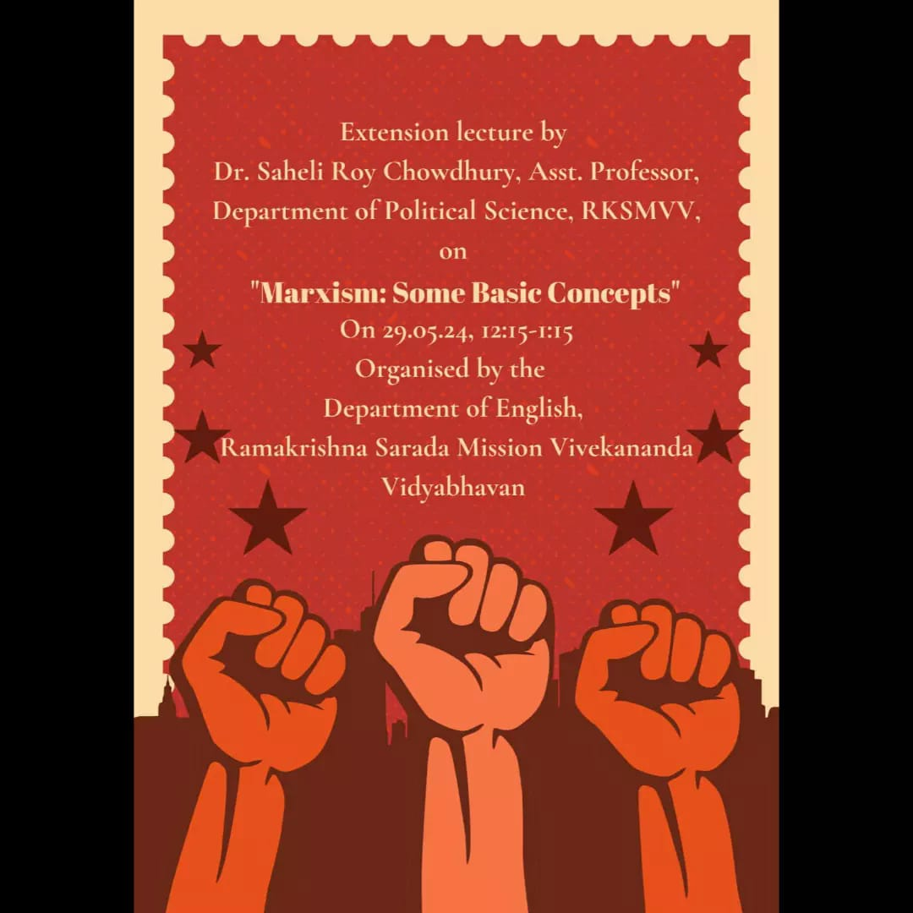**Organizing Unit** – Department of English, RKSMVV

**Resource Person** – Dr. Saheli Roy Chowdhury, Assistant Professor, Department of Political Science, RKSMVV

**Date**- 29.05.2024

**Time** – 12:15-1:15 PM

**Venue** – Room no. 8

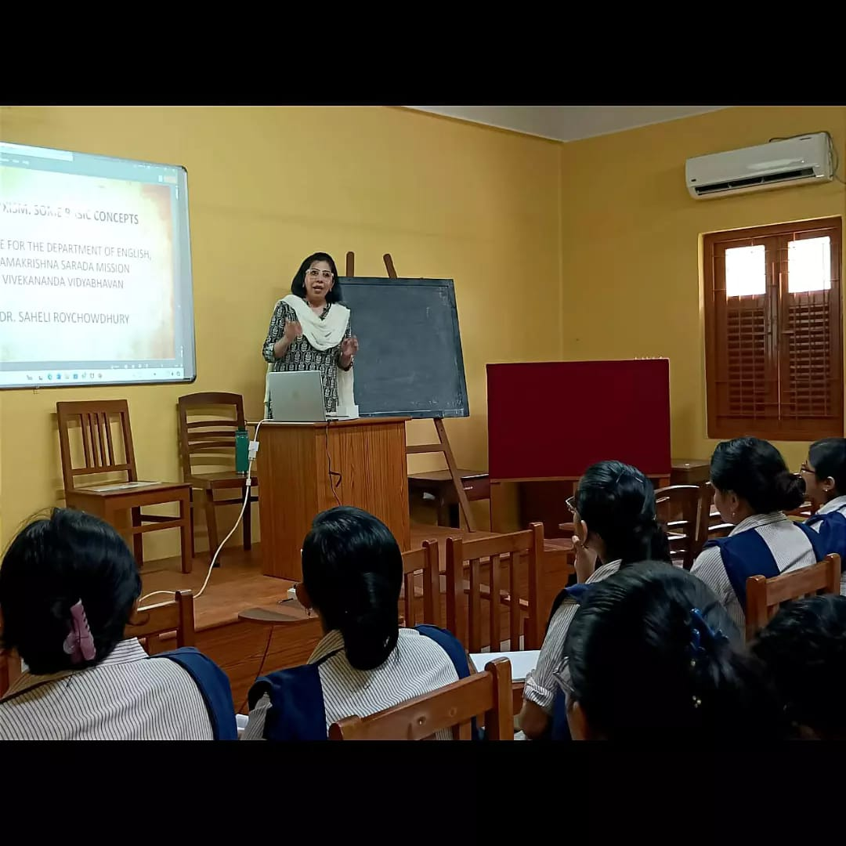**Brief Description of the event** – On 29th May, the Department of English organized an extension lecture for the undergraduate students of semester IV and VI. Dr. Saheli Roy Chowdhury, Assistant Professor, Department of Political Science, RKSMVV began her lecture by introducing the students with the fundamentals of Marxist theory, such as “base and superstructure”and the dynamics between the “haves and have- nots”. Her discussion included various forms of Marxist criticisms such as: “Leninist Marxism”, “Vulgar Marxism”and “Engelsian Marxism”. Dr. Roy Chowdhury extensively elaborated on the topic of Russian formalismfocusing upon some influential figures like Jakobson, Bakhtin, Gramsci, Althusser. Additionally, she explained about the ideals of the aforementioned figures and enlightened the students about the concepts of “Rule versus Hegemony”, “Defamiliarization”, “Interpellation” and the two kinds of “Apparatuses”.

**Outcome**- The students are grateful since the lecture enabled them to obtain a critical perspective, learn the intricate details of the theoretical concepts and improve their overall comprehension and preparation for the upcoming end semester examination.

**Number of Participants** – 18

**5. Title** – Celebrating the legacy of Shakespeare - “Puck’s Party: A Midsummer’s Day’s Festival”

**Category** – inter-college competition

**Organizing unit** – Department of English

**Venue** – AV Room, College Auditorium

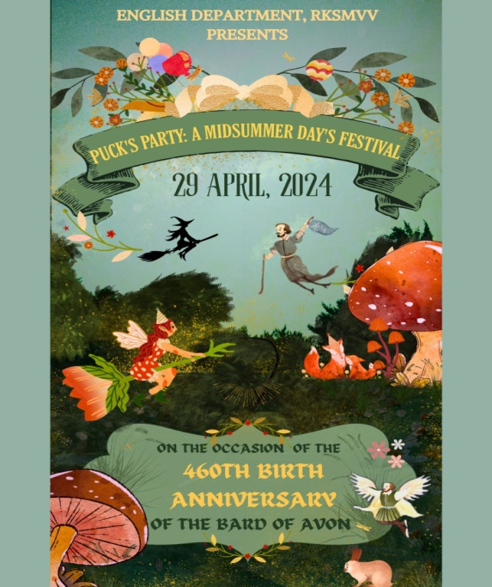**Date** – 29.04.2024

**Time**- 10:15 am – 3:30 pm

**Resource person** - None

**Brief Description of the event** –

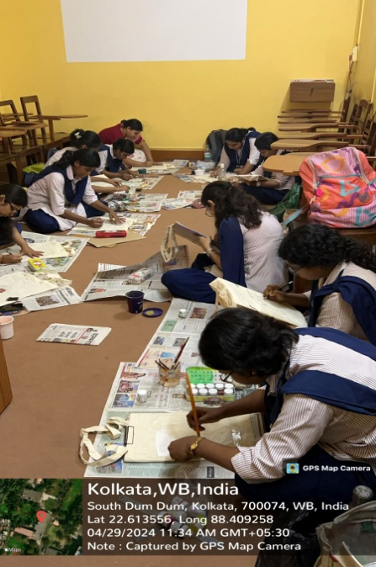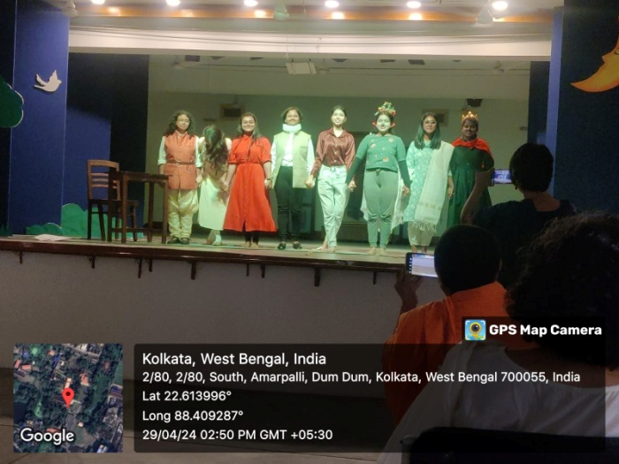The English Department of Ramkrishna Sarada Mission Vivekananda Vidyabhavan celebrated the 460th birth anniversary of Shakespeare on 29th April, 2024. Several competitions on different categories such as – short story writing with a prompt (“Quills and Quirks”), poster making (“The Bard in Brushstrokes”) were held online. Students from other colleges submitted short stories and art works too. The day comprised a host of fun-filled activities since the students enthusiastically participated in a number of competitions held offline, such as tote bag painting (Tote-Ally Shakespeare), and skit competition (Spotlight on Shakespeare). Students of the English Department also presented a play named “Alice in Puck's Land”, both written and enacted by them.

**Programme Outcome** –

The event allowed the students to explore their creative side, where they could apply their academic knowledge both passionately and innovatively. Their presentation of dramatic performance, imaginative poster, or short-story writing enabled them to interpret Shakespeare in an unconventional manner, both connect and understand his works on a deeper level.

**Number of Participants** - 32

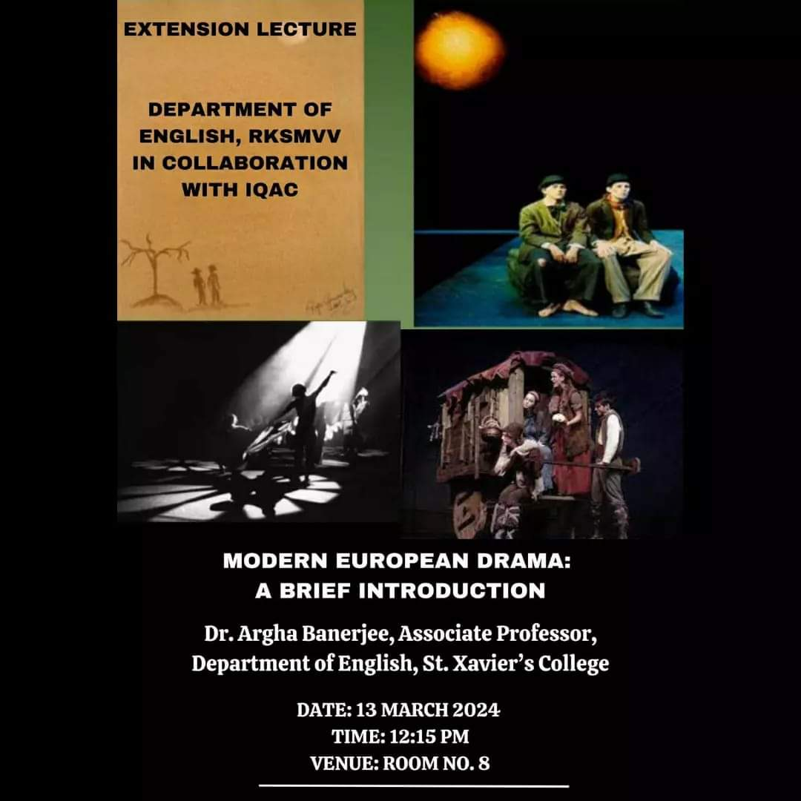**6. Title** – Modern European Drama: A Brief Introduction

**Category** – Extension Lecture

**Organizing unit** – Department of English, RKSMVV in Collaboration with IQAC

**Resource Person**- Dr. Argha Banerjee, Associate Professor, Department of English, St. Xavier’s College

**Date**- 13.03.2024

**Time** – 12:15PM

**Venue** – Room no. 8

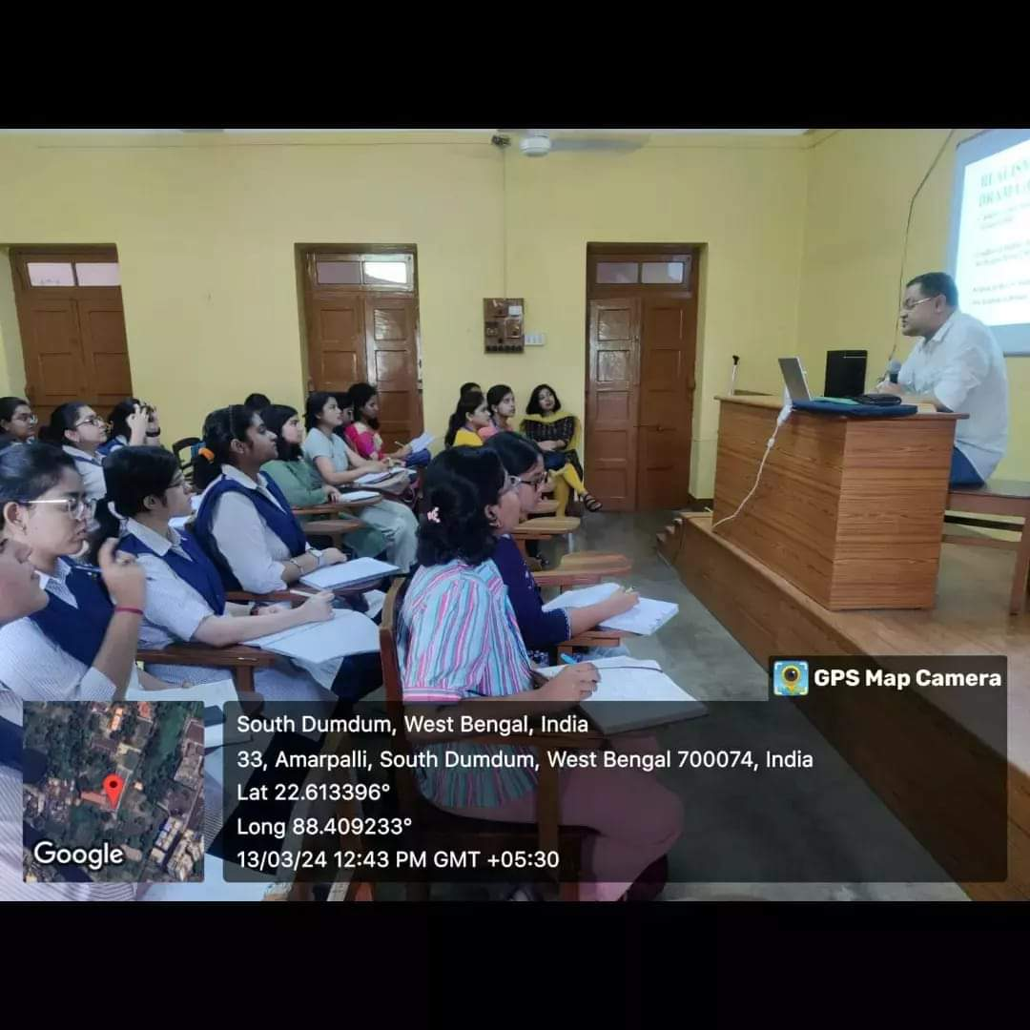**Brief Description of the event**- Dr. Banerjee introduced the students with the context of **2**0th century European drama crucial for the uninitiated students to comprehend its distinct style, and unique features. He outlined the chronological timeline from 1859 (the year Darwin’s Origin of Species was published) to 1962 (Theatre of the Absurd) mapping the evolution of Modern European drama. A significant part of his lecture dwelled on the transition of Modern drama from realistic style of theatrical representation till Brecht’s Epic Theatre. He elucidated many significant terms related to modern theatre, discussed at length the characteristic features of the

theatre of Absurd, with specific examples from texts. He ended the broad arena of Modern European Drama with a discussion on Bertolt Brecht’s Epic theatre.

**Outcome**- The CBCS syllabus has a major section comprising four plays on modern European drama. For the Semester VI Students, this lecture was invaluable since it offered a comprehensive study of the Modern European drama from beginning to end. Students learnt the intellectual context that connects each playwright and his school of drama in terms of similarities or difference.

**Number of Beneficiaries –** 17

7**. Title** – An Introduction to Postcolonial Theory

**Category**- Extension Lecture under Global Engagement Programme

**Resource Person** – Dr. Madhuchhanda Mitra, Professor at St. John's University, Minnesota, USA

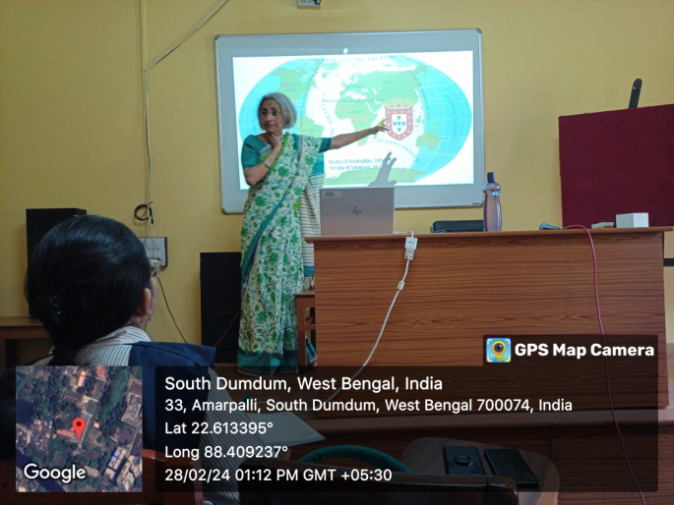**Organizing Unit** – English Department

**Date** – 28.02.2024 & 01.03.2024

**Time** – 12:30 pm

**Venue**- AV Room

**Brief Description of the Event** – The Department of English organised an extension lecture in two parts for the undergraduate students of semester IV and VI on 28th February and 1st of March, 2024.

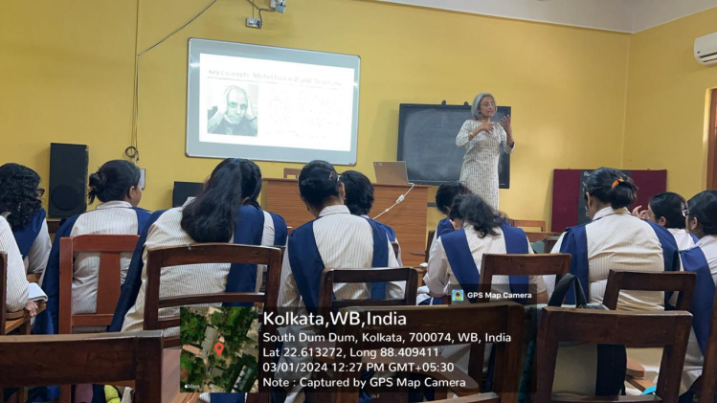 The lecture began with the introduction of the term “Postcolonialism”followed by a brief discussion of the history of European colonization. The lecture explored Karl Marx’s theory of colonialism and the critical perspectives of two eminent figures of Negritude movement Aimé Césaire and Frantz Fanon. The lecture also included a through elucidation of some of the significant theoretical terms, such as – Imperialism/Empire, Decolonization, Anti-colonialism and Neocolonialism***.***

On the second day of the lecture***,*** some excerpts from the Introduction of *Orientalism* by Edward Said was shared to explain the students the power of language and the differences between the imaginary East and West.The lecture also focused on some of the distinguished theorists and their critical works such as Gramsciand Althusser and theirdifferent critical concepts of hegemony. The lecture concluded with a brief reference to Gayatri Chakravarty Spivak’s essay on “Can the Subaltern speak?”and a brief discussion on Bhabha’s mimicry.

**Outcome** – The lecture has been productive since the students participated actively after the lecture regarding their queries. It would immensely help them to prepare the particular sections of their curriculum for their upcoming exams.

**Number of Participants** – 17

**8. Title** – Global Engagement Programme on Joseph Conrad's "Heart of Darkness"

**Category -** Global Engagement Programme

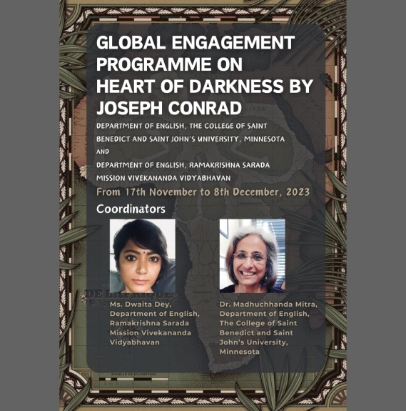**Organizing Unit** – Department of English, RKSMVV in collaboration with Department of English, The College of Saint Benedict and Saint John’s University, Minnesota.

**Date** – 17.11.2023 to 08.12.2023

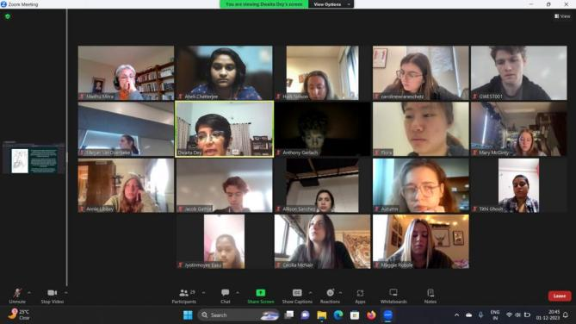**Venue** – Virtual

**Resource Person** – Ms. Dwaita Dey, Department of English, Ramakrishna Sarada Mission Vivekananda Vidyabhavan & Dr. Madhuchhanda Mitra, Department of English, The College of Saint Benedict and Saint John’s University, Minnesota

**Brief Description of the Event** – The Department of English at RKSMVV organized a Global Engagement Programme on Joseph Conrad's "Heart of Darkness" in collaboration with St. John’s University and the College of Saint Benedict, Minnesota. This initiative brought together students from diverse backgrounds and geographies to explore varied interpretations of the same literary text.

**Outcome** – The endeavour provided an enlightening and exciting opportunity for students to broaden their perspectives beyond the confines of the traditional classroom curriculum.

**Number of Participants** -27

**9. Title** - "Modernism: An Introduction"

**Category** – Extension Lecture

**Organizing Unit** – Department of English

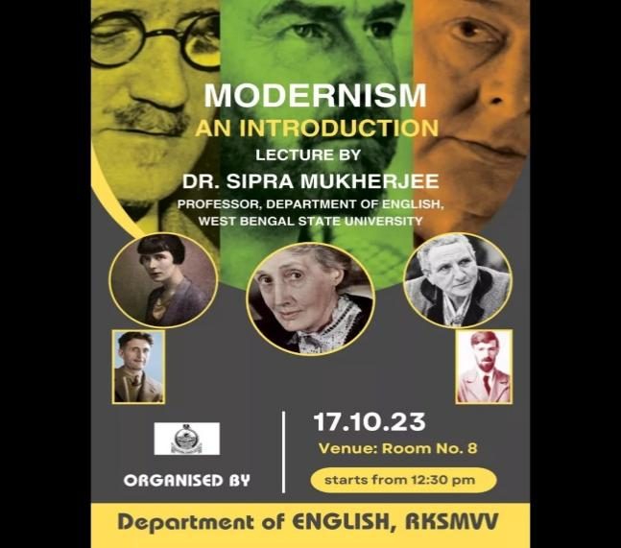 **Date** – 17.10.2023

**Time** – 12:30 pm

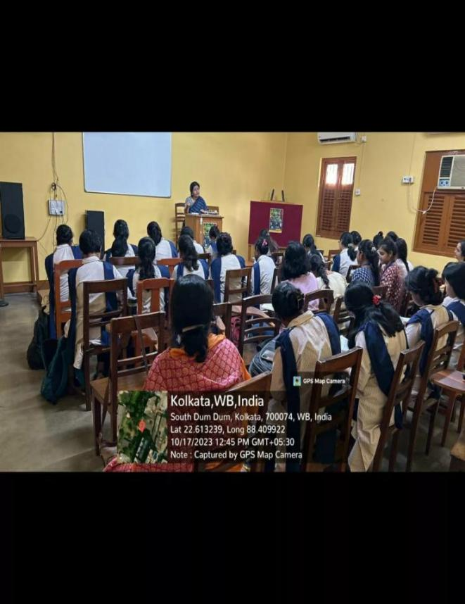 **Venue** – Room no. 08

**Resource Person** - Dr. Sipra Mukherjee, Professor, Department of English, West Bengal State University

**Brief Description of the Event** - The extension lecture primarily focused on Modernism as a literary movement. The lecture illustrated the impact of First World War on the Modernist authors, and their changing ideologies as response to the disillusionment caused by War. A number of students from other colleges also attended this lecture.

**Outcome** – Dr. Mukherjee’s engaging and insightful lecture enabled the students to understand the unique style of Modernist authors who were known for their innovative and experimental works.

**Number of Participants** – 45

10.  **Title** – attend the movie show of Barbie

**Category** – Beyond classroom activity

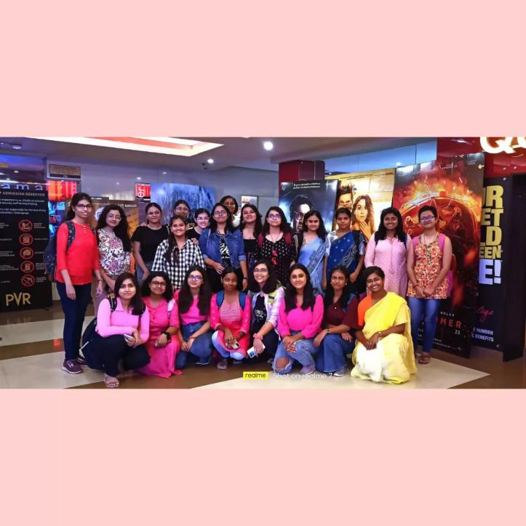**Organizing Unit** – Department of English

**Date** – 08.08.2023

**Resource Person** – None

**Venue**- movie theatre

**Time** – 4:30 – 6:00 pm

**Brief description of the even**t - The English Department of RKSMVV had the pleasure of attending a screening of the Barbie movie, directed and co-written by Greta Gerwig, starring Margot Robbie and Ryan Gosling as Barbie and Ken. The film artfully celebrates and deconstructs a beloved pop culture icon. Employing satire, it takes on themes of patriarchy, misogyny, and pseudo-feminism, all set against a whimsical and sparkling pink backdrop.

**Outcome**- The students got the opportunity to observe and note how the ideas of genuine equality are actually governed by gender norms. They received the first hand experience of recognizing the critical implications of gender being constructed along the line of power-dynamics.

**Number of Participants - 22**

**11. Title** – Farewell and Freshers’ Welcome

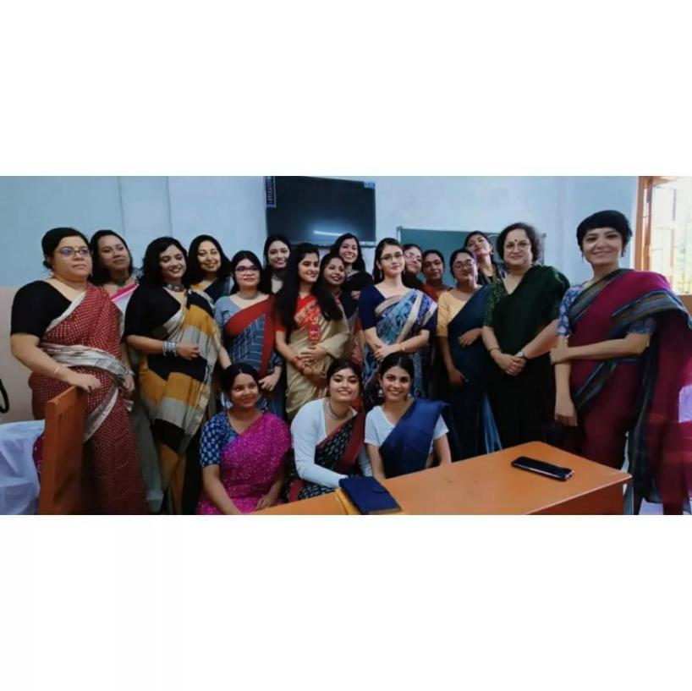**Category**- Cultural Activity

**Organizing Unit-** Department of English

**Date** – 11.07.2023

**Venue**- Room no. 16

**Time**- 2:00 – 4:00pm

**Resource Person** – None

**Brief description of the event** - The Department of English, RKSMVV, with a bittersweet heart bid adieu to the Batch of 2023 and welcomed the Batch of 2025 on the 11th of July, 2023. The event commenced with the recitation of one of Tagore's poems, followed by a cordial welcome speech and a song for the freshers. The farewell programme started off with a hearty speech dedicated to the outgoing students as they were greeted with handmade cards, bookmarks and bouquets prepared by the students of 2nd year. Dance performances and delightful song renditions were staged by the students of 1st and 2nd year, compelling the seniors to join in the celebration as well. The day concluded with the departing students sharing some of their fondest memories of college-life and the department wishing them the best as they embark on a fresh journey in their lives.

**Outcom**e – Such occasions allow the students to be imaginative and collaborative with their classmates in their creative ventures.

**Number of Participants**- 40

**12. Title**- Marxism: Some Basic Concepts

**Category** – Extension Lecture

**Date** – 19.06.2023

**Time**- 2 pm

**Venue**- AV Room

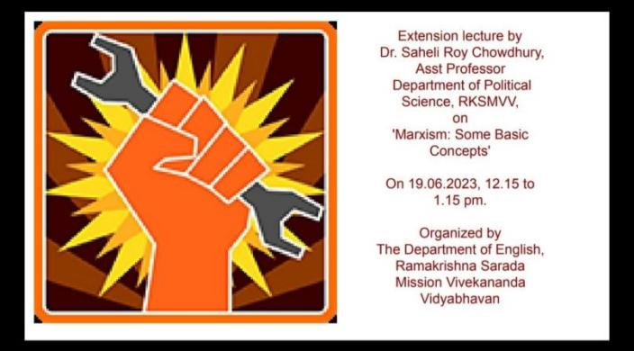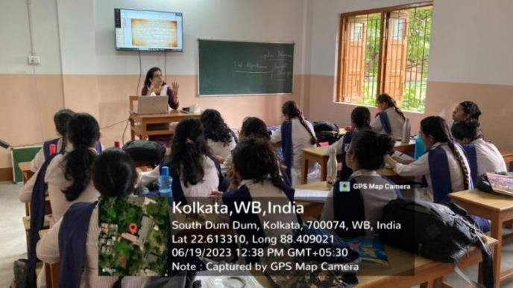**Resource Person** - Dr. Saheli Roy Chowdhury, Assistant professor, Department of Political Science, RKSMVV

**Brief Description of the Event** –On 19th June 2023, an extension lecture titled 'Marxism: Some Basic Concepts' was delivered by Dr. Saheli Roy Chowdhury, Assistant professor, Department of Political Science, RKSMVV.

**Outcome** - The lecture offered the students an introduction to the difficult theoretical concept of Marxism. It explored not only the theoretical aspects but also the socio-political perspectives attached to it. The lecture elucidated the concept of class struggle between the 'haves' and 'have-nots' and also explained concepts like 'Base' and 'Superstructure'. The students were also introduced with the Marxist literary criticism. Dr. Roychowdhury’s lucid presentation also incorporated Marxist theories of Lenin and Stalin in her lecture. Since Marxism is part of the students’ curriculum, the session proved to be most valuable for them.

**Number of participants** – 45

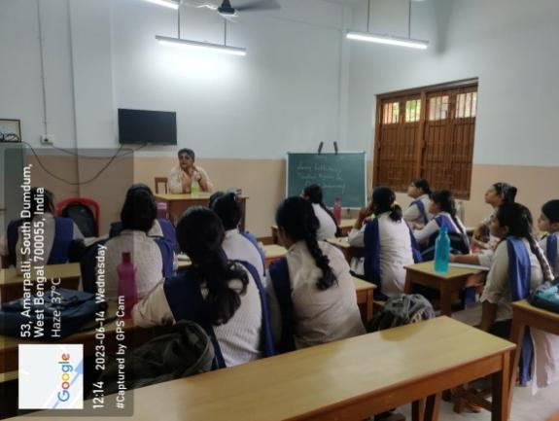**13. Title**- The Partition of Indian 1947

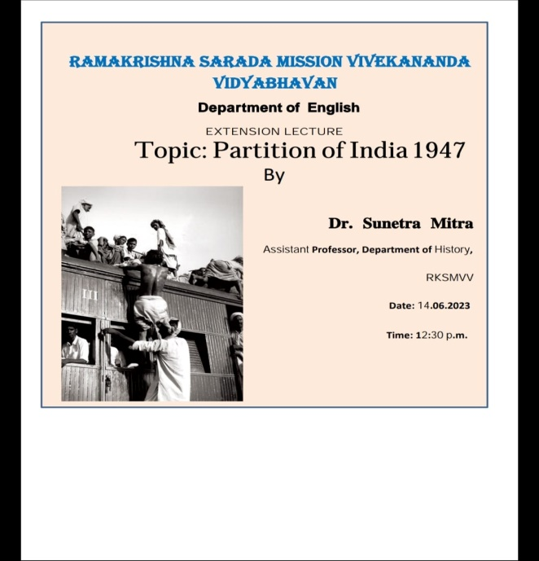**Category** - Extension lecture

**Date**- 14.06.2023

**Time**- 2pm

**Venue**- AV Room

**Resource Person** - Dr. Sunetra Mitra, Assistant professor, Department of History

**Brief Description of the event**- on 14th June 2023, an extension lecture titled “The Partition of Indian 1947” was delivered by Dr. Sunetra Mitra, Assistant professor, Department of History, RKSMVV.

**Outcome**- The discussion focused on the political turmoil in Bengal and Punjab during Partition. Not only did she talk about the fragile political situation between Erstwhile Western Pakistan and Punjab, she also talked about the cataclysmic condition of Western Bengal and Erstwhile Eastern Pakistan. She talked about how women were the greatest victim and also alluded to the works Manto, Atin Bandyopadhyay, Manik Bandopadhyay, Khuswant Singh. Her lucid and engaging account of Partition of 1947 greatly facilitated the students to recognize the interconnection between the Partition history and the literary works written at the backdrop of Partition of India.

**Number of participants** – 45

**14.Title**- Global Engagement Programme ‘Throwing Light’ on *Heart of Darkness*: An Analysis of the Title of Conrad’s Novel

**Category**: Online Lecture

**Date**: 11.05. 2023

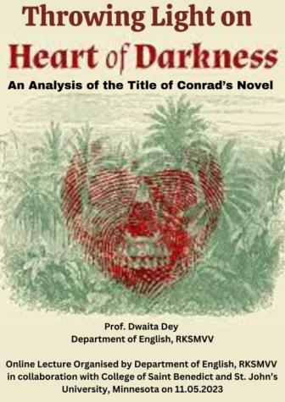**Time**: 7:30 p.m. – 8:45 p.m.

**Mode:** Online

**Name of Resource Person**: Professor Dwaita Dey, Department of English,

RKSMVV

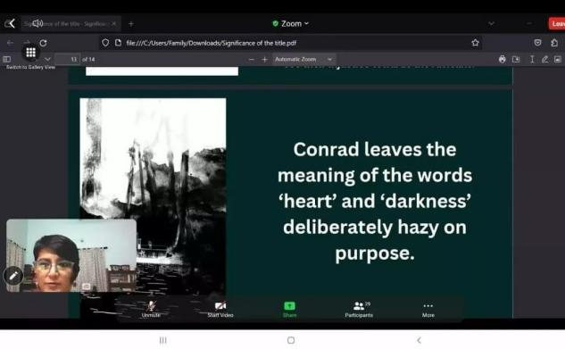

**Brief Description of the Event** - Professor Dey’s lecture helped the participants develop a deeper appreciation for the multifaceted meaning of Conrad’s novel, while exploring the title’s symbolic implications of moral ambiguity, psychological descent, and the darker aspects of human nature within the colonial context.

**Outcome**: The lecture has been enriching for the students as it enabled the students to explore the thematic concerns of the text with greater confidence.

**Number of Participants**: 27students (10 Semester 4 RKSMVV + 17 CSBSJU)

**15Title** – Revelio’23

**Category** - Departmental Fest

**Date** – 10.04.2023

**Time**- 11am to 2 pm

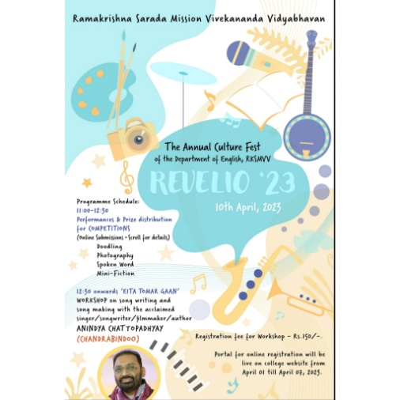**Venue** – College Auditorium

**Resource Person** – Anindya Chattopadhyay, singer, songwriter, filmmaker, author

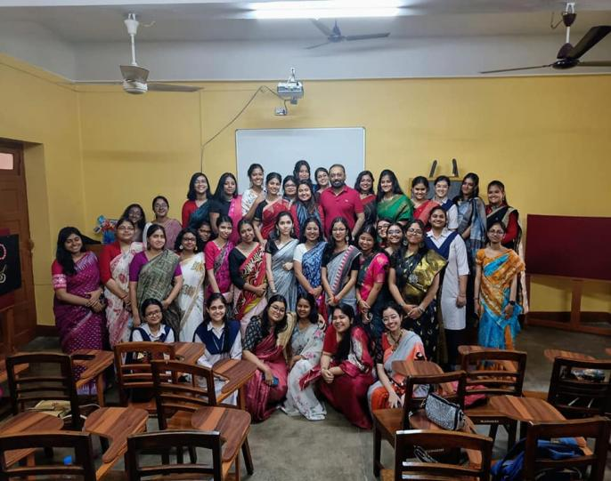**Brief Description of the event** - On 10th April 2023, the department arranged the annual culture fest “Revelio 23”. The event comprised a ceremony of prize distribution for several competitions, on numerous categories such as Photography, doodle and mini-fiction and slam poetry. It also included a singing performance of Ashmita Kar, joint winner of Sa Re Ga Ma Pa, alumna of our college and music teacher at RKSMVV. A special workshop was also held on song writing and song making with award-winning singer, songwriter, author and filmmaker Anindya Chattopadhyay.

**Outcome** - The departmental fest apart from offering an opportunity to explore the hidden talents of the students also arranged for an engaging session on the process of writingsong on their own. **Number of participants** - 39

**16Title** – Departmental Excursion

**Category** – Educational

**Date** – 10.01.2023

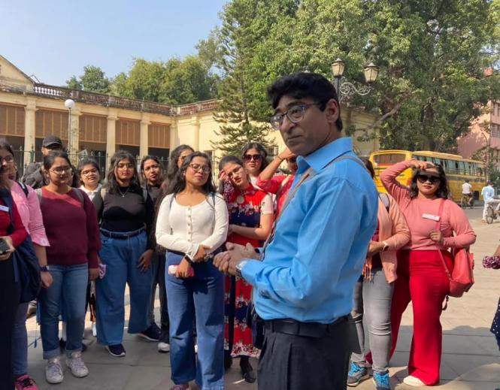**Venue**- Chandannagar

**Time** –

**Resource Person** – None

**Brief Description of Event** - On 10th January’2023, the department of English paid a visit to Chandannagar, the French colony of Bengal as part of the yearly educational tour.

**Outcome** - The students explored the colonial history of the place by visiting museum andobserving the distinctive French colonial architectural designs.

**Number of Participants** - 48

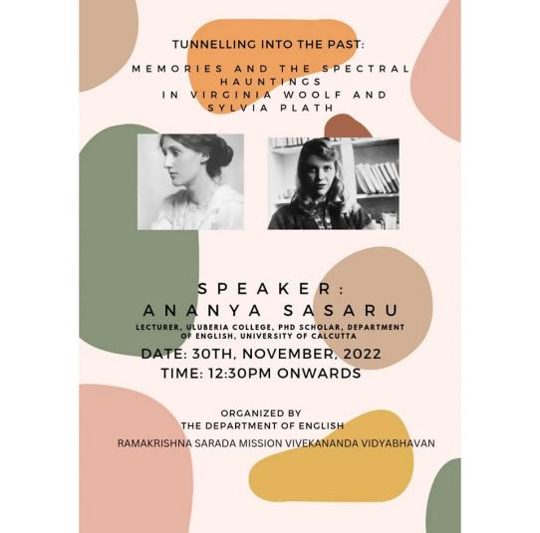**17. Title** – Tunnelling into the Past: Memories and the Spectral Hauntings in Virginia Woolf and Sylvia Plath

**Category** – Extension Lecture

**Date** – 30.11.2022

**Time**- 2 pm

**Venue**- AV Room

**Resource Persons**- Ananya Sasaru, lecturer of English, Uluberia College and PhD scholar, Department of English, the University of Calcutta

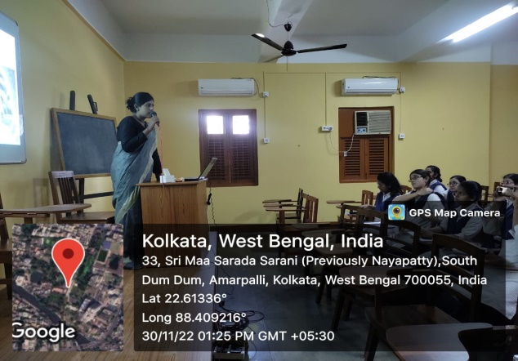**Brief Description of event** - On 30th November, 2022, an extension lecture titled "Tunnelling into the Past: Memories and the Spectral Hauntings in Virginia Woolf and Sylvia Plath" was held by the department of English. Ananya Sasaru, lecturer of English, Uluberia College and PhD scholar, Department of English, the University of Calcutta was invited to deliver an extension lecture regarding the selected works of the two authors mentioned in the title.

**Outcome** -The lecture centred upon the biographical details of the authors, which contained their unique experiences associated with their gendered identities in their respective contexts. She has conferred special attention in discussing their struggle with mental illness under patriarchal oppression. The students found the lecture particularly valuable since the discussion enabled them to interpret the complex autobiographical elements of the texts in a new light. The objective of the extension lecture was to introduce the students with not only the biographical details of the authors but also enable the students to recognize the interrelations with their texts.

**Number of participants**- 19

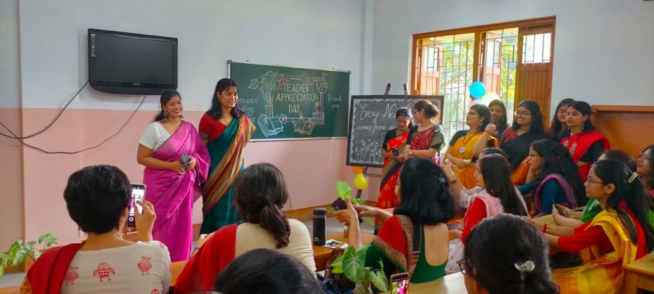

**18.Title** – Teachers’ day celebration

**Category** – Cultural

**Date** – 25.09.2022

**Time**- 2:00 PM – 3:30 PM

**Brief description of the event** - The Department of English, RKSMVV celebrated some Teachers' Day. Filled with performances, memories, fun and laughter, it was a treasured time for all present.

**Outcome** – This allows students a platform to present their talents.

**Number of Participants** - 38

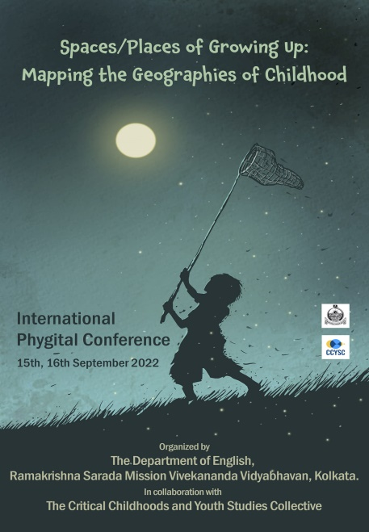

**19. Title** – Spaces/Places of Growing Up: Mapping the Geographies of Childhood

**Category** – International Conference

**Date**- 15.09.2022 – 16.09.2022

**Time**- 10am – 5 pm

**Venue** – Swamiji Bhavan

**Resource Persons** - Dr. Rimli Bhattacharya Professor, Department of English, Delhi University and Christoph Knoblauch, the Institute for Theology and the Institute for Early Childhood Education, Ludwigsburg University of Education. Dr. Swapna Banerjee, Brooklyn College and The Graduate Center of the City University of New York

**Brief Description of the event**- The Department of English, RKSMVV, and the Critical Childhoods and Youth Studies Collective organized an international phygital conference titled ‘Spaces/Places of Growing Up: Mapping the Geographies of Childhood’, on 15th and 16th September 2022. On the first day of the conference, the keynote addresses were delivered by Dr. Rimli Bhattacharya Professor, Department of English, Delhi University and 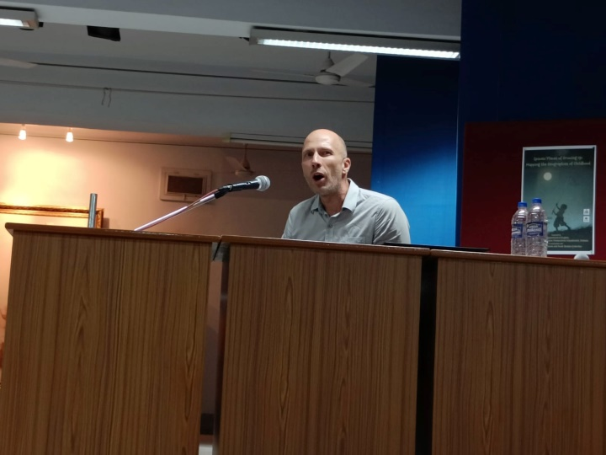Christoph Knoblauch, the Institute for Theology and the Institute for Early Childhood Education, Ludwigsburg University of Education. Dr. Swapna Banerjee, Brooklyn College and The Graduate Center of the City University of New York, delivered the keynote address on the second day of the conference.

**Outcome**- The conference presented not only varied scopes of exploring the arena of childhood but also possibilities of engaging the study through interdisciplinary critical lens. It also provided a suitable platform for the students of the department to present their own academic write-ups. Additionally the stimulating conversations initiated by the noted speakers as well as by the panelists contributed to an atmosphere most conducive to academic learning for the students.

**Number of participants** – 45

**20. Title** – Farewell

**Category** – Cultural

**Date** – 01.06. 2022

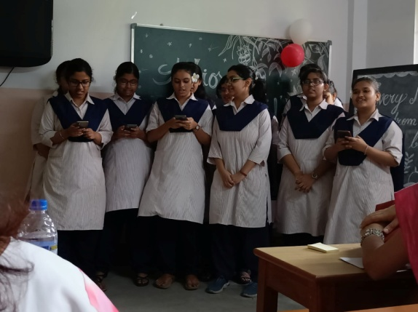**Brief Description of the event** - On 1st June, 2022, the 1st and 2nd year students of Department of English, RKSMVV, organised a Farewell programme for their outgoing seniors. The students performed songs and skits to bid adieu to their seniors.

**Outcome** – Students get the opportunity to explore their creative side

**Number of Participants** - 33

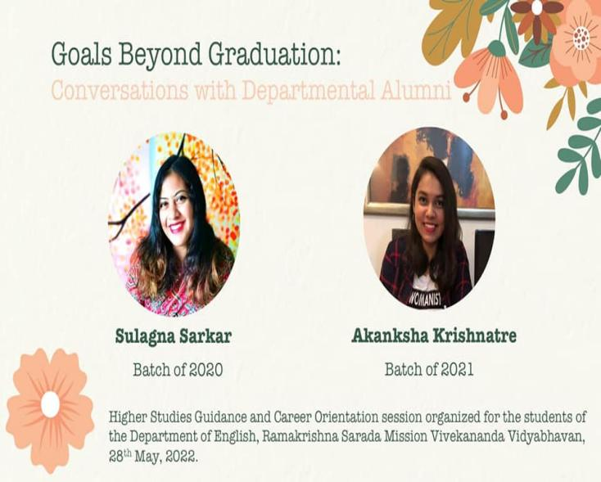**21. Title -** Goals beyond Graduation: Conversations with the Departmental Alumni

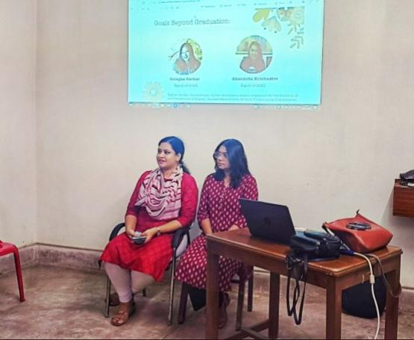 **Category** -Session on Career-planning

**Date** – 28.05.2022

**Time** – 1:30 – 2:30pm

**Venue** – AV room

**Resource Persons** - Sulagna Sarkar (Batch of 2020) and Akanksha Krishnatre (Batch of 2021)

**Brief Description of the event** – A Higher-studies guidance and career orientation session titled “Goals beyond Graduation: Conversations with the Departmental Alumni” was organized on 28th of May 2022. Two of the Department's recent alumni, Sulagna Sarkar (Batch of 2020) and Akanksha Krishnatre (Batch of 2021) talked at length about their academic and professional experiences, about setting targets and achieving them through discipline, hard work and intelligent planning.

**Outcome** - The session was engaging enough since itoffered the undergraduate students practical means of preparing oneself right after graduation.

**Number of Participants** – 18

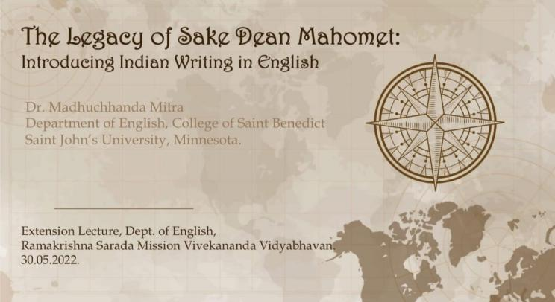**22.Title** – The Legacy of Sake Dean Mahomet: Introducing Indian Writing in English

**Category** – Extension Lecture

**Date** – 30. 05.2022

**Time** – 2pm

**Venue** – AV Room

**Resource Person** - Dr. Madhuchhanda Mitra, Department of English, College of Saint Benedict,

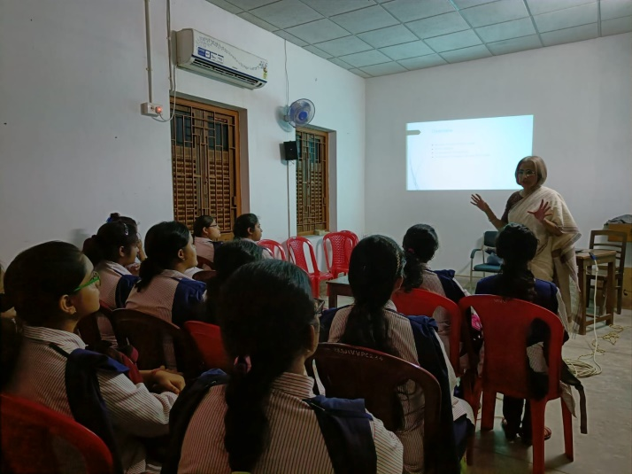**Brief Description of the Event** –The Department of English, RKSMVV, arranged the extension lecture 'The Legacy of Sake Dean Mahomet: Introducing Indian Writing in English' on 30th May, 2022. Dr. Madhuchhanda Mitra, Department of English, College of Saint Benedict, talked about the germinations and development of Indian Writing in English and its prominent place in the contemporary literary map.

**Outcome** -For the students, the historical context also enlightened upon the colonial history which is essential to understand Indian writing in English.

**Number of Participants** - 10

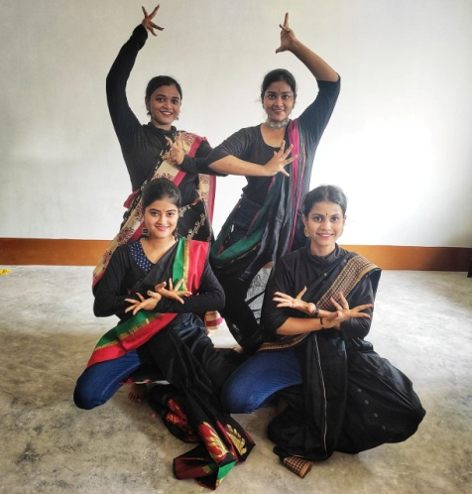**23.Title** – Freshers’ Welcome

**Category** – Cultural

**Date**- 26.04.2022

**Time**- 2:00pm -3:30 pm

**Venue**- room 16

**Resource Person** - None

**Brief Description of the event** - On, 26th April 2022, the 2nd and 3rd year students of Department of English, RKSMVV, organised a program to warmly welcome the freshers of first year. The newcomers were inducted into our family with a happy medley of songs and dances.

**Outcome**- Such events allow students to showcase their extra-curricular activities.

**Number of Participants** - 32

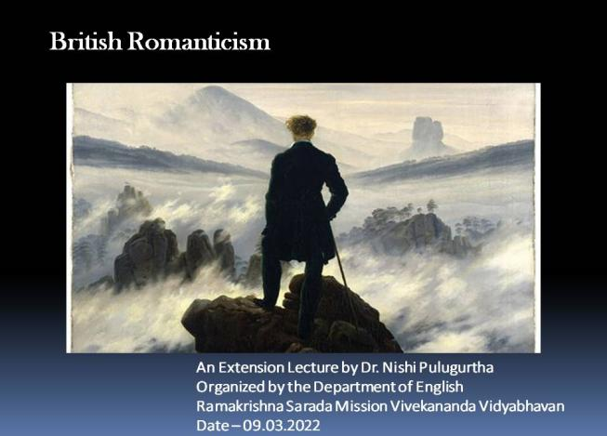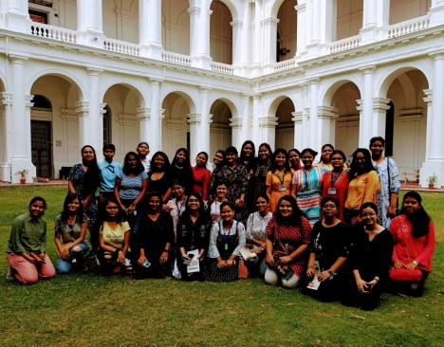

**24.Title** -A visit to Indian Museum –

**Category** – Educational

**Date** – 10.04.2022

**Time** – 10:00 am

**Venue**- India Museum

**Resource person** - None

**Brief description of the event** - The students of the department of English visited Indian Museum on 20th April 2022.

**Outcome** - In post-pandemic new normal session, the department made a day trip to Indian Museum. The students explored the archival history and learned the fascinating past of Indian subcontinent.

**Number of participants** – 32

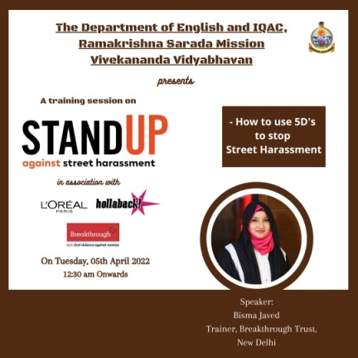**25.Title** – Training session

**Category** - Educational

**Date** – 05.04.2022

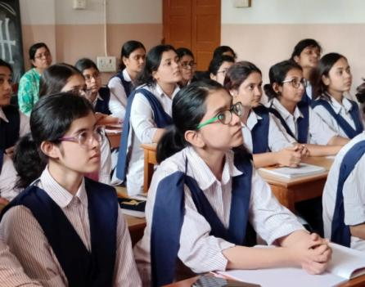**Venue- room** - 16

**Time**- 12:30 pm

**Brief Description of the event** - On 5th April 2022, a training session is held on 'Stand Up Against Street Harassment', organized by the Department of English, RKSMVV and IQAC in association with Breakthrough India.

**Outcome**- The session enlightened the students upon the various types of street harassments and the possible means of resisting them.

**Number of Participants** – 21

**26.Title** - British Romanticism

**Category** – Extension Lecture

**Date** – 09.03.2022

**Time**- 2 pm

**Venue** – AV Room

**Resource Person**- Dr. Nishi Pulugurtha, Assistant Professor, BKC College

**Brief Description of the Event** -on 9th March, 2022, an Extension Lecture on British Romanticism was delivered by Dr. Nishi Pulugurtha, Assistant Professor, BKC College.

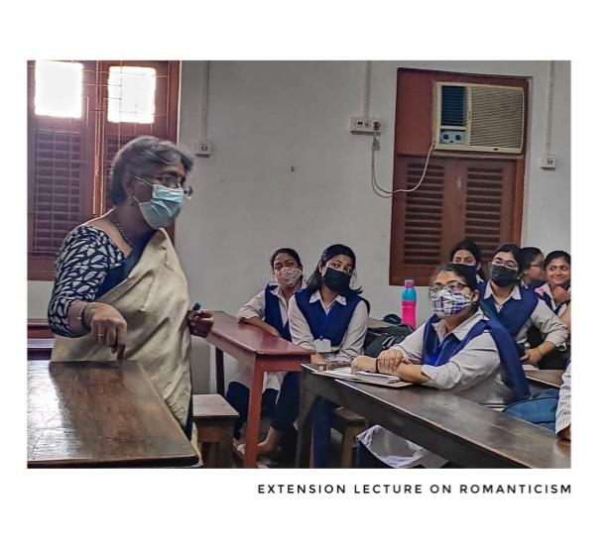**Outcome** - The lecture aimed to offer an adequate intellectual background on Romanticism for the students dealing with Romantic poetry in their syllabus. The lecture discussed the continental influence of Romantic Movement on English poetry. The speaker’s comprehensive presentation of the prominent Romantic poets further elucidated the philosophical concepts essential to the understanding of British Romanticism.

**Number of Participants** – 08

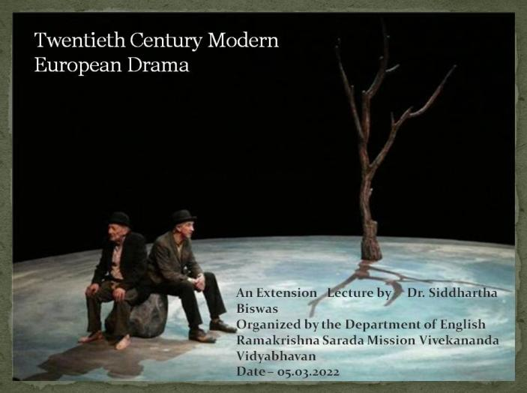**27.Title** – Twentieth century Modern European Drama

**Category**- Online Extension Lecture

**Date** – 05.03.2022

**Time** – 2pm

**Venue**- AV Room

**Resource Person** - Dr. Siddhartha Biswas, Assosiate Professor, University of Calcutta

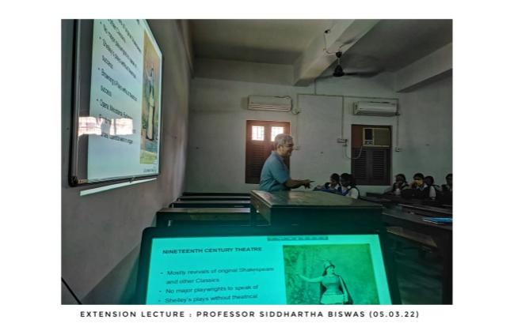**Brief Description of the Event**- On 5th March, 2022, Dr. Siddhartha Biswas, Assosiate Professor, University of Calcutta delivered a lecture titled “Twentieth century Modern European Drama”.

**Outcome** - The lecture presented the intellectual context of the modern European drama ranging from the late 19th century British drama under the influence of Norwegian dramatist Henrik Ibsen, till the most experimental period of English drama in the 20th century. The enriching lecture included a lively discussion upon the several kinds of dramatic experiments, and genres produced in this period. The session also addressed the political and philosophical aspects attached to each of these new kinds of plays. With specific examples from the renowned dramatists and texts, the lecture enabled the students to critically engage with their texts from curriculum.

**Number of Participants** – 08

**28.Title** – Who cares, who killed Roger Ackroyd, or do we?

**Category** - Extension Lecture

**Date** – 17.01.2022

**Time**- 4:30 pm

**Venue**- Online

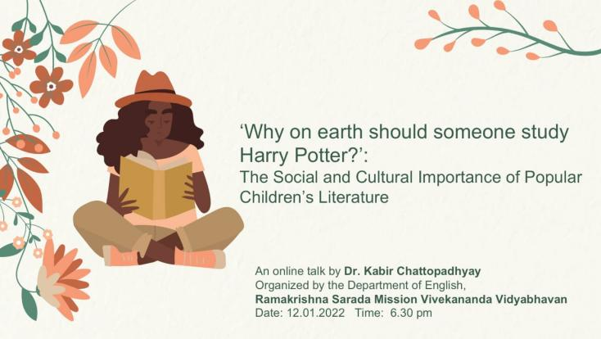**Resource Person** - Dr. Debarati Dutta, Assistant Professor, Dhupguri Girls’ College

**Brief Description of the Event** - An extension Lecture titled “Who cares, who killed Roger Ackroyd, or do we? :Unsettling the detective convention in the world of Christie”, was delivered by Dr. Debarati Dutta, Assistant Professor, Dhupguri Girls’ College on 16th January 2022.

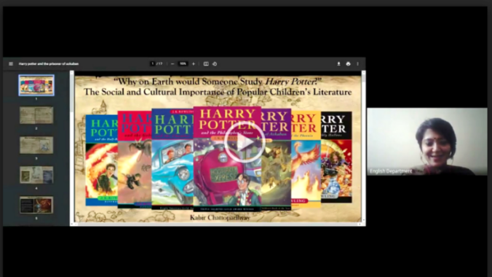**Outcome**- The lecture was part of the Social and Cultural importance of Popular Children’s Literature lecture series. By exploring the genre of detective novels, the speaker critically discussed the possible theories and conjectures of a reader which constitute a successful detective novel. The students also shared their own thoughts and probable theories of the murder-mystery and the session thus proved to be more interacting in the end. Thus the lecture on the conventions of a Detective novel by Christie encouraged the students to explore their own analysis more.

**Number of Participants**- 10

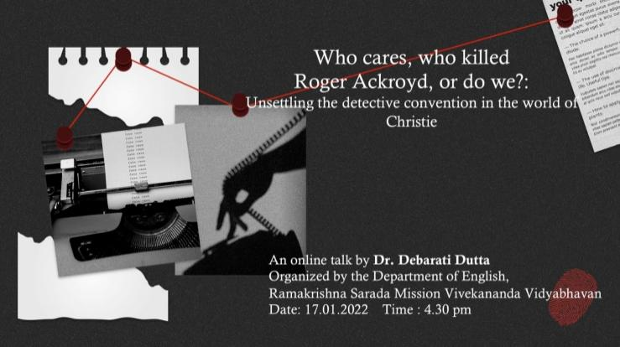**29. Title** - Why on earth should someone study Harry Potter?

**Category** – Online Extension Lecture

**Date** – 12.01.2022

**Time**- 6:30 pm

**Venue**- Online

**Resource Person** – Dr. Kabir Chattopadhyay, Assistant Teacher, the Heritage School

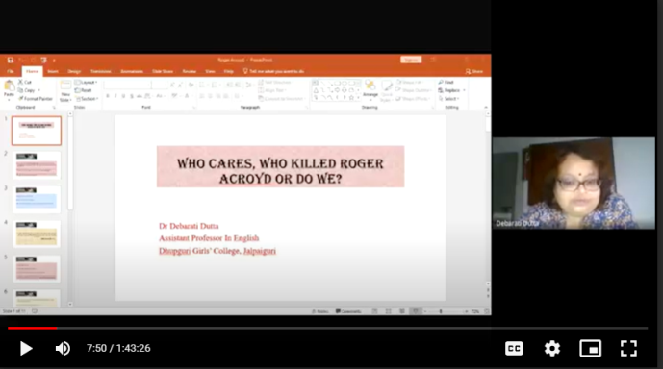**Brief Description of the event** -On 12th January, 2022, an extension lecture titled “Why on earth should someone study Harry Potter?” as part of the “Social and Cultural Importance of Popular Children’s Literature” was delivered by Dr. Kabir Chattopadhyay, Assistant Teacher, The Heritage School.

**Outcome** - The engaging session attempted to introduce the students with the definition and the several elements of popular culture through a critical reading of the famous Harry Potter series. The discussion ranged from the author’s deviation of her genre, the presentation of the protagonist to the appeal of a popular novel. Since the first book of the Harry Potter series is also part of the curriculum, students were greatly benefitted by the illuminating discussion.

**Number of Participants** – 10

**30.Title** - ‘Decoding Gender: Interdisciplinary Perspectives’

**Category** – Add-on Course

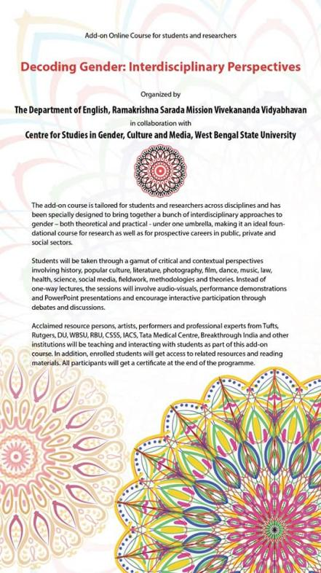**Organizing Unit** - The Department of English, RKSMVV, in collaboration with the Centre for Studies in Gender, Culture and Media

**Date** – 20.09.2021- 03.11.2021

**Time** – 5:30 – 7:30pm

**Venue-** Virtual

**Resource Person** - Dr.Raili Roy, (Teaching Fellow, Honors College, Rutgers University) Dr. Meenakshi Malhotra, (Associate Professor, English, Hansraj College, DU) , Mr. Prabuddha Banerjee (Musician and Music Director), Dr.Modhumita Roy (Professor, English,Tufts University), Ms. Anuradha Ghosh (Art Critic, Author, Associate Professor, English Dinabandhu Andrews College), Ms. Vandana AlaseHazra (Performer, Dance Studies Expert, Guest Faculty, Rabindra Bharati University) Dr. Hardik Brata Biswas ( Mellon Fellow, Centre for studies in Social Sciences, Kolkata), Dr.Chandrava Chakravarty (Professor, English, West Bengal State University, Director, Centre for Studies in Gender, Culture and Media), Dr.Sanmita Ghosh (Assitant Professor, Hooghly Mohsin College), Dr. Sneha Kar Chaudhuri (Assitant Professor, English, West Bengal State University), Dr. Sugata Ray (Senior Professor, Indian Association for Cultivation of Science), Dr.Soumitra Shankar Datta (Psychiatrist, Tata Medical Centre, Visiting Reseacrher and Honorary Lecturer, University College London, UK), Ms. Subhangi Singh 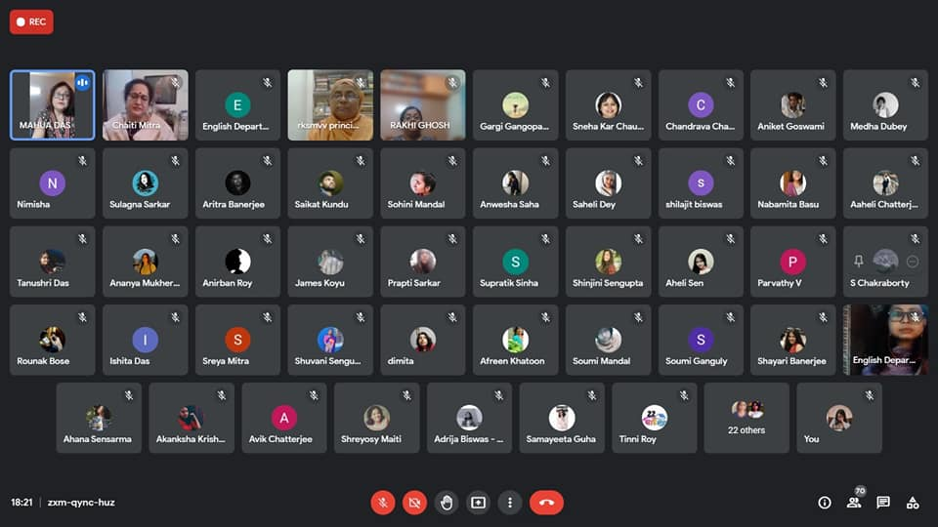(Feminist Legal activist, and Human Rights Lawyer ), Ms. Barsha Chakraborty (Senior Manager, Breakthrough India)

**Brief Description of the event**- We were honoured to have the respected VC, West Bengal State University and the Principal, Ramakrishna Sarada Mission Vivekananda Vidyabhavan, with us for the opening session. They spoke on the value of Gender Studies, the benefit of add-on courses and about the broadening scope of online studies. Dr. Chandrava Chakravarty, Professor of English, WBSU and the Director of the Centre for Studies in Gender, Culture and Media, gave a succinct keynote, dwelling on the chosen title of the course. The sessions covered a range of contexts and perspectives including methodology, history, theory, painting, photography, films, dance, music, literature, popular culture, social media, law, health and science.

**Outcome** - The add-on certificate course aimed to explore the area of gender from a numerous perspectives by engaging it with different theoretical parameters and critical lens. The lecture sessions offered an opportunity to learn the critical aspects of gender studies by engaging to a variety of medium.

**Number of Participants** - 73

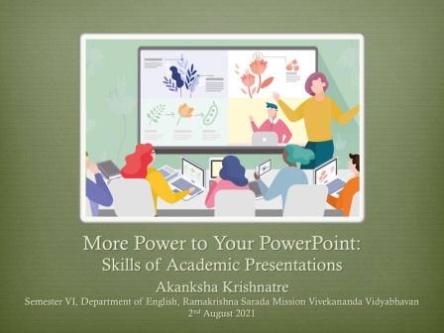**31. Title**- More Power to Your Power Point

**Category** – Online session, activity oriented

**Organizing Unit** – Department of English, RKSMVV

**Date** – 02.08.2021

**Time** – 12:30 – 1:30pm

**Venue** – Virtual

**Brief description of the event** – On 2nd August 2021, ex-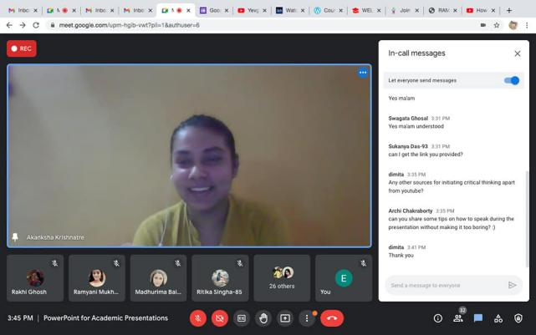student of the department Akaksha Krishnatre, held a virtual session titled ‘More Power to Your PowerPoint: Skills of Academic Presentation’ for her juniors. The session was attended by all students of the department.

**Outcome** - The session was organized to guide the uninitiated about the various methods, tips and tricks of preparing a power-point presentation for academic purpose.

**Number of Participants - 28**

**32. Title** – Students’ Research Circle Talk

**Category** – Academic

**Date** – 10.07. 2021

**Time** – 4:30pm -6pm

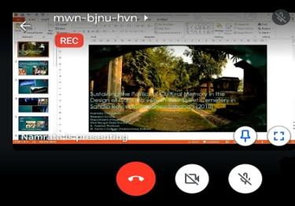**Venue**- Online

**Brief Description of the event** –On 10th July, 2021 (1.5 hours), as part of “Students’ Research Circle”, Ms. Namrata Chowdhury, an Assistant Professor of St. Xavier’s college and an ex-student from the Department presented a talk titled “Sustaining the Politics of Calcutta’s South Park Street Cemetery in Sandip Ray’s Gorosthaney Sabdhan (2019)” Attended by 45 students, present and past.

**Outcome** - The objective behind organizing the session was to evoke the research interest among the present students of the department. For the students, the talk offered an interesting insight regarding the possibilities of exploring a variety of texts.

**Number of Participants – 18**

**33. Title** - Partition Narratives: four day Interdisciplinary Lecture Series

**Category** – Online Lecture Series

**Date –**28. 06.2021 – 29.06.2021,

01.07.2021 – 02.07.2021

**Time –** 6:30 pm – 8 pm

**Venue -** Online

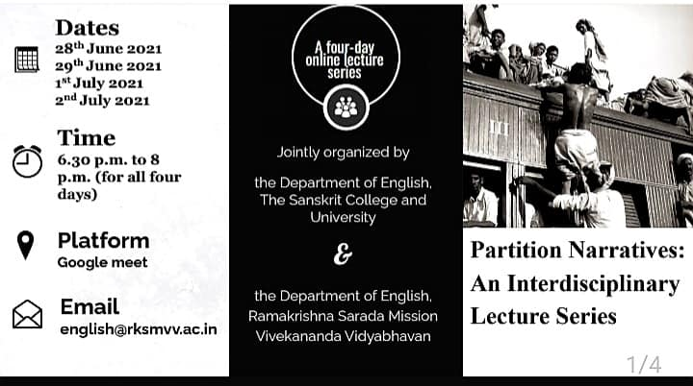Resoure Persons- Roy, Assistant Professor, Heritage College, Mr. Nazes Afroz, Journalist, Author, Photographer, Dr. Tista Das, Assistant Professor, Department of History, Bankura University, Dr. Tista Das, Assistant Professor, Department of History, Bankura University

**Brief Description of the event** - An online lecture series titled “Partition Narratives: four day Interdisciplinary Lecture Series” in collaboration with the Department of English, Sanskrit University, Kolkata, and IQAC, RKSMVV was organized that spanned from 28th June to 2nd August 2021. The speaker for the first day was Rituparna Roy, Assistant Professor, Heritage College, Kolkata, Initiator, Kolkata Partition Museum Project delivered a lecture titled was “Train to Pakistan: Revisiting a Classic”. On the second day of the series, Mr. Nazes Afroz, Journalist, Author, Photographer delivered his lecture titled “Uncertain Landscape: Refugee Memories of Kolkata”. On the third day Dr. Tista Das, Assistant Professor, Department of History, Bankura University delivered a lecture titled “Women in India’s Partition”. The last lecture titled “The Railway Refugees of Bengal Partition: Revisiting Sealdah Station of 1950s- 60s’ was delivered by Dr. Anwesha Sengupta Assistant Professor, Institute of Development Studies Kolkata.

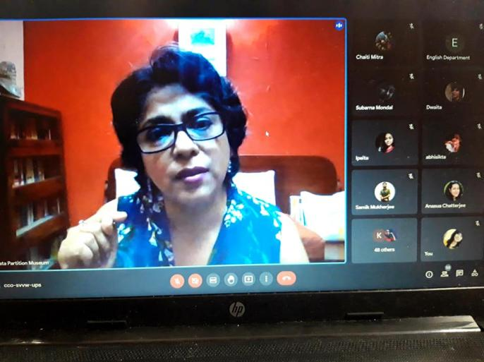**Outcome** - The lecture series offered a multifaceted discussion on the topic of Partition. The speakers critically engaged with the interesting sub-topics of gender and the formation of distinctive identities, such as that of the refugees at the aftermath of Partition. Furthermore, it aimed to engage the students critically with the several aspects of our socio-political and socio-cultural beings in the aftermath of Partition. The discussion enabled the students to interpret Partition as a collection of narratives that exists beyond the discipline of literature.

**Number of Participants** – 11

34. **Title** - Chinua Achebe and the Postcolonial Novel

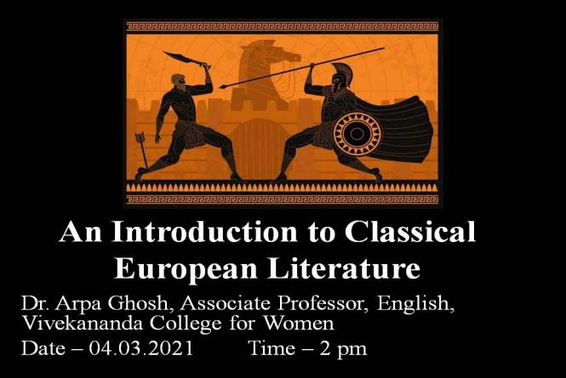**Category** – Online Lecture

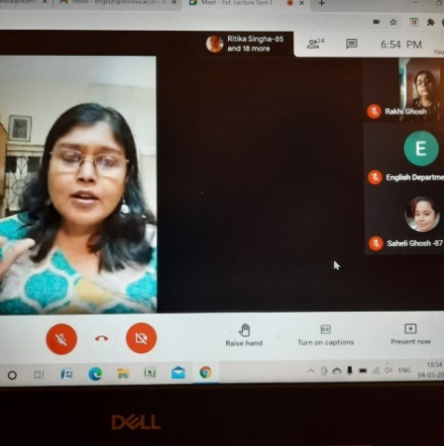**Date** – 13.06.2021 – 16.06.2021

**Time –** 2pm

**Venue -** Online

**Resource Person** - Dr. Madhuchhanda Mitra, , Professor, Department of English, College of Saint Benedict, Saint John’s University Minnesota

**Brief Description of the Event** - On 13th and 16th June 2021 Dr. Madhuchhanda Mitra, , Professor, Department of English, College of Saint Benedict, Saint John’s University Minnesota delivered an online lecture in two parts titled “Chinua Achebe and the Postcolonial Novel”.

**Outcome** -The objective of the lecture was to introduce the students with the author Chinua Achebe and discuss the predominant characteristics of a postcolonial text. The lecture enriched the students by providing them with adequate context of Achebe’s text for analysis. It additionally presented them with the theoretical framework of Postcolonialism for further critical and theoretical explorations.

**Number of participants** – 11

35.**Title**- An Introduction to Classical European Literature

**Category** – Online Lecture

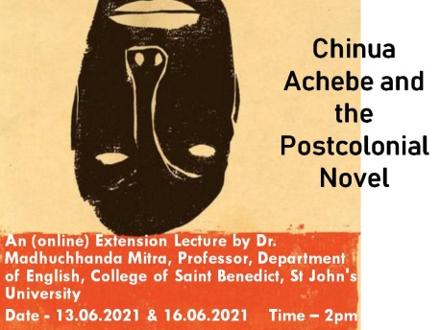**Date** – 04.03.2021

**Time**- 2 – 4 pm

**Venue** – Online

**Resource Person** - Dr. Arpa Ghosh, Associate Professor, English, Vivekananda College

**Brief Description of the Event** -On 4th March 2021, Dr. Arpa Ghosh, Associate Professor, English, Vivekananda College for Women delivered a lecture titled “An Introduction to Classical European Literature”.

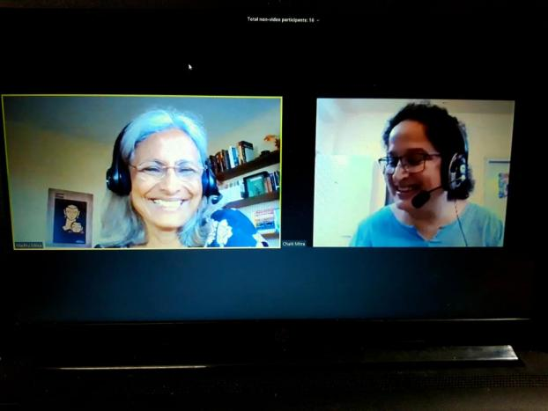**Outcome** - Her introductory lecture was primarily aimed to evoke the interest of the students towards Classical European literature and culture. She dwelt upon the context of the Greco–Roman epics in her lecture, and consequently it enabled the students to gain a better grasp over the intellectual background of such texts. Students are made acquainted with the overview of the Ancient European classical texts especially with few textual references such as from *Iliad* and *Metamorphoses* comprising their syllabus.

**Number of participants** – 19

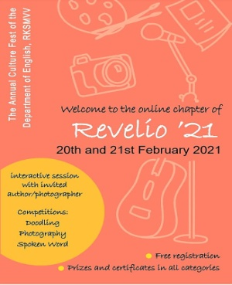

**36.Title** – Revelio’21

**Category** – Departmental Fest

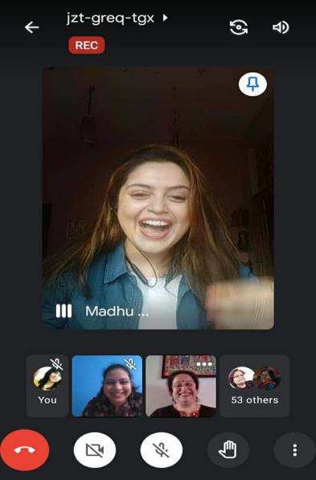**Organizing Unit** – Department of English, RKSMVV

**Date** – 20th and 21st February 2021

**Time** –

**Venue** – Online mode

**Resource Person** - Nazes Afroz, author, translator, photographer and freelance journalist

**Brief Description of the event** - On the 25th year of the Department of English, RKSMVV, students virtually joined for Revelio '21 on 20th and 21st February 2021. Students participated in a number of competitions on several categories, such as - Doodling, Photography and presenting Slam Poetry (in English, Bengali or Hindi). On the first day of the fest, an interesting session included a talk by the invited guest-author Nazes Afroz. As part of a session with the author, he talked about the Kabuliwalas of Kolkata. On the second day of the departmental fest all Departmental students - present and past, virtually joined on 21st February.

**Outcome** – Learning about the community of Kabuliwalas in Kolkata has been a highly impactful experience for the students, as they learn about the diversity of Kolkata, and its varied heritage and history. The second day of the fest was an occasion of reminiscence and also an opportunity for a brief session of career-counselling by the Alumni.

**Number of Participants –** 58

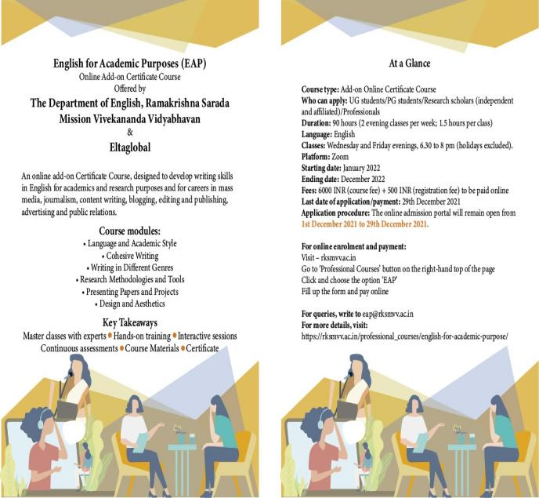

**37.Title** – English for Academic Purpose

**Category** - Add-on Certificate course

**Organizing Unit** - Department of English in collaboration with Eltaglobal

**Date** – 13.01.2022 – 08.12. 2022

**Time** –

Venue - virtual

**Resource Person** – Debarati Roy, Sheikh Shamim, Dr. Gargi Gangopadhyay, Dwaita Dey, Dr. Anasuya Chatterjee, Dr. Chaiti Mitra, Dr. Sipra Mukherjee, Dr. Rakhi Ghosh, Nazes Afroz, Kathakali Jana, PS Bhavna, Dr. Soumitra Shankar Datta, Suchetona Pal, Agibesh Das

**Brief Description of the Event** – The EAP course is designed to develop writing skills, strengthen vocabulary and grammar and build structuring and organisation skills – key elements for any academic or professional writing. Along with these foundational building blocks, the course also includes modules on drafting original essays/papers, making smart presentations, referencing, proofreading and avoiding plagiarism. The programme aims at upgrading the overall written proficiency in English for students (at B.A., M.A. & research level) and professionals.

**Outcome** - Upon successful completion of the course students will be able to exhibit a high level of competence in using English for a variety of academic pursuits. They will be able to produce well-structured, coherent, and persuasive academic essays, research papers, and reports that meet the rigorous scholarly standards. In addition, students will adeptly apply critical thinking and analytical skills to their writing, enabling them to construct cogent arguments and engage deeply with complex texts and ideas. The course will also enable the students to transfer the linguistic, rhetorical and critical skills developed in academic writing to broader contexts, including professional and public discourse. They will be capable of composing articulate, thoughtful, and impactful pieces for diverse audiences and purposes, such as op-eds, reviews, art criticism, and digital content. This adaptability will ensure that students can effectively communicate their ideas and insights in both academic settings and beyond, contributing meaningfully to various fields and public conversations.

**Number of Participants -** 11

**38. Title** – Why Masculinity Studies is Feminist?

**Category** – Online Lecture

**Date** – 21.01.2021

**Time** – 4 – 5:30 pm

**Venue** – Online

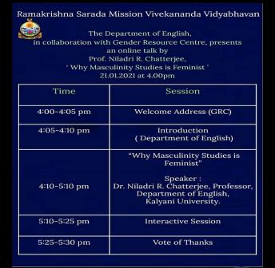**Resource Person** - Niladri R Chatterjee, Professor, Department of English, Kalyani University

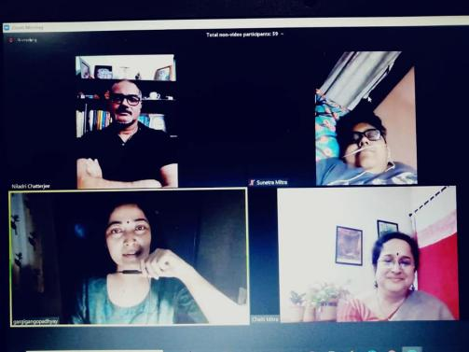**Brief Description of the Event**- On 21st January, 2021, the Department of English, RKSMVV, in collaboration with the Gender Research Cell of the College, organized and hosted an online lecture titled 'Why Masculinity Studies is Feminist?'. The invited speaker, for the session was the eminent Professor Niladri R Chatterjee, from the Department of English, Kalyani University. **Outcome** - The lecture explored a number of possibilities in which masculine study enables one to critically engage with the study of Gender. To elucidate the contradictory theoretical aspects of gender, the speaker often relied upon non-literary yet conceptually coherent examples. The lecture helped the students to expand the outline of gender from the exclusivity of a feministi point of view.

**Number of Participants** - 38

**39. Title** – Interrogating the Colonial: Lectures on Heart of Darkness and Wide Sargasso Sea

**Category** - Workshop & Online Lecture Series

**Organizing Unit** – Department of English

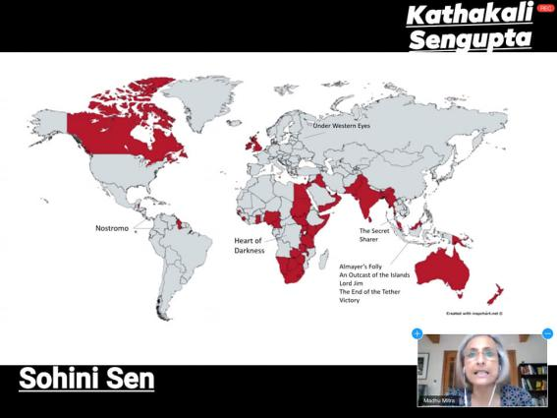**Date** – 04.08.2020 – 10.08.2020

**Time** – 6:30- 7:40 pm

**Venue**- Online

**Resource Person**- Dr. Madhuchhanda Mitra, Professor, Department of English, College of Saint Benedict, Saint John’s University Minnesota

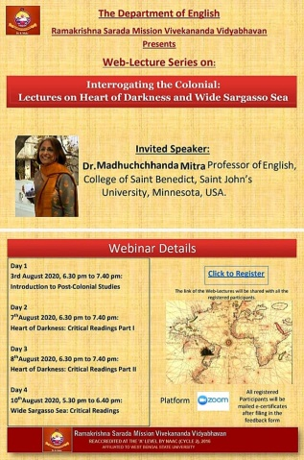**Brief Description of the Event**- From 4th to10th August 2020, a Teachers’ Workshop and Online Lecture Series “Interrogating the Colonial: Lectures on Heart of Darkness and Wide Sargasso Sea” was introduced by Dr. Madhuchhanda Mitra, Professor, Department of English, College of Saint Benedict, Saint John’s University Minnesota. The lecture series dealt with two significant texts from the syllabus under the theoretical aegis of Postcolonialism.

**Outcome**- The lecture enabled the students to recognize and reflect upon the uneasy relationship shared by the colonial master and that of a colonized slave within the text. The discussion also touched upon the concern of gender in the exploitative colonial context defined by the binaries of powerful coloniser and victimised colonized.

**Number of Participants** – 19

40. **Title** – Indian Writing in English

**Category** – Extension Lecture

**Time** – 6 – 8 PM

**Venue** – Online

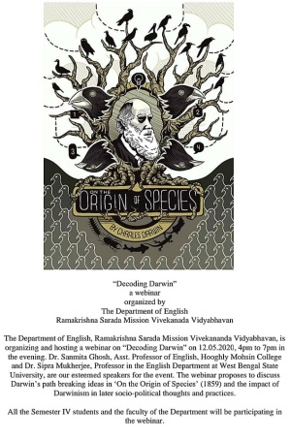**Resource Person** - Dr. Madhuchhanda Mitra, Professor, Department of English, College of Saint Benedict, Saint John’s University Minnesota

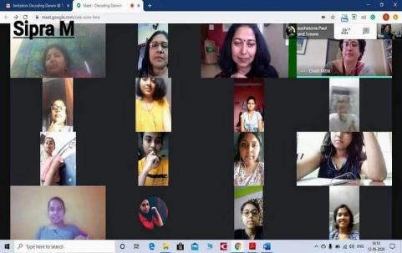**Brief Description of the Event** – On 22nd June-2020 (from 6-8 pm), A Webinar titled “Indian Writing in English” was presented by Dr. Madhuchhanda Mitra, Professor, Department of English, College of Saint Benedict, Saint John’s University Minnesota.

**Outcome -**This webinar introduced the students with the very context in which Indian writing in English issued from. The discussion comprised a brief history of the colonial encounter in the political, lingual and socio-cultural realm of colonised India. The lecture further focussed on the renowned Indian authors and their remarkable contributions in consolidating the history of Indian Writing in English.

**Number of Participants –** 8

**41.Title** - “Decoding Darwin”

**Category** - Webinar

**Organizing Unit** – Department of English, RKSMVV

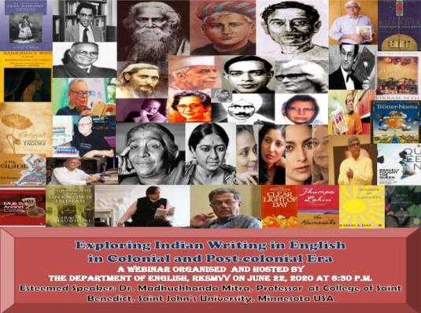**Date** – 12.05.2020

**Time** – 4pm – 7pm

**Venue** – Online

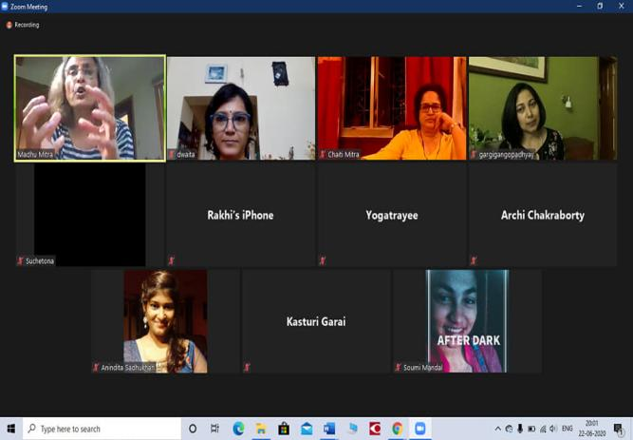**Resource Person** - by Dr. Sanmita Ghosh, Assitanat Professor of English, Hooghly Mohsin College and Dr. Sipra Mukherjee, Professor in the English Department at West Bengal State University

**Brief Description of the Event** – A Webinar titled “Decoding Darwin” was held in collaboration with the IQAC, RKSMVV on 12th May, 2020 (from 4pm – 7pm). Lectures were delivered by Dr. Sanmina Ghosh, Assitanat Professor of English, Hooghly Mohsin College and Dr. Sipra Mukherjee, Professor in the English Department at West Bengal State University.

**Outcome** - The webinar served as an introductory lecture on Darwin not only as a scientist famous for his evolutionary theory, but also as an eminent Victorian non-fictional prose-writer. Two speakers discussed and expanded upon the impact of Darwinism, the reflection of his groundbreaking ideas upon contemporary Victorian literature.

**Number of participants** – 11

**42.Title** – The Sounds of Silence

**Category –** Open Event on Social Media

**Organizing Unit**- Department of English, RKSMVV

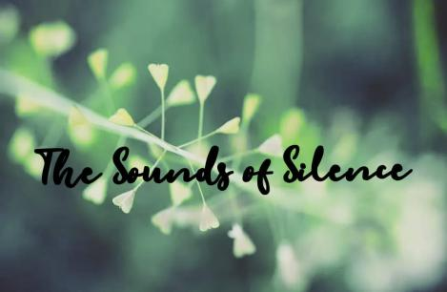**Date –** 26.04.2020

**Time –** Virtual submission

**Brief Description of the Event**– On 26th April 2020, Department of English arranged an open Facebook event titled “Sounds of Silence”. Existing Students along with the ex-students from the Department and a few guest contributors shared their original artworks.

**Outcome** -During the period of pandemic, the occasion enabled the students to focus on their creative and imaginative faculties**.**

**Number of Participants -** 21

**43.Title – Book Fair Visit**

**Category –** Educational

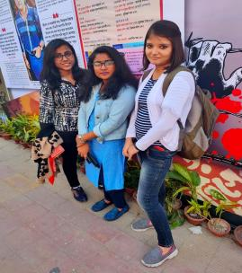**Organizing Unit** – Department of English, RKSMVV

**Date** – 25.02.2020

**Time** – 2:00 Pm

**Brief Description of the event**- Students from the department of English made a visit to Kolkata Book-fair, and explored the books of their interest, both academic and non-academic.

**Outcome –** Students got the opportunity to enhance their interest beyond the academic syllabus.

**Number of Participants** – 11

**44.Title** - Departmental excursion

**Category** – Educational

**Date**- 19.01.2020

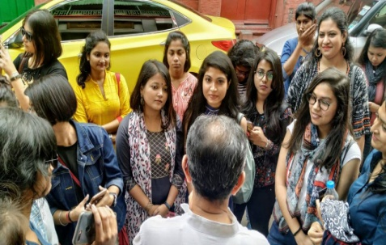**Time-** 09:30 am -11 am

**Brief Description of the Event** -On 19th January, 2020 students of the department of English participated in a heritage walk and explored the “Grey Town” of Kolkata, starting a tour from GPO, through Dalhousie and Burrabazar to Chinese Town near Tiretta Bazaar. The importance of heritage walk is to acquaint the citizen with the rich history of the city. The purpose behind this particular walk was to encourage the students to explore the long-lost history of their own city, Kolkata.

**Outcome** -The heritage walk enabled the students to recognize the opulence of the city, a commercial centre high in demand, among various groups of foreign merchants before the arrival of British Colonizers in Kolkata.

**Number of Participants -** 27

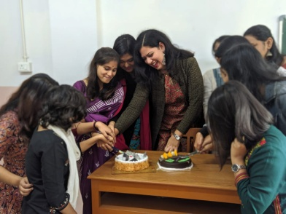**45. Title** – Farewell

**Category** – Cultural

**Organizing Unit** – Department of English

**Date** –13.01.2020

**Time** – 2:00 pm

**Venue**- Room no 16

**Brief Description of the Event**- On 13th January, 2020 the students of the department of English arranged a short cultural program for the students of third year, the batch of 2018 -2020. Since it is organized entirely by the students of the department, it enables the students to work together on every aspect of making an event successful.

Outcome- From preparing a program schedule to wrapping gifts for their beloved seniors, they recognize the significance of being part of a department as well as an educational institute.

**Number of Participants**- 27

**46. Title** -A visit to Theatre

**Category** – Educational

**Organizing Unit** – Department of English, RKSMVV

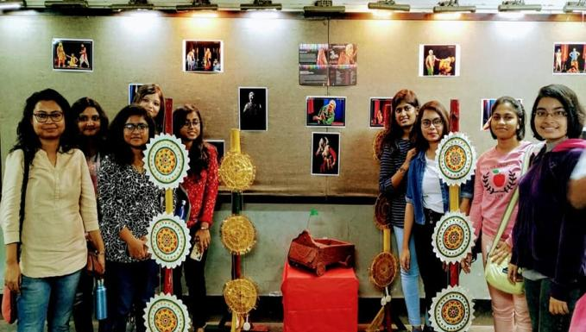**Date** – 29.11.2019

**Time** – 6:30PM – 8:30PM

**Venue**- Academy

**Brief Description of the event** -On 29th November 2019, students from the first Semester, (batch of 2019- 2021) experienced a dramatic performance of the play 'Mrichchhakatika', which is part of their syllabus. It was performed by the renowned theatre group Naye Natua, and was directed by thespian Goutam Haldar. It is undeniable that a play is primarily written for the stage and not for reading.

**Outcome** -The purpose behind the visit to theatre is to ensure that the students discover myriad possibilities of interpreting a dramatic text. Experiencing the play from the perspective of a performance also enables the students to analyze the text from a different light and therefore leads to an all-encompassing comprehension.

**Number of Participants**- 6

**47.Title** - Revelio’19

**Category** – Departmental Fest

**Organizing Unit** – English Department, RKSMVV

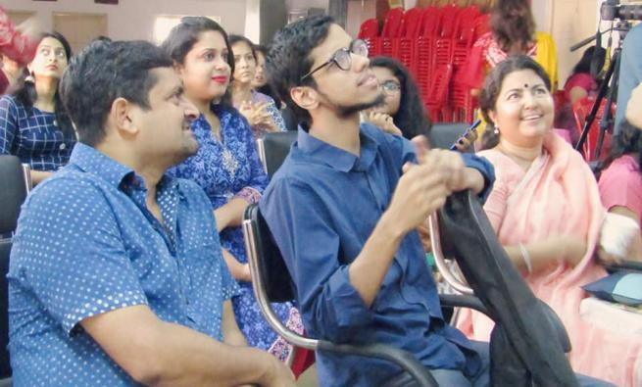**Date** – 17.11.2019

**Time –** 10 AM -04 PM

**Venue** – College Auditorium

**Resource Persons** - Dr. Sipra Mukherjee, Professor in the English Department at West Bengal State University,Kabir Chattopadhyay, lyricist, musician and PhD Scholar at Trinity University, Dublin, Upal Sengupta, singer and cartoonist

**Brief Description of the Event** - On 17th November, 2019, English department organized a literary and cultural fest for the students. Sessions on literature included “Translating the Margins: Facts, Fictions and Findings” by Dr. Sipra Mukherjee and “Performance and Songs as the Confluence of Music” by Kabir Chattopadhyay. A workshop on cartoons was conducted by singer and cartoonist Upal Sengupta for students. Students also participated in a competition based upon their performances of original composition of a song, a dance, a slam poem, a doodle, a monologue, a dialogue or a design.

**Outcome** - The purpose of the departmental fest is to break the monotony of the year-long academic pressure. Revelio’19 was a perfect blend of academic, co-curricular and performance-oriented workshop cum fest that celebrates literature as well as many facets of creative outpourings.

**Number of participants** – 42

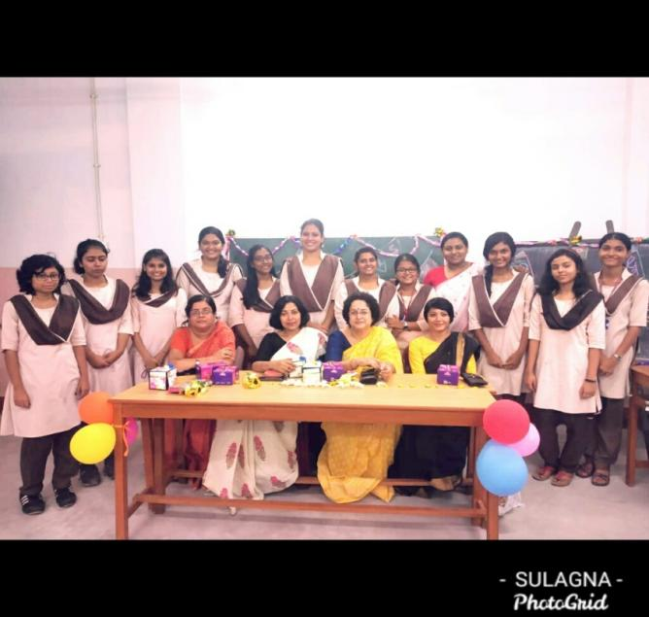**48.Title**- Teachers’ Day

**Category** – Cultural

**Organizing Unit**- Department of English, RKSMVV

**Date**- 05.09.2019

**Time-** 02:00 PM

**Venue**- Room 16

**Brief Description of the Event** -On 5th September 2019, students of the department of English celebrated Teachers' Day by presenting a short cultural program. Such occasions offer the students to be creative, imaginative and showcase their talent in the home-ground.

**Outcome**- As the students prepare on their own a program full of cultural performances the students get an opportunity to explore their co-curricular activities.

**Number of Participants**- 23

**49.Title** – Postmodernism

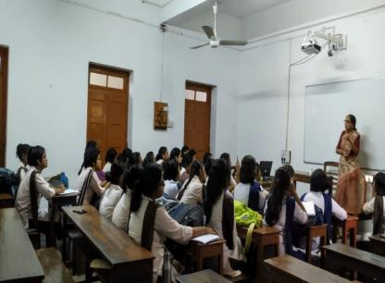**Category** – Extension Lecture

**Date** -16. 08.2019

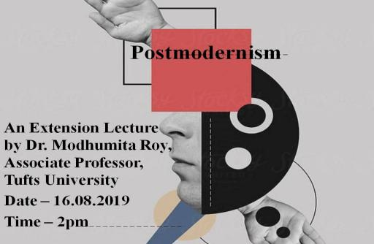**Time** – 2 pm

**Venue** – AV Room

**Resource Person** - Dr. Modhumita Roy, Associate Professor, Tufts University

**Brief Description of the event** – On 16th August, 2019, Dr. Modhumita Roy, Associate Professor, Tufts University delivered a lecture titled “Postmodernism”.

**Outcome** -The extension lecture, organized by the department of English aimed to introduce the students with the rudimentary concepts of Postmodernism. For the uninitiated, the term ‘Postmodernism’ poses a number of difficulties in terms of theoretical definition as well as deciphering its characteristics in a literary work. By incorporating simple examples into her lively discussion, the speaker not only explained the term but also demonstrated the means of applying the abstract theory into the analysis of a literary text.

**Number of participants** – 12

**50.Title**- Shakespeare’s Day Celebration

**Category**- Cultural

**Organizing Unit**- Department of English, RKSMVV

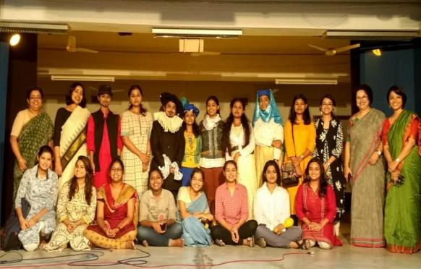 **Date**-24.04.2019

**Time** – 12:30

**Venue**- College Auditorium

**Brief Description of the event**-On 24th April, 2019 students of the English Department presented a short play 'Shakespeare Lives’ to commemorate Shakespeare's 455th birthday. The script was written and directed by the students, and was performed under the guidance of the Departmental professors. Costumes and stage set-up were also the idea of the students.

**Outcome**-For the students it served not merely as a learning process on the creative aspect, it also demonstrated the significance of team-effort**.**

**Number of Participants - 42**

**51.Title** - Heart of Darkness

**Category** - Extension Lecture

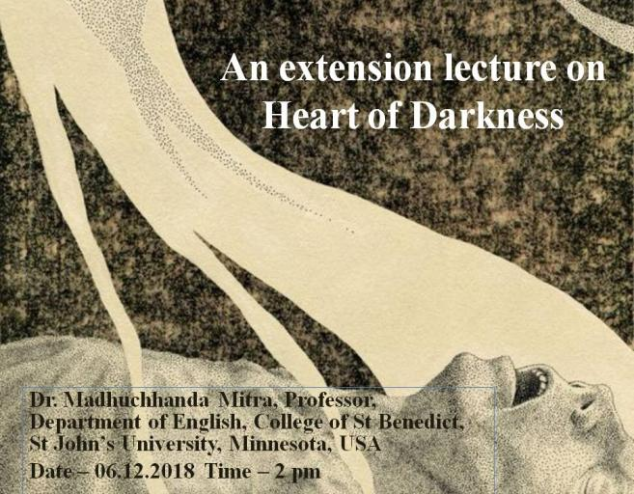**Time** – 6.12.2018

**Venue**- AV Room

**Brief description of the event**- An introductory lecture on the text *Heart of Darkness* was presented by Dr. Madhuchhanda Mitra, Professor, Department of English, College of St. Benedict, St. John’s University, Minnesota, USA on 6th December, 2018.

**Outcome**- The objective of the lecture was to introduce the students with the various challenges the text poses for the uninitiated. Conrad’s one of the most renowned texts *Heart of Darkness* requires both a thorough discussion on the contextual details as well as an analysis of the novelist’s experimental approach to writing modernist novel. The extension lecture offered an engaging session for the students who learnt to recognize the intertwined relation between the form of the novel with the colonial context that goes above and beyond the classroom discussion of the text.

**Number of Participants** – 15

**52. Title** – “The Human Body in Gothic Literature & Films”

**Category**- Extension Lecture

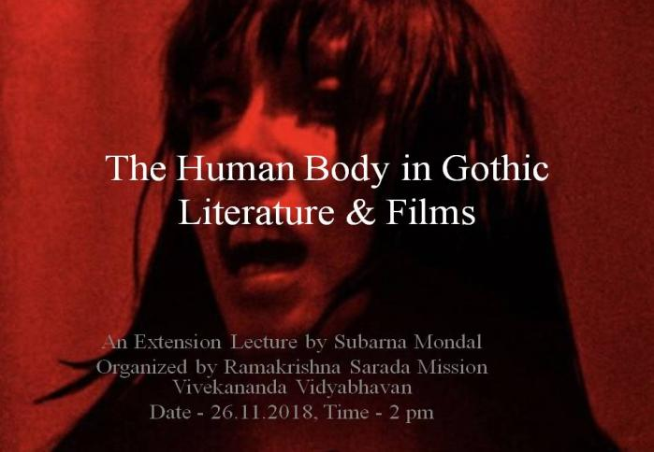**Date** - 26.11.2018

**Time** – 2 pm

**Venue** – AV Room

**Resource Person** - Subarna Mondal, Assistant Professor, P.R. Thakur Government College

**Brief Description of the Event** - An Extension Lecture titled “The Human Body in Gothic Literature & Films” was presented by Subarna Mondal, Assistant Professor of P.R. Thakur Government College on 26th August 2018.

**Outcome** - The lecture introduced the students with the various aspects of the Gothic genre especially with a focus on the representation of human body in films and literature. The preoccupation with human bodies in Gothic, whether in films or in literary texts generate certain significant questions. The lecture attempted to answer such inevitable questions and thereby enabled the students to perceive the genre with greater understanding.

**Number of Participants –** 12

