Sanju Lal 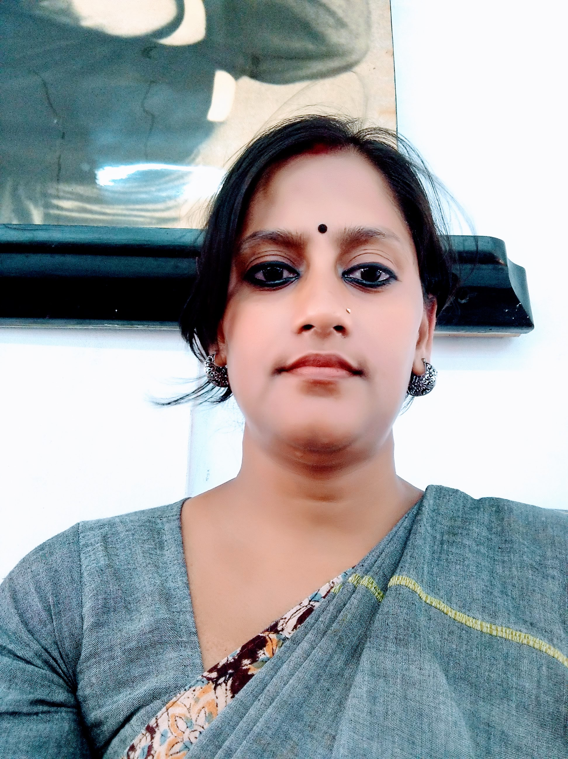
General Information
Department: Political Science
Designation: Political Science
Qualification: M.A
Specialization: Public Administration
Email:Sanjulal1202@gmail.com

Teaching Experience
Name of Institution (period) (only if any full-time position held earlier)
RKSMVV (07.07.2008- Present)

Research Interests

1. Aurobindo’s Thought on Education

Publication
Books
- Book Chapter: National Development: Emerging Issues Edited by Rajyasri neogy, Arnab Kumar Banerjee and Santanu Banerjee, article name’s Local Self Govt. in India, 1st Edition: 28 February 2019, ISBN: 978-81-938439-3-2, Published by Piyali Chakraborty on behalf of Kalyani Foundation for Media Science and Community Research.pg 77-93

Articles in Journals/ E – journals

- An International Peer Reviewed International Journal named Education Research & Analysis issue: 1.2, Volume-6 , April,2019, Article named Social Awareness Through Education. , ISSN: 2348-571X pg 41-45
- An International Peer Reviewed International Journal named Education Research & Analysis, issue: 1.3, Volume-6 , April 2019, Article named Gender Discrimination At Working Place , ISSN: 2348-571X pg 43-48

- National Development: Emerging Issues Edited by Rajyasri neogy, Arnab Kumar Banerjee and Santanu Banerjee, article name’s Local Self Govt. in India, 1st Edition: 28 February 2019, ISBN : 978-81-938439-3-2, Published by Piyali Chakraborty on behalf of Kalyani Foundation for Media Science and Community Research.pg 77-93
- An International Peer Reviewed International Journal named Education Research & Analysis, issue: 2, Volume-7, July 2020, Article named Did the Speaker Suffer from Disqualification on Ground of Defection? ISSN: 2348-571X. pg 10-17
- An International Peer Reviewed International Journal named Education Research & Analysis, issue: 1, Volume-8, January 2021, Article named Digital Education in Higher Education, Environment Consciousness and Green World Movement During Pandemic in West Bengal and Bangladesh , ISSN: 2348-571X.pg 59-63
- An International Peer Reviewed International Journal named Education Research & Analysis, issue: 2, Volume-8, July, 2021, Article named Status of Women In Social Movement In India , ISSN: 2348-571X. pg 15-21
- An International Peer Reviewed International Journal named Education Research & Analysis issue: II, Volume-9, July 2022, Article named Democracy: Past, Present and Future In India , ISSN: 2348-571X. pg 27-33

Seminar/ Conference Proceedings
- UGC Approved an International Peer Reviewed International Journal named Education Research & Analysis, issue: 1.1, Volume-5 , January 2018, Article named Girl child education in rural India. , ISSN: 2348-571X pg83-86

Invited Lectures/ Paper Presentation
- International Multidisciplinary Webinar on “New Trends In Education” jointly organized by International Benevolent Research Foundation(IBRF), Kolkata, West Bengal, Hiralal Mazumdar Memorial College For Women, West Bengal , Confederation of Indian Universities , New Delhi.

- International Webinar on Higher Education during Covid-19: The Situation in West Bengal and Bangladesh jointly organized by Kanyashree University, Krishnanagar, West Bengal.

Seminar/ Conference Proceedings
- Paper Title: “Girl Child Education in Rural India” in the International Seminar on Multidisciplinary Research Organized by Vijaygarh Jyotish Roy College in collaboration with Education Research and Analysis, Kalyani Foundation for Media Science &Community Research, held on 29th January, 2018.

- Paper Title: “Distressed Childhood In Modern Culture”: Department of Education-West Bengal State University In Collaboration with Ramakrishna Sarada Mission Vivekananda Vidyabhavan and Byanjanbarna Foundation Organised two-days Internaional Seminar on Reflections of Chilhood and Adolescence in Literature, Culture and Psychology held on 26th &27th July, 2018.

- Paper Title: “Working Women and their Problems”: Organised by Diamond Harbour Women’s University two-days International Seminar on Contemporary Issues of Women Education in the Global Context held on 3rd &4th September 2018.

- Paper Title: “Religious Influence on Politics in India”: Maulana Abul Kalam Azad Institute of Asian Studies (MAKAIAS) sponsored International Conference on Nationalism, Ethnicity, Religion and Security in South Asia Organised by Department of Political Science, Kazi Nazrul University in Collaboration with The Centre for South and South East Asian Societies and Bengal Institute of Political Science held on 3rd September,2018

5. Paper Title: “Violation of GIRLS’ Right in India” International Conference on the theme Status of GIRL in Society –The Indian and Global Perspectives held on 10th October, 2018.

Awards/ Fellowships/ Grants

Administrative Responsibilities in College
1. HOD, Department of Political Science (2022-24)
2. Convenor- Infrastructure Sub-committee
3.Member- Student’s Welfare Committee

