|  |  |  |
| --- | --- | --- |
| **ACADEMIC ACHIEVEMENT** | | |
| **NAME** | **PERCENTAGE** | **RANK** |
| **2015 - 2018** |  |  |
| Swapna Sarkar |  | 5 |
| Namita Adhikari |  | 6 |
| Indrani Mondal |  | 7 |
| **2016 - 2019** |  |  |
| Pallabi Mondal |  | 1 |
| Sreyashri Karmakar |  | 3 |
| Ritu Polley |  | 5 |
| Mithu Dey |  | 7 |
| Bina Bali |  | 9 |
| **2017 - 2020** |  |  |
| Mousumi Ghosh | 81.88% | 1 |
| Supriya Mondal | 73.38% | 8 |
| **2018 - 2021** |  |  |
| Sarada Bera | 84.9% | 1 |
| Riya Mondal | 84.45% | 2 |
| Raritri Paul | 81.9% | 3 |
| Hritu Mukherjee | 78.6% | 8 |
| **2019 - 2022** |  |  |
| Tanusree Mondal | 86.85% | 1 |
| Swagata Saha | 85.05% | 3 |
| Moumita Biswas | 83.55% | 6 |
| Priti Roy | 83.1% | 8 |
| **2020 – 2023** |  |  |
| Arpita Dalui | 82.95% | 1 |
| Usha Hazari | 81.45% | 4 |
| Priyanka Guin | 80.85% | 5 |
| Smriti Mondal | 77.1% | 8 |
|  |  |  |

**CO-CURRICULAR ACHIEVEMENT**

**Shuvasree Dey - 1st semester - Creative Dance - 2nd**

**Arpita Dolui - 1st semester - Creative Dance -2nd**

**2022**

**Menakshi Mondal - 5th seme - Rabindranritya - 1st**

**Megha Bahadur - 3rd Semester - classical Dance - 1st**

**Antara Das - 1st Sem - Rabindranritya - 2nd**

**2023**

**Megha Bahadur - 5th seme - Classical dance - 1st**

**Antara Das - 3rd seme - Creative Dance - 1st**

**Antara Das Rabindranritya - 2nd**

**Sudeshna Pal - 3rd seme - Bhajan - 2nd**

**Rika Das - 3rd seme - Alpana -1st**

**Sagarika koley - 1st seme - Painting - 1st**

**Sagarika Koley - Sanskrit Recitation - 3rd**

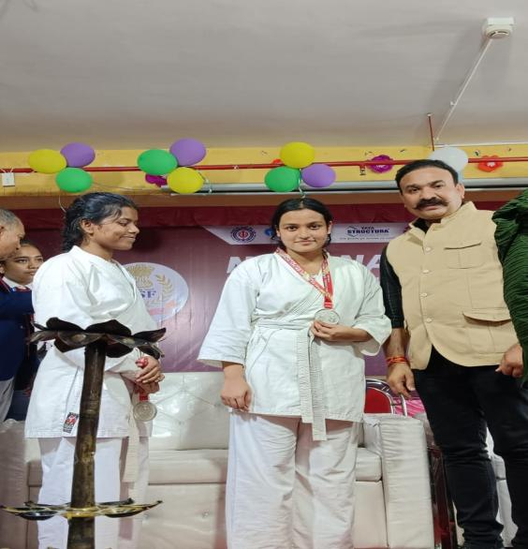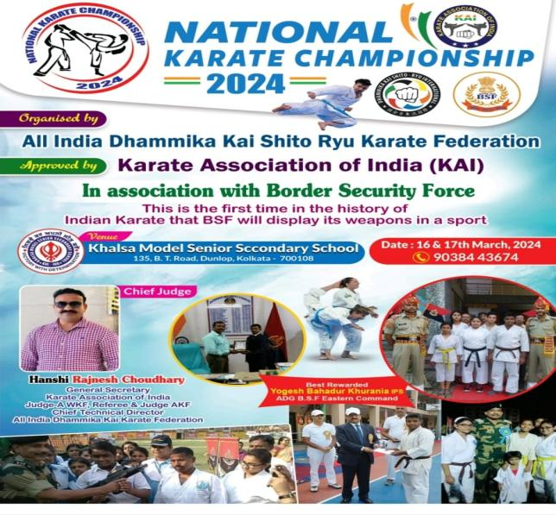

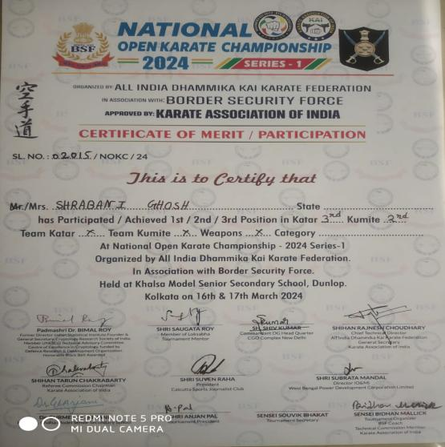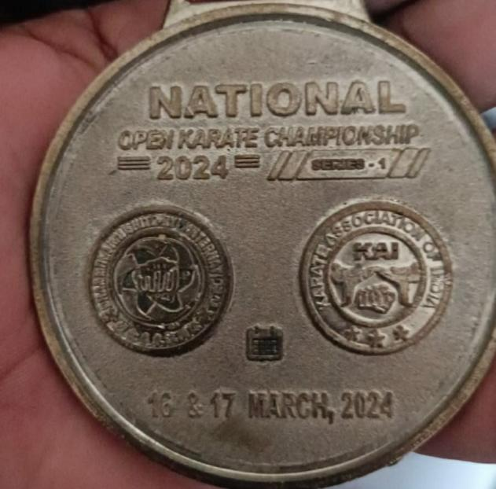

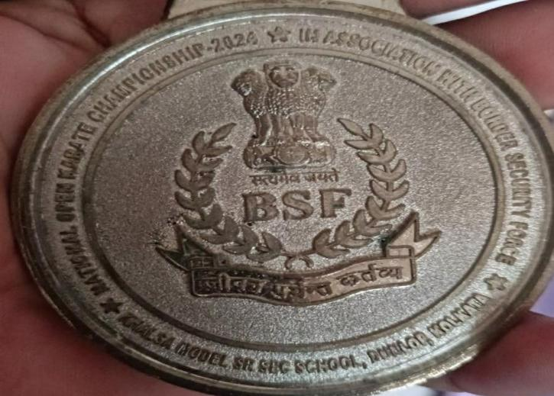

SHRABONI GHOSH, IST IN KARATE & 2ND IN KATA (International Karate Championship)

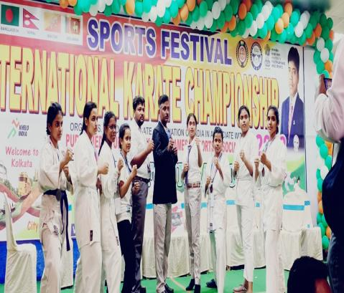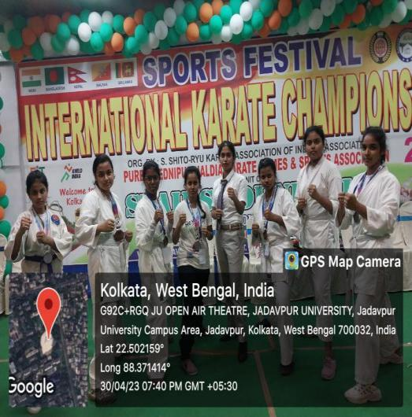

SHRABONI GHOSH, NEHA DAS

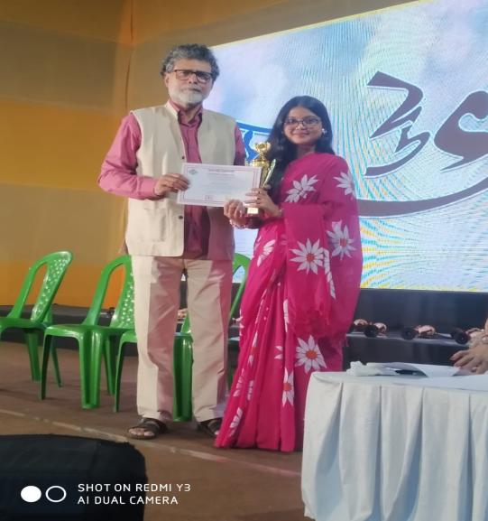

MEGHA BAHADUR

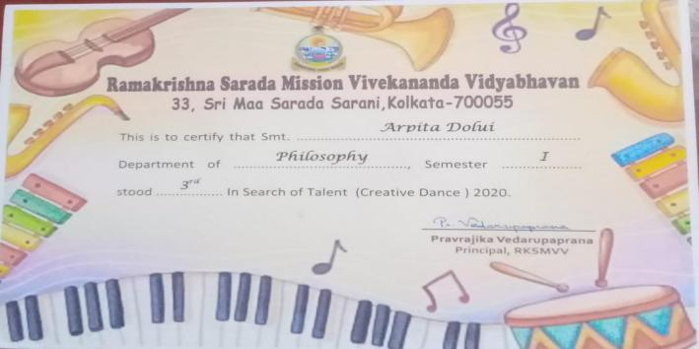

ARPITA DALUI

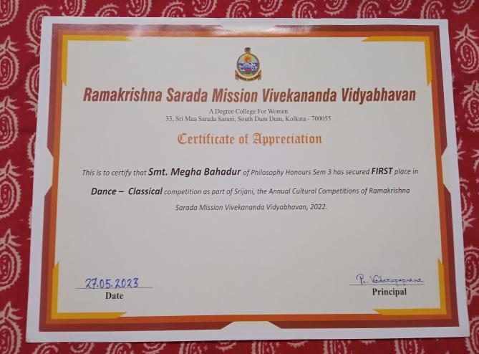

MEGHA BAHADUR

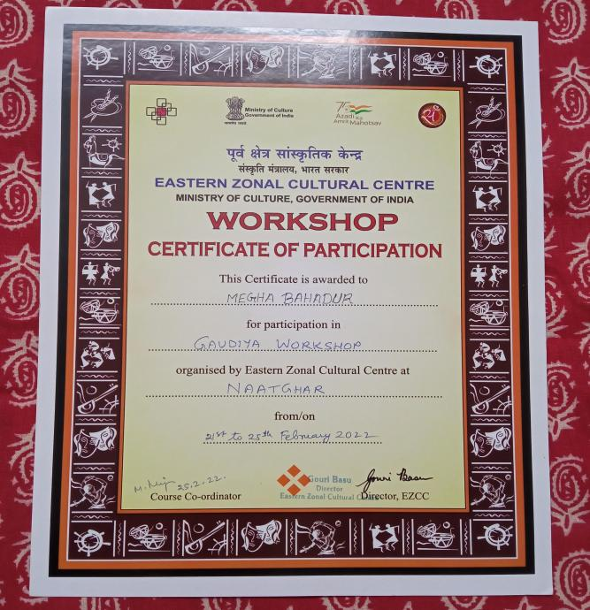

MEGHA BAHADUR

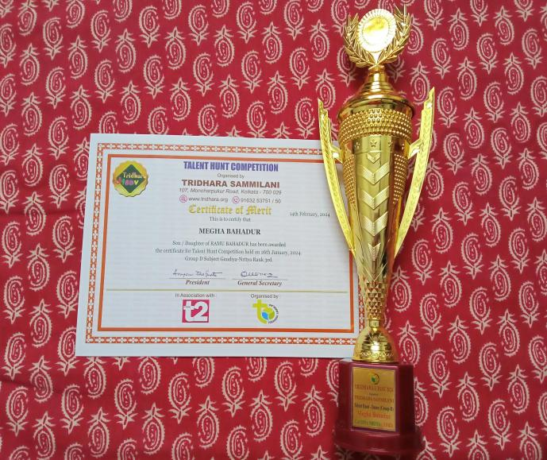

MEGHA BAHADUR

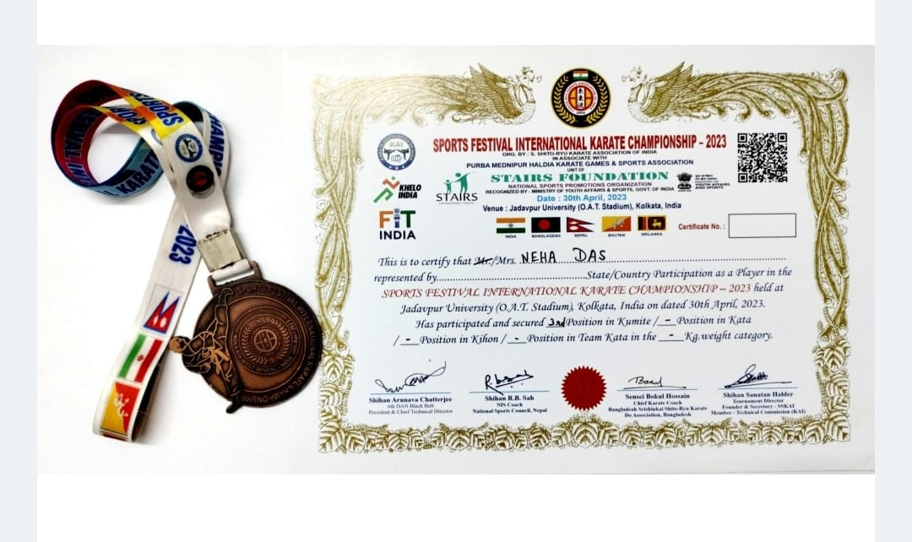

NEHA DAS

**Our Star achiever -**

**SNIGDHA MONDAL**

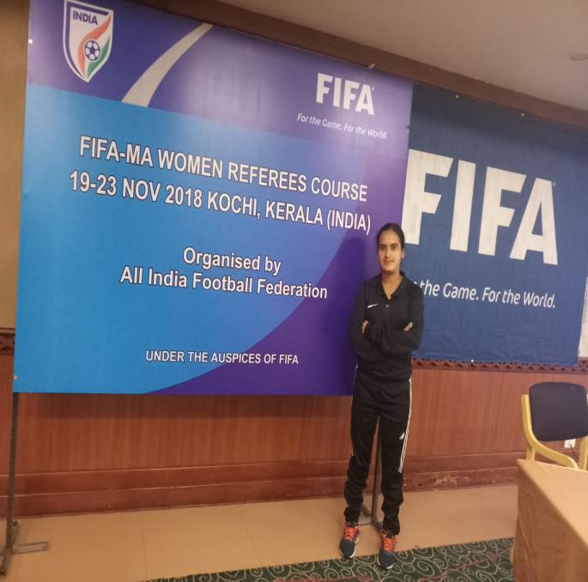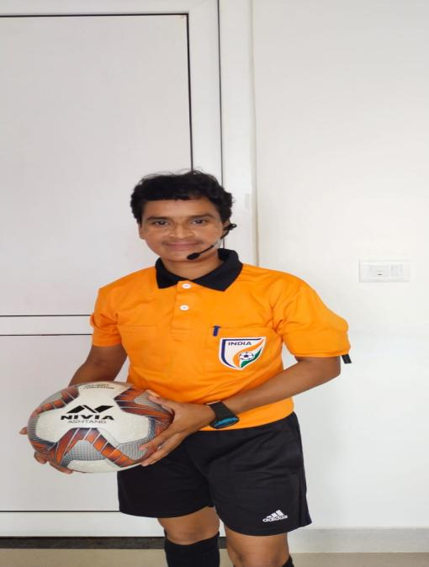

**One of our ex-students, Smt. Snigdha Mondalhas made us proud . She is a pass out of Department of Philosophy, 2004-2006 batch.**

**She ranked Ist in School Service Examination in 2011.**

**She joined as Assistant Teacher of Mitra Institution (Bhowanipur) in 2011.**

**Snigdha is also a Gold medalist in Physical Education from Calcutta University, 2012.**

**She got the award of National Player of Bengal (Hand Ball), in 2012.**

**Apart from this, Snigdha at present is also the “Active National Referee of AIFF (All India Football Federation , New Delhi).**

**She also coaches our students in various sports activities and train them for outdoor games.**

**Snigdha’s Officiating & Participation information are given below :------**

**1. FIFA MA ELITE WOMEN'S REFEREE COURSE -- 2021**

**2. HERO INDIANS WOMEN'S LEAGUE - 2020-2021(BHUBANESWAR )**

**3. KHELO INDIA UNIVERSITY GAMES -- BHUBANESWAR, GUWAHATI, CHENNAI LUCKNOW,PUNE**

**4. U -- 17 WOMEN'S FOOTBALL CHAMPIONSHIP --209 (KALYANI )**

**5. SENIOR WOMEN'S NATIONAL FOOTBALL CHAMPIONSHIP -- 2019 (ARUNACHAL PRADESH )**

**6. SUBRATA CUP FOOTBALL TOURNAMENT --2019, 2023,2024(WEST BENGAL )**

**7. SUB JUNIOR GIRL'S NATIONAL FOOTBALL CHAMPIONSHIP --2018 ( ODDISHA - CUTTACK, )**

**8. FIFA MA WOMEN'S REFEREE COURSE -- 2019 (KERALA - KOCHI)**

**9. JUNIOR GIRL'S NATIONAL FOOTBALL CHAMPIONSHIP --2019( KOLHAPUR )**

**10. KHELO INDIA YOUTH GAMES --2019 (PUNE )**

**FIFA MA WOMEN'S REFEREE COURSE -- 2018 (KERALA - KOCHI )**

**12. SENIOR WOMEN'S NATIONAL FOOTBALL CHAMPIONSHIP -- 2018 (ODDISHA - CUTTACK )**

**13. U - 18 YOUTH LEAGUE (PLAY OFF) KOLKATA**

**14. U - 13 YOUTH LEAGUE (FINAL ROUND )KOLKATA**

**15. U - 13 YOUTH LEAGUE (ZONAL ROUND )KOLKATA**

**16. PREMIER SKILL LEVEL 2 COURSE -- 2017(MUMBAI )**

**17. SENIOR WOMEN'S NATIONAL FOOTBALL CHAMPIONSHIP -- 2017( CUTTACK)**

**18. U - 15 YOUTH LEAGUE (ZONAL ROUND)KOLKATA**

**19. FIFA MA WOMEN'S REFEREE COURSE -- 2017 (GWALIOR )**

**20. SUB JUNIOR GIRL'S NATIONAL FOOTBALL CHAMPIONSHIP -- 2017 (IMPHAL )**

**21. JUNIOR GIRL'S NATIONAL FOOTBALL CHAMPIONSHIP -- 2017(GOA)**

**22. WEST BENGAL STATE INTER COLLEGE FOOTBALL TOURNAMENT FOR BOYS ---2018, 2019(SALT LAKE STADIUM ).**

**23. Khelo India youth Games 2023 at Lucknow**

**24. Khelo India University games 2023 at Chhenai**

**25. Sub Junior national football championship RAJASTHAN 2023**

**26. Juniour National Football championship 2024 Karnatak**

**27. Seniour National football championship (zonal) 2024 at Andhrapradesh**

**28. Indian Women's League 2024 at Navi Mumbai**

**29. Seniour National football championship (final round ) 2024 at Chhatishgarh.**

