Name of the Activity: Trends in Mesopotamian Bronze Age Economy
Category: Extension Lecture
Organising Unit: Department of History, RKSMVV
Date: 17/01/2023
Time: 12.15pm—1.30 pm
Venue: History Room 15
Name of the Resource Person: Dr. Prasenjit Biswas, Associate Professor, Department of History, Bhairab Ganguly College, Belghoria, North 24 Parganas
Number of the Participants: 26
Brief Description: This lecture was organised for the First Semester students, who were little hesitant as their Core Course 1began with an Ancient Civilization, about which they are not fully aware.
Programme Outcome: The lecture delivered by Dr. Biswas was insightful and analytical enough to let them know the agrarian roots of and fertile crescent of the urban and commercial economy without which social surplus would not have been enough for a growing temple state and state. The students were curious to know the connections between Urban Revolution and the Neolithic Revolution.
Flyer

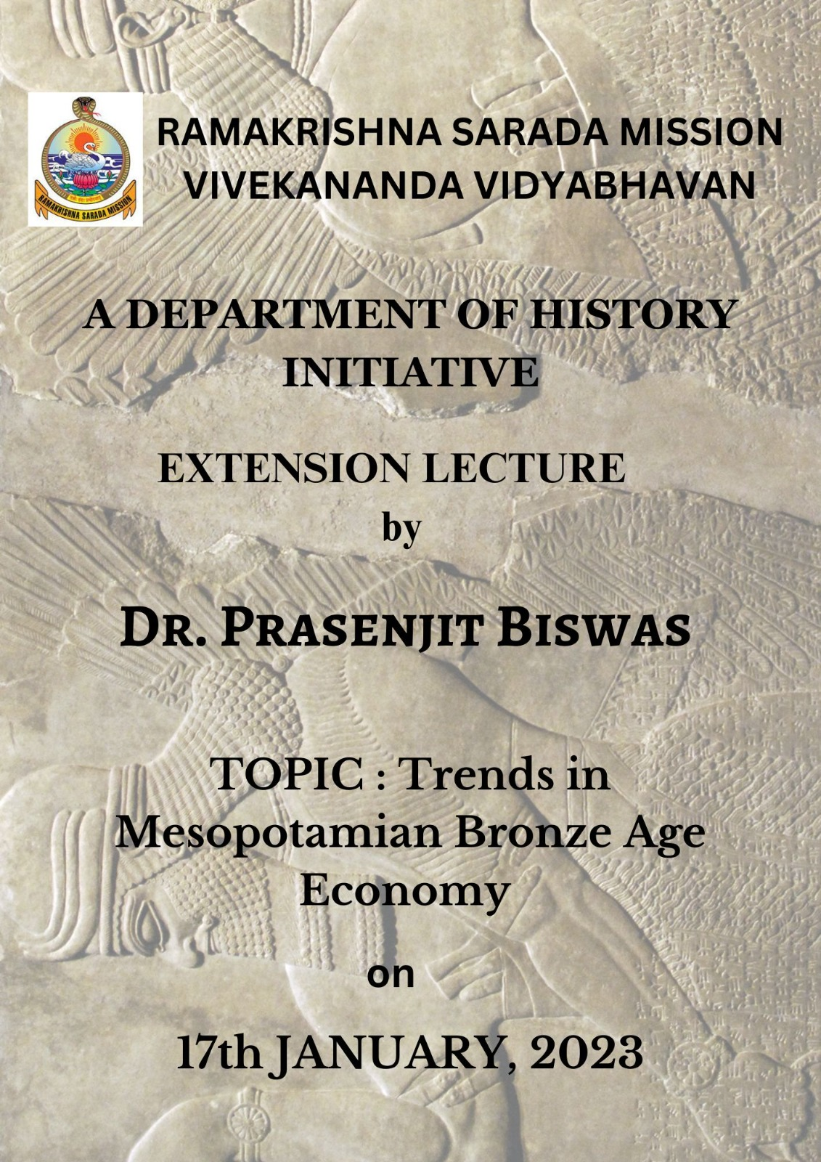

Geotagged photos
