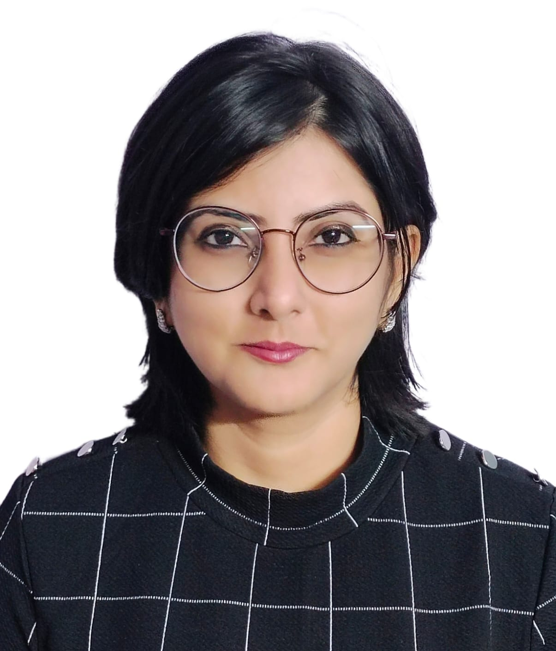

SREEJAYA CHATTERJEE
General Information
Department | Journalism and Mass Communication
Designation | State Aided College Teacher
Qualification | M.A., B.Ed.
Specialization | Advertisement and Society.
Email | sreejaya.chatterjee@rksmvv.ac.in

Teaching Experience

Ramakrishna Sarada Mission Vivekananda Vidyabhavan – 4th December, 2010 – till date.

Research Interests
- Development Journalism
- Digital and Social Media
- Advertising and Society
- Musical Communication

Publication

Chapters in Book

1. “Changing Pattern of Education in The New Media Era- A Study” published in NEW MEDIA IN INDIA: CURRENT TRENDS AND FUTURE PROSPECTS, A SERIES OF ESSAYS, Chief editor Dr. Sumit Narula, Utkarsha Publishers, ISBN: 978-93-84312-76-3, March 2016

2. “Women- A Product Itself in Advertisement: A Longitudinal Content Analysis” published in MEDIA TEACHING, Editor Dr. Arnab kumar Banerjee, Rupali, ISBN: 978-93-81669-84-6, 2016

3. “Byakhyamulak Sangbadikota”, published in Sambadpatro Sangbadikata- Tattwo Theke Proyog , ed. Pallab Mukhopadhyay, Byanjonbarno, ISBN: 978-93-84729-12-7, May 2016

4. “Sangbader Sampadakiyakaran”, published in Sambadpatro Sampadana- Tattwo Theke Proyog, ed. Pallab Mukhopadhyay, Byanjonbarno, ISBN: 978-93-84729-26-4, April 2016

5. "COVID-19: A Catalyst for E-Commerce Following a Transition in Buyer Behaviour–A Study" published in COVID 19–The Showcase of Potential in Indian Economy, Editor-Prof. (Dr.) Amarjeet S. Khalsa, Excel India Publishers, ISBN: 978-93-91355-05-0 (e-Book), July 2021

6. "Empowering Women Through ICT - A Critical Literature Review" published in GST – The New Inclusive Growth Model of India, Editor- Prof. (Dr.) Amarjeet S. Khalsa, Excel India Publishers, ISBN: 978-93-91355-00-5 (Paperback), 978-93-91355-01-2 (e-Book), July 2022

Articles in Journals/e-Journals

1. “Scope of RTI Towards Ensuring an Accountable Panchayat System” in Global Media Journal, Indian edition, University of Calcutta (WINTER ISSUE/ DECEMBER 2010) edited by Prof. Saumendranath Bera and Prof. Buroshiva Dasgupta. [ISSN 2249 – 5835 Global Media Journal Indian (Online)]

2. "Panic Buying: A Pandemic Stress Syndrome –An Observation in Reference to Covid-19" published in International Refereed Peer Reviewed Interdisciplinary Journal, former UGC Journal no. 64674,"Education, Research & Analysis", Volume 7, Issue - 2, July 2020, Chief Editor - Santanu Banerjee, ISSN: 2348-571X, pp 37-44

3. "Theoretical Framework for Social Media Marketing" published in International Refereed Peer Reviewed Interdisciplinary Journal, former UGC Journal no. 64674,"Education, Research & Analysis", Volume 9, Issue - 2, July 2022, Chief Editor - Santanu Banerjee, ISSN: 2348-571X, pp 35-40

4. “Impact of Social Media in Women Entrepreneurship – Unlocking Potentials for Business Success” published in Journal of Mines, Metals and Fuels, Volume-71, Issue 5, May 2023, Editor- P.K Chanda, Print ISSN: 0022-2755, pp 661-670

5. “Looking at Women Empowerment Through the Window of Entrepreneurial Culture: A Quantitative Analysis on Select Women Entrepreneurs of North 24 Parganas, West Bengal, India” published in Third Concept: An International Journal of Ideas, Volume – 37, no. 436, June 2023(Special Issue), Editor- Babuddin Khan, ISSN – 0970-7247, pp 91-101

Articles in web portals/online portals

1) “Women Smokers on Rise -A Trend and A Tendency”

http://www.youthensnews.com/article/women-smokers-on-rise-a-trend-and-a-tendency/

2) “ ‘Selfie’ Craze Undying But People Are Dying!”

http://www.youthensnews.com/article/selfie-craze-undying-but-people-are-dying/

3) “Will it be a gay moment for India’s gay-rights movement?”

http://www.youthensnews.com/article/homosexuality/

4) “CM directs not to see political colours while taking action against syndicates.

http://www.youthensnews.com/article/cm-directs-not-see-political-colours-taking-actionsyndicates/

5) “ ‘MODI’fied ban on Rs 500 and Rs 1000 currency notes!!!”

http://www.youthensnews.com/article/modified-ban-rs-500-rs-1000-currency-notes/

6) No Indian University in Top 100 – An Analysis of its Deficiencies.

http://www.youthensnews.com/article/no-indian-university-in-top-100-an-analysis-of-its-deficiencies/

7) A Bestowal For PM: ‘Netaji’ Jacket

http://www.youthensnews.com/a-bestowal-for-pm-netaji-jacket

8) Recycling Significance to Waste Management – A Call for Rethinking of ‘Waste’

https://newssense.in/2021/07/25/recycling-significance-to-waste-management-a-call-for-rethinking-of-waste/

9. Onishchoyotar Haatchhani in Ahharnish (online), Dwitiyo sonkolon, pp 89-90

https://drive.google.com/file/d/1rwq3TJSxDsLLCxoQ7Tr6v7JDngBSnaiT/view

Papers presented:

1. Paper presented in a National Seminar on "New Media in India: Current Trends and Future Prospects” on 30th March, 2016, organized by Amity School of Communication, Amity University Madhya Pradesh. Topic : "Changing Pattern of Education in the New Media Era- A Study ”

2. Paper presented in IPER's 5th National Conference on "COVID 19–The Showcase of Potential in Indian Economy" on 31st July, 2021, organised by Institute of Professional Education and Research (Group of Institutions) Bhopal & Confederation of Indian Industry, Madhya Pradesh. Topic : "COVID-19: A Catalyst for E-Commerce Following a Transition in Buyer Behaviour–A Study".

3. Paper presented in IPER's 6th National Conference on "GST – The New Inclusive Growth Model of India" on 1st July, 2022, organized by Institute of Professional Education and Research (Group of Institutions) Bhopal & Confederation of Indian Industry, Madhya Pradesh. Topic : " Empowering Women Through ICT - A Critical Literature Review".

4. Paper presented in the International Conference on Engineering Design and Computing (ICEDC)- 2023 organized by Swami Vivekananda University and Technically cosponsored by IEEE Kolkata Section, held on 28th-29th January 2023. Topic : “Impact of Social Media in Women Entrepreneurship- Unlocking Potentials for Business Success”

5. Paper presented in the Two days International Seminar on Recent Trends or, Challenges in Social, Cultural and Educational Sectors: An Overview, organized by Department of Education, Jadavpur University in collaboration with Byanjanbarna Foundation held on 7th-8th February 2023. Topic : “Empowerment of Women Entrepreneurs of Small Medium Enterprises Using Social Media”

6. Paper presented in the 3rd International Conference on Multidisciplinary Research in Current Era, held on 18th March, 2023, organized by Research Solutions Global, Gurugram in association with Department of Psychology, Muralidhar Girls' College, Kolkata. Topic : “A Study of the Influence of Social Media on Women Empowerment with Mediating Role of Self-Efficiency in North 24 Parganas, West Bengal: An SEM Approach”

7. Paper presented in the International Conference on Literature, Media &Cultural Studies: Symbiosis & Emerging Trends, held on 28th April, 2023, organized by School of Humanities and Social Sciences (Dept of English, Journalism and Mass Communication and Education, Swami Vivekananda University, Kolkata. Topic: “Looking at Women Empowerment Through the Window of Entrepreneurial Culture: A Quantitative Analysis on Select Women Entrepreneurs of North 24 Parganas, West Bengal, India”

8. Paper presented in the International Conference on Innovation and Advancements in Management and Social Science, held on 28th September 2023 – 30th September, 2023, organized by School of Management, Swami Vivekananda University, Kolkata. Topic: “Women in Small and Medium Enterprises: Embracing Social Media for Women Entrepreneur’s Economic Empowerment and Well-being – A Qualitative Analysis on Select Women Entrepreneurs of North 24 Parganas, West Bengal”

Administrative Responsibilities in College
- Member of Cultural sub committee
- Member of Placement Cell

Honorary Posts/Positions Held

1. Associate Member, Public Relation Society of India from 16th July, 2021 till date.

2. Columnist, News Sense (The digital first Solutions Journalism initiative focused on Solutions Stories and Fact Check) from 22nd October, 2017 till date.

