Name of Activity: Kolkata International Book Fair, Visit
Category: Extension Activity
Organizing Unit: Department of Bengali
Date: 03.02. 2023.
Time: 12.00 noon
Venue: Salt Lake Book Fair Ground
Number of participants: Students of Semester II & IV (15 students)
Brief description of the event: Students of Bengali Department were taken to Kolkata International Book Fair on 03.02. 2023.
The outcome of the Event: A book fair visit always is a golden opportunity for the students to get informed about the recent currents of literature and other socio-political, historical, scientific research. It also helps them to collect their references, study materials.

Flyer:
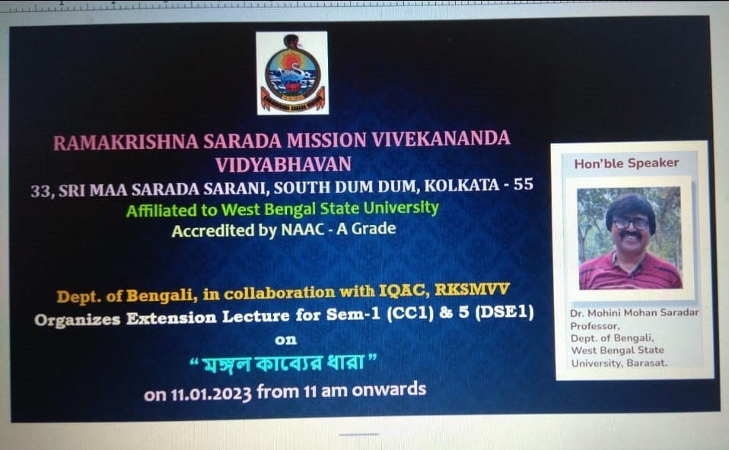

Geo-tagged photos:
