Name of activity: Workshop on ‘Hire Smart: the smart way to get hired’
Category: Students’ Workshop
Organising unit: RKSMVV Placement Cell and IQAC, in collaboration with ELTA GLOBAL
Date: 4th April 2023
Time: 11.15 am – 2.15 pm
Venue: Swamiji Bhavan, RKSMVV
Name of the Resource person/s (with designation):
- Debarati Roy, founder & trainer, ELTA GLOBAL
- Shamim Ahmed, trainer, ELTA GLOBAL
Number of participants: 90
Brief description of the event: This is a women empowerment project of RKSMVV.The event, organized for the final semester students, was planned as an extensive skill-building session to familiarize the outgoing batch with the interview process. Around 15 students from the partner institution, Bhairab Ganguly College, accompanied by a faculty member, were also present. The trainers Debarati Roy and Shamim Ahmed focussed on interview skills and covered all facets of job interviews, including resume writing, self-presentation, interviews, and group discussions.
Programme Outcome:
English for Business Purpose aims at 100% College Employability Access. The students of Semester 5 present in the workshop greatly benefitted from the interaction with the expert trainers, who clarified several doubts about interview skills and the current job market. This three-hour English Competence Workshop with experts taught the students smarter ways to prepare for a Job where they learned tips on Resume Writing, Interview Skills, Group Discussion Methodology, Art of Self-presentation, Group Presentation Skills, Email writing tips and Mastering Body language.

Flyer:
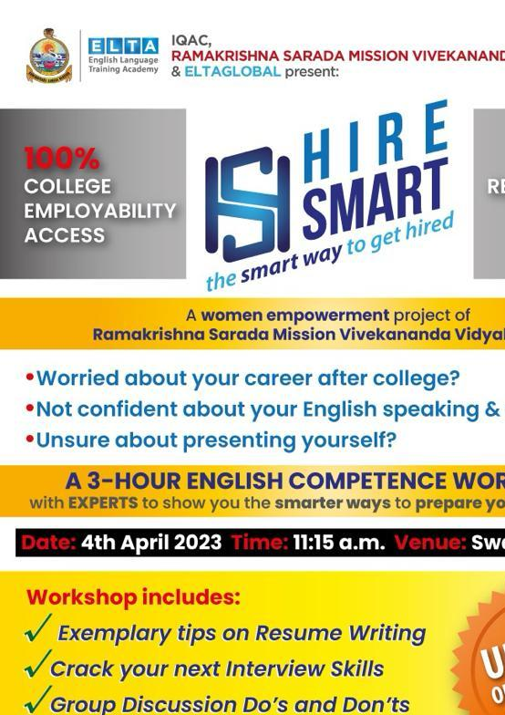

Geo-Tagged Photos
