  - Name of the Activity : World Environment Day Celebration
  - Category : Student’s activity
  - Organising unit : Geography Department & NSS Unit of RKSMVV.
  - Date : 05/06/2023
  - Time : 2pm-3pm
  - Venue : RKSMVV, Muktiprana Auditorium.
  - Number of students : 120 students
  - Number of Resource Persons : Students of SEM-II of the Geography Dept.
  - Number of Participants : 22
  - Number of Beneťciaries : All students, teachers & staffs of RKSMVV
  - Brief Description of the event : The celebration of World Environment Day started with the inauguration speech of our respected Principal Mataji. Thereafter, our IǪAC Coordinator Dr. Chaiti Mitra delivered her speech regarding the serious effects of plastic pollution of recent times. Next, all the participants highlighted the issue of environmental awareness through a very beautiful cultural program. Some of them tried to explain the issue of plastic pollution by making a slide-show presentation about what plastic pollution is and how plastic is destroying our environment. The NSS Unit of our college along with all students & teachers present in the auditorium took a pledge for not destroying our mother earth through irrational use of plastics. The program ended with our national anthem. This session was of 1 hour in duration (2pm-3pm).
  - Program Outcome : The theme of World Environment Day of 2023 was ‘Plastic Pollution’. Through this work, the students tried to explain how conscious we need to be about the environment. This activity made other students very motivated. Use of Plastics in different forms is very much detrimental for our sustainable survival and also for future generations as it does a lot of harm to us and also our environment. All the students & teachers became aware of these bad effects of plastics and they took a pledge for a plastic free environment.
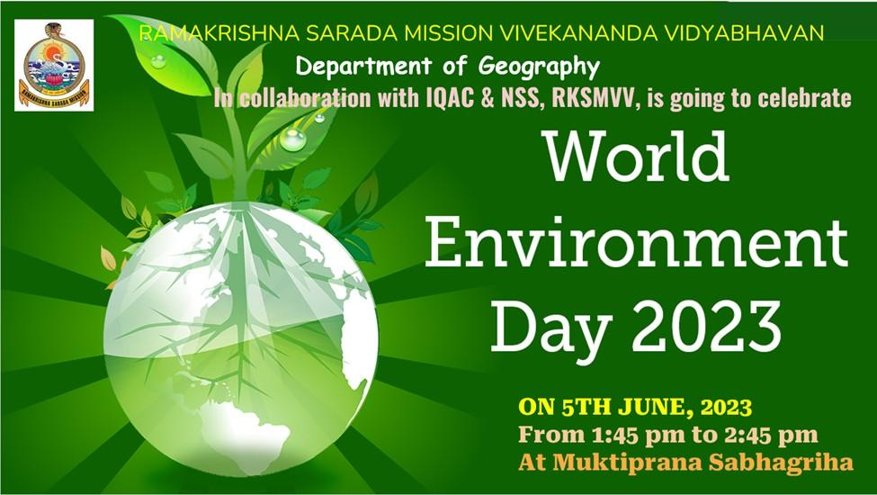

Flyer of the program

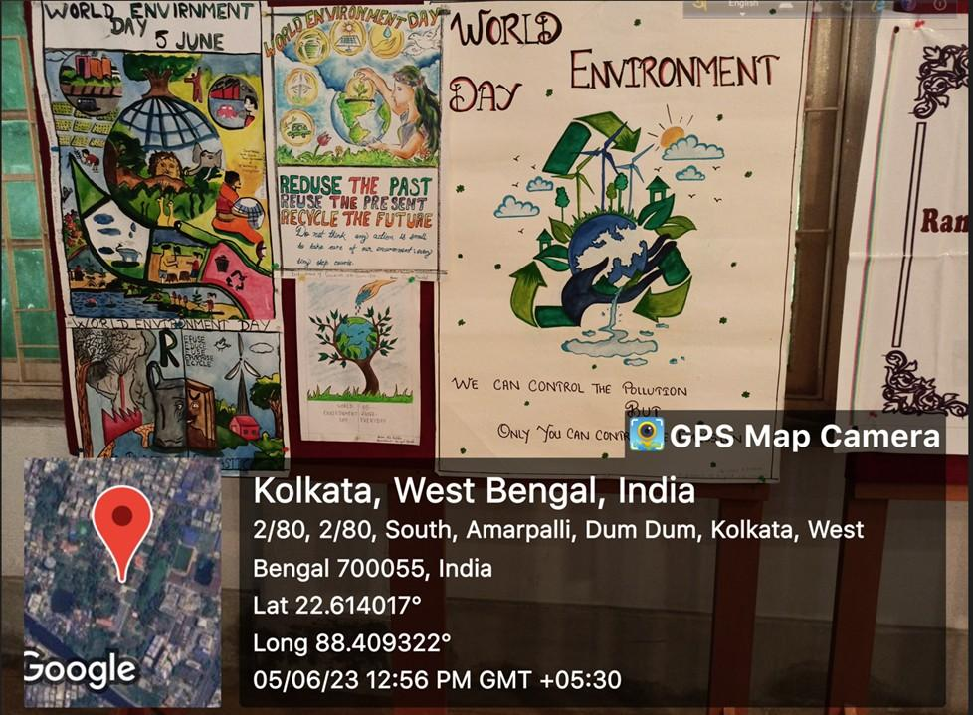

Posters made by students
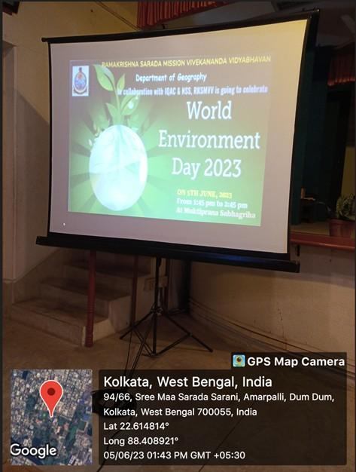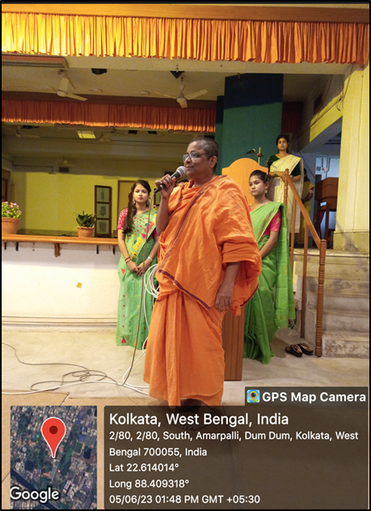

Inaugural speech of Principal Mataji on 5th June





