Name of the Activity: Medical Ethics
Category: PG Seminar Talk
Organising Unit: Department of Philosophy, Ramakrishna Sarada Mission Vivekananda Vidyabhavan

Date: 05.08.2022
Time: 10.30 A.M
Venue: AV room
Number of Participants: 35
Name of the Resource Person/s (with designation): Dr. S. Roy Chaudhuri, Department of Endocrinology, KPC Medical College & Hospital
Brief Description of the Event: Discussion on medical ethics, real life experience and difference between theoretical knowledge and real-life situations.
Programme Outcome: Dr. Roy Chaudhuri discussed about the real life ethical dilemmas he faced in his career as a physician. He also talked about the challenges that confronted him at times in maintaining a healthy patient-physician relationship. The speaker also depicted about the theoretical ethical rules they have learnt during their training period. However, it is not easy to implement these in reality and overcoming them has been a trying time. It was a very informative session.

Flyer:
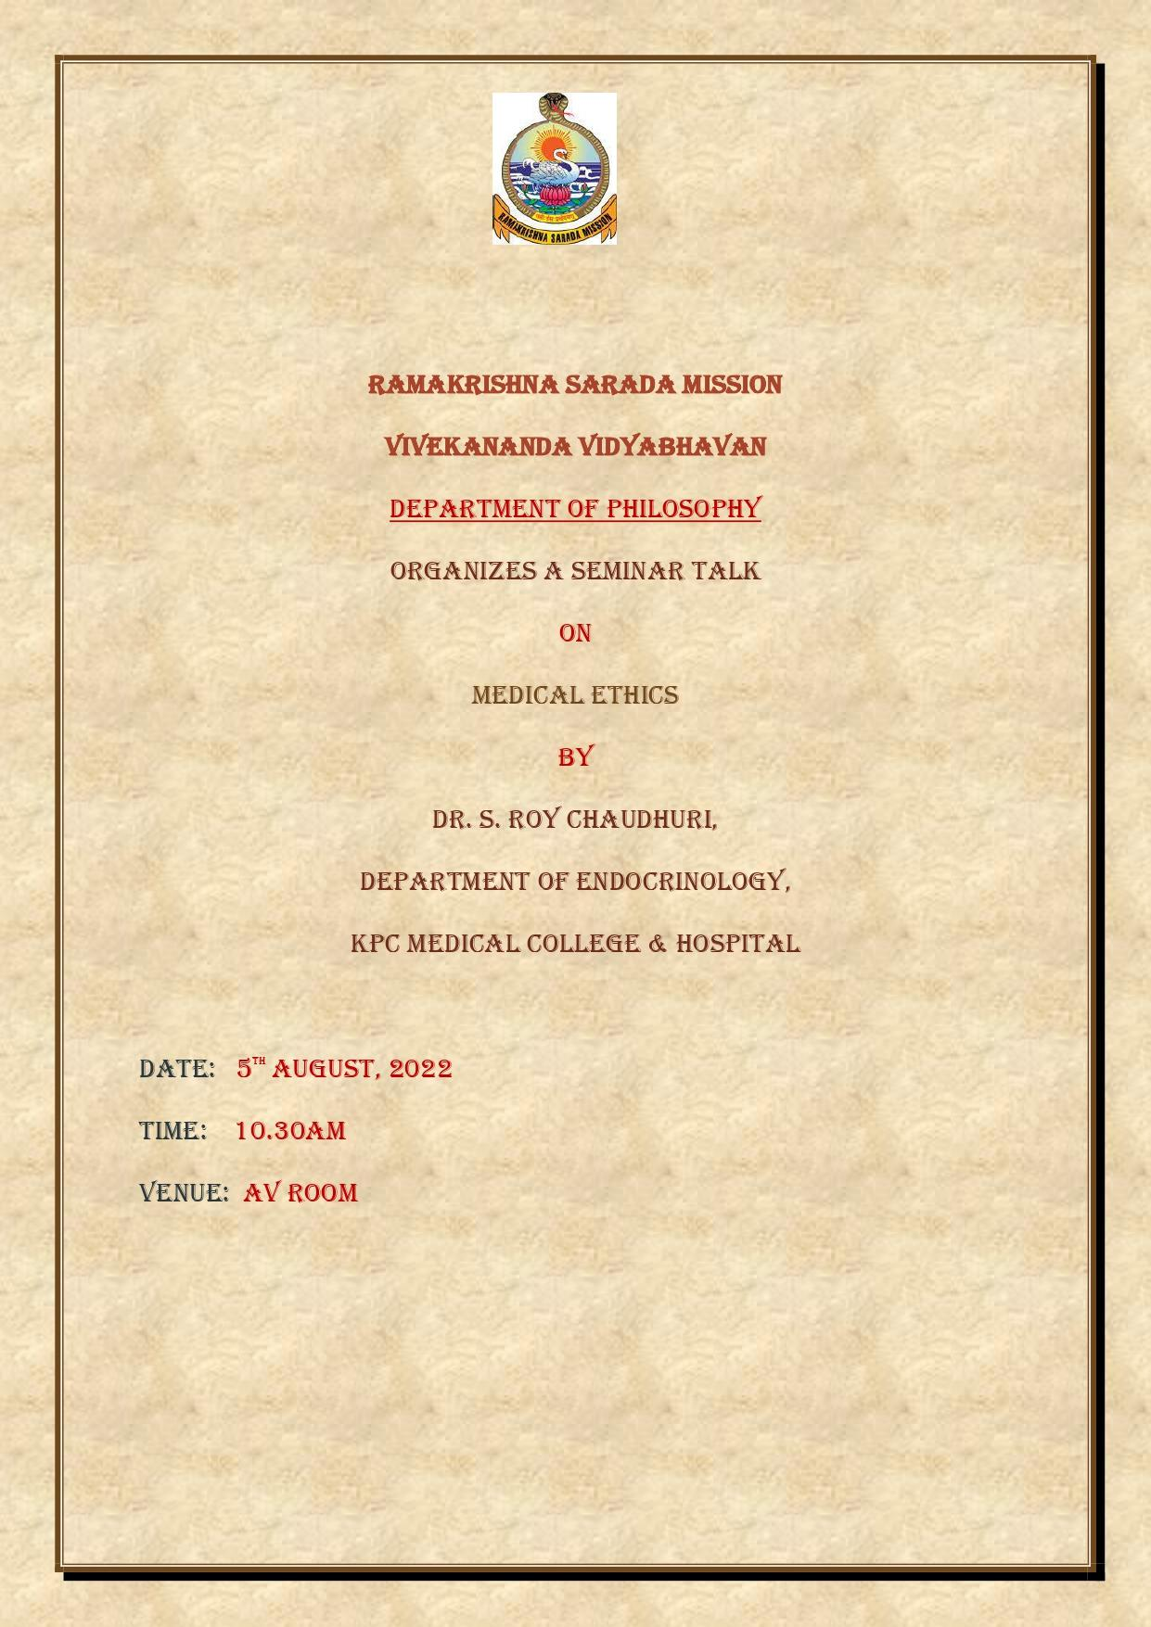

Geo-Tagged Photos
