Name of activity: Extention Lecture on Mathematics in Daily Life
Category: Extention Lecture
Topic: Mathematics in Daily Life
Organising unit: Mathematics Dept.
Date: 06.05.23
Time: 12:30 p.m. to 1:30 p.m.
Venue: Swamiji Bhavan
Name of resource person/s (with designation): Dr.Kalyan Brata Chatterjee; Assistant Professor, Department of Physics, RKM Vivekananda Centenary College, Rahara.
Number of participants: All Students
Brief description of event and Programme outcome:
The students are made aware of different examples of how mathematics helps us in many ways in our daily lives. They were informed with examples of how maths is involved in figuring out distance, time & cost for travel; understanding loans for cars, trucks, homes etc.; shopping for the best price; balancing the chequebook; understanding sports results & statistics; preparing food; household budgeting; playing an instrument; crafts such as sewing etc. It was also discussed how our universe can be understood through the language of mathematics. The world is interconnected, and everyday maths shows these connections & possibilities. In today's time, it is impossible to live without mathematics. The Golden Ratio which is needed to achieve symmetry & beauty was discussed. A person is thought to be attractive if the length of their face divided by the width of their face equals 1.618 It was also explained by mathematics on that day.
Program Outcome: The interest of the students in maths has increased noticeably and the seats are filled as soon as the portal is opened in the next value add-on course on Mathematics in Daily Life. Arts-based students have taken classes very attentively. Everyone has done all class work, homework and assignments with great interest. Most of the students got very good marks in the final evaluation.

Flyer
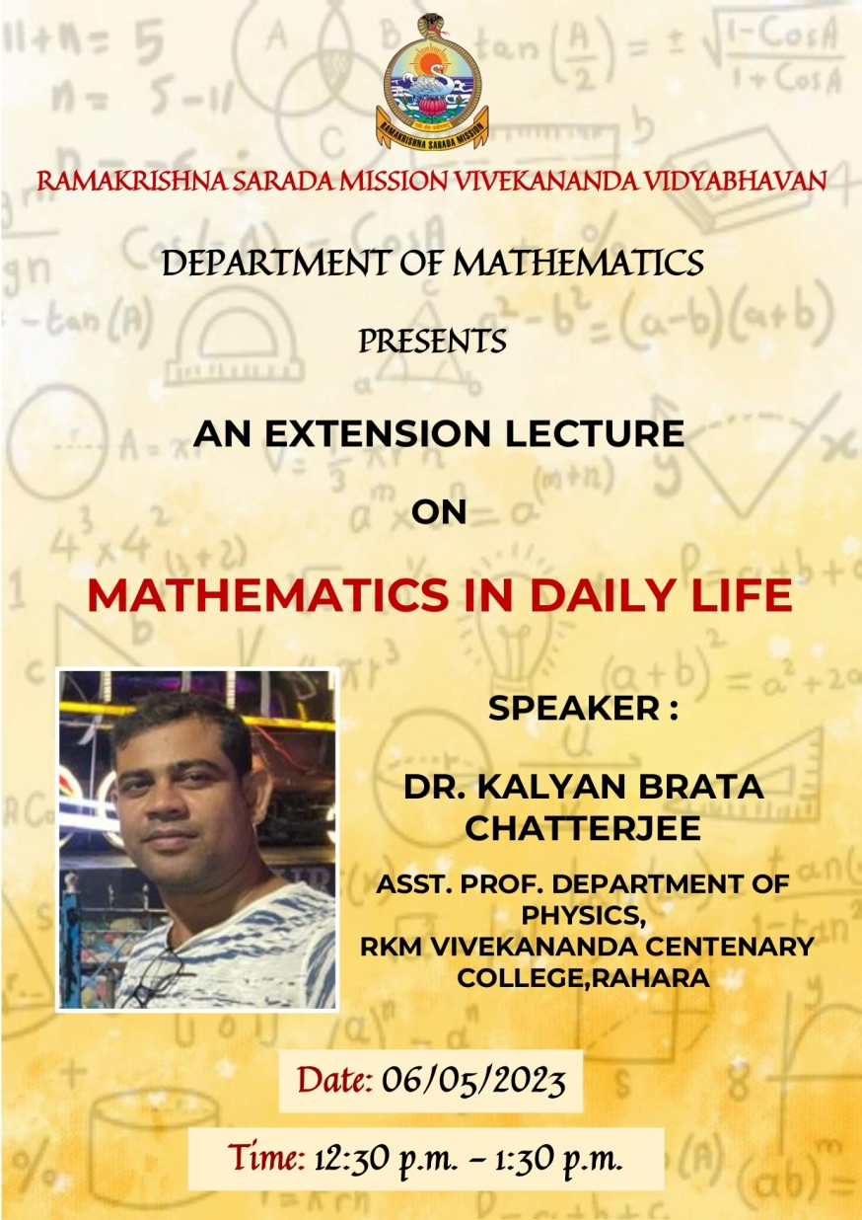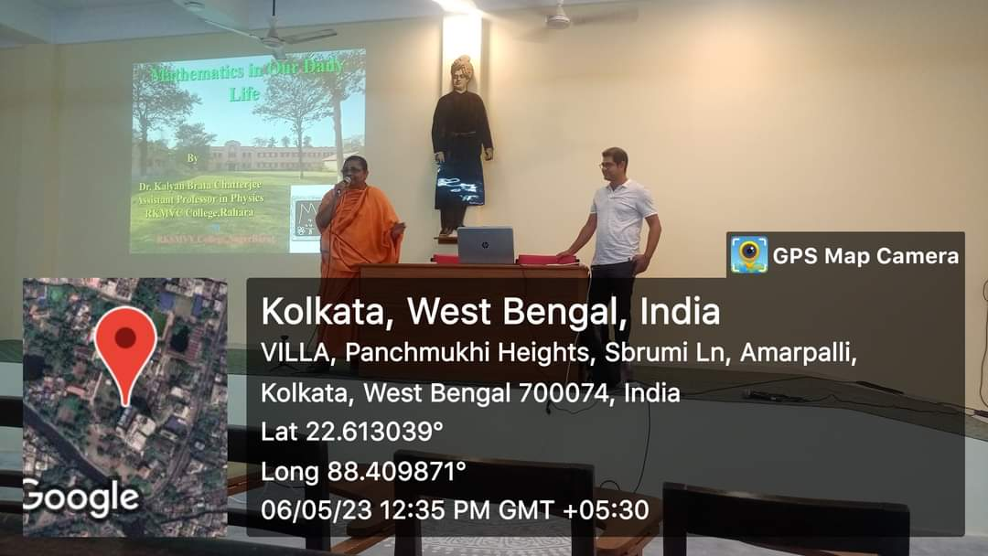
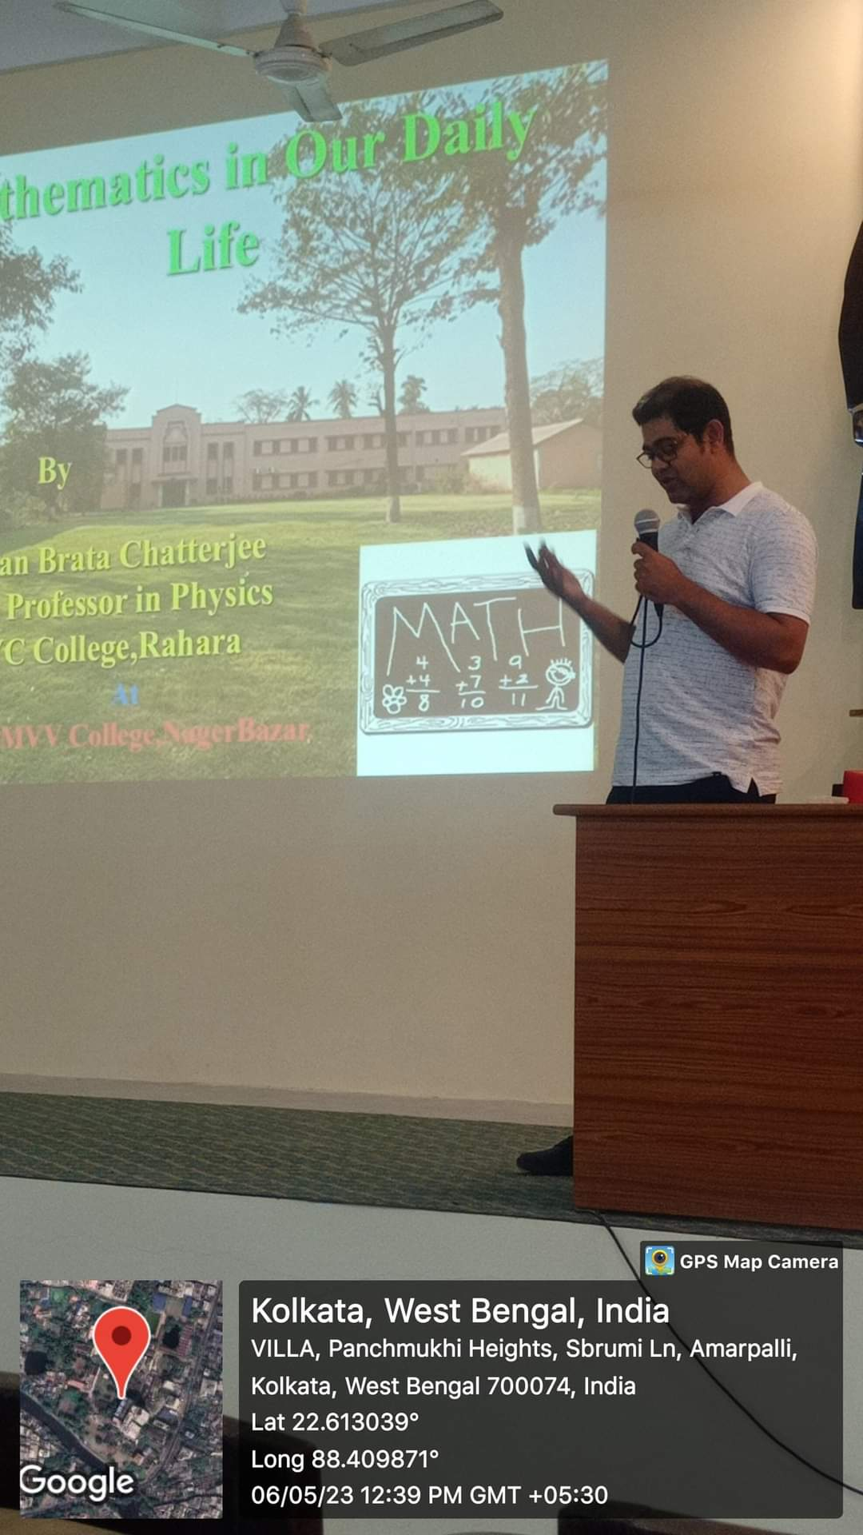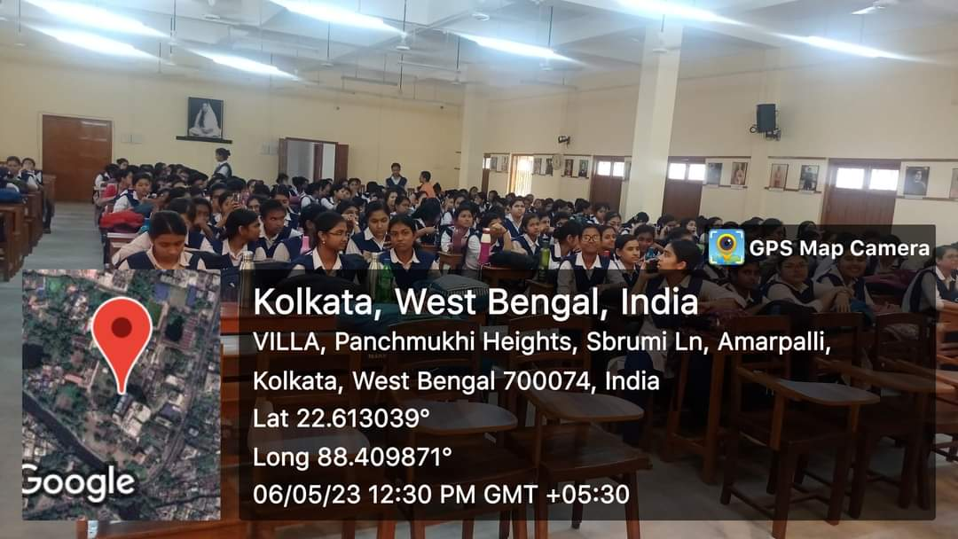

F

