Name of Activity: Prasanga: Shambhu Mitra
Category: Extension Lecture
Topic: Prasanga: Shambhu Mitra
Organizing Unit: Department of Bengali
Date: 08.06.2023
Time: 11.30 a.m.
Venue: Audio-visual room of college
Name of Resource person/s: Abhijit Sen, Retired Professor, Department of English,
Visva-Bharati, Santiniketan
Number of participants: Students of Semester IV & VI (40 students)
Brief description of the event: The book of Shambhu Mitra, ‘Sanmarga Saparja’is in the syllabus of SemesterVI Bengali honours. Shambhu Mitra’s views on the history of Bengali drama in contest of world’s Drama. In the 2 hours lecture Prof. Sen analysed the essays clearly.
Program outcome: This lecture is a part of curriculum that helps the students to go deep into the thoughts and theories of plays written, produced and staged by Shambhu Mitra. This lecture provides the study material for the students and also enhances their thought about plays and dramas. The lecture will enrich students to understand. They will prepare themselves to write answers on these texts.
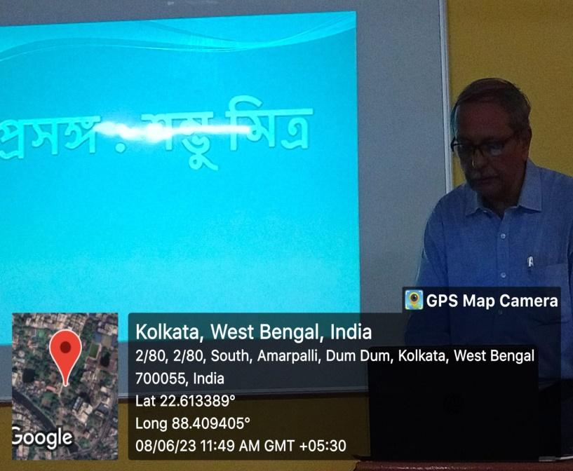
Geo-tagged photos:
