Name of Activity: Seminar on the occasion of the bicentenary of Madhusudan Dutta.
Category: Departmental Seminar
Topic: 1. Unish Shataker Naribhabna O Madhusudan,
2. Sangeetdhwani Madhu-hena.
Organizing Unit: Department of Bengali
Date: 09.03.23
Time: 10.30 a.m.
Venue: Audio-visual room of the college
Name of Resource person/s:
1. Dr. Aditi Chottopadhyaya, Associate Professor, Department of Bengali, Victoria Institution
2. Dr. Subhashis Chatterjee, Assistant Professor, Department of Bengali, Kalinagar Mahavidhyalaya
Number of Participants: 54
Brief description of the Event: Madhusudan Dutta, the eminent poet and dramatist of the 19th century made a great contribution to Bengali literature. This year is celebrating his bicentennial birth ceremony.
Programme Outcome: Students were very much enriched by the two lectures. In their CBCS syllabus, there are two writings of Madhusudan Dutta, one ‘Meghnadbadh kabya’, and another ‘Krishnakumari’ Drama. So they came to know about his life, his literary works, his vision towards society, women of the 19th century. These lectures as a part of curriculum, not only help the students to enrich their study but also encourage them to celebrate and understand the significance of the literary stalwart Madhusudan Dutta at his bicentenary.

Flyer:
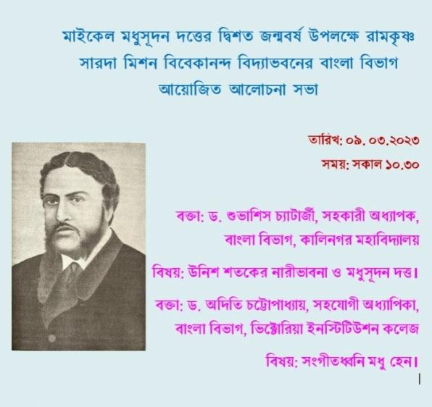

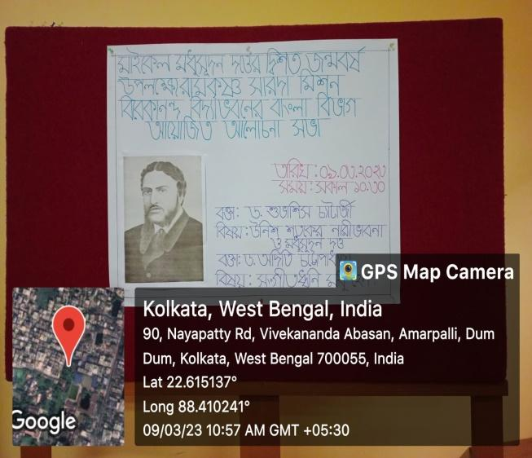
Geo-tagged Photos:

