Name of the event – Revelio’23

Category - Departmental Fest

Date – 10.04.2023

Time- 11 am to 2 pm

Venue – College Auditorium

Number of participants - 38

Resource Person – Anindya Chattopadhyay, singer, songwriter, filmmaker, author

Brief Description of the event - On 10th April 2023, the department arranged the annual culture fest “Revelio 23”. The event comprised a prize distribution ceremony for several competitions in numerous categories such as Photography, doodle, mini-fiction, and slam poetry. It also included a singing performance by Ashmita Kar, joint winner of Sa Re Ga Ma Pa, an alumna of our college and music teacher at RKSMVV. A special workshop was also held on songwriting and songmaking with award-winning singer, songwriter, author and filmmaker Anindya Chattopadhyay.

Outcome - The departmental fest apart from offering an opportunity to explore the hidden talents of the students also arranged for an engaging session on the process of writing songs on their own.

Flyer:
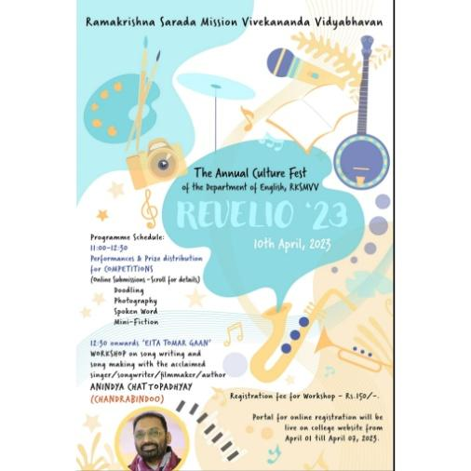

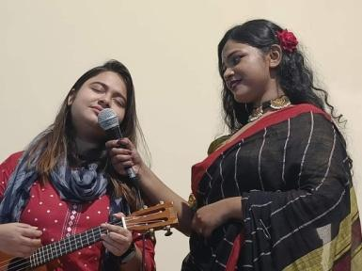
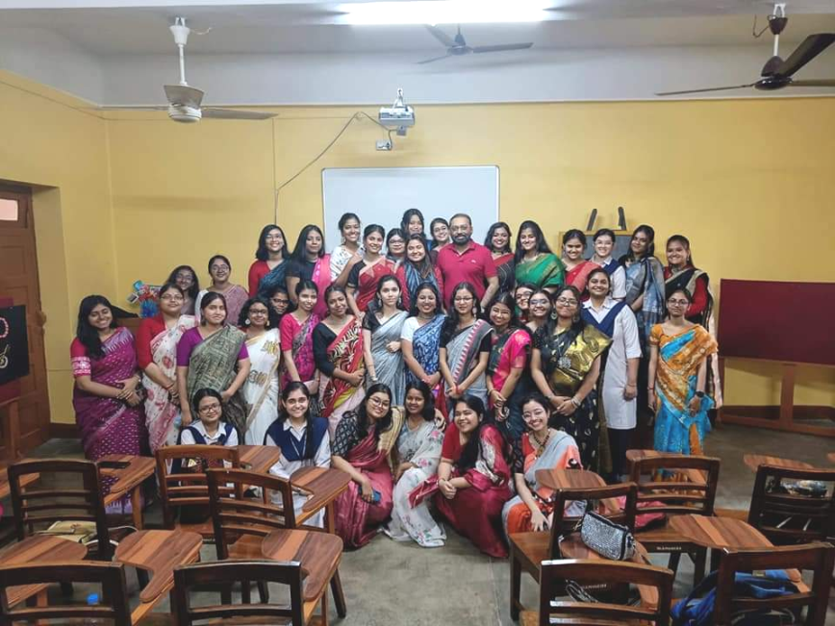
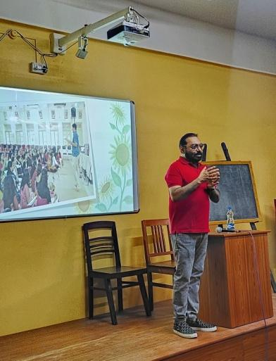
Photos:

