Name of Activity: Madhyojuger Bangla Mangal Kabyer Dhara
Category: Seminar
Topic: Mangal Kabyer Dhara
Organizing Unit: Department of Bengali
Date: 11.01.23
Time: 12.00 noon
Venue: Audio-visual room of college
Name of Resource Person/s with Designation: Dr. Mohini Mohan Saradar, Professor, Dept of Bengali, West Bengal State University, and Ms. Debarupa Das, Assistant Professor of Bengali Department
Number of participants: 41 students
Brief description of the event: This topic is under SEMESTER I & V, CC 1& DSE1 (CBCS System). Malgal Kabya was the important stream of Medieval Bengali Literature. In CBCS syllabus there are four texts on Malgalkabya: kabi Mukundaram Chakraborty’s Chandimangal, Kobi Dwijo Madhober Chandimangal, Bipradas Pipilaiyer Manasamongal, Kabi Bharatchandrer Annadamangal. To understand these texts, it is important to know about the stream of spiritual, social, political perspective of Medieval Bengal. Prof. Sardar clearly analyzed the same to the students.
Programme Outcome: This lecture is a part of curriculum that helps the students to understand the special genre –MANGAL KABYA of Medieval Bengali literature and also provides study materials so that they can incorporate them in their writings.

Flyer

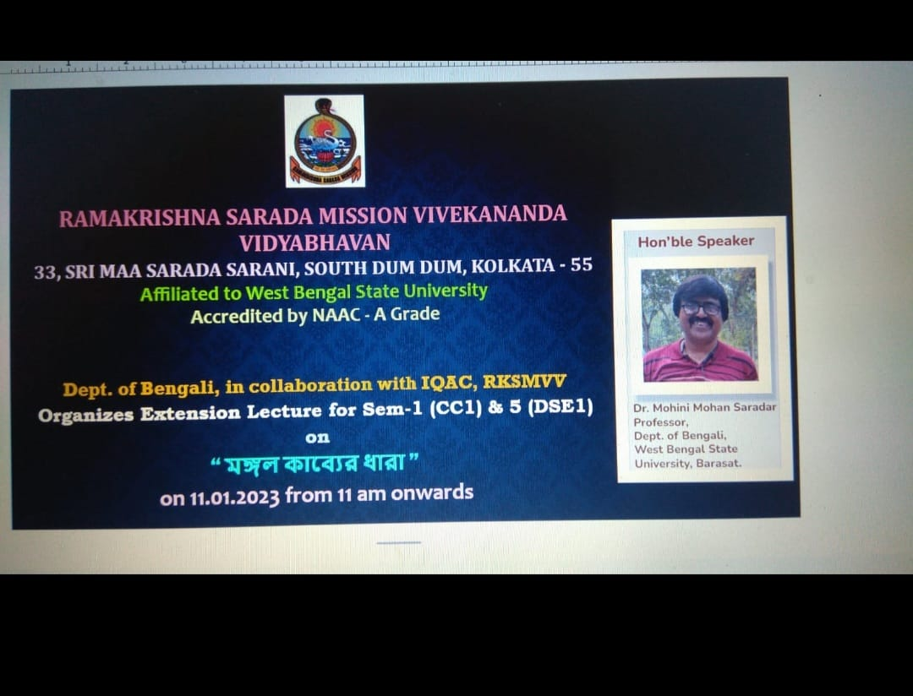

Geo-tagged Photos:
