Name of the activity: State-Level Seminar
Topic: “Application of RS / GIS & Its Career Prospects”
Category: Seminar
Organising unit: Department of Geography & IǪAC, RKSMVV in collaboration with Department of Earth Sciences & Remote Sensing, JIS University, Kolkata.
Date: 12.06.2023
Time: 2 pm to 4 pm
Venue: Room no 21
Number of Participants: 62
Number of Resource Person/s: 02
Name of the Resource Person/s :
- Dr. Anatu Bhattacharya, Associate Professor, Dept. of Earth Sciences & Remote Sensing, JIS University, Kolkata
- Dr. Ratnadeep Ray, Assistant Professor, Dept. of Earth Sciences & Remote Sensing, JIS University, Kolkata.
Brief description of the event :
The programme started with the welcome address of Dr. Amrita Pramanick, faculty of the Geography Dept. and then a very short inaugural speech of our IǪAC Coordinator Dr Chaiti Mitra. Then the resource persons delivered their presentation on different aspects of Remote sensing & GIS. The Seminar was organised keeping in view the importance of Remote Sensing and GIS in the UG and PG levels. Both eminent Professors gave insightful and informative lectures on the applicability and different Prospects of RS & GIS. The session ended with a vote of thanks by Dr. Soma Mukhopadhyay to the resource persons, the Principal & IǪAC Coordinator of the college, participant students and other delegates and lastly all members of the organising committee.

Programme Outcome: In fact, we can’t imagine our day-to-day life without the help of GIS. It has become a part and parcel of our lives. The Seminar was very fruitful, particularly for the students who are interested in Remote Sensing and GIS. Every year after completion of graduation in Geography Honours, many students are admitted for Post-graduation in GIS and Remote Sensing in West Bengal and other States of India as the job opportunities are better, & the popularity of the subject is increasing day by day. So, students are largely motivated to continue their careers with GIS as its prospects are gradually growing to a great extent.
Flyer:
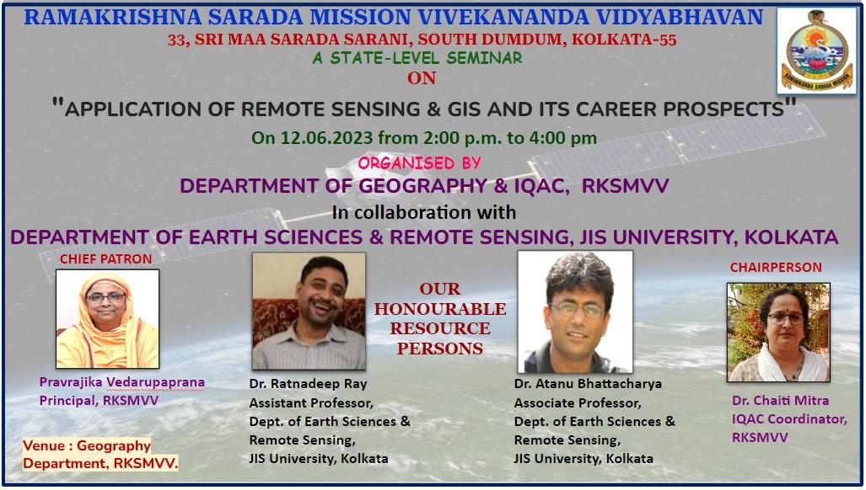

Inaugural Speech of IǪAC Coordinator

Faculties with the resource persons

Students listening speech of resource persons
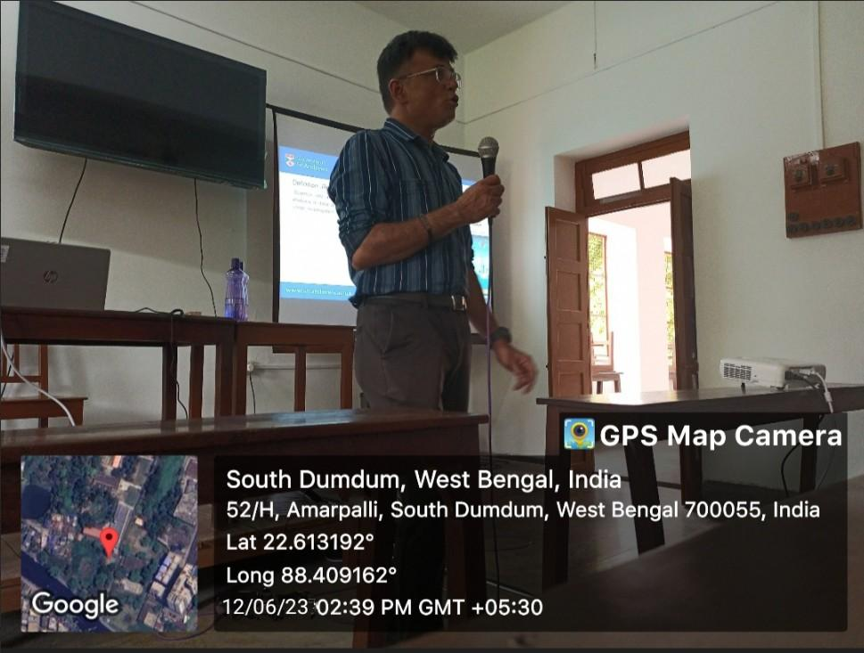

Speech of Dr. Atanu Bhattacharya
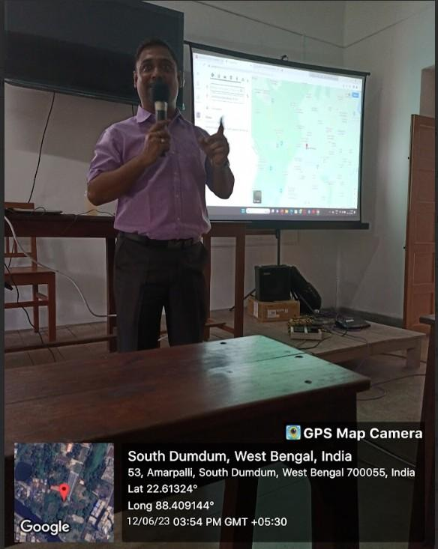

Speech of Dr. Ratnadeep Ray

……………………………….

