Library Orientation Report
Name: Library orientation of 1st year students 2022 held on 13,14,15 September
Category: Library Orientation
Organising unit: Library

Date: 13/9/2022, 14/09/2022, 15/09/2022
Time: 10.15a.m.
Number of Students: Total students of 1st Year
Number of Resource Person: 1
Name of Resource Person: Parama Sarkhel Dutta
Number of Beneficiaries:

Brief description of the event: Library Orientation was held for 1st year students from 13.9.2022 to 15/09.22. On 13.9.2022 students of History, Political Science, Sanskrit and Sociology Honours, on 14.9.2022 Economics, Geography Journalism and Philosophy Honours and on 15.9.2022 Bengali and Education Honours and also general students orientation was done. All the students were taught library rules and regulations of the library, library shelving according to subject, process of lending books and journals etc.. In addition, training is provided on how to use nlist, wbcolor and other free sites to download e-resources. They were shown how to go to library OPAC and search the catalog and how to log in and how to renew their issued books online.

PROGRAMME OUTCOME: Students gained a basic understanding of the library's layout, facilities, and various sections, such as circulation, reference, and special collections. They become acquainted with library terminology and the organization of books, journals, and other materials. They become aware of the different services provided by the library.
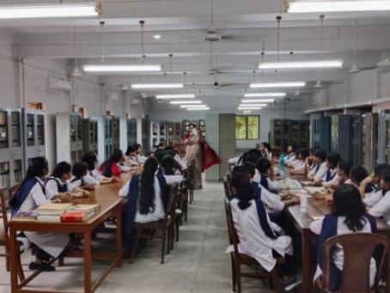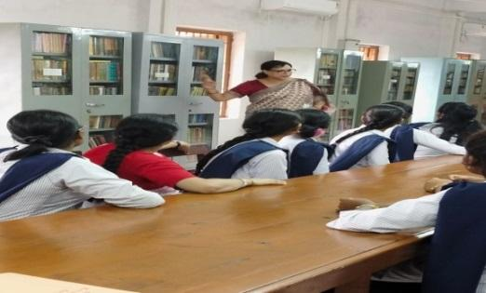

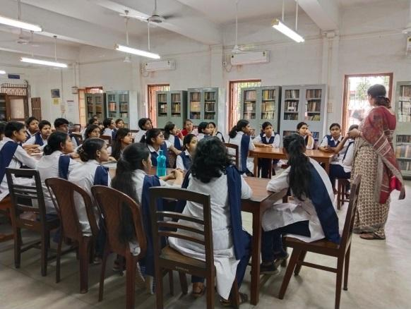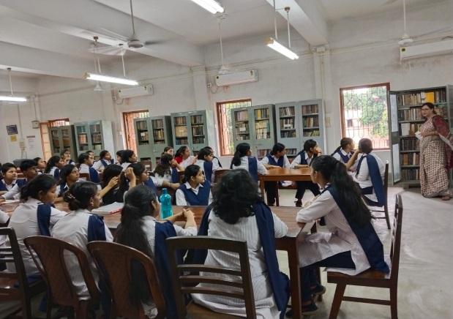

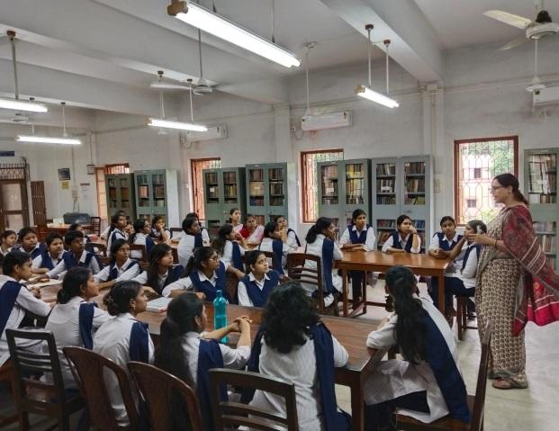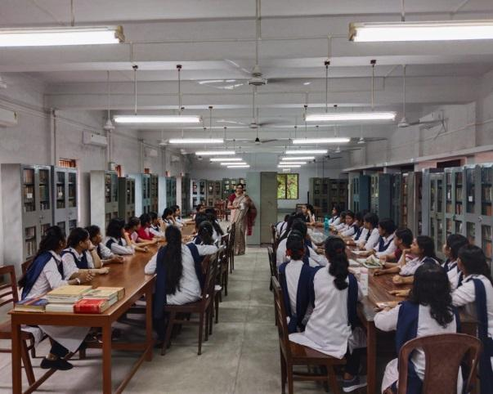

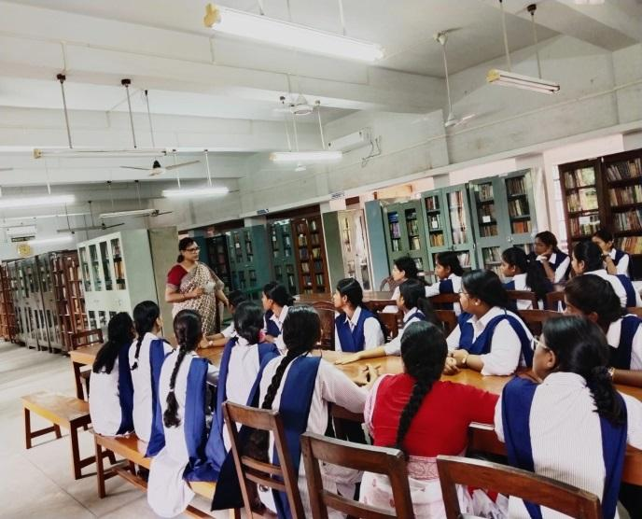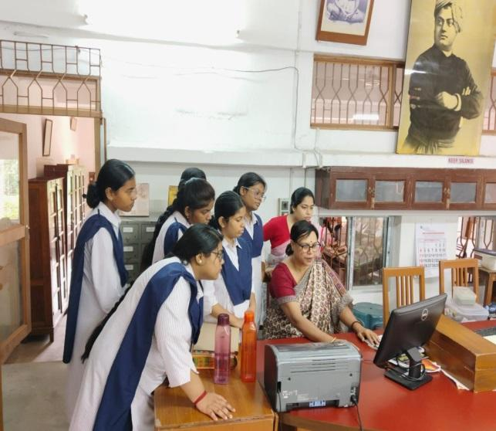

P.T.O
