Name: Extension Lecture on World War I: Causes and Consequences

Category: Extension Lecture

Organising Unit: Department of Political Science

Date: 13.12.2022

Time: 1.45 pm-2.45 pm

Number of Students: 26

Number of Resource Person: one

Name of Resource Person: Dr. Sunetra Mitra, Assistant Professor in the Department of History, Ramakrishna Sarada Mission Vivekananda Vidyabhavan

Brief description of the event: The Extension lecture on the topic ‘First World War’ was organised for all-semester honours students of the Department of Political Science. Dr. Sunetra Mitra, Assistant Professor in the Department of History, Ramakrishna Sarada Mission Vivekananda Vidyabhavan, the distinguished resource person, was invited to deliver her lecture. The talk ended with an inquiry session of 15 minutes.

Programme Outcome: The students have truly benefited from the illustrious presentation of the speaker. They came to know the perspectives, causes as well as corollaries of this great event, the First World War, one of the bloodiest wars in history, lasted from 1914-1918. The programme was very helpful in making the students aware of the altered world’s social and political landscape.

Photo
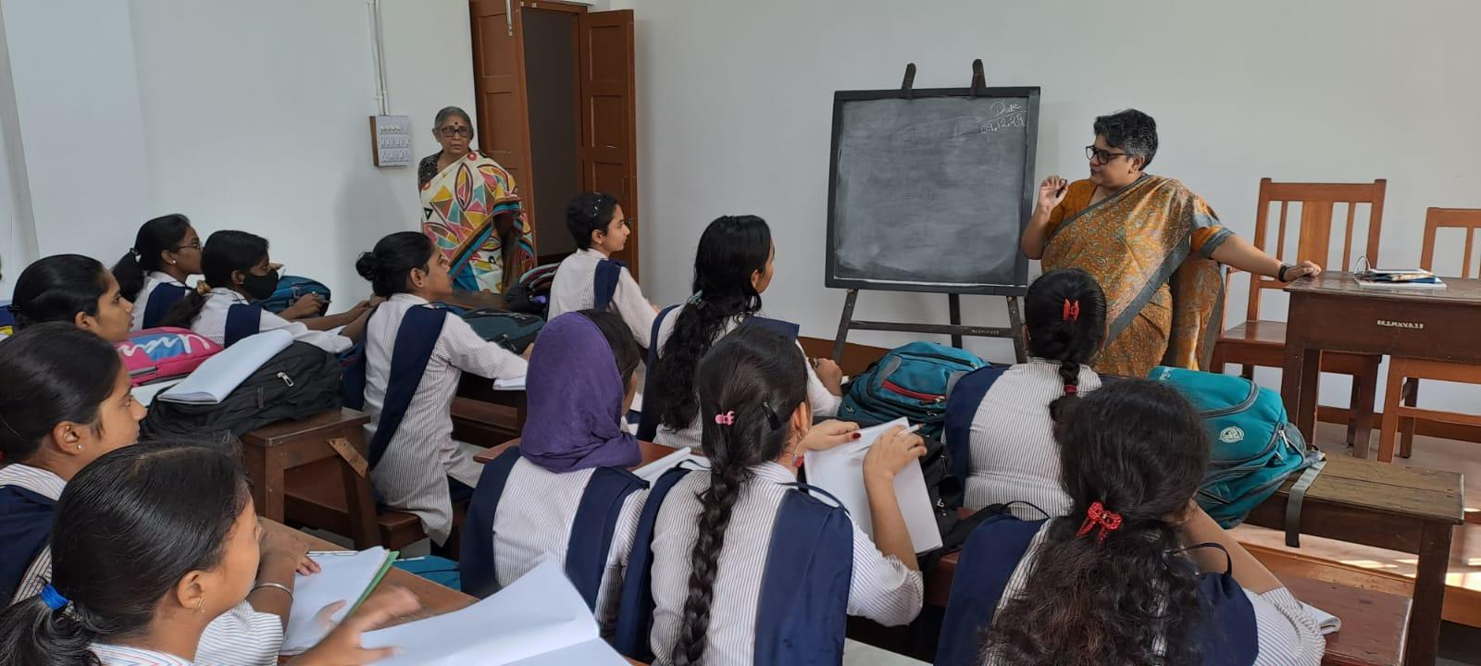

Flyer

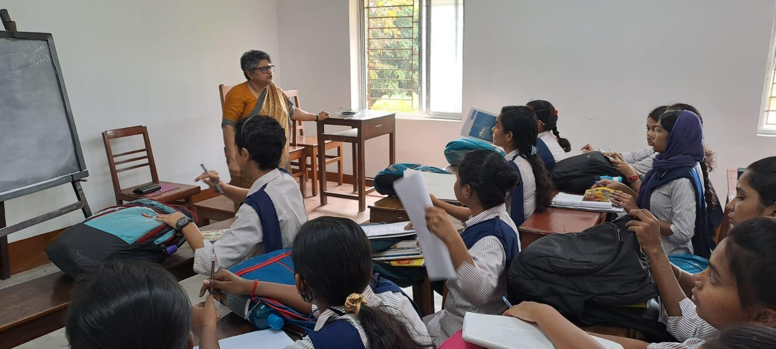

Flyer

