Name: Extension Lecture on World War II

Category: Extension Lecture

Organising Unit: Department of Political Science

Date: 13.12.2022

Time: 11.30 am-12.30 pm

Venue: RKSMVV classroom

Number of Students: 26

Number of Resource Person: One
Name of resource Person: Dr. Panchali Majumdar, the Associate Professor of the Department of History, Ramakrishna Sarada Mission Vivekananda Vidyabhavan

Number of Students: 26
Brief description of the event: The Extension Lecture was organized for all-semester honours students of the Department of Political Science. Dr. Panchali Majumdar, the Associate Professor of the Department of History, Ramakrishna Sarada Mission Vivekananda Vidyabhavan was the honourable speaker. In her Lecture, Dr. Majumdar threw light on the causes and consequences of World War II. The question-answer session was for 15 minutes.
Programme Outcome: World War II, the largest global conflict in human history lasted from 1939 to 1945 is to be studied from various perspectives. As the attending beneficiaries of this lecture, our students have become acquainted with the important terms as well as events related to this worldwide phenomenon. They became knowledgeable about the atrocities and costs of war, the end of European global supremacy, the replacement of European dominance, the creation of many international organisations and so on. This very significant lecture truly benefited our students a lot.

Flyer

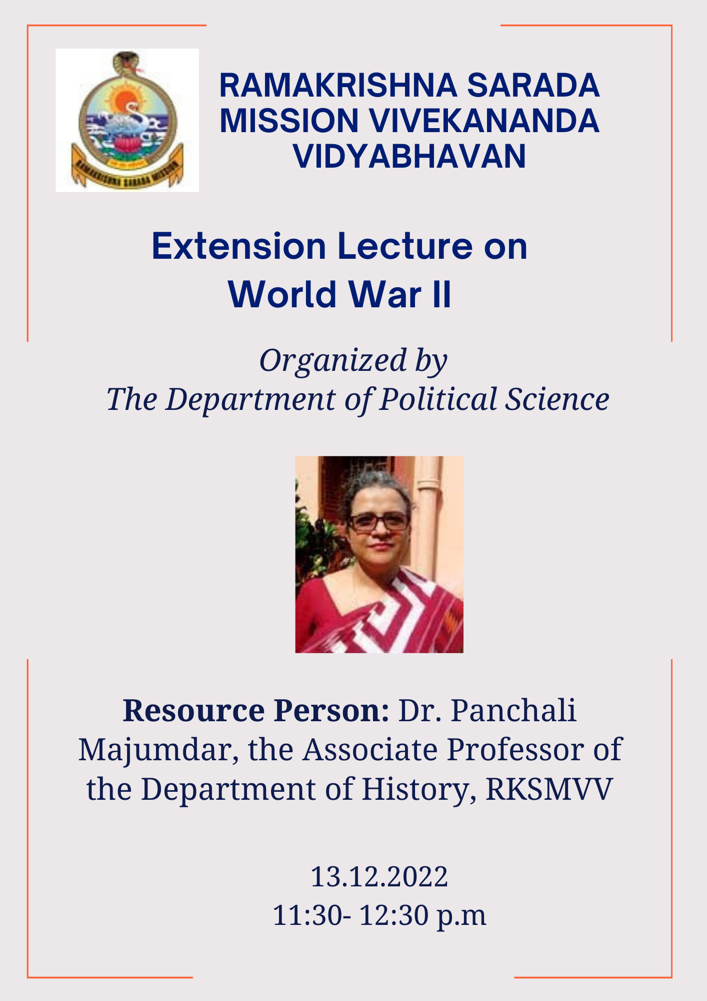

Photo:

