Name of the event: Cultural Tour
Category: Cultural
Organizing unit: RKSMVV
Date: 14 January 2023
Time: 2.30 PM ONWARDS
Venue: Sri Sarada Math, Dakshineshwar
Name of resource persons: Pravrajikas Amalaprana, Vivekaprana and Akhilatmaprana (Sri Sarada Math) and Sm Chirasree Bandyopadhyay.
Number of participants: 25
Brief description of the events: Students were taken to Sri Sarada Math, Dakshineshwar to attend the evening public meeting on Swami Vivekananda’s birthday to commemorate the Youth Week from 12-19 January 2023.
Program outcome: Students are introduced to the principles for which RKSMVV stands for. They enjoyed to be reminded of Swami Vivekananda’s teachings.
Flyer

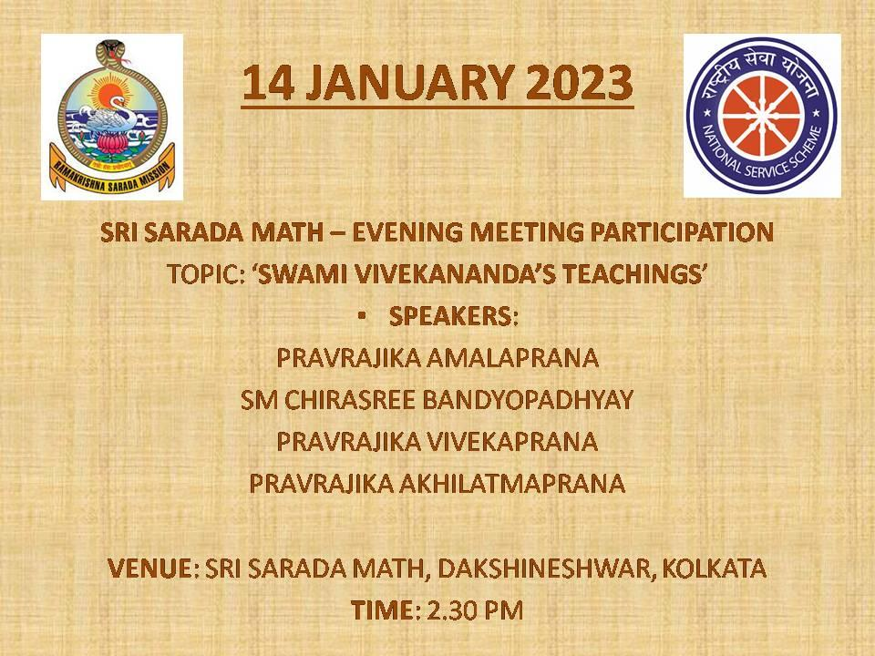

Geo-tagged photos
