Name of the Activity: Study Visit‘ on NAMAMI GANGE’
Category: Departmental Activity
Organising Unit: Department of Geography in collaboration with National Mission for Clean Ganga, Ministry of Jal Shakti (Department of Water Resources, River Development & Ganga Rejuvenation), Government Of India.
Date: 15.02.2023
Time: 9 am to 2 pm
Venue: Dr. Triguna Sen Hall, Jadavpur University, Kolkata
Number of Participants: 10 students of SEM-4 & 2 faculty members.
Brief description of the event: The Department of Geography of RKSMVV organised a study visit to Jadavpur University on the Occasion Of the Blended Capacity Building Program For Stakeholders Of River Ganga - FIFTH COLLOQUY: GANGA SAMVAD at Dr. Triguna Sen Hall of Jadavpur University. This project was led by the Indian Institute of Public Administration, New Delhi, in collaboration with the South Asian Institute of Advanced Research & Development. The project was conducted as a part of the Ganga Conservation Programme.

Programme Outcome: Students became familiar with the stakeholders of the holy River Ganga, various projects and a blended capacity-building program for stakeholders to keep the Ganga clean, the initiatives taken by the Department of Water Resources of Govt. of India to maintain the cleanliness of River Ganga flowing besides the different cities of India. It was a very knowledgeable program for us to know the united efforts of different organisations to clean the Ganga river from source to mouth.

Flyer:
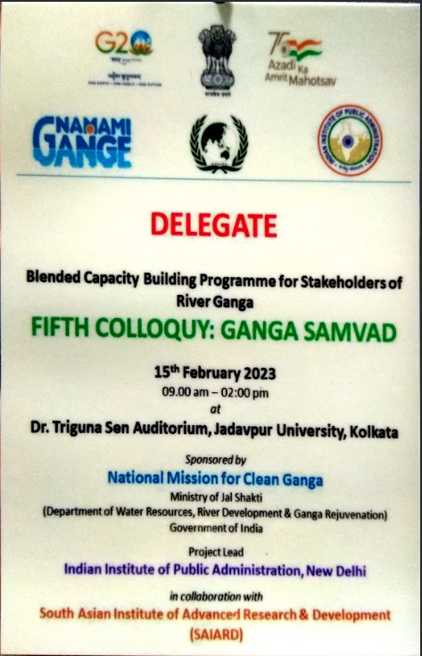

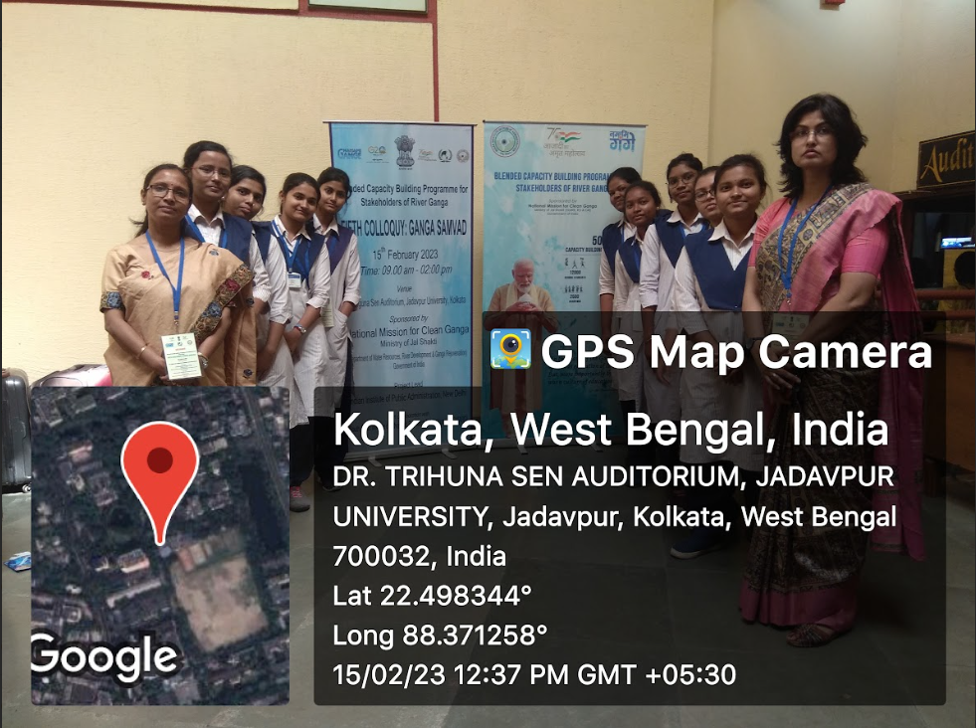
We are in front of Dr. Triguna Sen Hall, Jadavpur University

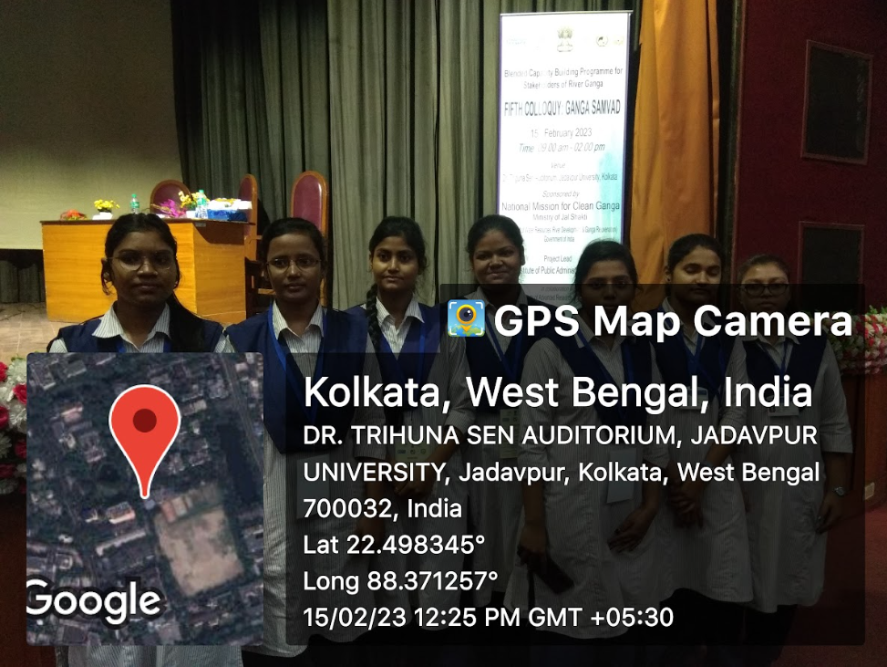
Delegates’ I-Card Students inside the hall
…………………………………………………………………….

