  - Name of the activity - Study Visit to Geological Survey of India, Kolkata.
  - Category - Student’s Activity
  - Date - 15.07.2022
  - Time - 10 am to 4 pm
  - Venue - Geological Survey of India (GSI), Eastern Region Headquarters, Bhu-Bijnan Bhavan, Block DK-6, Sector II, Salt Lake, Kolkata-700091.
  - Number of Participants - 12 Students of SEM-4 & 6 and 3 faculty members.
  - Brief Description of the program
The program was organised by the Ministry of Mines in celebration of “Azadi ka Amrit Mahotsav” to commemorate 75 years of India’s Independence. It was an ICONIC WEEK from July 11 to July 17, 2022 for them. The Geological Survey of India celebrated the ICONIC DAY on July 15, 2022.
  - Programme Outcome
Students visited and keenly observed the geological instruments like Abney level, compass and clinometers etc. which are used in different purposes, demonstrations and presentations of the different items organised by staff of this institution, various kinds of corals and igneous, sedimentary and metamorphic rocks, a no. of GSI publications etc. They gathered knowledge about all these to a great extent. Students also participated in the quiz on the ICONIC DAY celebration of “Azadi ka Amrit Mahotsav”, a Government of India initiative to commemorate 75 years of India’s Independence and took the 2nd runner up position. It was really a knowledgeable visit for the students indeed.
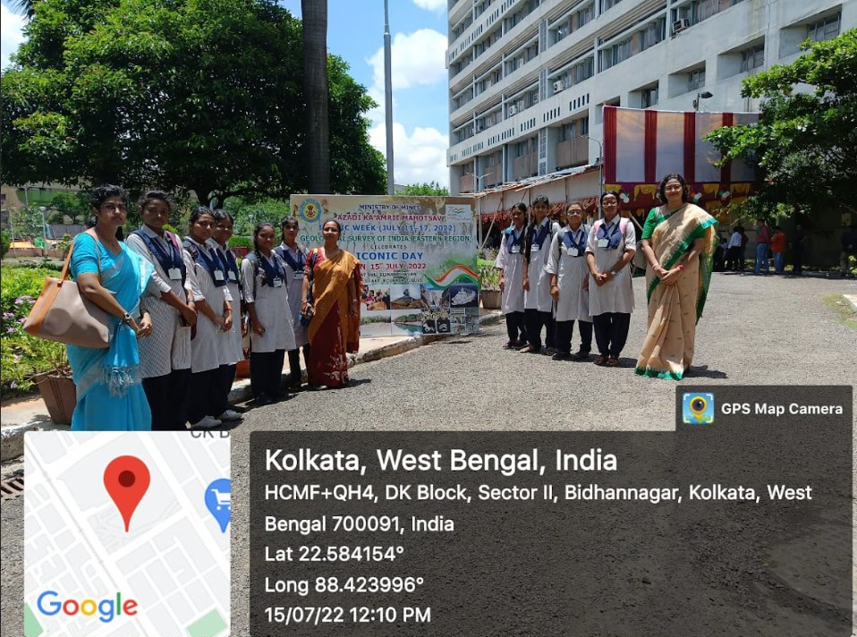

Our team in front of GIS
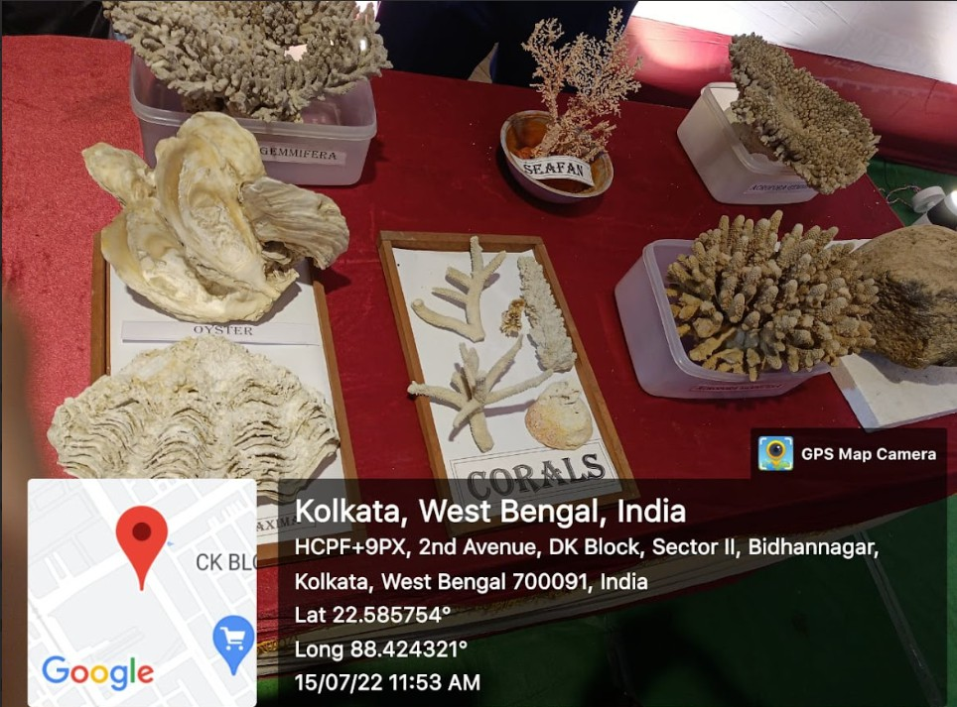

Different types of Corals displayed at GIS
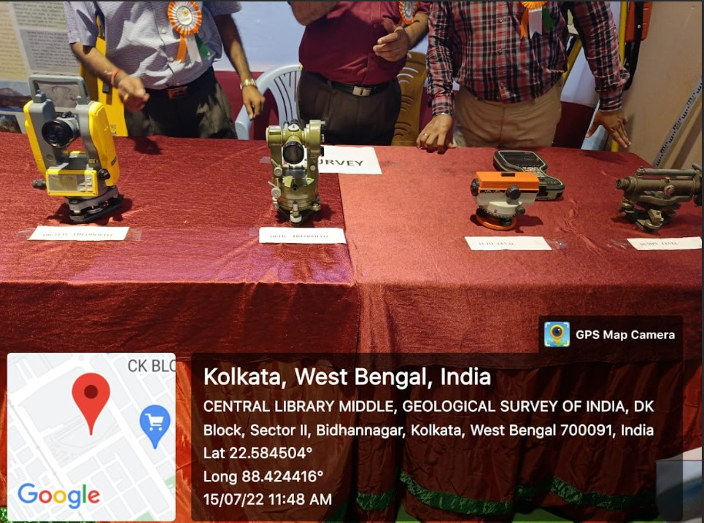

Different types of Geological instruments
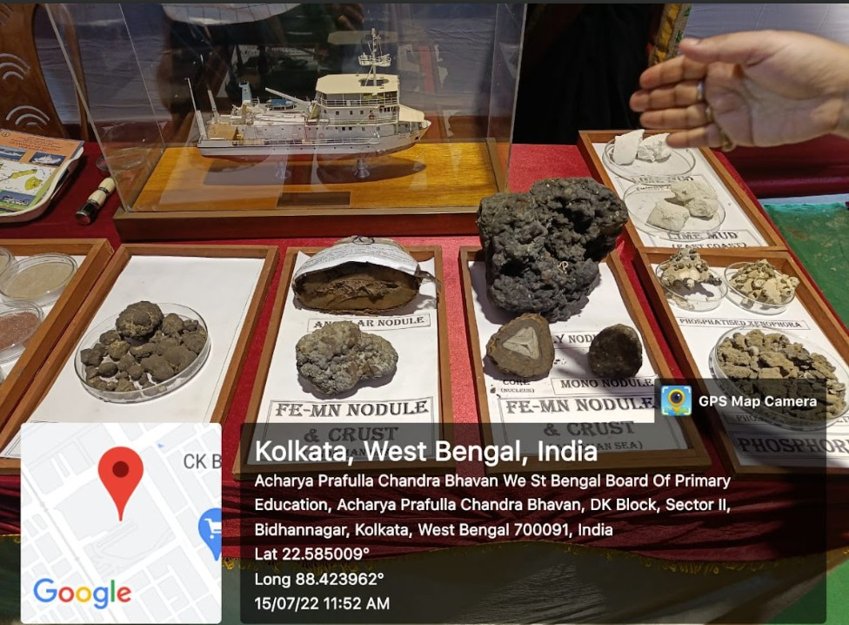

Various types of Nodules
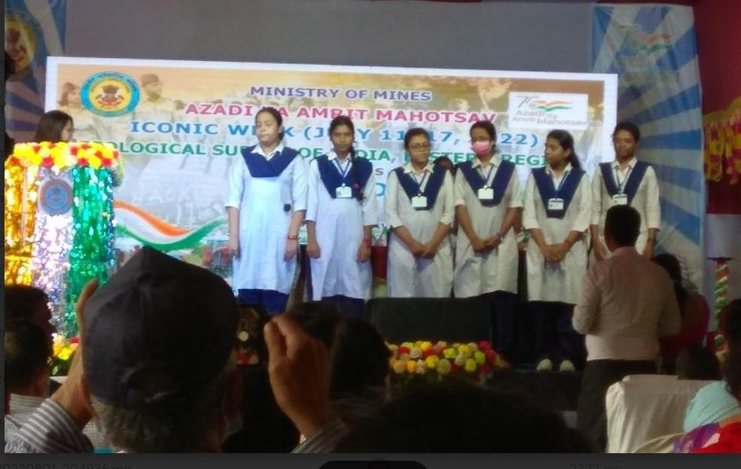
Students are 2nd Runner up in Ǫuiz contest
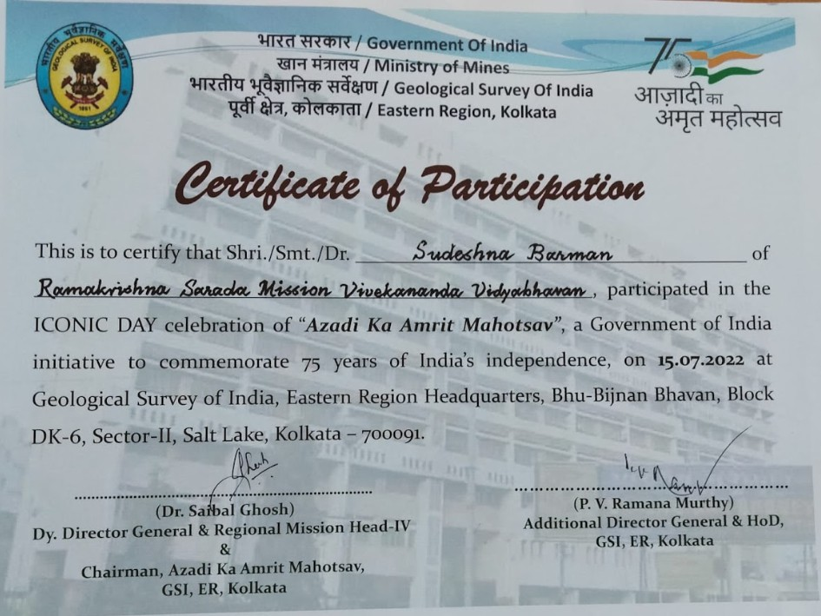

Student’s participation certificate in quiz contest at GIS

…………………………………………………

