Name of the activity: Extension Lecture
Category: Extension Lecture
Topic: ‘Learning about Landsat and IRS LISS 3 Image’
Organising unit: Department of Geography in collaboration with IQAC, RKSMVV.
Date: 16.01.2023
Time: From 1 pm to 4 pm
Venue: Geography Department classroom.
Name of the Resource Person/s with designation: Dr. Jhantu Saradar, Assistant Professor, Department of Geography, Nahata Jogendranath Mondal Smriti Mahavidyalaya Kolkata.
Number of Participants: 19 students of SEM-5.
Brief description of the event :
This extension lecture was organised for Semester 5. The session was of three hours in duration (1 pm-4 pm) and mainly enlightened upon the study of Landsat and IRS LISS 3 Image which is an important part of the curriculum (GEOACOR12T - Remote Sensing & GIS in Geography). It started with a brief introduction of the resource person before the students. After that the session was handed over to Dr. Saradar. He continued his presentation for 3 hours. All the students listened to the presentation with keen attention. The lecture ended with giving thanks to the resource person, all students, and also organising faculty members of the department.
Programme Outcome :

Remote sensing and GIS being an integral part of daily life, it is a very important aspect of syllabus too. The session helps the students to understand the usefulness of digital image interpretation. Landsat satellites have the optimal ground resolution and spectral bands to efficiently track land use and to document land change due to climate change, urbanisation, drought, wildfire, biomass changes and a host of other natural and human-caused changes. Landsat data inform good decisions in many disciplines, especially in human health, agriculture, climate, energy, fire, natural disasters, urban growth, water management, ecosystem, biodiversity and forest management.

LISS III sensor is an optical sensor working in four spectral bands (green, red, near infrared and short wave infrared). It covers a 141 km wide swath with a resolution of 23 metres in all spectral bands. Students learnt the difference between LANDSAT images & LISS III images, their characteristics, uses, importance etc. The resource person cleared all doubts of the students. It was a very helpful session for the students in studying satellite images.

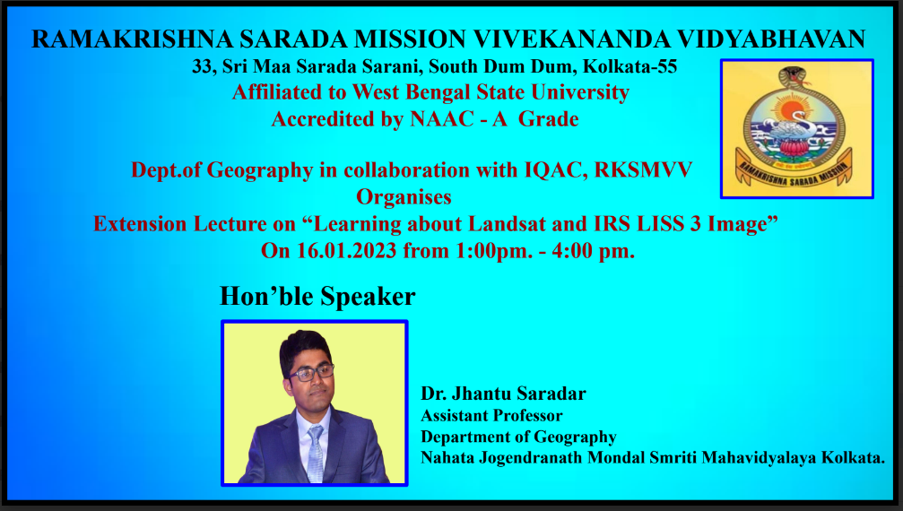
Flyer of the program

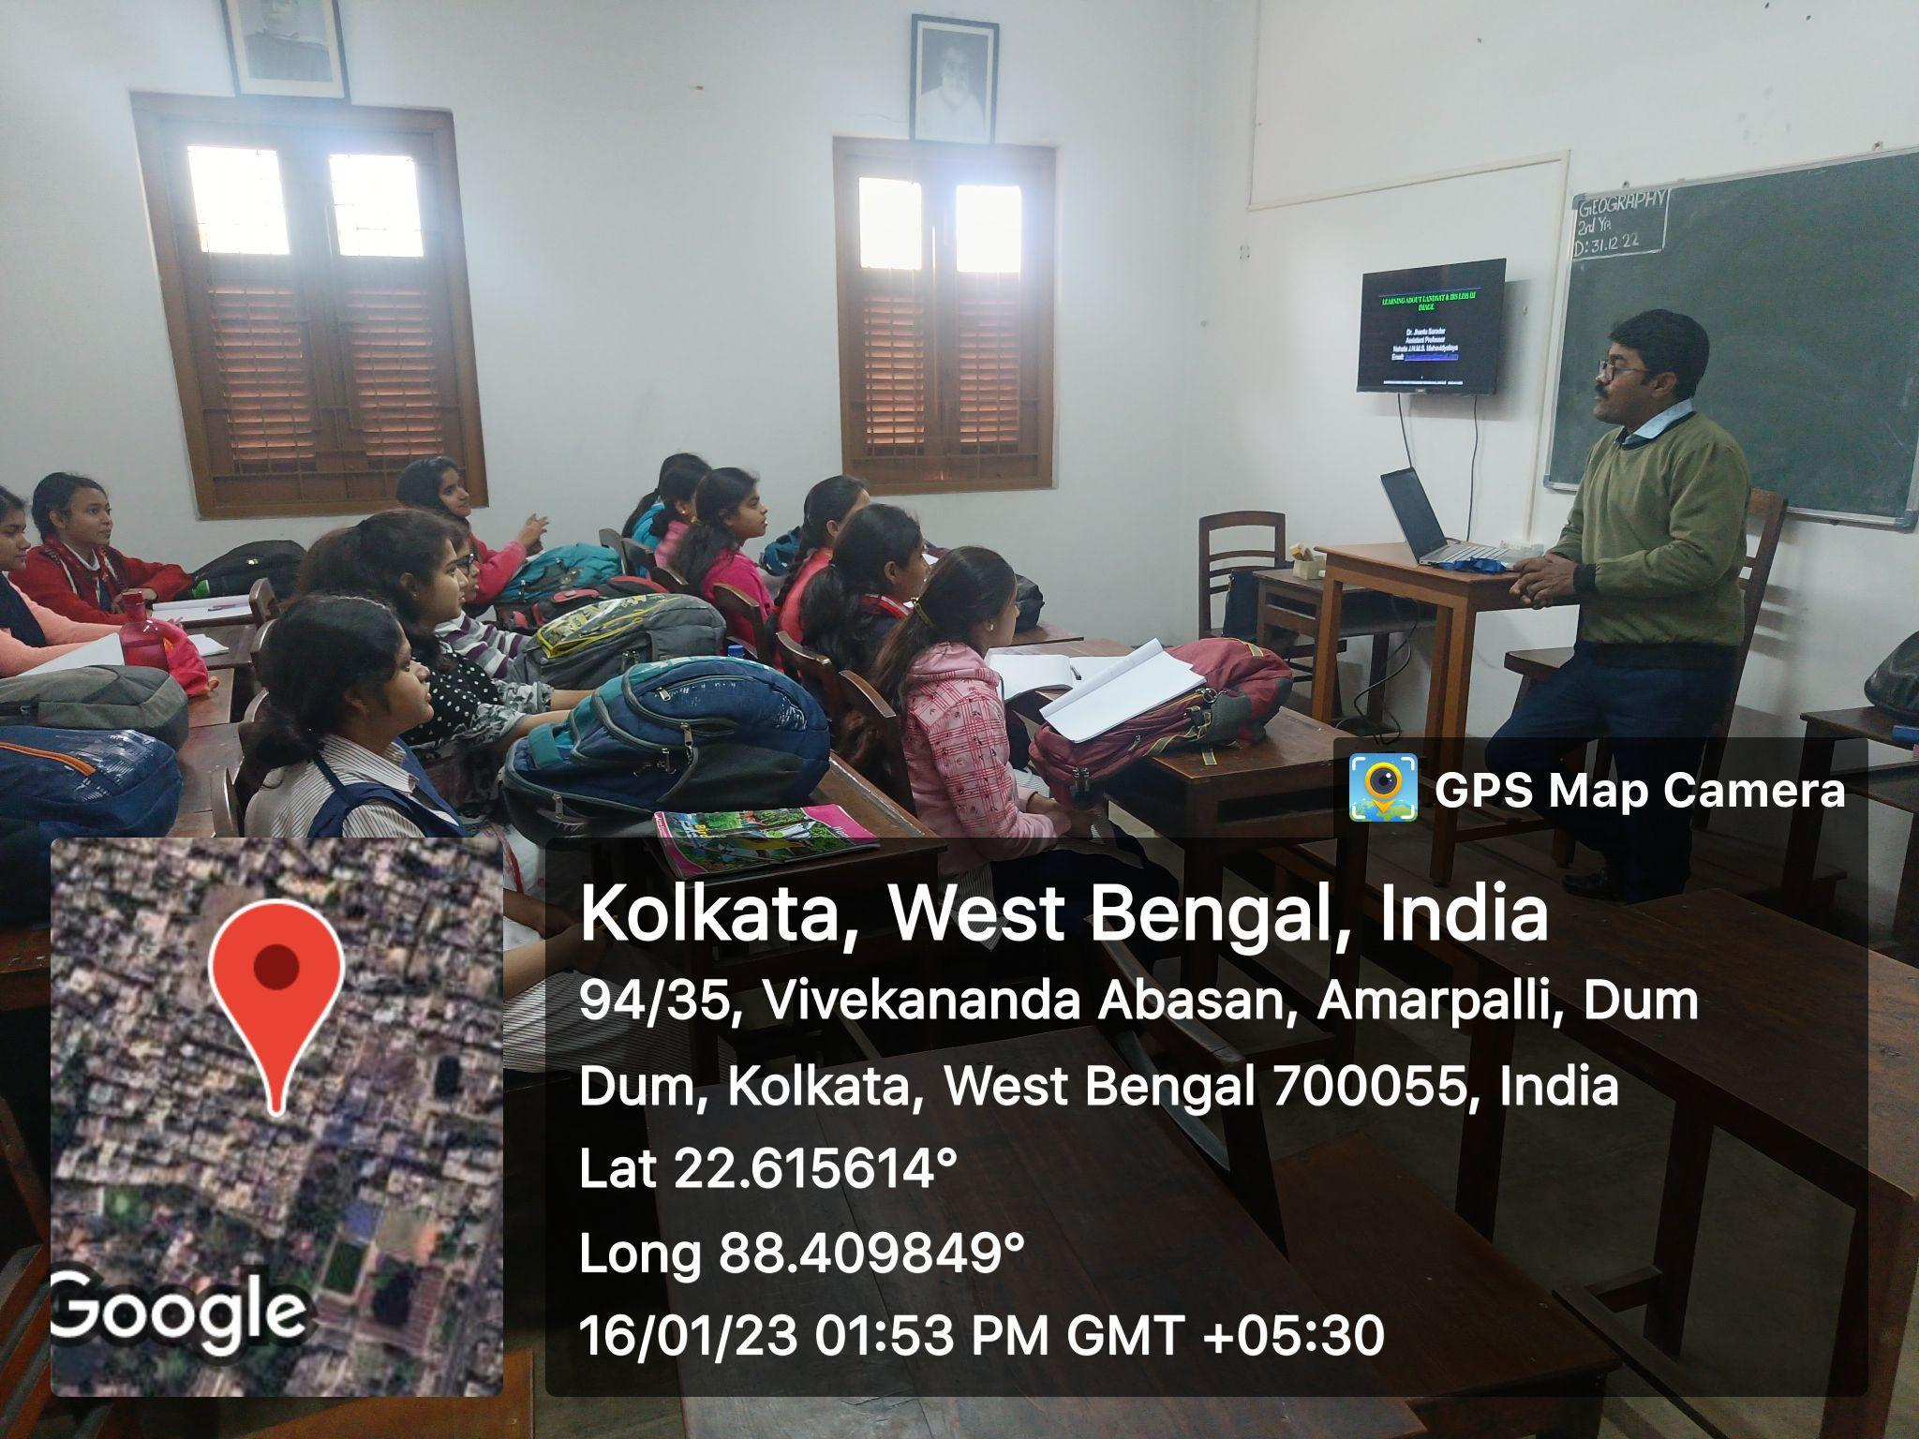
Resource person with the students
…………………..

