Name: Why Do We Need An Internal Complaints Committee?
Category: Students’ Seminar
Organising Unit: RKSM Vivekananda Vidyabhavan Internal Complaints Committee in Collaboration with the IQAC, RKSMVV
Date: 16 December 2022
Time: 1.45 pm
Number of Students: 190
Number of Resource Persons: Nil
Name of Resource Person: Nil
Number of Beneficiaries: 190
Brief description of the event: This Seminar has been devised as an awareness campaign on sexual harassment at higher educational institutions where the Second and Third Year students themselves organized different forms of presentation stated in the following paragraph:
- A PowerPoint presentation entitled ‘Know Your Strength’ on Internal Complaints Committee as perceived by the students; its benefits and what more they wanted
- Skit: Speak Out Loud: Reel Versus Real
- Mime: Step Out of the Shadows
Program Outcome: The last Session on Interaction with First Year Students shows that they getting to know the issues within the crime of sexual violence mostly faced by cis and trans women students in the higher educational institutions. Their queries and comments reflect their resolve to stop this assault trivialized in society as Eve-Teasing. The students talked about the ways they can reach out to the public with these issues. They also want more events like this where they can be involved and gain insights of the diverse areas of this issue of sexual harassment.

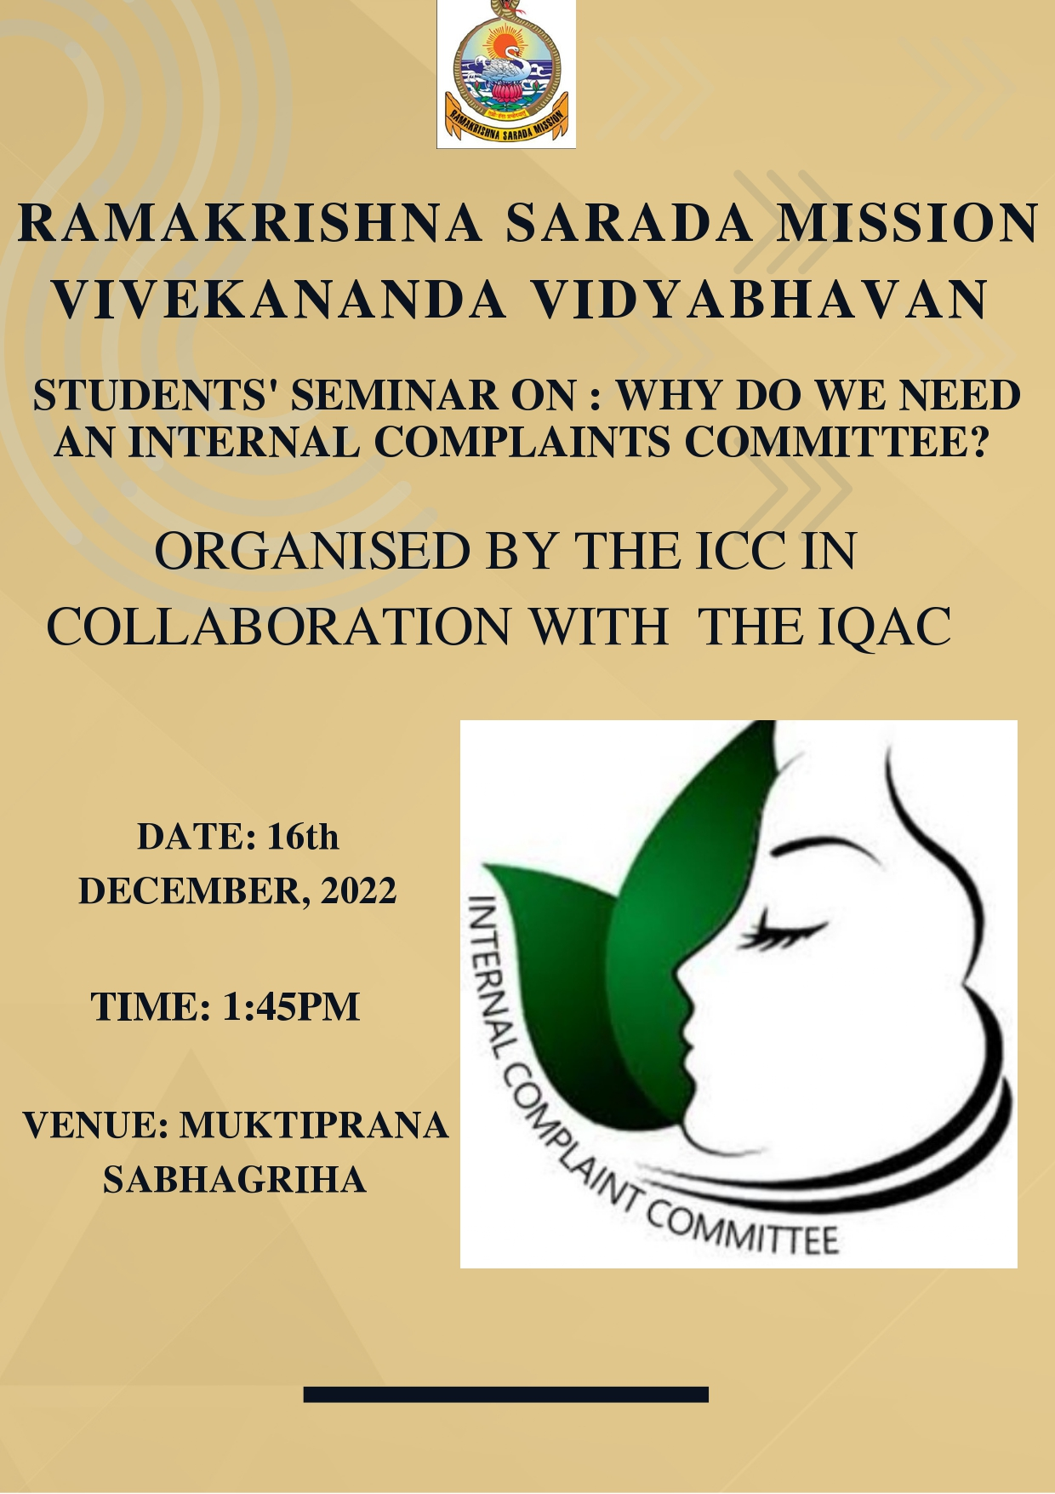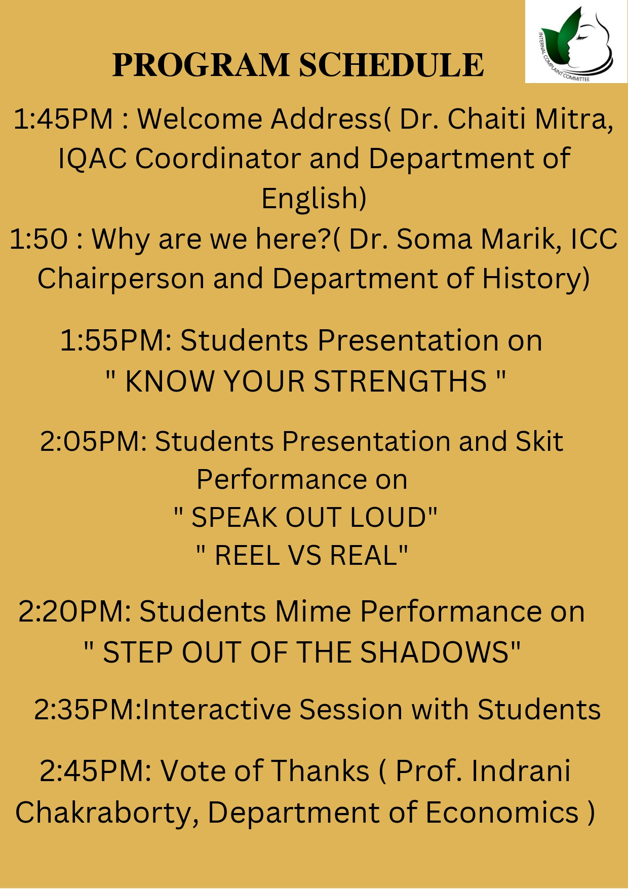

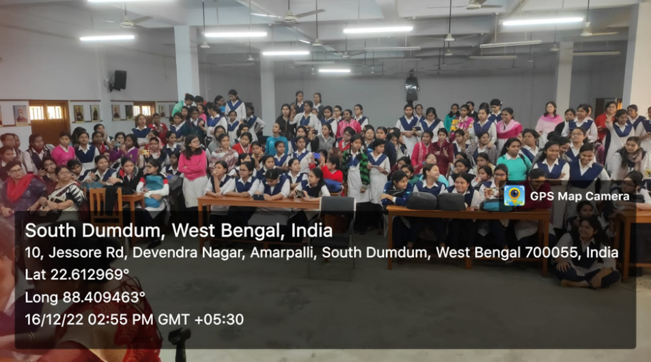

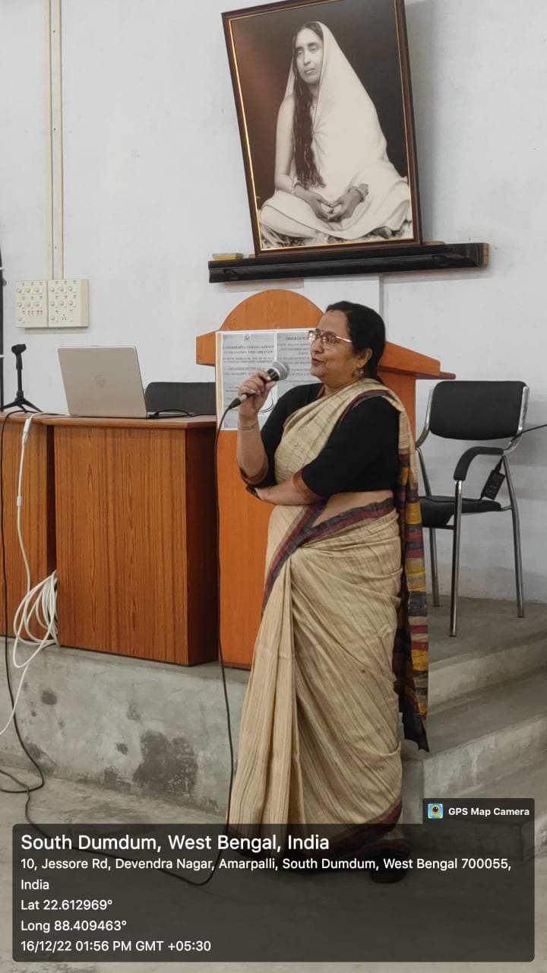

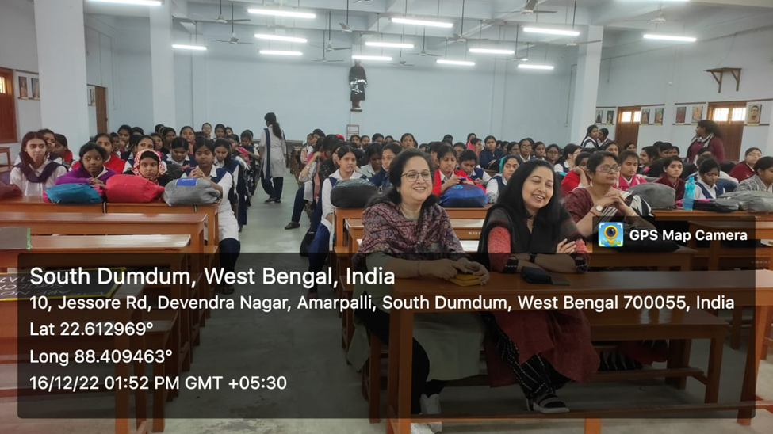

Mime-
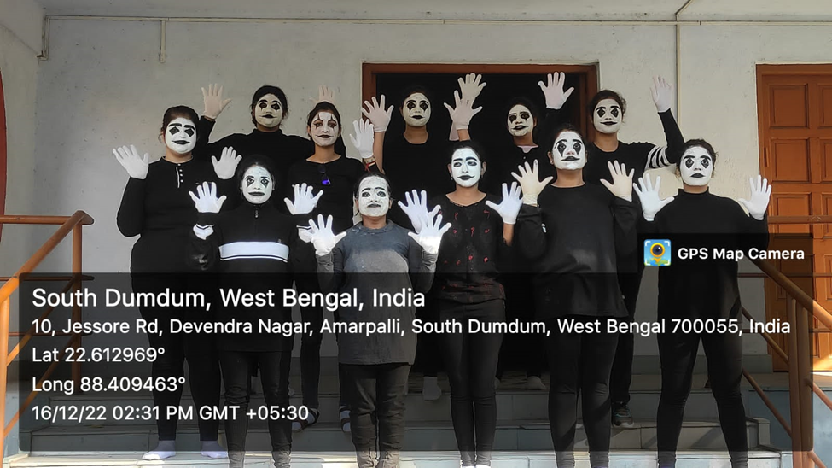
PPT Presentation-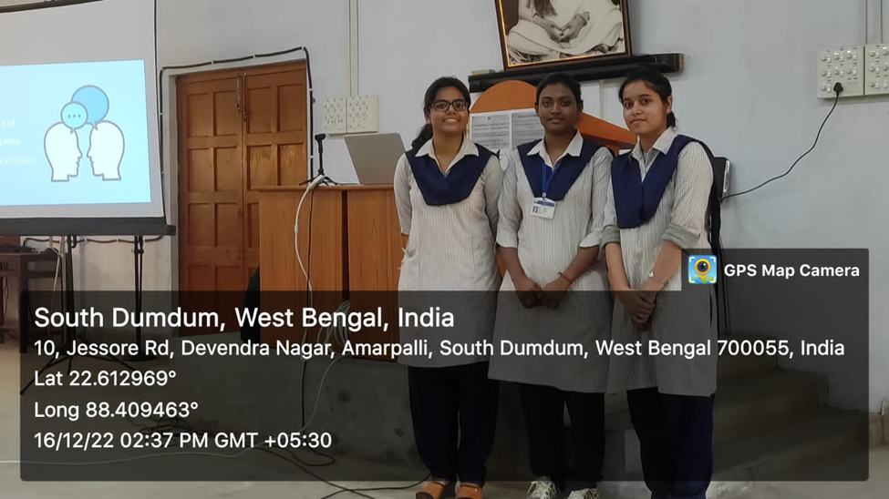

Skit-
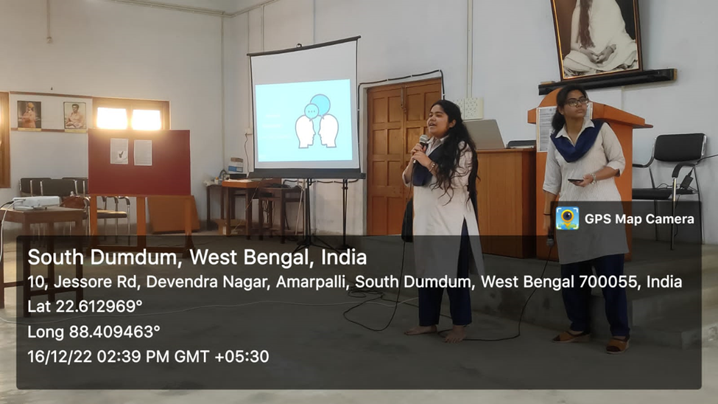
Organizing team-
