Name of the event: M.K. Gandhi: His Ideas on Principles of Social Regeneration and Basic Education
Category: Online National Students’ Seminar
Organising Unit: Department of History, Netaji Subhas Open University and in association with the Departments of Human Rights and Philosophy, in collaboration with NSOU Centre for Social Studies
Date: 17th November 2022
Time: 12 Noon to 3 pm
Venue: Audio-Visual Room
Number of resource persons: 2
Name of the Resource Person:
- Dr. Ritu Mathur (Mitra), Associate Professor of History, School of Social Sciences, Netaji Subhas Open University
- Ms. Debarati Banerjee, Associate Professor in History, School of Social Sciences, NSOU (Contractual)

Number of the Participants: 150

Brief Description: This jointly held online National was organized for the students at both UG and PG Levels and conducted by Professors Mathur (Mitra) and Banerjee on behalf of NSOU, Kolkata on different aspects of social regenerative ideas of M.K. Gandhi
Programme Outcome: This event encouraged the students to conduct more in-depth research on the iconic and debated figure of the Indian national movement in diverse fields apart from the more known Non-Violence/ Satyagraha. They took a pitch on Khadi and its relevance in the contemporary economy. M.K. Gandhi’s conceptualization of gender was also taken up and the issue of feminization of politics came up. This helped the UG students to explore and learn the methodologies of research.

Flyer
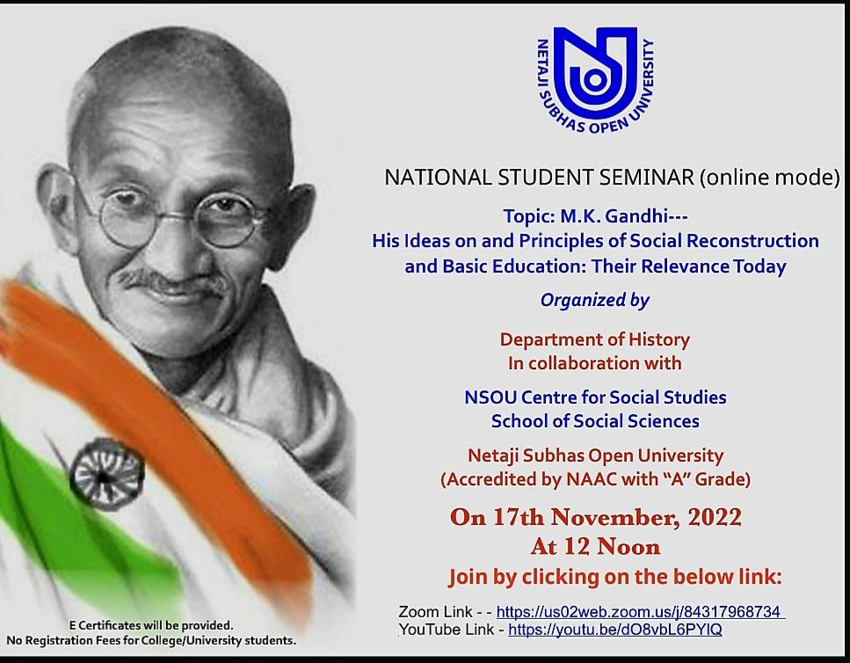

Geo-Tagged Photos
