Name of the Activity: Trends in Mesopotamian Bronze Age Economy
Category: Extension Lecture
Date: January 17, 2023
Time: 12.15pm—1.30 pm
Venue: History Room 15
Name of the Resource Person/s (with Designation): Dr. Prasenjit Biswas, Associate Professor, Department of History, Bhairab Ganguly College, Belghoria, North 24 Parganas
Number of the Participants: 26
Brief Description of the Event: This lecture was organised for the First Semester students, who were little hesitant as their Core Course 1 began with an Ancient Civilization, about which they are not fully aware. But the speech lucidly discussed the major features of Mesopotamian economy and its connection with agriculture and environment.
Programme Outcome: The lecture delivered by Dr. Biswas, was insightful and analytical enough to let them know the agrarian roots of and fertile crescent of the urban and commercial economy without which social surplus would not have been enough for a growing temple state and state. The students were curious to know the connections between Urban Revolution and the Neolithic Revolution. The students learnt about the genesis of temple-controlled economy and society as it thrived on the social surplus
Flyer:
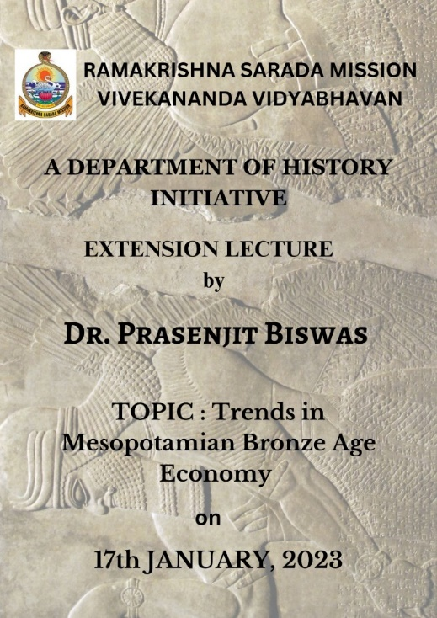
Geo-Tagged Photos in jpeg. Format
