Name of the activity: Extension Lecture
Category: Extension Lecture
Topic: “UTM projection”
Organising unit: Geography Department in collaboration with IQAC, RKSMVV.
Date: 18.01.2023
Time: 11.30 am-3.30 pm
Venue: Geography Dept. classroom.
Name of the Resource Person/s with designation: Prof. Dulal Chandra Das, Former Associate Professor, Dept. of Geography, Bidhannagar College, Kolkata.
Number of Participants: 24 students of SEM-I and 4 teachers.
Brief description of the event: This extension lecture was organised for Semester I. The session focuses on the concept of UTM projection including the definition, meaning, properties, uses and formation of UTM grid zones very lucidly and vividly. After that, he cleared all their doubts regarding this topic with an easy and understandable explanation. The session ended with giving thanks to the honourable resource person and the students and all faculties of the department.
Programme Outcome: Map projection is the method of transferring the graticules of latitude and longitude on a plane surface. UTM provides a constant distance relationship anywhere on the map. In angular coordinate systems like latitude and longitude, the distance covered by a degree of longitude differs as we move towards the poles and only equals the distance covered by a degree of latitude at the equator. Since land navigation is done in a very small part of the world at any time using large-scale maps, the UTM system allows the coordinator numbering system to be tied directly to a distance measuring system. Students learnt every aspect of UTM Projection like UTM grid zone, importance and properties of UTM etc. The session was very resourceful for the students and they learnt a lot.
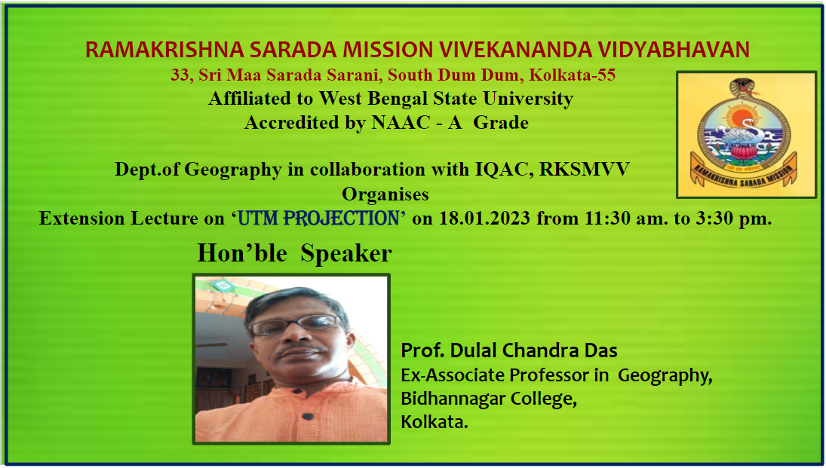
Flyer of the program

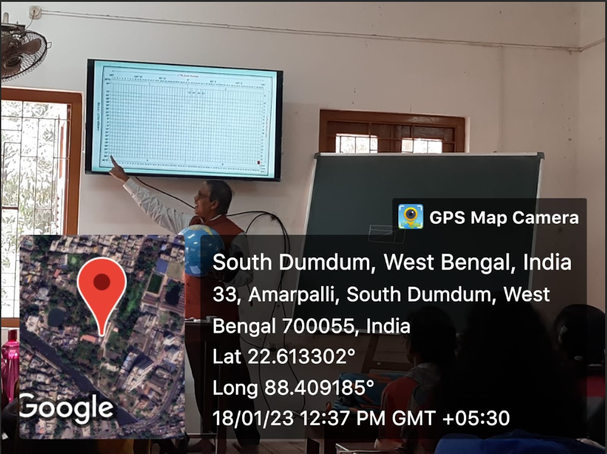
Presentation of the Resource person
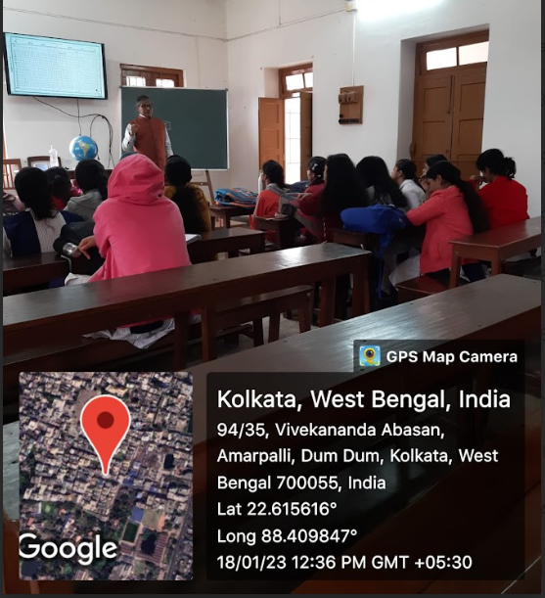
Resource person was presenting

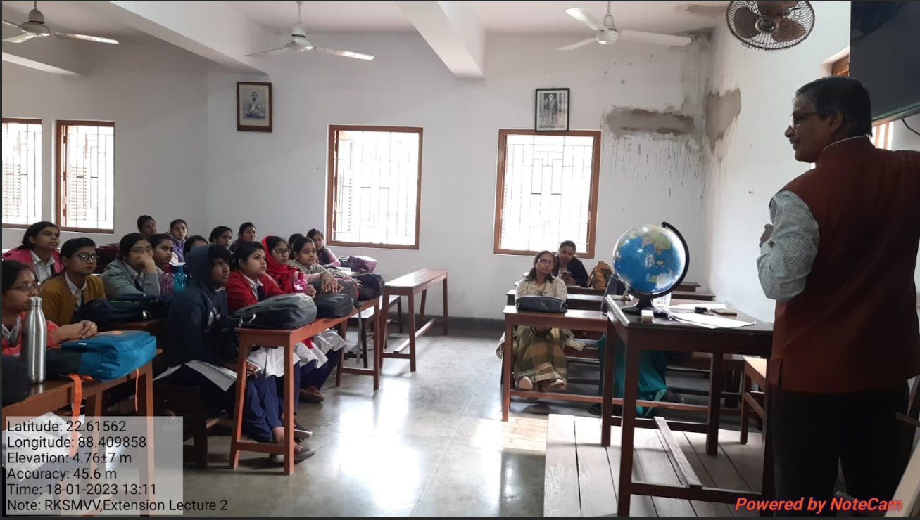
Resource person with the students
……………………….

