Name of the Activity: Applications of Psychology on Work, Law and Health
Category: Invited Lecture
Organising Unit: Department of Psychology, RKSMVV
Date: 20th January, 2023
Time: 11:15 am onwards
Venue: Room 37
Number of Participants: 32
Number of Resource Person/s (with designation): Dr. Anwesha Chakrobarty, Assistant Professor, Sarojini Naidu College for women
Brief description of the Event: This extension lecture was a syllabus orientation lecture. It was designed in such a way that students learned about the various branches of Psychology and specifically how psychology is applied in the field of Work, Law and Health.
Programme Outcome: At the end of this illuminating and thought-provoking lecture students learned a lot about the following topics:
1. Health psychologists can support people living with long-term conditions to improve or maintain quality of life, self-manage their conditions, and adjust to life with an illness, disability or long-term condition. Health psychology also concerns itself with bettering the lives of individuals with terminal illness.
2. Utilizing the required scientific methods to examine man behavior in place of work, a certified psychologist is then able to determine how well teams communicate, how invested people are in their jobs, as well as the happiness levels and how that impacts productivity and efficiency in the workplace.
3. Legal psychologists typically take basic social and cognitive principles and apply them to issues in the legal system such as eyewitness memory, jury decision-making, investigations, and interviewing.

Flyer:
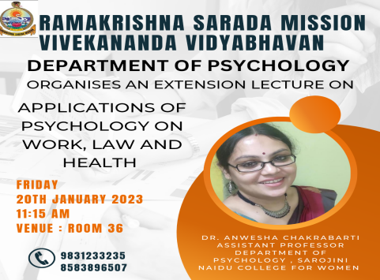
Geo-Tagged photos:
