Name of activity: Workshop on ‘Adolescence: The Stormy Phase of development’
Category: Workshop
Topic: Adolescence- Stormy phase of development
Organising unit: Psychological counselling
Date: 20th May, 2023
Time: 10:30 am onwards
Venue: Room no- 32
Name of resource person/s (with designation): Dr. Payel Talukdar, Acting HoD, RG Kar Medical College And Hospital
Number of participants: 25
Brief description of the event: The workshop was organised to increase education and awareness about the adolescence stage. The speaker talked about how to Increase community coordination and communication pertaining to body image, relationship, and identity formation issues. She addressed the ways on how to assess the needs of adolescents and families as they pertain to adolescent abuse issues
Program Outcome:
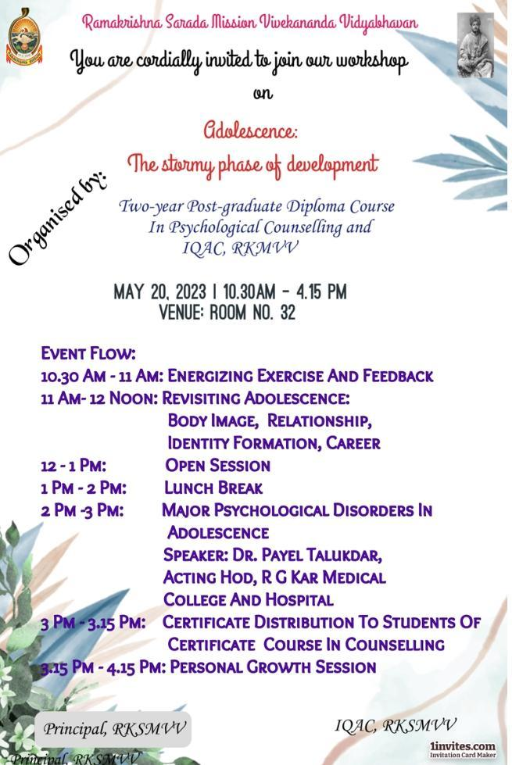
It empowered participants with knowledge, strategies, and a renewed commitment because the shared principle was that every adolescent deserves a safe and healthy environment. Participants learned and gathered knowledge about the strategies for prevention and how they can ethically assess the needs of adolescents and families
