Name of the activity: Extension Lecture on “Changing Concept Of Time & Space In Geography In The 21st Century”
Topic: “Changing Concept Of Time & Space In Geography In The 21st Century”
Category: Departmental activity
Organising unit: Geography Department in collaboration with IǪAC, RKSMVV
Date: 22.03.2023
Time: 12 noon to 3 pm
Venue: Geography Department classroom.
Number of Resource Person/s: 01
Name of the Resource Person/s: Mr. Ujjwal Bhandari,SACT, Syamaprasad College, C.U
Number of Participants: 19 students of SEM-6
Brief description of the event: This extension lecture was organised for SEM-6 through online mode. After a brief introduction of our resource person by Soma Mukhopadhyay, faculty of the Geography department, the main session started. Mr. Bhandari very lucidly and chronologically described the developments of geographical thoughts through changing concepts of time & space in geography in the 21st century. Students cleared their doubts after his presentation. It was a fruitful session indeed.
Programme Outcome: In fact, geographical thought provides clear information on key ideas and ťgures in human geography. The study of geographical thought is the study of the philosophical and theoretical assumptions we make in developing geographical knowledge and how different philosophies and theories have become dominant within Geography at different times. Students acquired clear knowledge about developing geographical ideas and thoughts through time and space, particularly in the 21st century. It was a successful event for the students of semester 6.
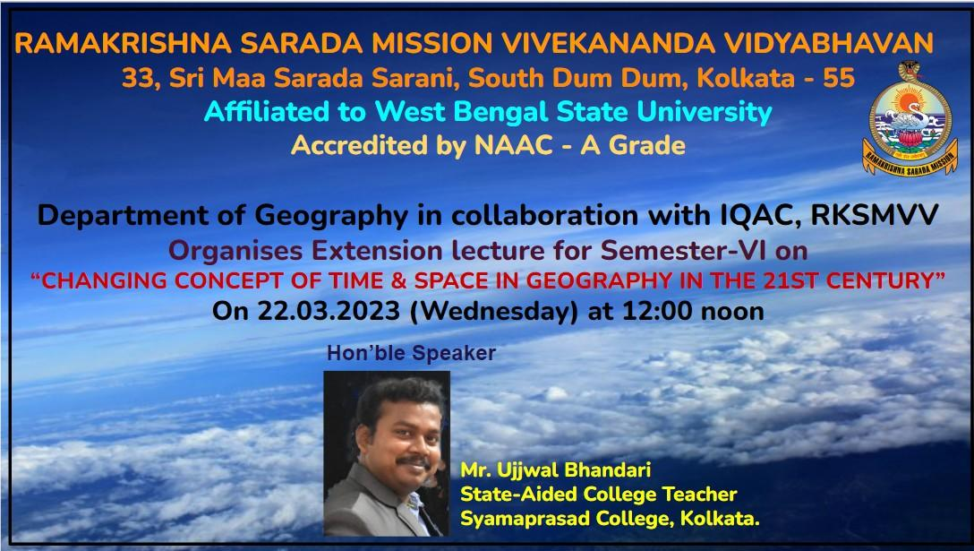
Flyer of the program

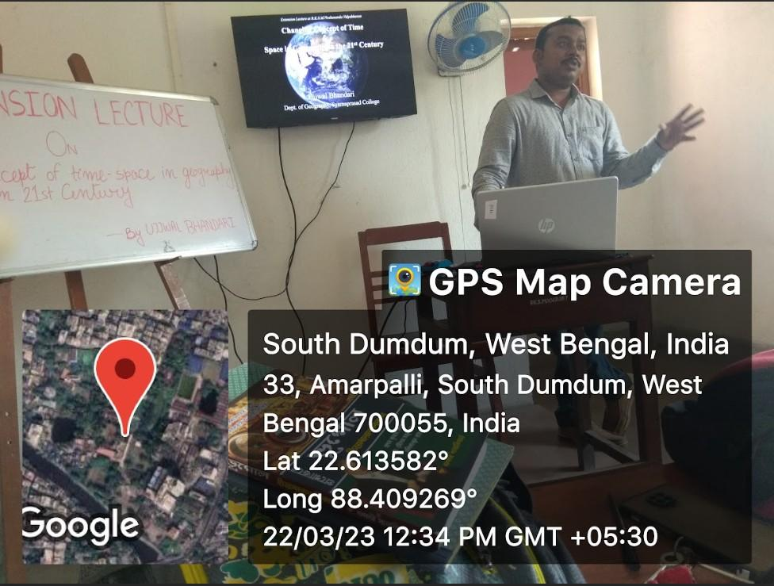
Resource person was presenting

Resource person was delivering speech

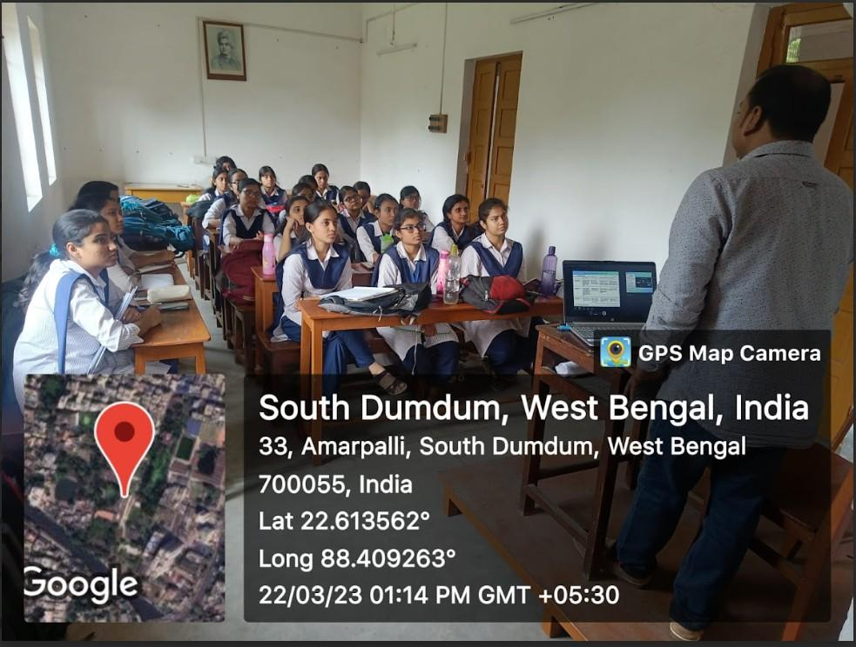
Students were listening the speech
………………………………………………

