Name of the Activity: Suicide Prevention and Awareness
Category: Seminar
Organising Unit: Jointly held by the Departments of History and Psychology, Ramakrishna Sarada Mission Vivekananda Vidyabhavan
Date: 22nd September, 2022
Time: 12.15 pm to 1.45 pm
Venue: Seminar Room (8)
Name of the Resource Person with Designation: Faculty from the Departments of History, Dr Soma Marik, Associate Professor, and Psychology, Ms. Aishwarya Banerjee, SACT II.
Number of Participants: 72
Brief Description of the Event: This session was initiated as an interactive programme started by speeches of the Resource, followed by short presentations of the students exploring the historical psychological roots. The students of both departments also held poster exhibitions. The goal has been to build awareness of suicides and how to stop them. The programme is organised to commemorate 22 September, as the International Day for Suicide Prevention.
Programme Outcome: This was a highly engaging and interactive seminar where the questions and presentations revealed the growing awareness of mental health among the students. The main contention that came out was suicide is not primarily a mental health issue. Lack of awareness, support, empathy, helplessness, and loss of self-esteem sometimes are the probable factors. The Seminar also highlighted the greater number of suicides among Gender-Sexual Minorities. 24-hour Online Support systems should be more proactive and effective.

Flyer
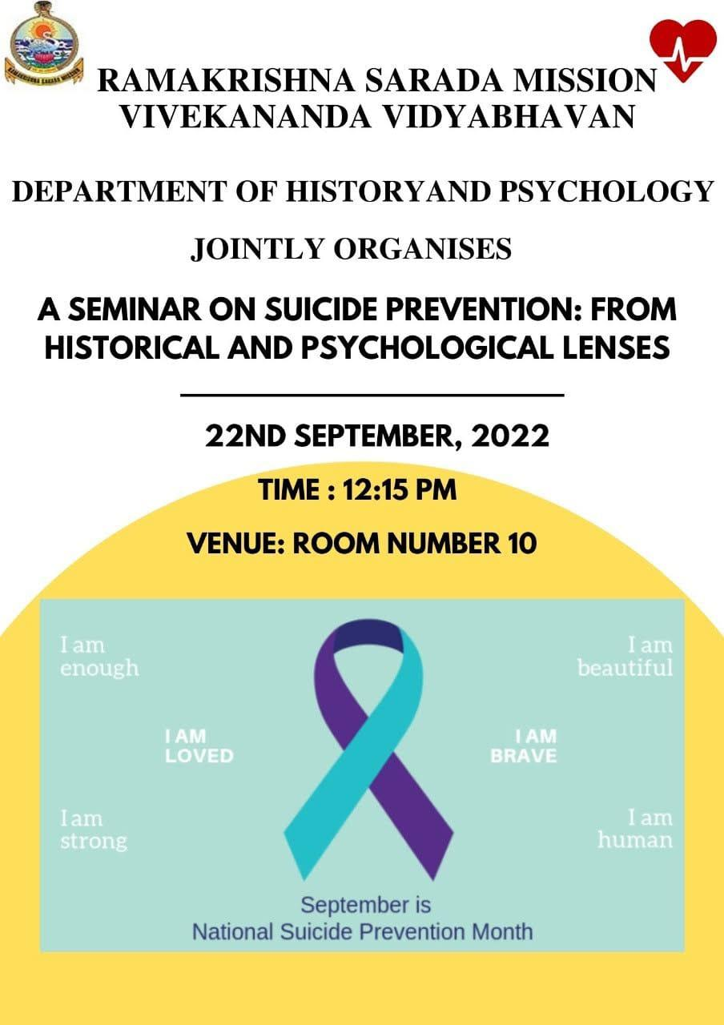
Geotagged photos
