Name of the activity: Celebration of "World Meteorological Day"
Category: Study Visit– Departmental activity for Educational purposes.
Organising unit: Department of Geography, RKSMVV.
Date: 23.03.2023
Time: 11:00 am - 2:30 pm
Venue: Regional Meteorological Centre, Alipore, Kolkata.
Name of the Resource Person/s with Designation: Staff of RMC, Alipore.
Number of Participants: 15
Brief descriptions of the Event: Fifteen students from Semester 4 of the Geography department took active participation in the visit. The visit included a field survey of the observatory where Weather scientists gave demonstrations of different surface instruments that measure temperature, humidity rainfall etc. It was a very knowledgeable experience for the students which gave them an understanding of the weather elements in particular and geography in general.

Programme Outcome:

The students got acquainted with the use and working of different meteorological instruments like max-min thermometer, wet-dry bulb thermometer, rain gauge, automatic weather station, automatic rain gauge, wind vane, anemometer, air balloon, theodolite etc. and collection and tabulation of weather data. The students also got familiar with the workings of radar and its use in the transmission and reception of information about the clouds and the collection and analysis of that information.
An interactive session was also held within the office, where the students were asked questions related to monsoons and other climatic phenomena. Also, our students participated in the quiz section and got prizes.

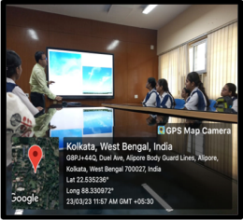

Students in front of RMC, Alipore Demonstration of clouds by a member
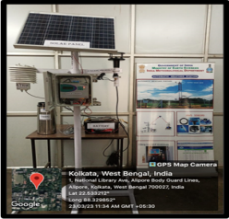

Meteorological instrument Source: Telegraph paper, Date:24/3/2023 ………………………………………………………..

