Name of the Activity: 7-Day Special Camp
Category: Workshop and seminar
Topic: Creating an awareness for improvement of the status of women and health
Organising Unit: NSS, RKSMVV
Date: 23rd March- 29th March 2023
Time: 11:15 am onwards
Venue: Smart Classroom, RKSMVV
Number of Participants:
Day 1- 49
Day 2- 49
Day 3- 49
Day 4- sunday
Day 5- 49
Day 6- 49
Day 7- 49 +24 teachers
Brief description of the event:
Day 1 (23.3.23) Thursday
The 1st day of the Seven Day Special Camp began as the Inauguration Programme started with the Vedic Chanting by NSS volunteers followed by the lightning of the Ceremonial Lamp. Our Principal, Pravrajika Vedarupaprana delivered an exhaustive lecture on NSS and the Mission and Vision of our college. She was followed by Dr. Chaiti Mitra, IQAC Coordinator, RKSMVV. Dr. Chaiti Mitra, in her speech, focused on the motto of NSS- ‘Not Me, But You’. Then, the Program Officer of NSS, Dr. Sanghamitra Mukherjee gave a speech focusing on ‘NSS and Seven Day Camp’, thereby also discussing its objectives.
In the 2nd Half of the 1st day, ‘Strategies of Women Empowerment and Social Change’ was thoroughly discussed by Dr Manjir Ghosh. She is the Founder and Director of Educhange, a social impact organization that makes efficient use of the play-based learning model to transform the overall learning infrastructure for students. The focus of this programme is to not just develop soft skills among the students but also to garner self-reliant attitudes and behaviour among them as professionals who want to be an active part of the Indian workforce. The programme aimed to impart skills to the students so that they may contribute to society as effective professionals and are also able to sustain themselves financially.

Day 2(24.3.23)Friday
In the 1st Half, a training programme was organized by Dr. Sanghamitra Mukherjee where a grooming session was conducted for young pupils to implement traits of leadership in them. The programme aimed at grooming the youth to help them become qualified as perfect leaders of an organization or group. Along with the training session, several skits and plays were set up for the students which focused on vital topics like ‘Leadership Qualities’ and ‘Enhancing Leadership’. The training programme eventually cultivated to be an efficient one as it indoctrinated the students with the several concepts of ‘Leadership’ and ‘Efficient Team-Work’.
In the 2nd Half, “Digital Marketing Training” was explained by Smt. Mitali Purkait Ghosh. She is the co-founder and CEO of Digital Concepts. This training is an initiative to educate students in the areas of Digital Marketing. Digital Marketing and Social Media have changed marketing and business practices across the world. This training provides an understanding of the growing digital landscape and examines the role of digital marketing processes and tools in designing overall marketing strategies. The students were excited after learning about Digital Marketing. They understood that Digital Marketing was a chance for them to make themselves stand out as best with a perfect financial career ahead.
Day 3(25.3.23) Saturday
In the 1st Half, a Psycho Drama was set up and acted out by the MSc students of Psychology at Sarojini Naidu College for Women. It was persuaded by a Group Discussion with the students of RKSMVV. Afterwards, Dr. Nilansuk Dutta, Consultant Psychiatrist and Rehabilitation Administrator delivered a speech on the topic ‘Why Music ?’ where he talked about the effectiveness of Music on Mental Health and how Music helps evacuate stress from the mind and thereby relaxes the mind.
In the 2nd half, an activity-based awareness workshop was conducted by Dr. Kasturi Mukherjee and her team members. Here screening of the students was done based on questionnaires’ and group counselling was performed. Meditation, deep breathing, some sorts of yoga etc were taught to the students for their healthy physique as well as strong minds.

Day 4(26.3.23)- Sunday
Day 5(27.3.23)Monday
In the 1st half, Dr. Subhadip Pal, an eminent physician delivered an informative lecture on “Getting in Shape…..Physically and Mentally”. The session was an interactive one with the students getting to know a lot about physical health. Dr. Subhadip Pal talked about all the necessary steps that should be taken to attain a healthy body, especially for women. In his lecture, he pointed out various health problems faced by women as well as AIDS awareness and preliminary health care.
In the 2nd half NSS unit of RKSMVV organized an Anti Plastic Campaign in the college campus and adjacent area to make the surroundings “Plastic Free Zone”. The NSS volunteers of RKSMVV visited the different flats and house apartments situated there. The students had a conversation with the people residing there regarding the harmful effects of plastics and requested them to use paper bags, jute bags, cotton bags etc instead of those made up of plastics. Not only the apartments but also they visited nearby shops. The volunteers gave cotton bags to the shopkeepers and advised them to use them instead of plastic ones.
The total no of students present-49

Day 6 (28.3.23) Tuesday
In the 1st half, a poster competition on “Women Empowerment” was organized and twenty students participated in it. Afterwards, an orientation programme on ‘Donation Drive’ was conducted by the Principal, Pravrajika Vedarupaprana. She pointed out how the volunteers could help underprivileged people.
In the 2nd half, the Donation Drive was organized where the pupils engaged themselves in helping the needy. Students, teachers and non-teaching staff submitted several different items and clothes. Everybody was instructed to make sure that the donated items were in good condition. Forty-nine NSS volunteers of the Special Camp purchased new pens, pencils, erasers, sharpeners and copies for 25 children. New clothes were arranged for 30 females with funding from NSS and the college authority. Volunteers and teachers distributed materials among 85 women, 40 men and 20 children residing in the locality. The items included sarees, salwar suits, kurtas, shirts, pants, sweaters, toys and stationeries.
The total no of students present was 49.
The total no of teachers present-14
Day 7(29.3.23) Wednesday
In the 1st half, a campus cleaning drive was held. The volunteers engaged themselves in cleaning dry leaves and creepers from the college ground and watering the plants. Not only that, but also they carried out efforts in spreading bleaching powder throughout the enormous campus, covering every area of the college; especially the drains where the population of mosquitoes and flies undergo rapid expansion, which in turn causes outbreaks of Dengue and Malaria.
In the 2nd Half, there was a valedictory session where a cultural programme was hosted by the students. At first, the NSS Song was sung by every student as an ode to NSS and its Services. It was followed by a dance performance. Then, a PowerPoint Presentation was delivered by the students, which focused on NSS, its programmes and activities. Two students gave a brief report of their experience in the Seven Day Special Camp. Then winners of the poster competition held on 28.3.23 were awarded by the Principal. Dr. Sharmistha Dutta, Associate Professor, Department of Education delivered a lecture creating awareness among students that they could avail of all kinds of occupations provided they have to acquire the requisite skills for the work. The valedictory speech was given by Principal, Pravrajika Vedarupaprana. The programme ended with a vote of thanks by the Programme Officer, NSS.

Photos
Day 1: 23.03.2023
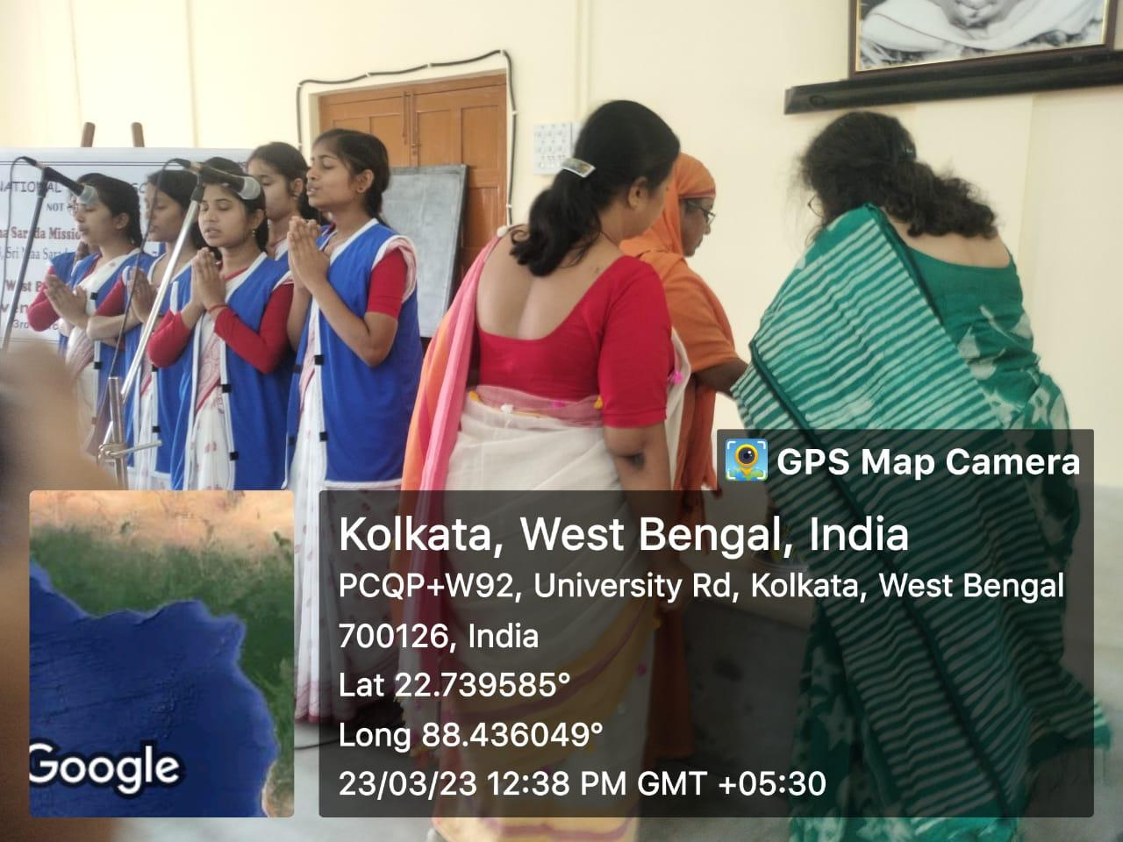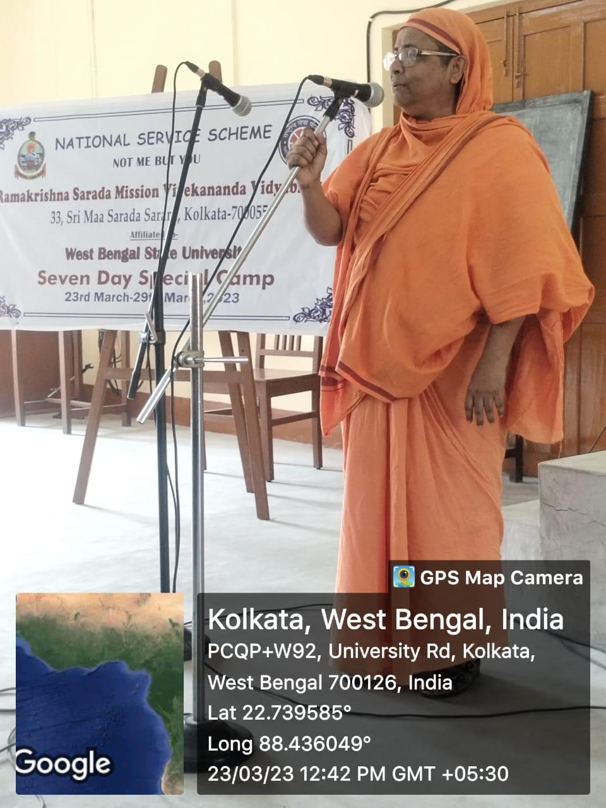
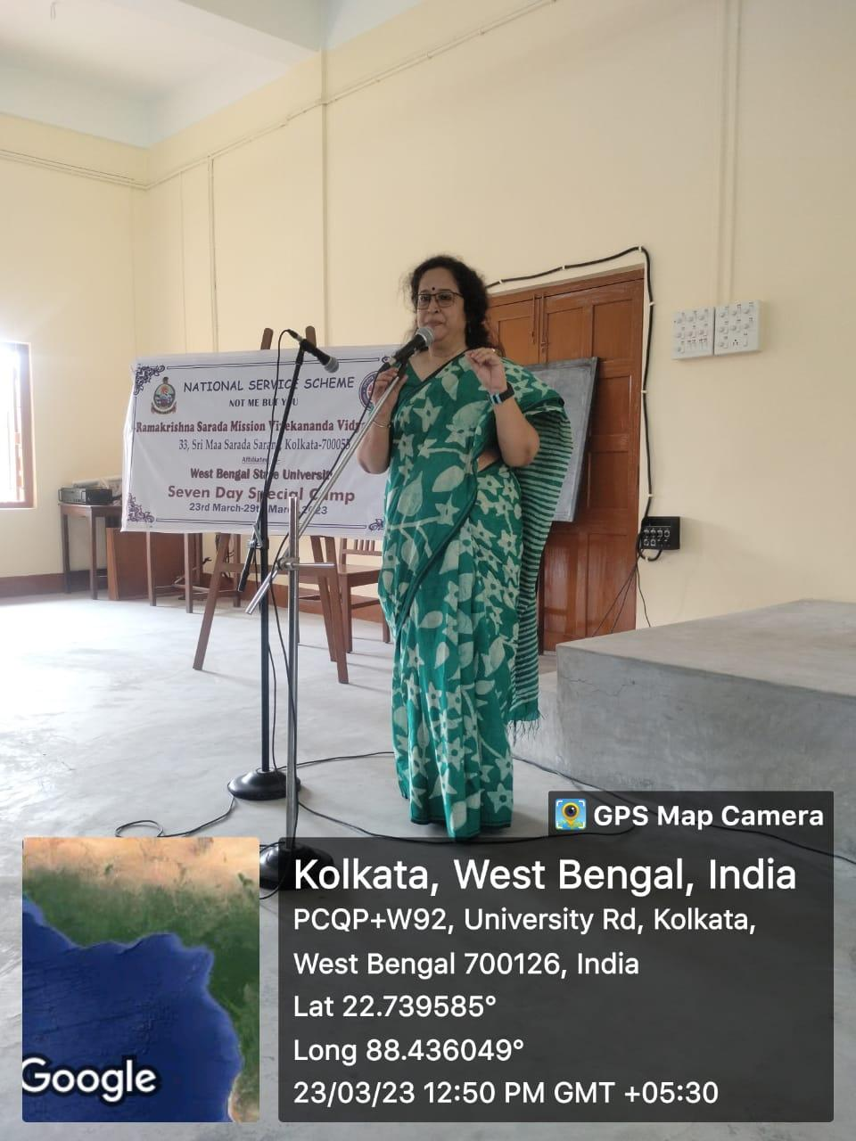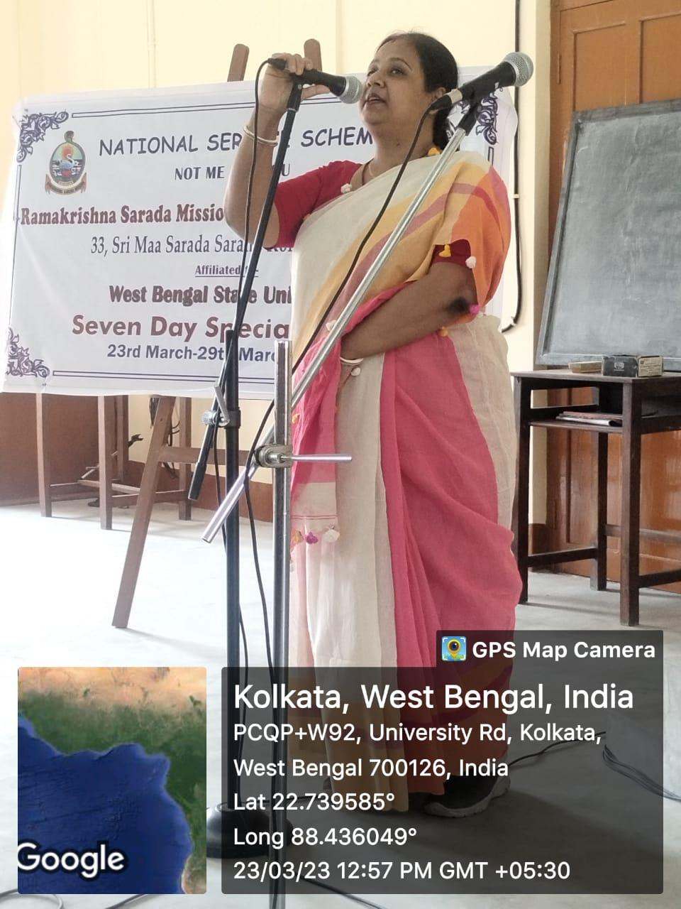

Day 2: 24.03.2023
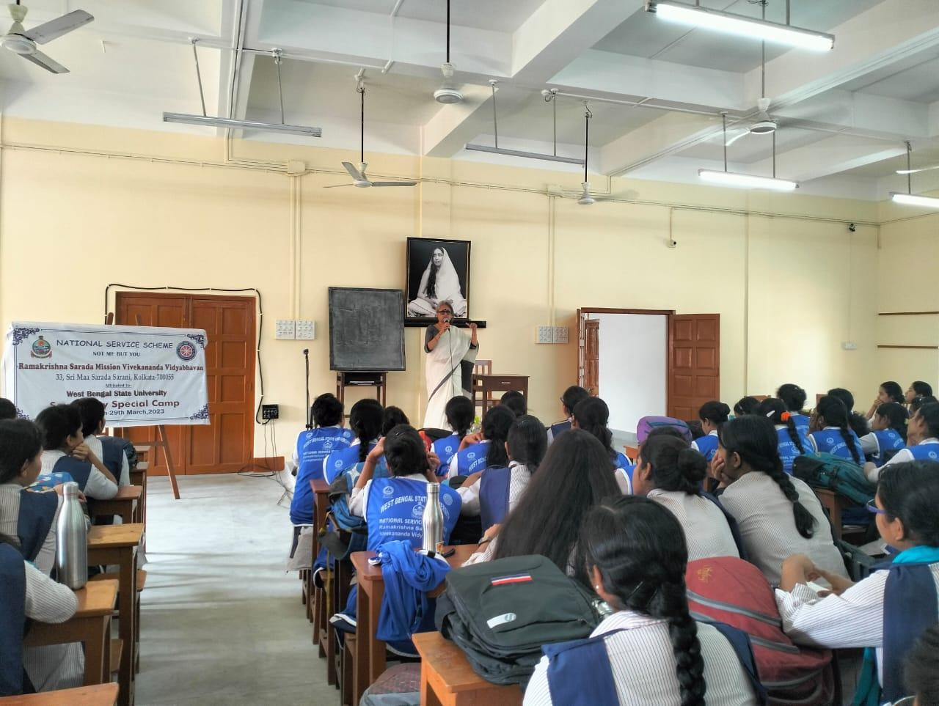
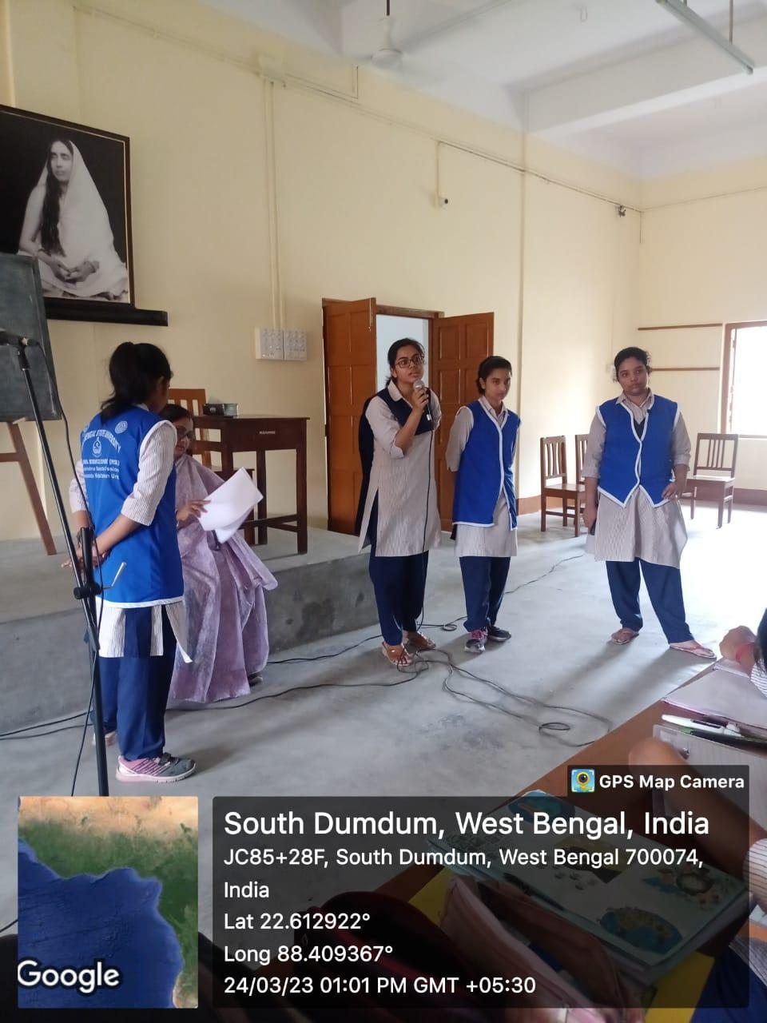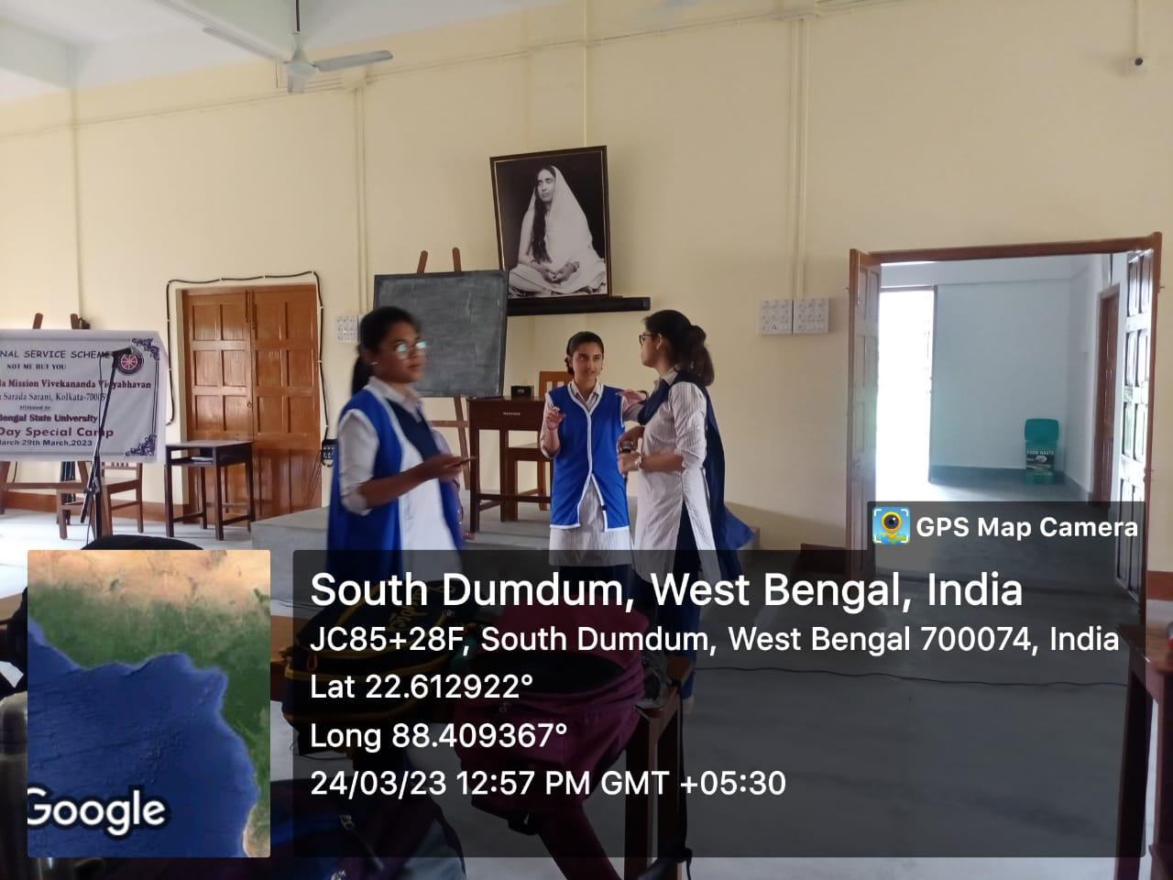
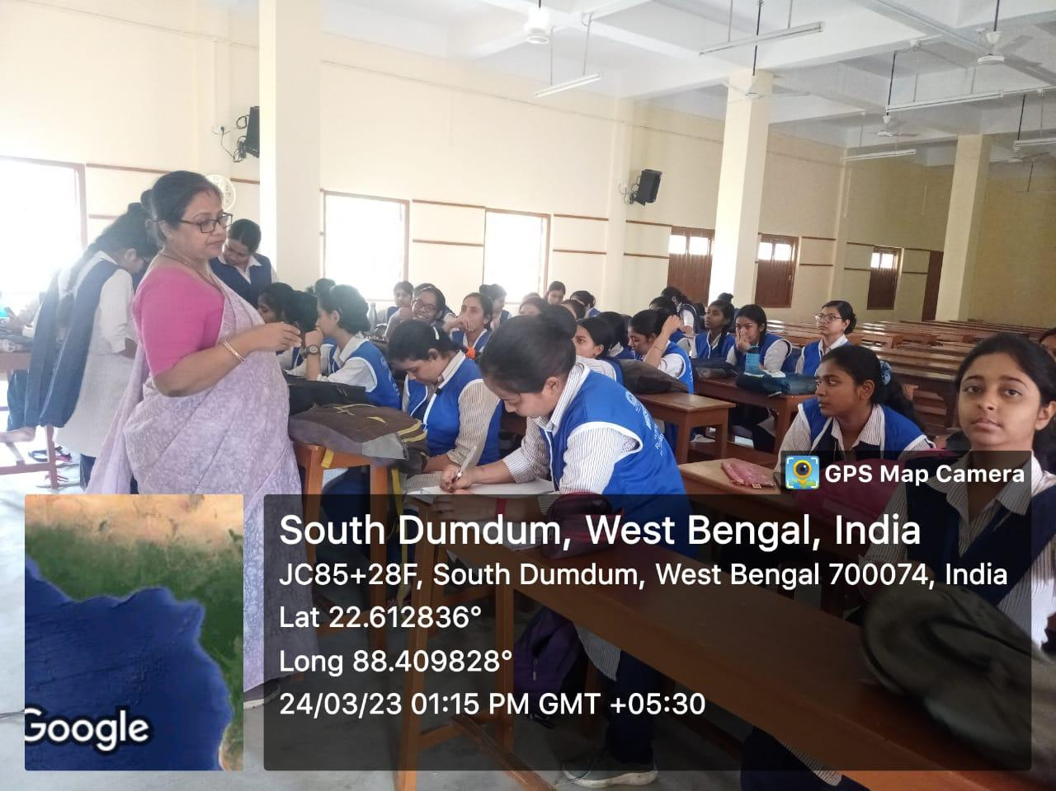

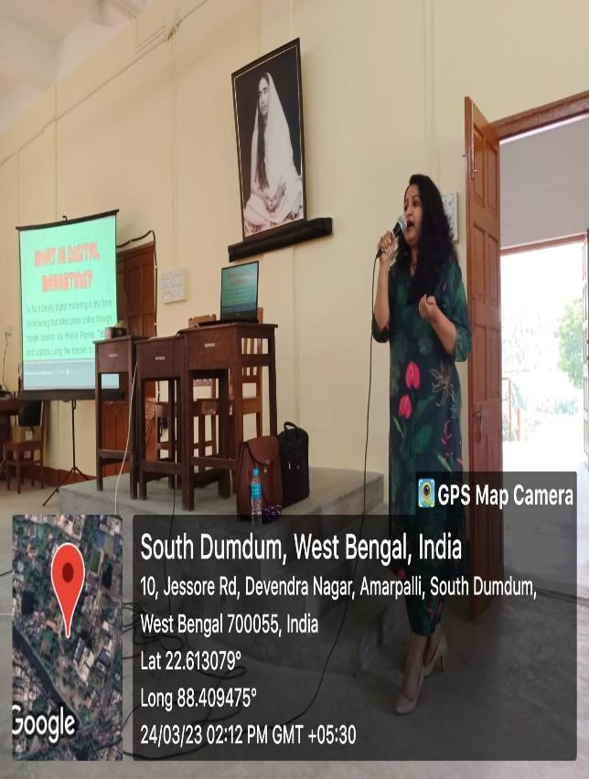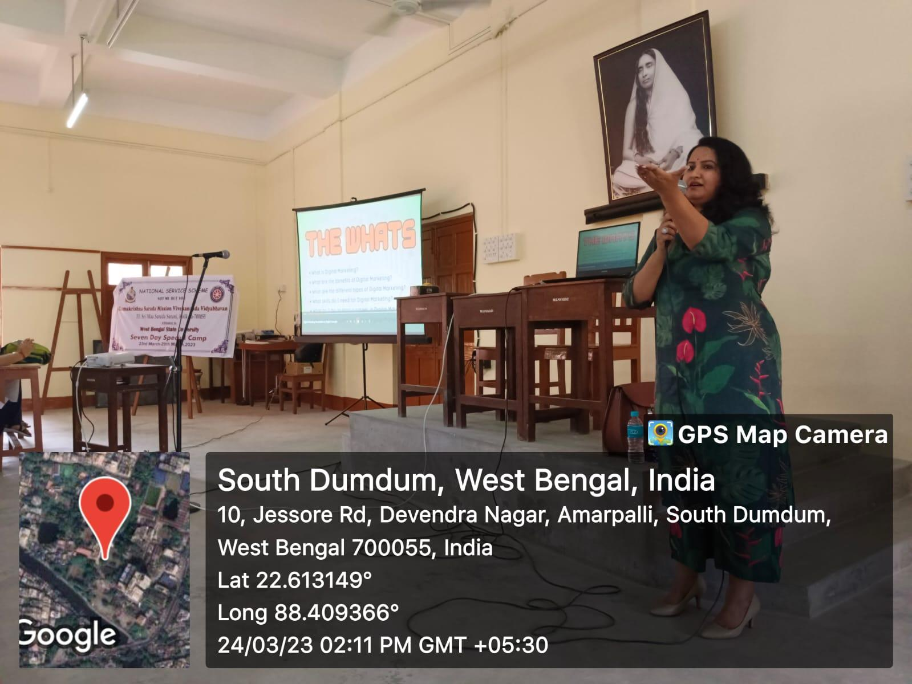

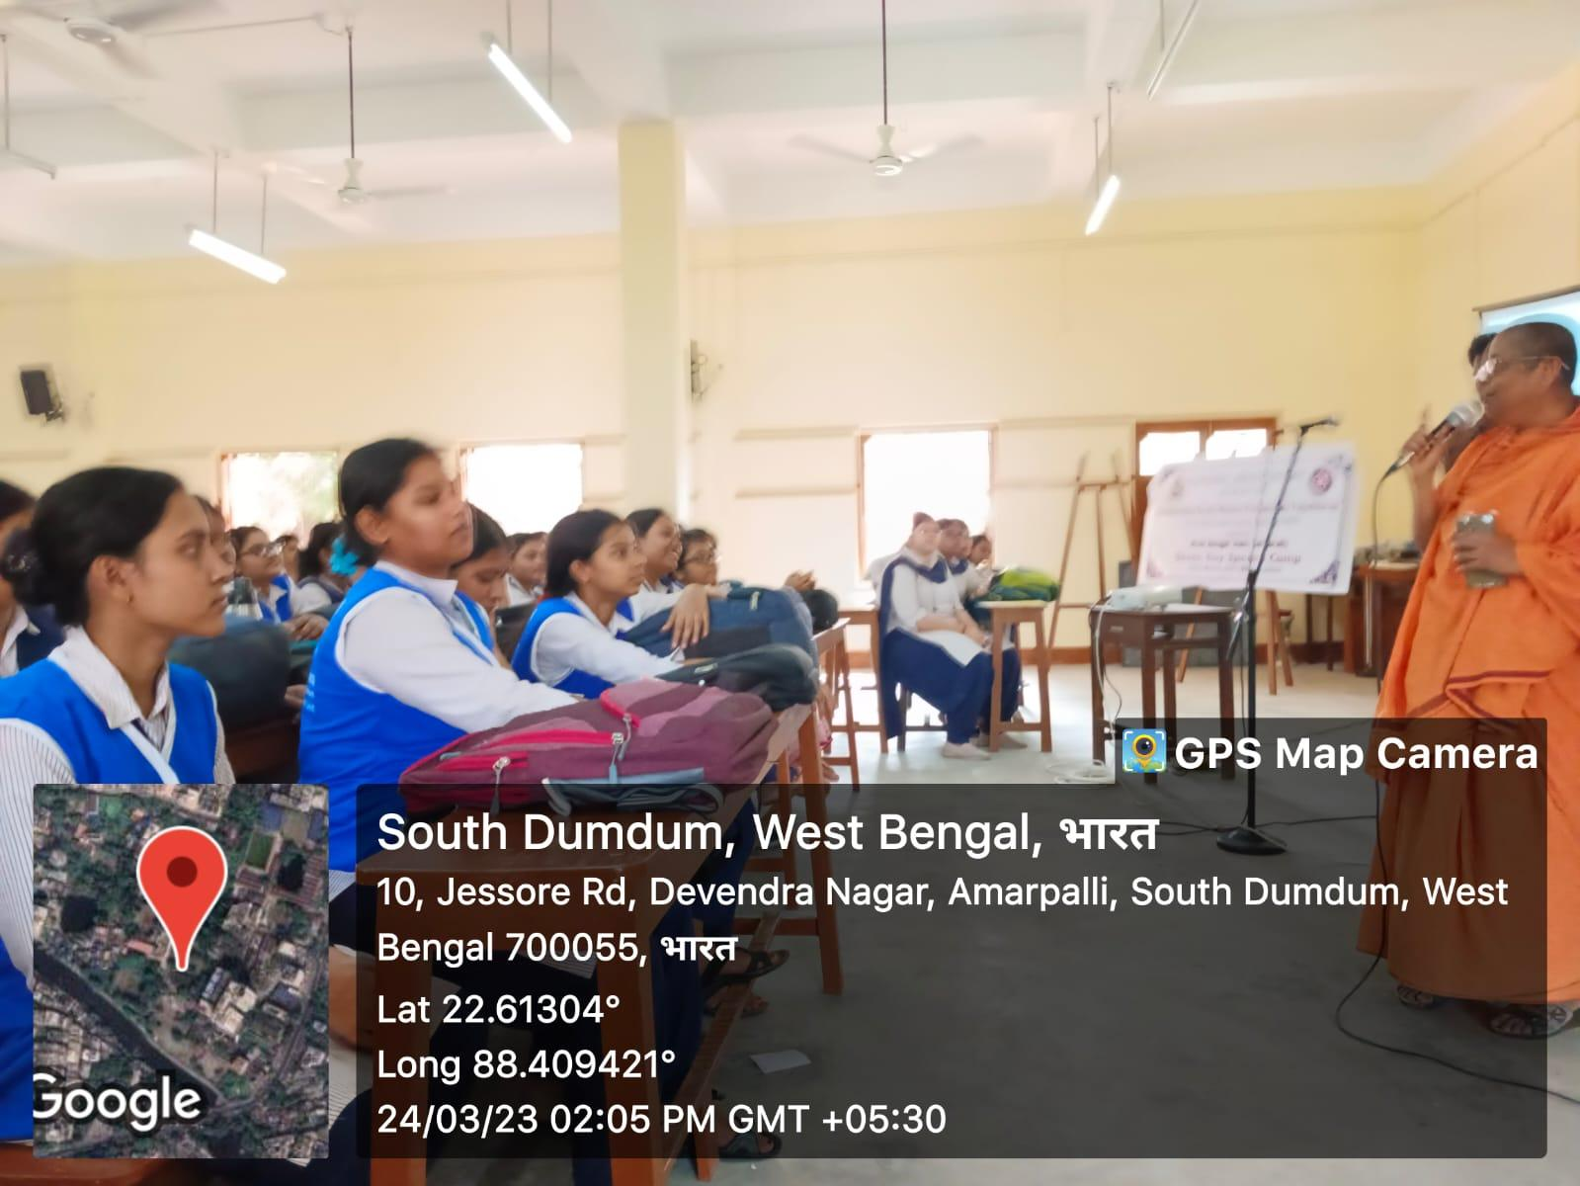

Day 3

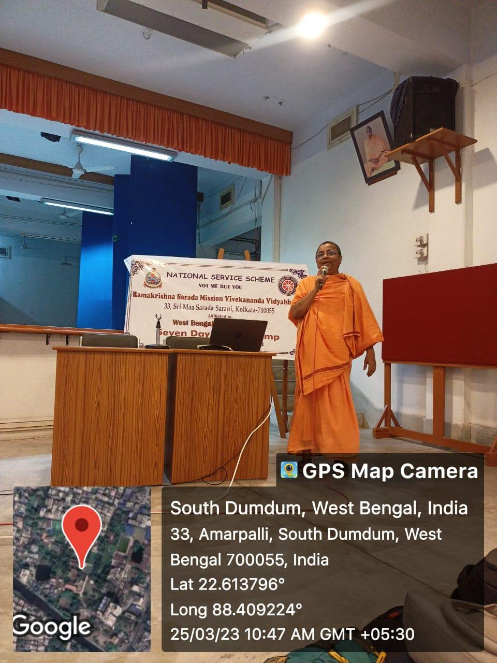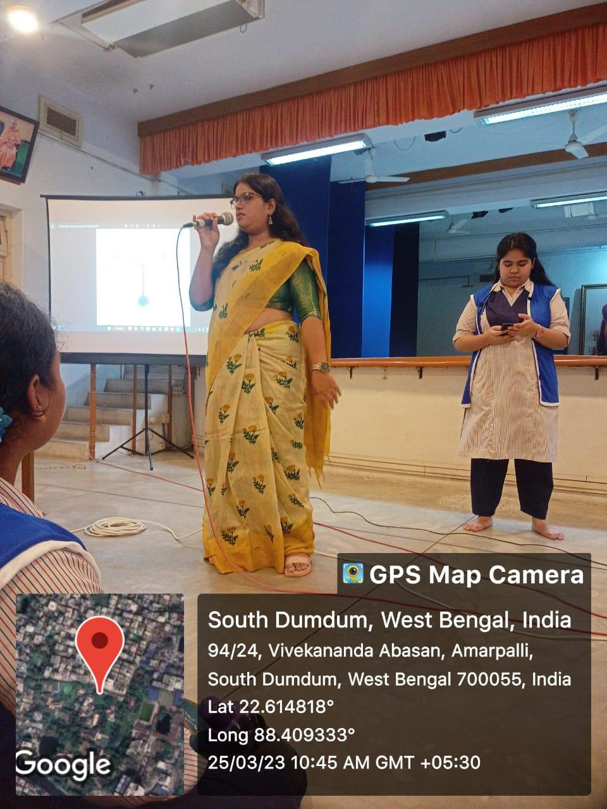
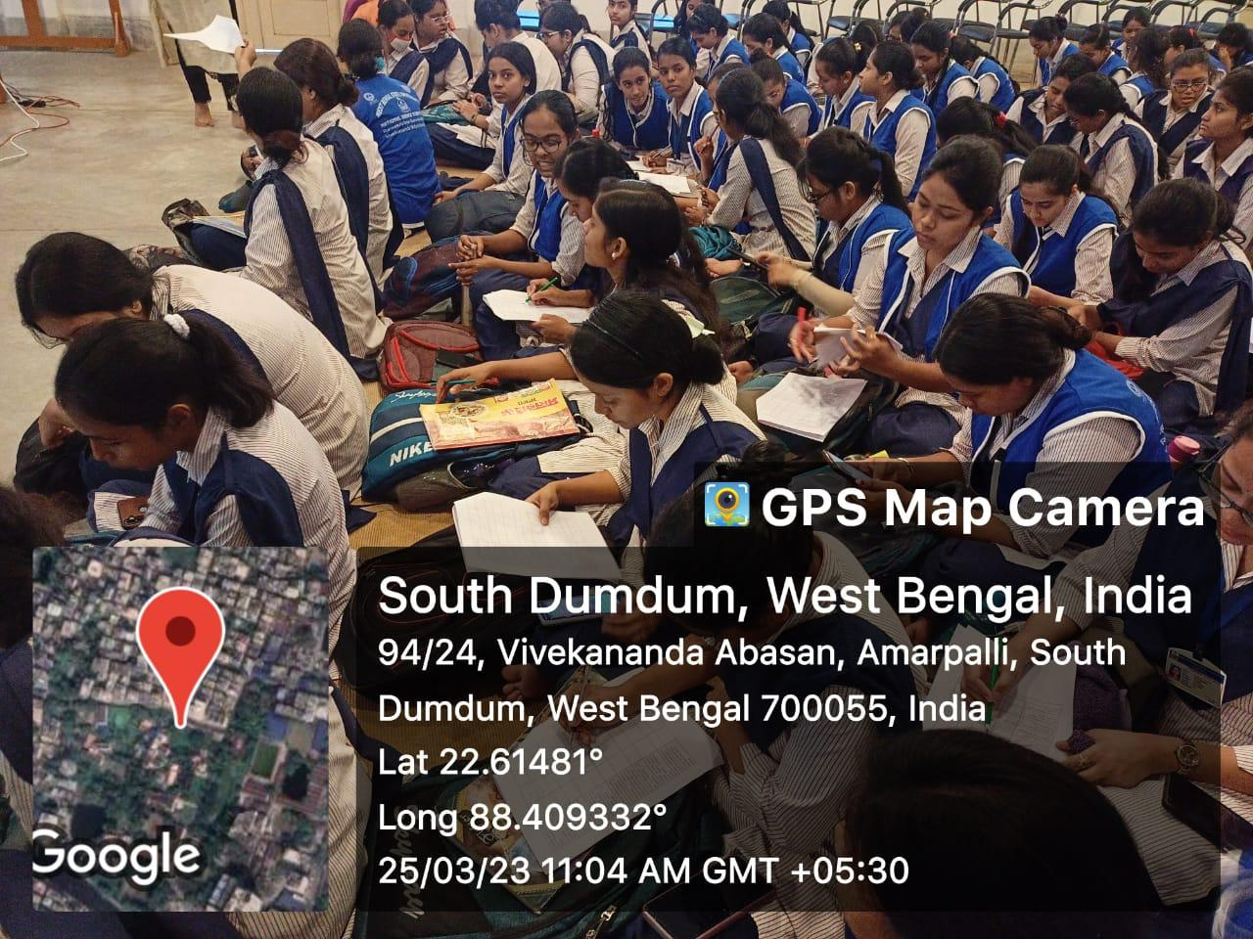
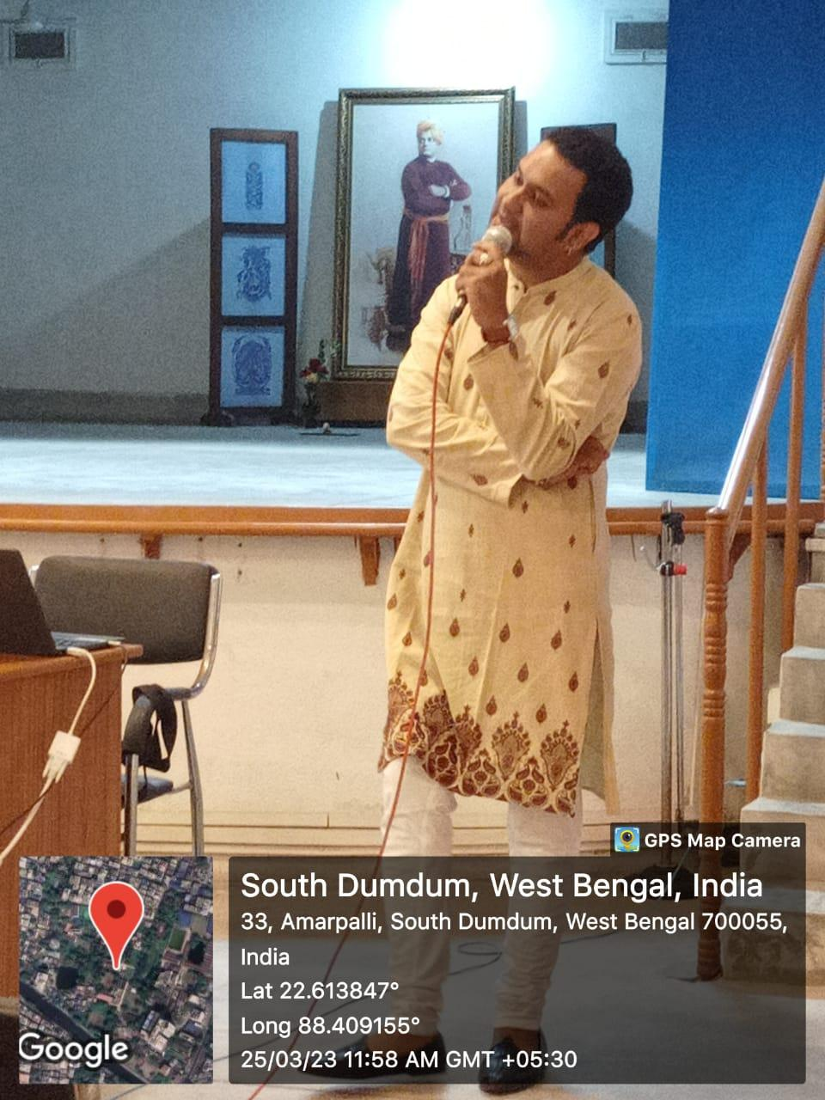
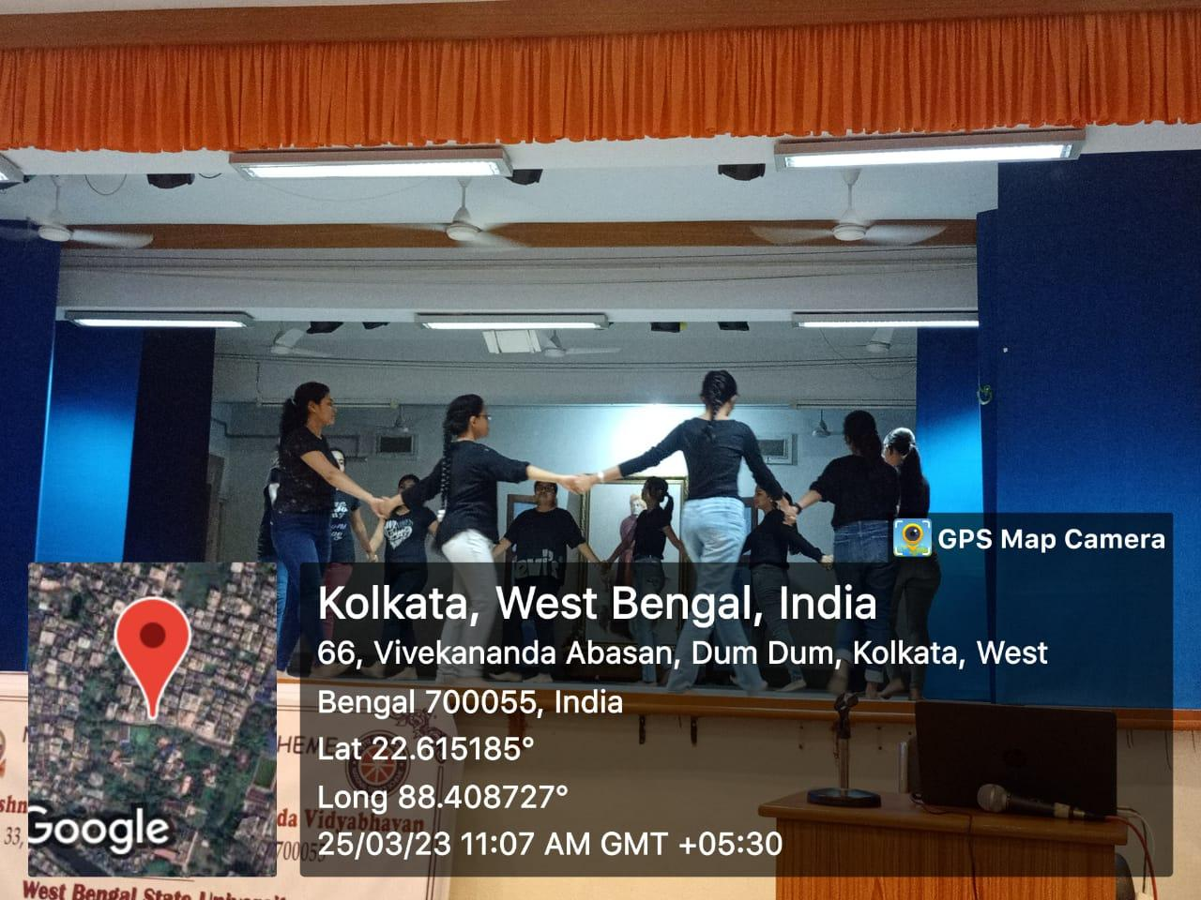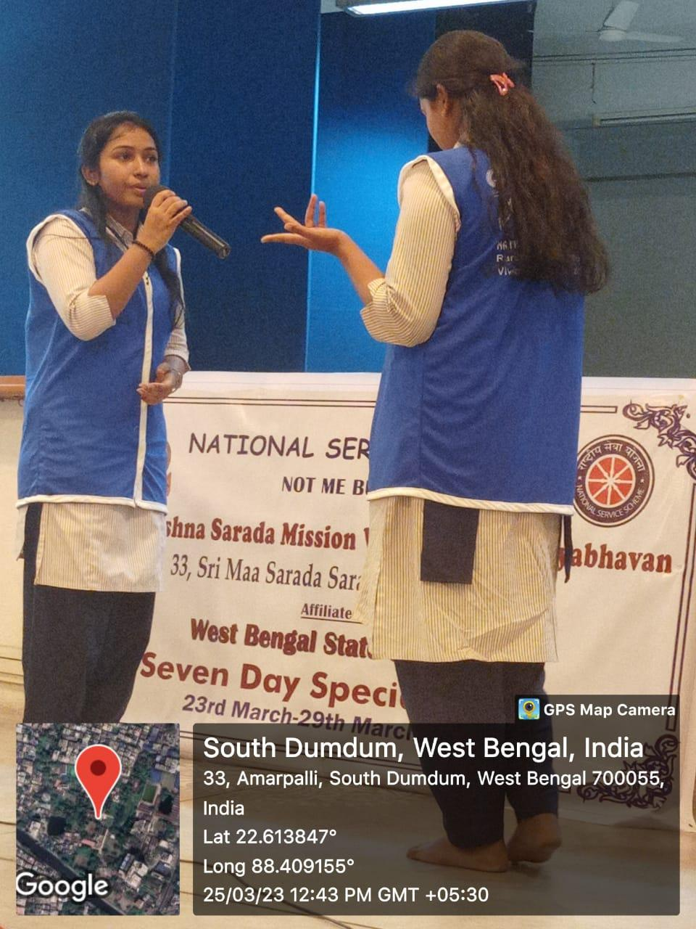
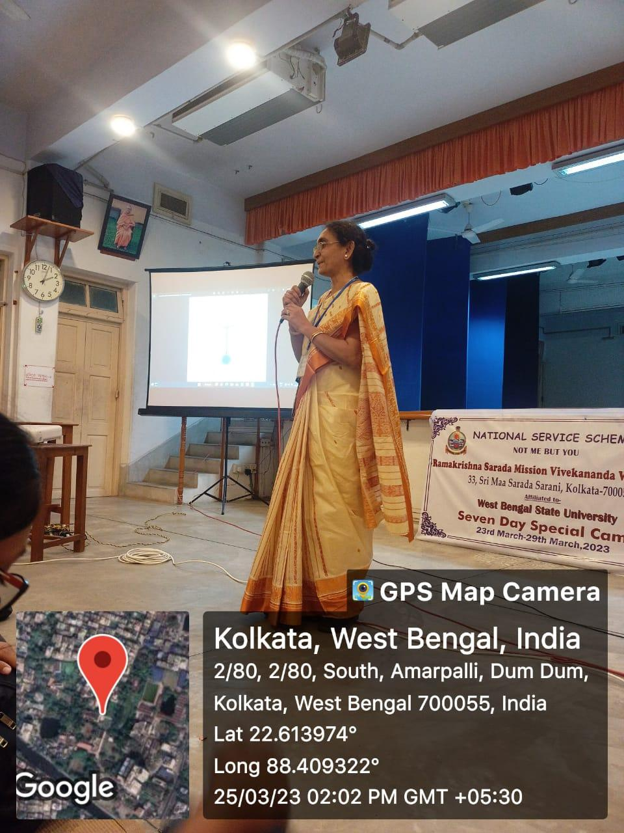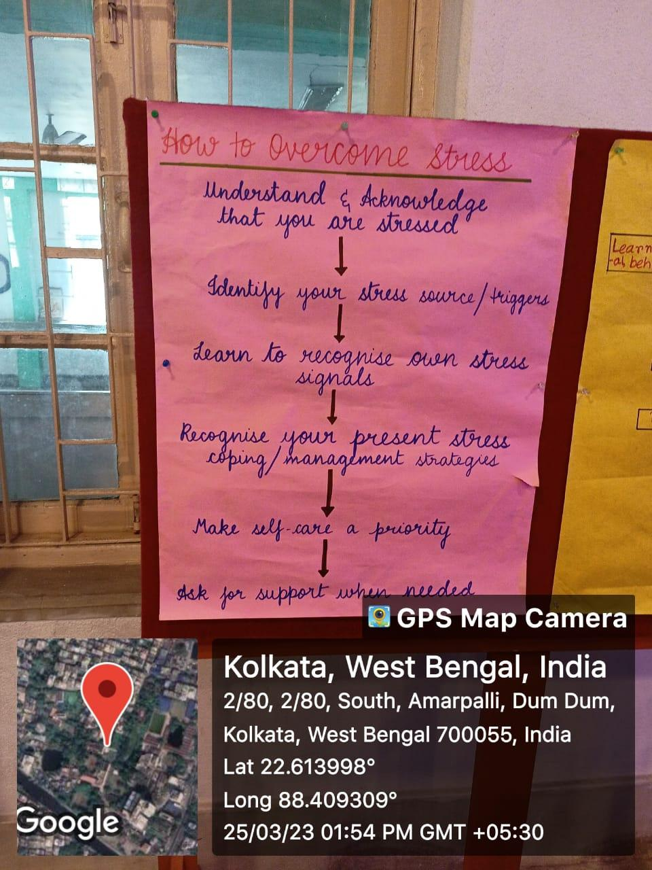
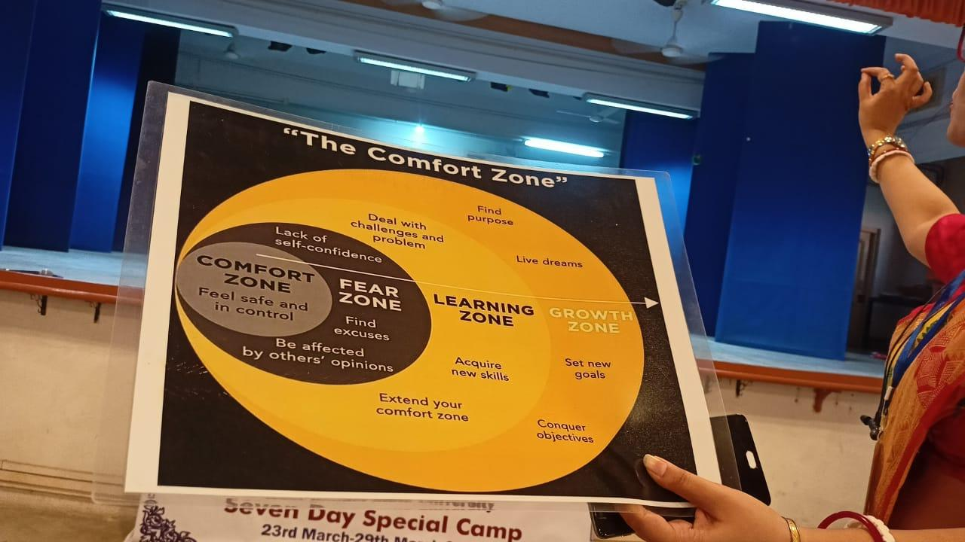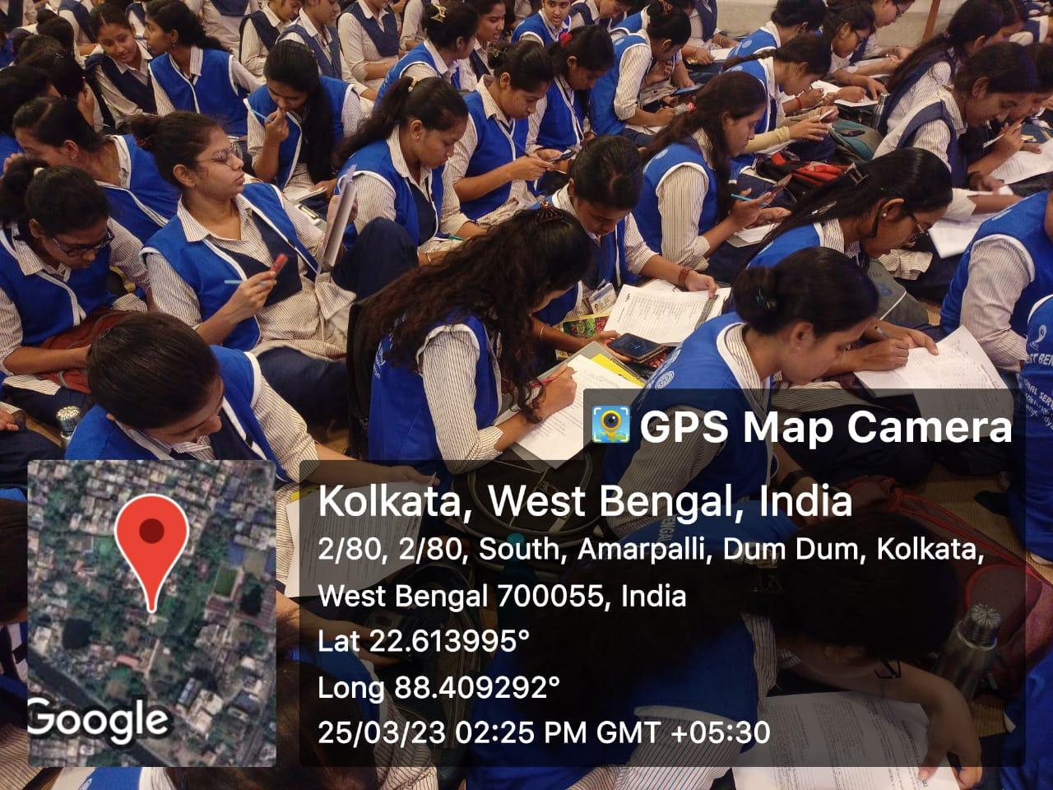

Day 5
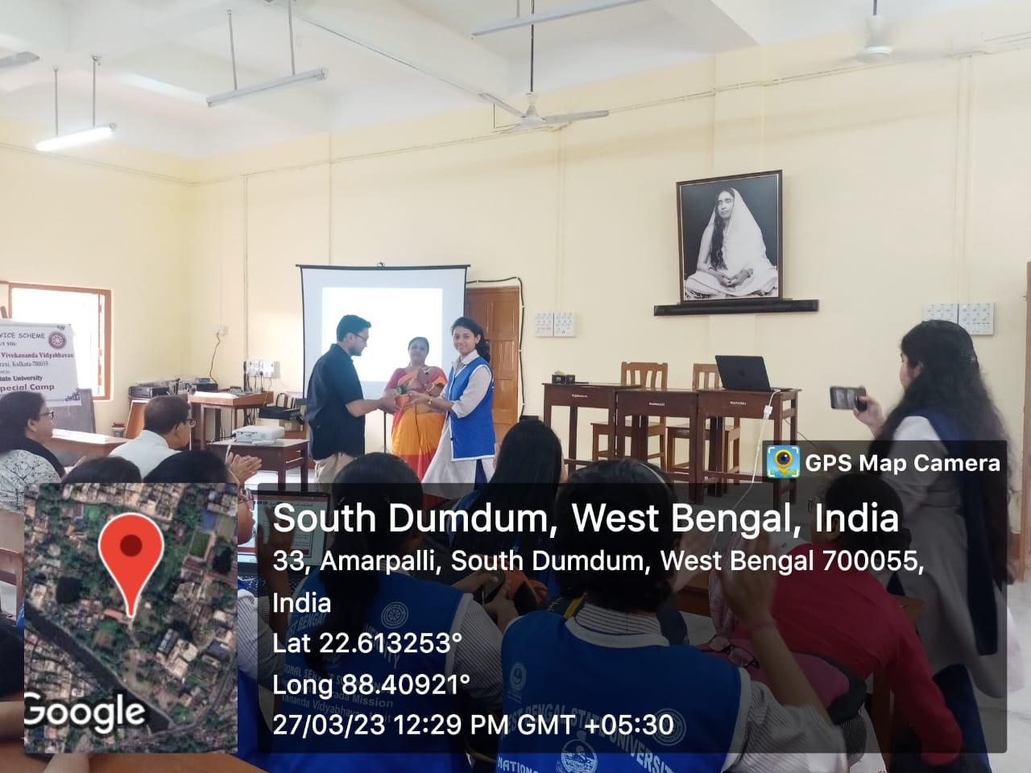
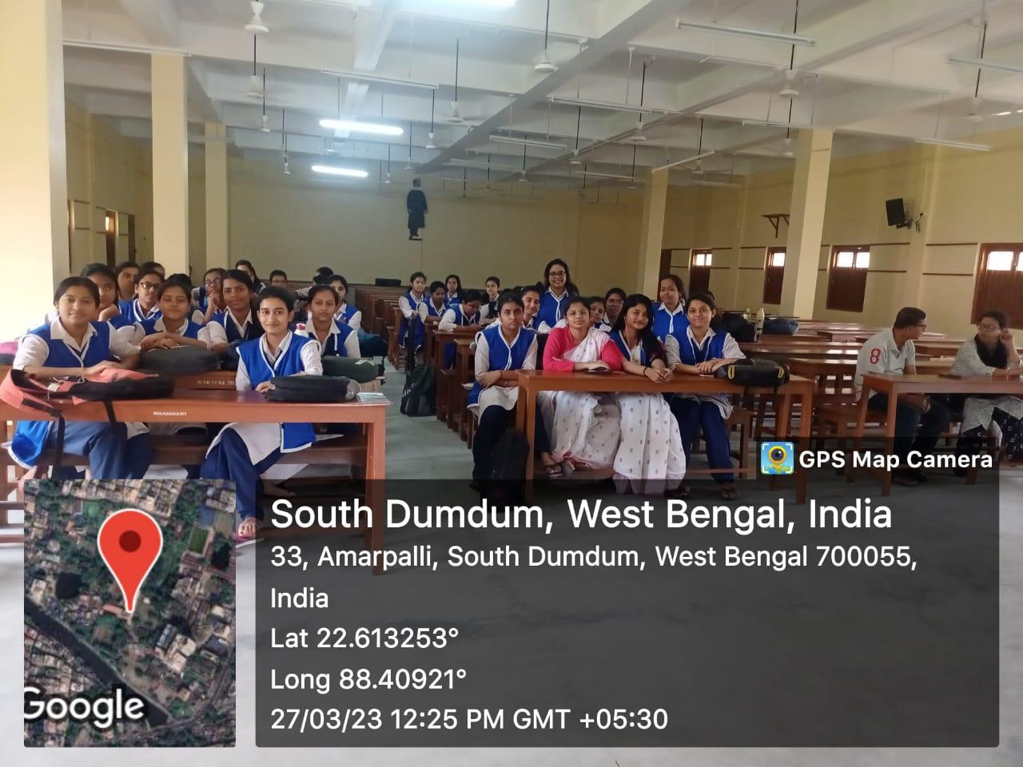

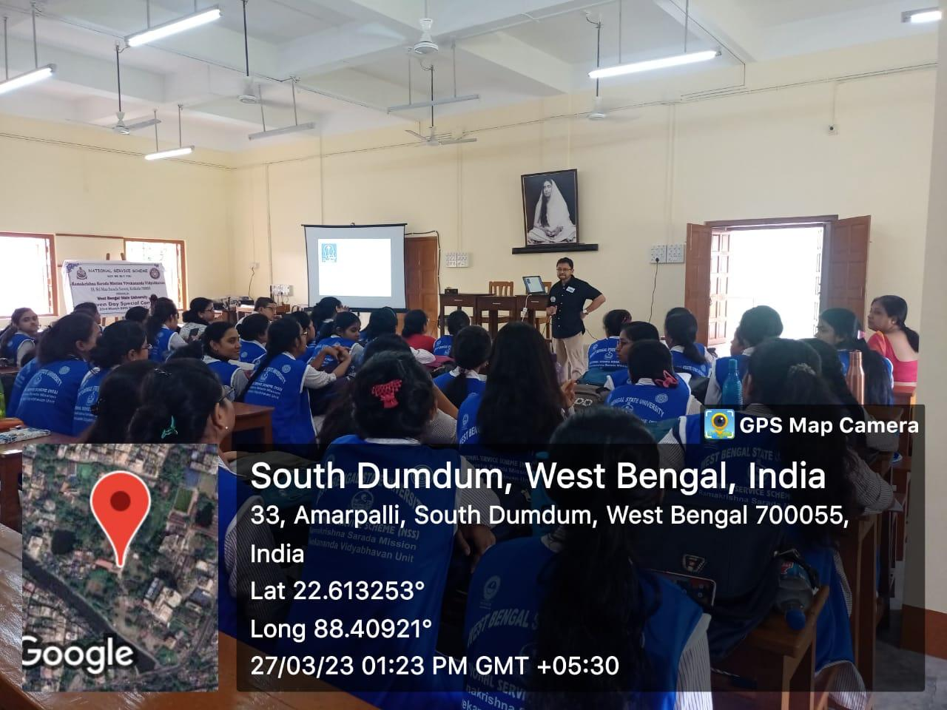
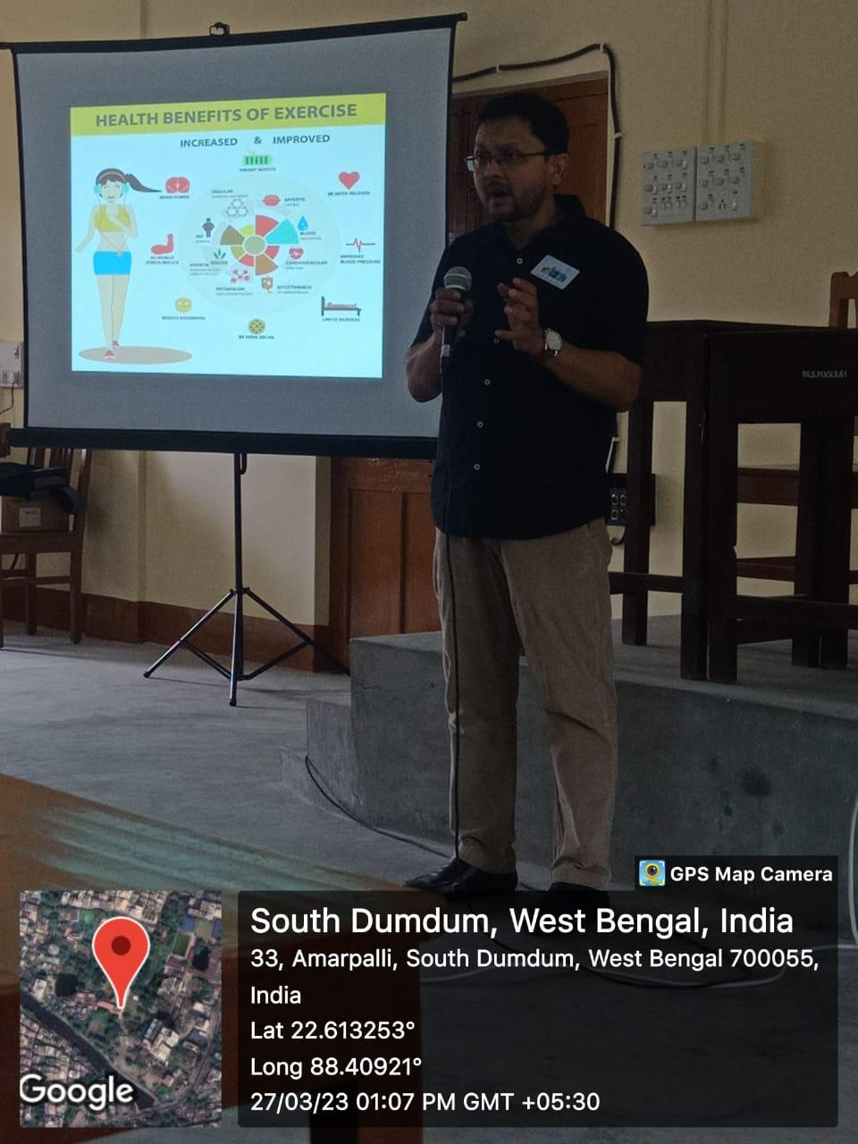

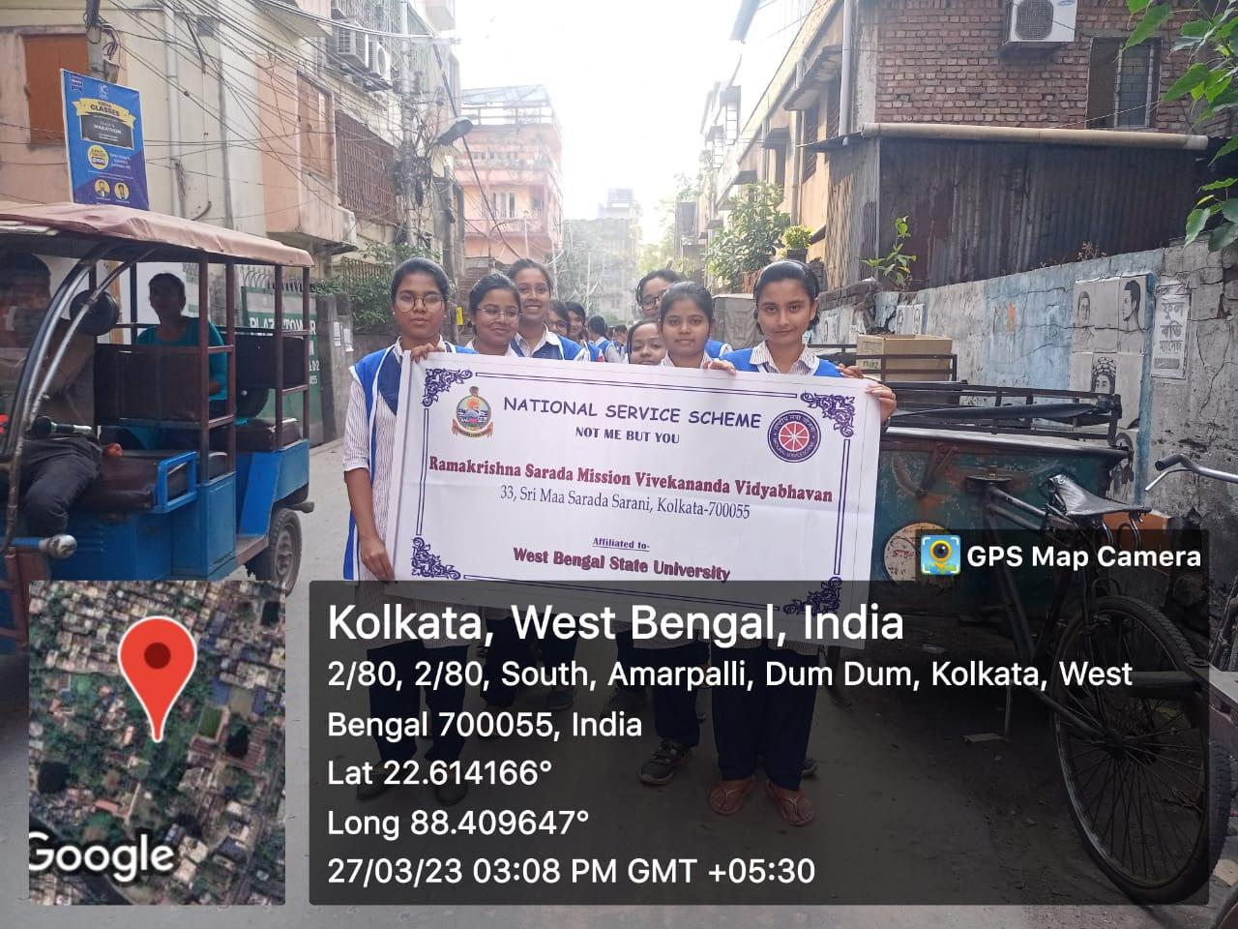
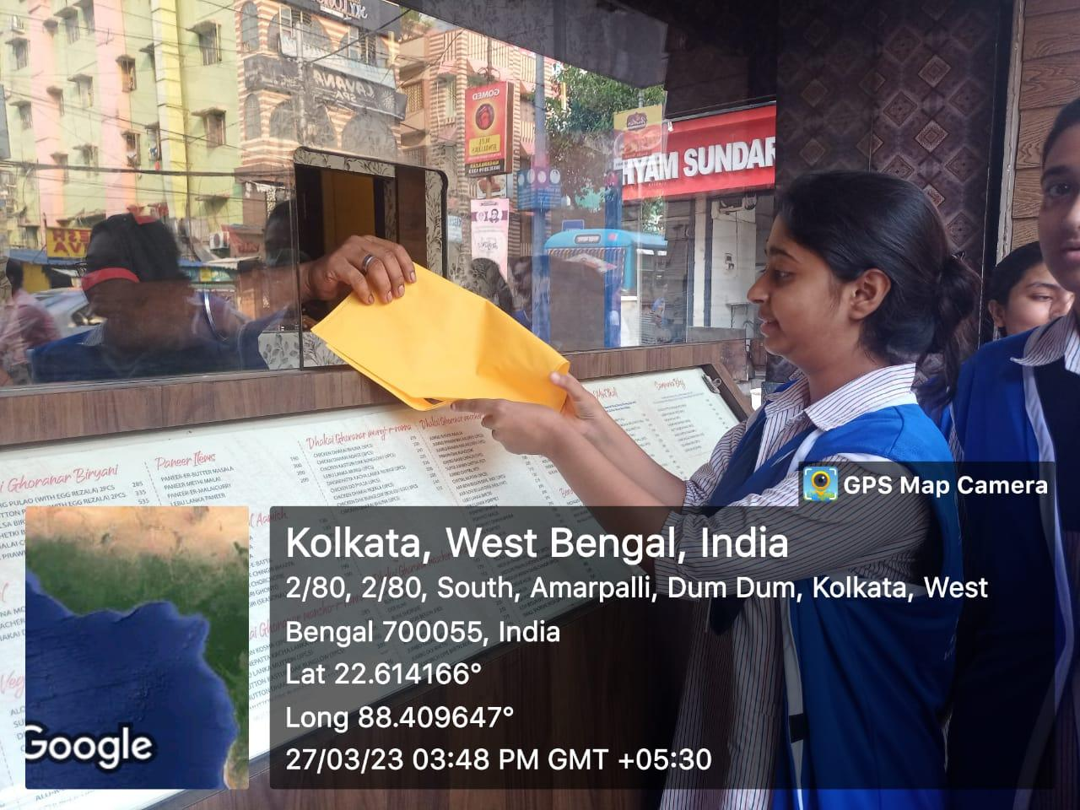
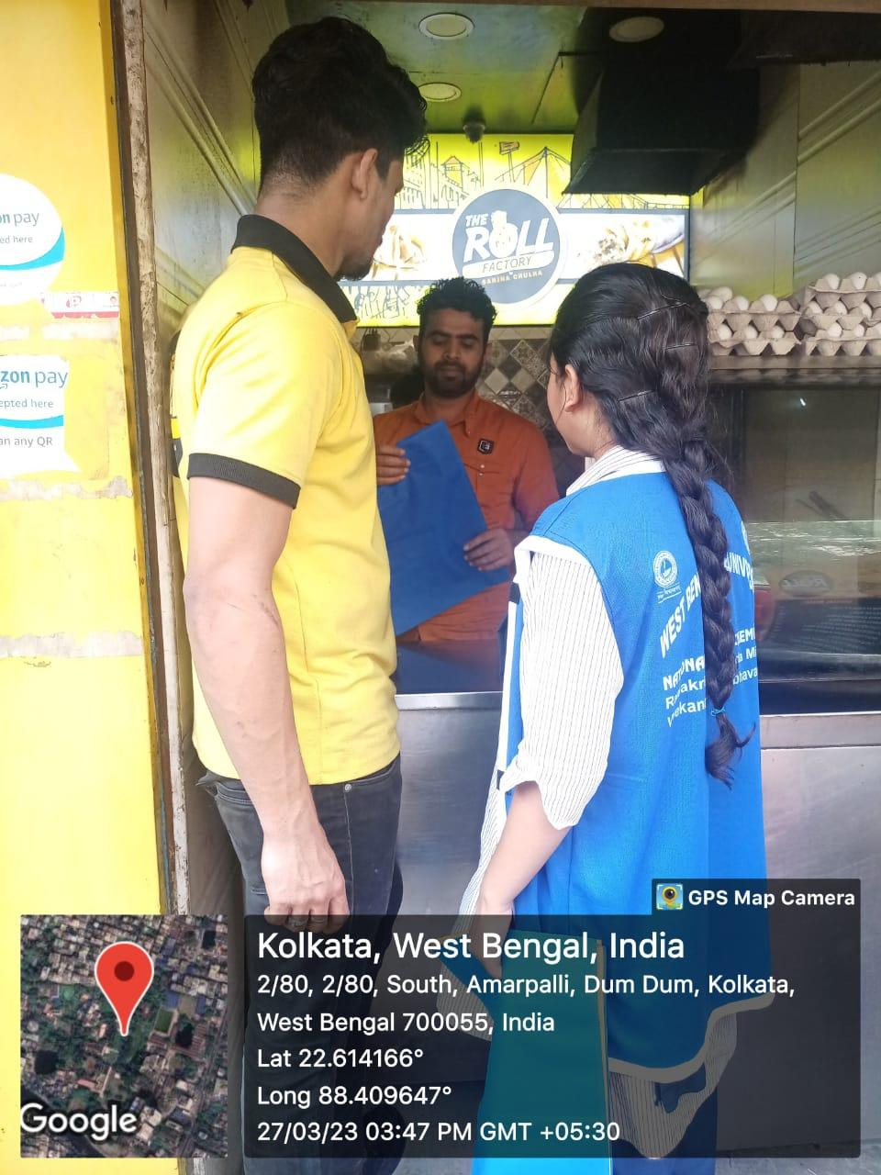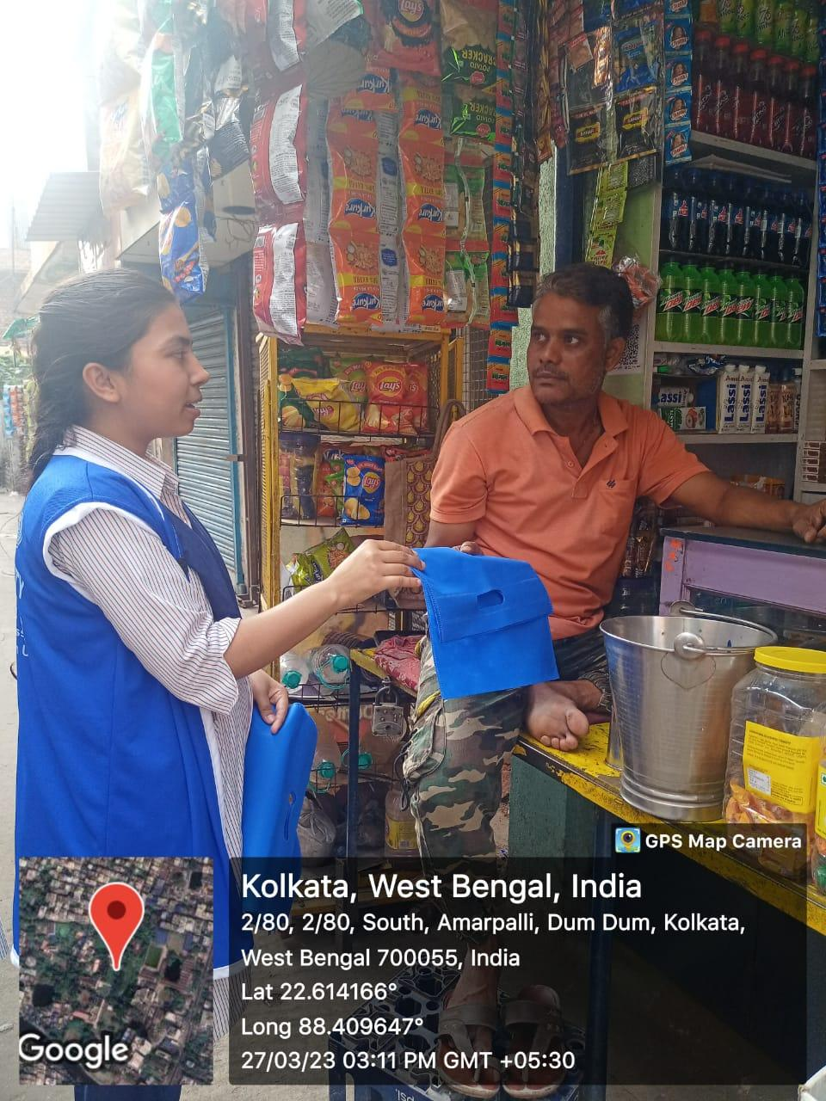
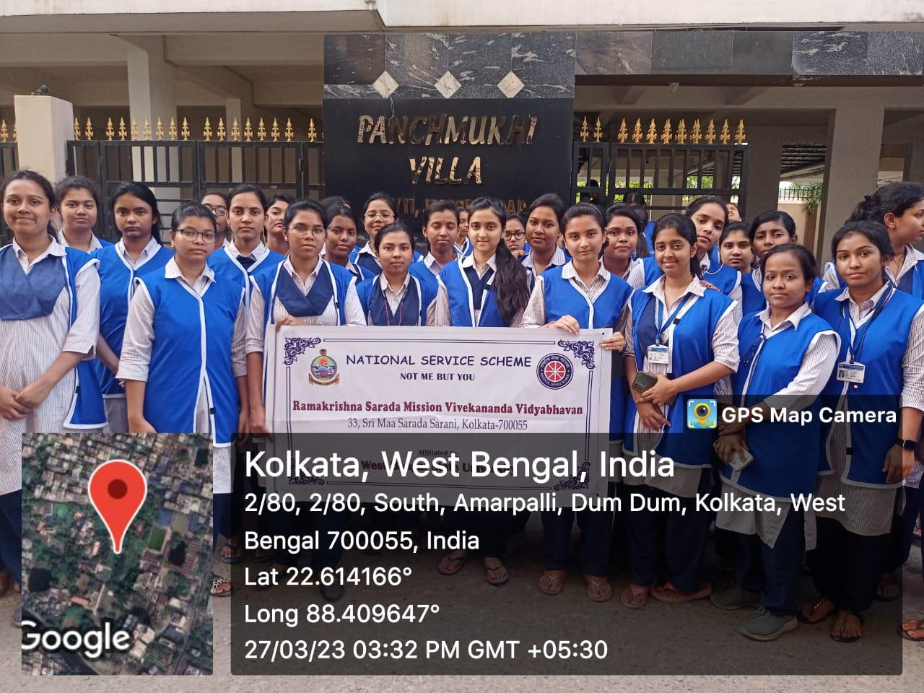

Day 6:
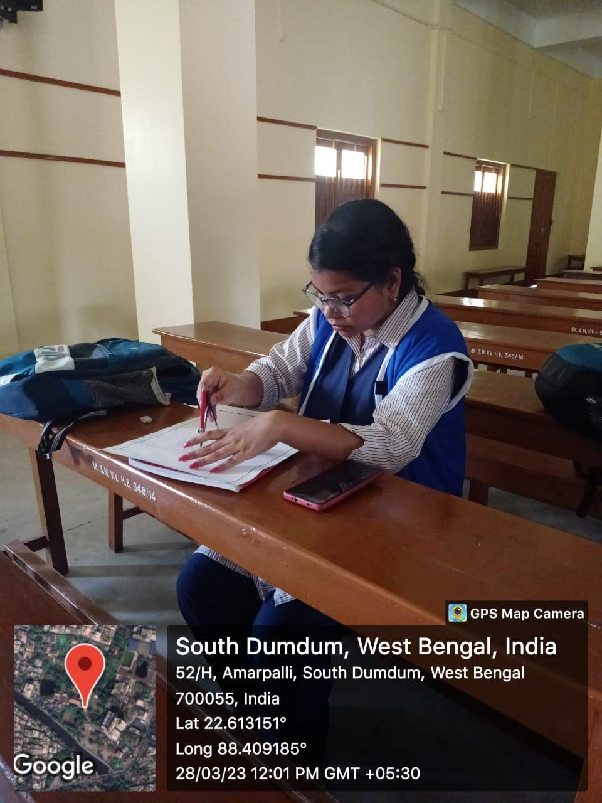
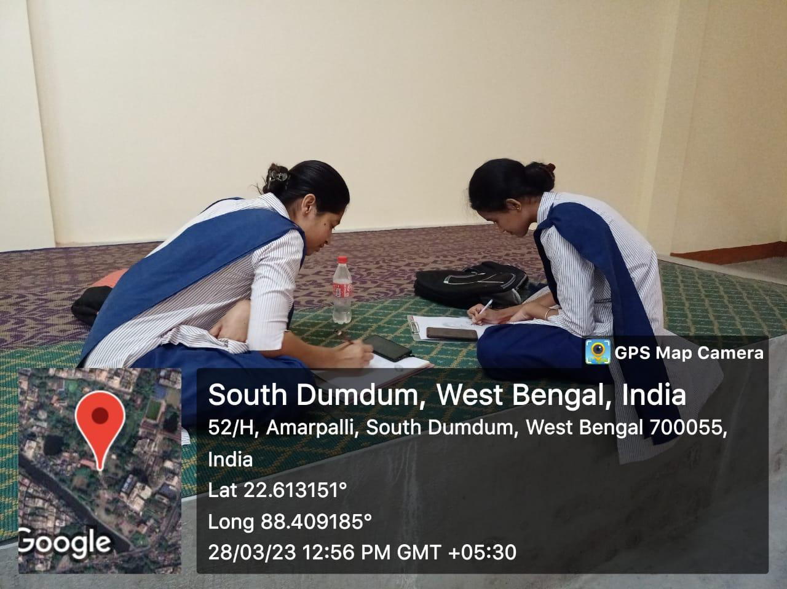

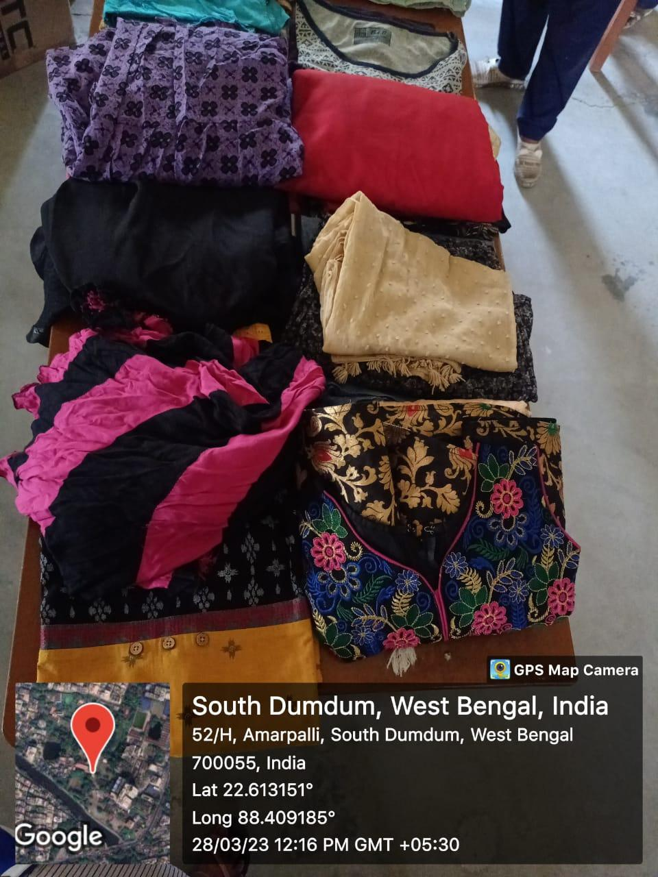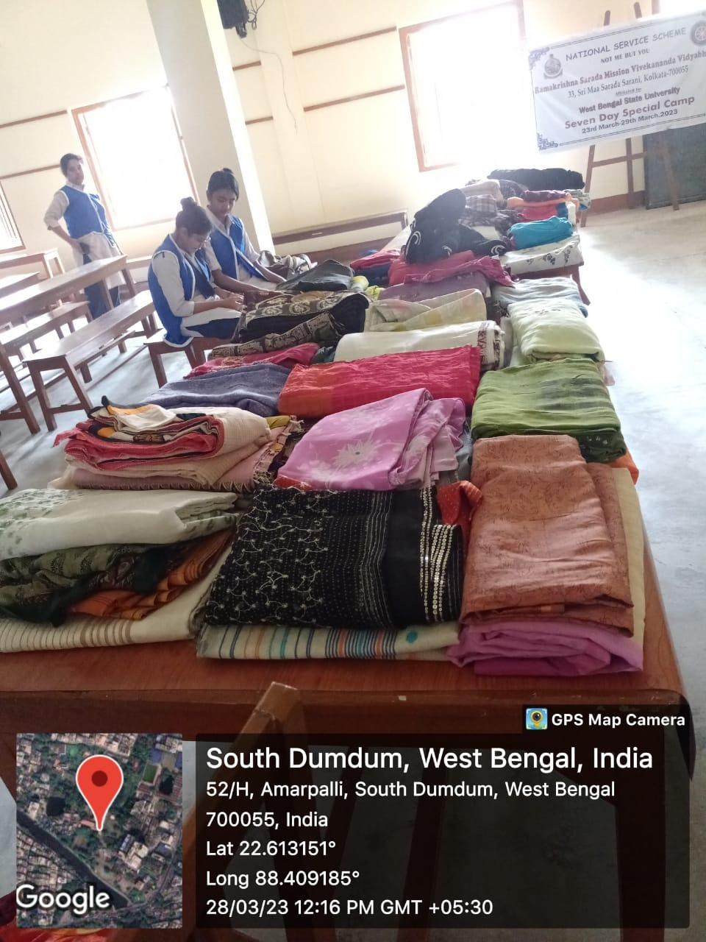
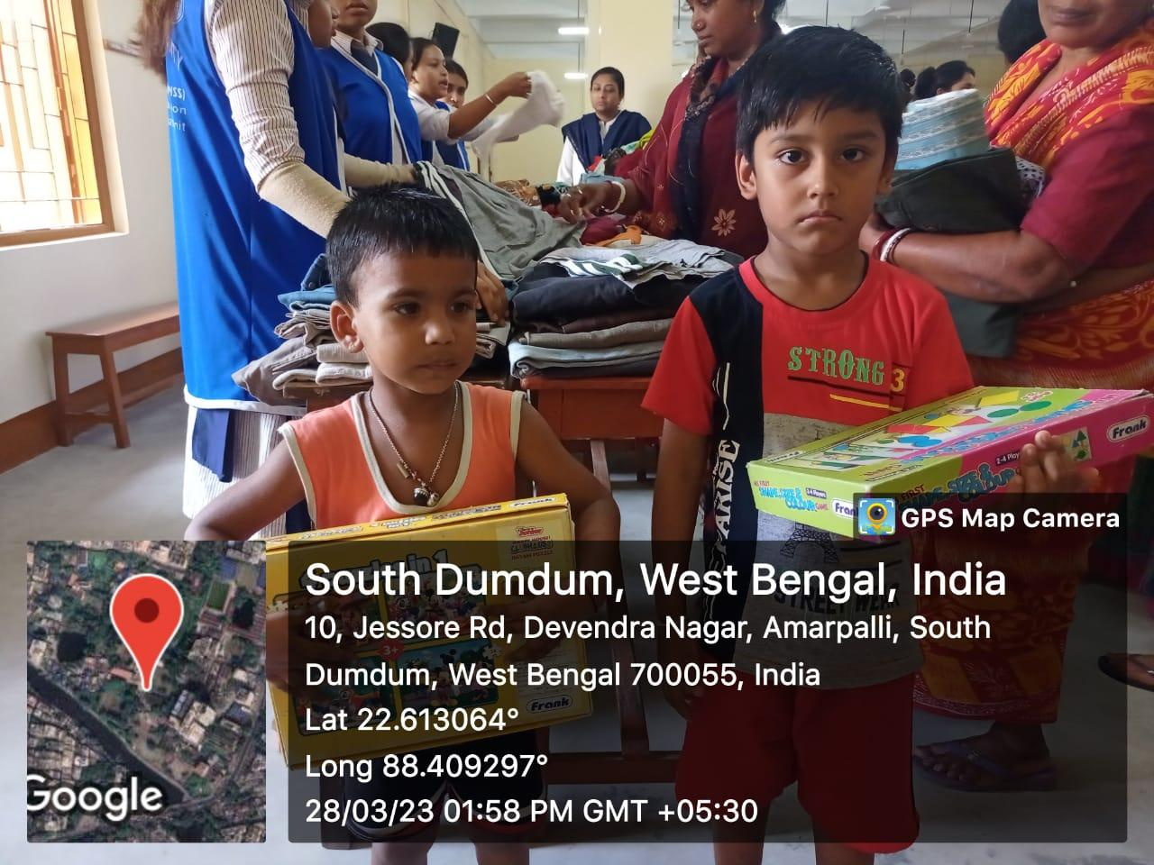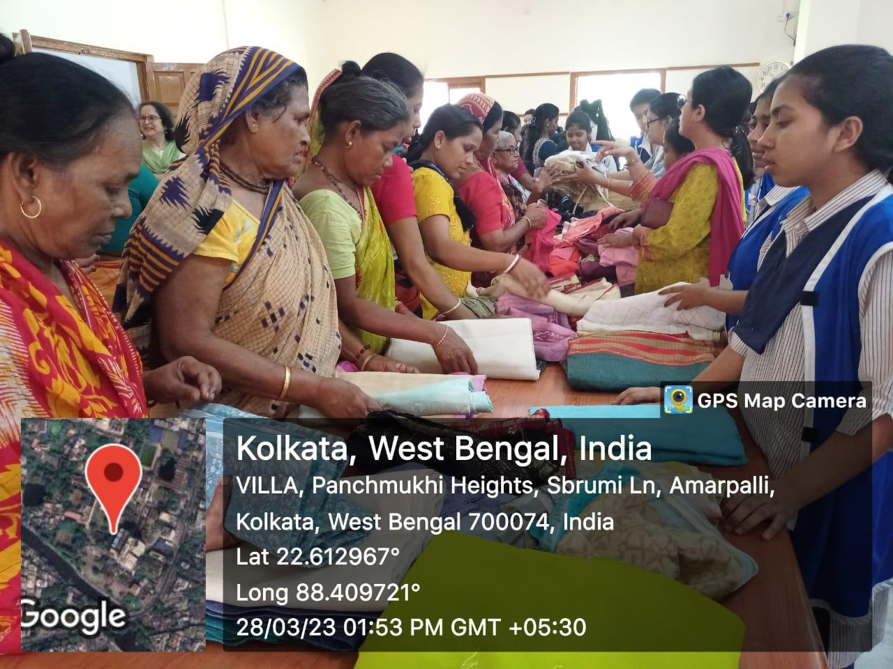
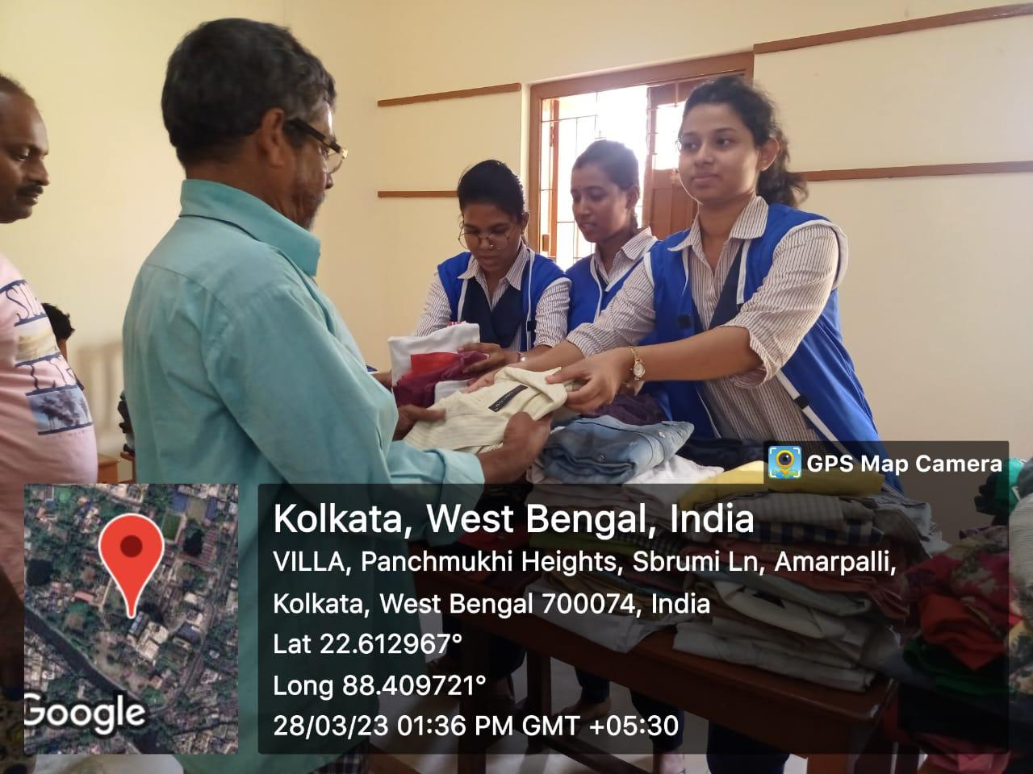

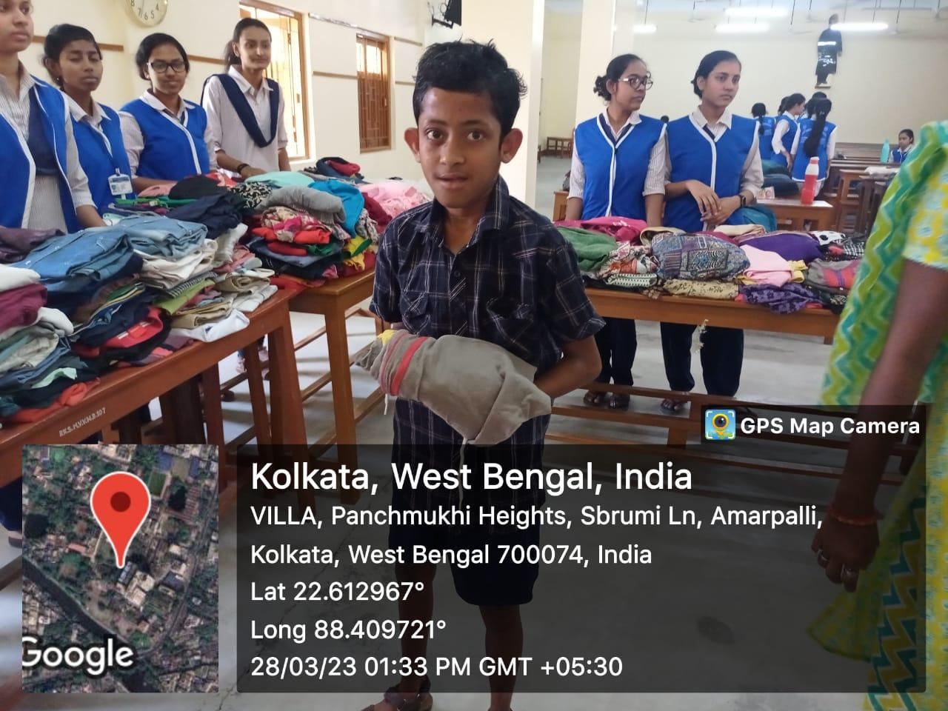

Day 7: 29.03.23
