Name of the Activity: Extension Lecture on ‘Adivasis/aboriginals and the land question: Australia and India’
Category: Extension Lecture
Organising Unit: Department of Political Science
Date: 24.02.2023
Time: 11 am-1 pm
Venue: Classroom
Number of Participants: 26
Name of the Resource Person/s (with designation): Prof. Kinshuk Nandi, Assistant Professor in the Department of Political Science at Taki Government College.
A brief description of the Event: The Extension lecture on ‘Adivasis/Aboriginals and the Land Question: India and Australia’ has been a very thoughtful audio-visual presentation.
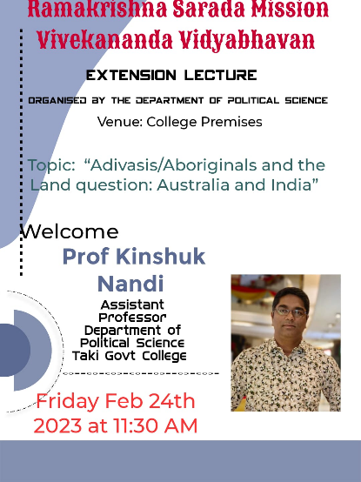
Programme Outcome: The programme has helped the students to get a vivid picture related to the land and property rights and the socio-economic status of the indigenous people of both countries. From this vital talk, the beneficiaries have gained knowledge about this global agenda, both from a legal and constitutional perspective.
Flyer

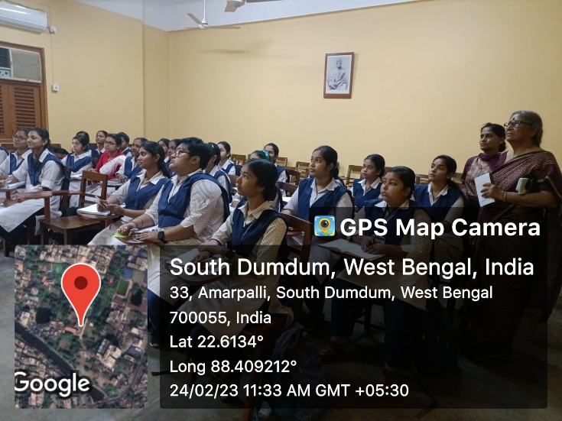
Geo-tagged Photos

