Name of Activity: Students’ Seminar on 75 Years of Indian Independence: Evolution of Gandhian Strategies in Politics and Social Regeneration

Category: Student’s seminar

Organising Unit: History Departments of both Ramakrishna Sarada Mission Vivekananda Vidyabhavan and Lady Brabourne College

Date: April 25, 2023

Time: 11:30 am onwards

Venue: Muktiprana Sabhagriha

Name of Resource Person/s (with Designation): Students of Both Colleges

Number of Participants: 460

Brief Description of Event: Students of both colleges presented their papers which revealed the depth of knowledge of the Gandhian movements and the philosophy behind them. Some students’ presentations critically looked at the caste dimensions in Gandhian ideology and his differences with B. R. Ambedkar. The cultural programme highlighted the diverse aspects of the Indian freedom struggle.

Programme Outcome: The Seminar was a success. This seminar provided a scope for getting into the historical intricacies of the nationalist politics of the Indian National Congress vis-a-vis MK. Gandh. Above all, the Seminar made a much-needed academic-cultural interaction between the students of the two colleges possible.
Flyer:
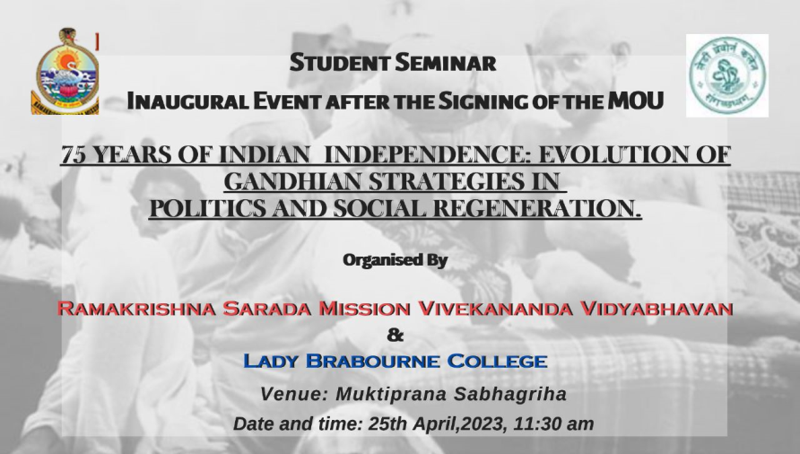
Geo-Tagged Photos:

