Name of Activity: Career Mentoring
Category: An interactive discussion between alumni and present students
Organizing Unit: Department of Bengali
Date: 27.04.23
Time: 11.00 a.m.
Venue: Audio-visual room of college
Name of Resource person/s: Ex-students of the Department:
- Shelly Neogi (School Teacher, Jodhpur Park Girls’ High School),
- Monideepa Banerjee (School Teacher, Calcutta Public School, ICSE Board),
- Dr.Chandana Chakraborty (Assistant Professor, Dept. of Bengali, Murra Gachha Govt. Degree College),
- Tapashi Chakraborty (Sales Executive),
- Priyanka Sikdar (journalist & T.V. anchor in News Time Channel)
Number of participants: Students of Semester IV & VI (45 students)
Brief Description of the Event: The resource persons were alumni of this Department. They expressed their views in various fields. They give opinions on how to make bio-data, apply to various companies, how to prepare for NET, SET or other competitive Examinations.
Programme Outcome: These interactive lectures have been organized for the job-orientation program to aware and inform the students for their future planning of career. The resource persons were alumni of this Department. Students were very much enriched by the lectures. After completing graduation, there are many job-oriented fields are open to them. They achieved self-confidence by their seniors. It was a very motivational session as now-a-days Government jobs are not easy to get. If one achieves, it is very good, but if not, then one should make herself so groomed as any job can knock for establishment. Students were very much profoundly inspired by them.
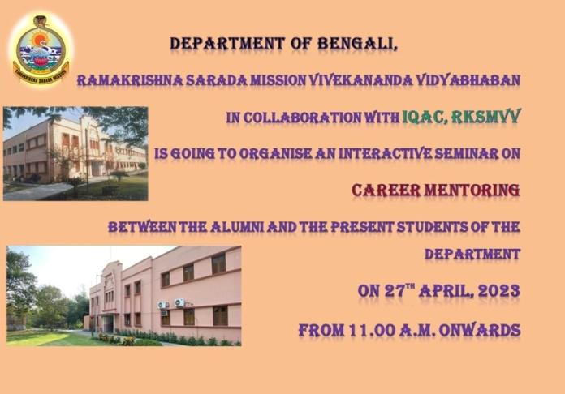
Flyer:

Geo-tagged Photos:

