Name of the Activity: Explore the Career Opportunities in Government Sector
Category: Seminar
Organising unit: Jointly organised by RICE Education City Office – Sealdah and the IQAC, Ramakrishna Sarada Mission Vivekananda Vidyabhavan
Date: 28.04.2023
Time: 2:30 PM to 3:30 PM
Venue: Swamiji Bhavan, RKSMVV
Name of resource person/s (with designation): Mr. Sourav Mitra, Sr. Academic Adviser, RICE Education
Number of participants: 250
Brief description of the event: This seminar was held on 28th April, 2023. 250 students of our college had attended the seminar. Mr. Sourav Mitra, Sr. Academic Adviser, RICE Education, addressed the students on behalf of RICE Education. The educators provided the final-year students with an overall view of the job market in the Government Sector. They learnt about different sectors of the Government of India, like, health care, social science, human resources, computer science etc.
Programme outcome:
The students came to know the process of applying for a government job, i.e., how to search for current job openings, how to apply for a government job, how to prepare the syllabus according to examination pattern, how to attend different levels of the examination (like, Preliminary, Main, Interview etc.) and how to check the final result. Overall the seminar was very effective for the final year students.

Flyer:
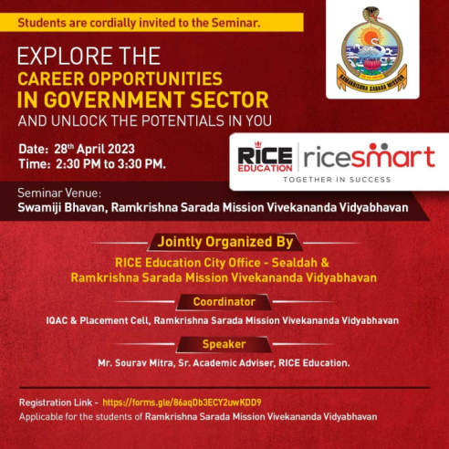

Geo- tagged photos :
