Name of the activity: Visit to the International Kolkata Book Fair
Category: Departmental Activity
Organising unit: Department of Geography
Date: 03.02.2023
Time: 10:30 am to 4:00 pm
Venue: Salt Lake, Kolkata
Number of Participants: 20 students of SEM-I & 3
Brief Description of the Event: The students were taken to this Book Fair so that they could see the wide range of books within and outside the curriculum
Programme Outcome:
A book fair is an excellent opportunity to build students’ home libraries. It further develops their reading and comprehension skills and often builds knowledge and vocabulary essential for understanding new subject matter. Books Play a significant role in our lives, especially for children. Reading books increases the knowledge of students, improves their intellect, and makes students aware of the various societies and civilizations across the globe. Moreover, the habit of reading books enhances imagination and creativity in the student’s mind. Book fairs often showcase more than just books. Audiobooks, electronic books, and other forms of digital media are often featured at book fairs. Some book fairs also incorporate performances, screenings and other types of entertainment. Students bought some books on drawing, adventure and detective stories, and also based on their syllabus. I also suddenly got a rare book on Geomorphology which I searched for a long time. They also bought some things used for home decoration. We all benefited from the visit to the book fair.

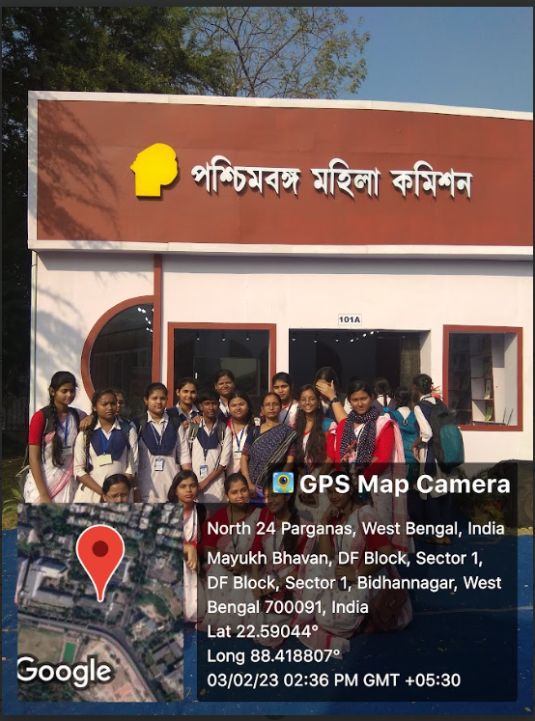
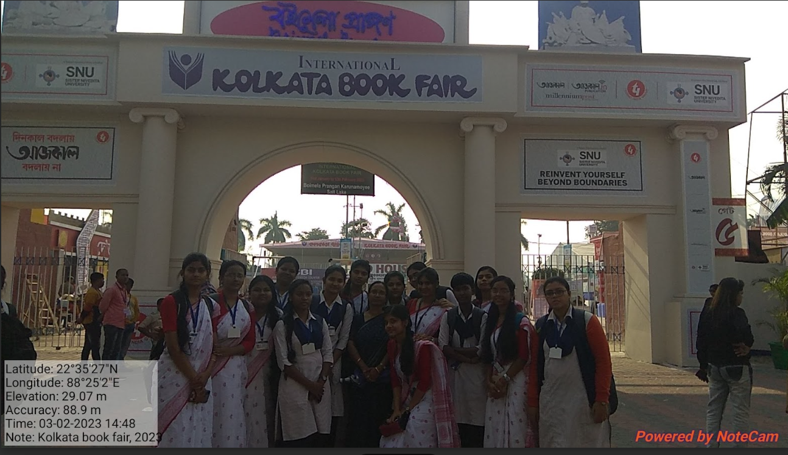
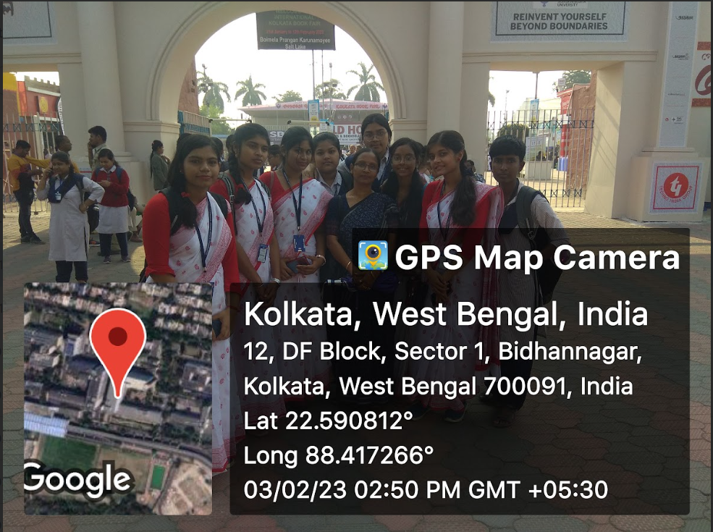
We are at Book Fair ground
………………………………….

