Name of Activity: Mega Job Fair
Category: Job Fair
Organizing Unit: Magic Bus India Foundation in collaboration with RKSMVV
Date: 30.01.2023
Time: 11:30 AM
Venue: Vocational Rehabilitation Centre for Handicapped
Number of Students: 10
Number of Teachers: 3
Brief Description of the Event:
Mega Job Fair was organized along with supervision of three faculty: Dr. Sanghamitra Mukherjee, Dr. Payal Bose Biswas and Dr. Rakhi Ghosh for the students. A few companies like Marble Box, Writers Information, Century Media 360, HDB Finance, MPokket, Tech Mahindra, YGM, and Life Style were present at this job fair. The event showcased an extensive spectrum of opportunities spanning various domains. Job seekers got the opportunity to engage directly with industry leaders, submit resumes, participate in on-spot interviews, and gain profound insights into the evolving dynamics of the job market.
Programme Outcome:
Networking opportunities at these events were invaluable for building professional relationships, gaining industry insights and discovering hidden job openings. Job seekers also received immediate feedback on their application material.

Flyer :

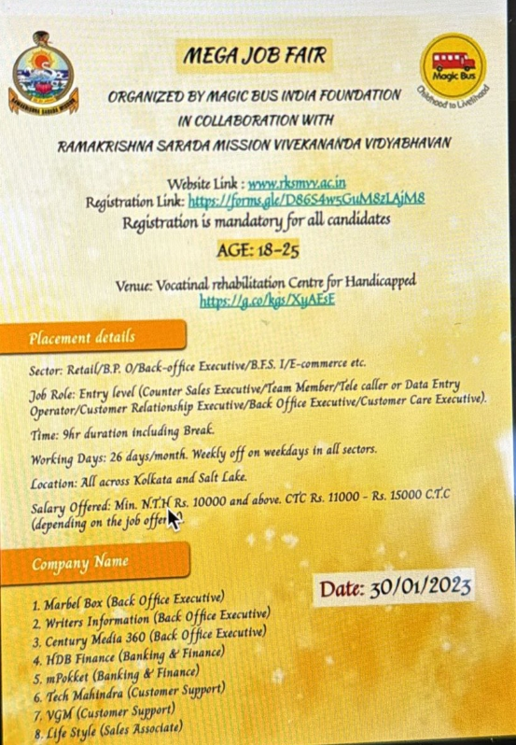

Geo-Tagged Photos
