Name of the Activity: Moral Impact of Media and Youth in the New Normal Society
Category: Inter-Disciplinary Seminar Talk
Organising Unit: Departments of Philosophy and Education
Date: 31.8.22
Time: 11.30 am – 1.30 pm
Venue: Muktiprana Sabhagriha
Name of the Resource Person/s (with designation): Dr. Swati Bhattacharjee, Senior Assistant Editor, Ananda Bazar Patrika.
Number of Participants: 90
Brief Description of the Event: Dr. Swati Bhattacharjee, spoke about the positive impact of media on youth and addressed it with practical examples. The seminar talk was also attended by the Post Graduate students of Department of Philosophy along with the Under Graduate students of Philosophy and Education Departments.
Programme Outcome: The students had the opportunity to listen to a very thought-provoking lecture as Dr Bhattacharya exposed both the positive and negative moral sides of media and how it is contributing to the making of the future minds. The interaction session with students at the end of the talk was also very interesting.

Flyer:
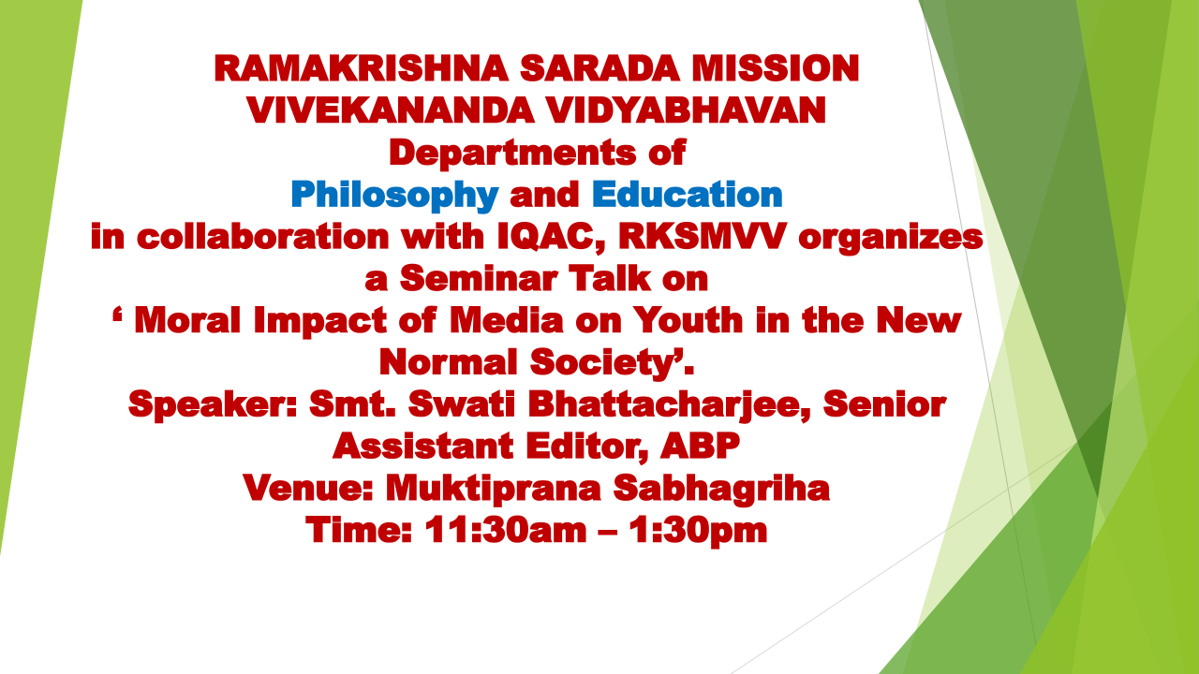
Geo-tagged Photos

