Name of activity: Seminar on Students'week
Category: General
Topic: Youth and Mental Health
Organising unit: Department of Psychology
Date: 7th January, 2023
Time: 12:15 pm onwards
Venue: Room Number 25
Name of resource person/s (with designation):
Ms. Aiswarjya Banerjee, Head of the Department of Psychology, RKSMVV)
Number of participants: 50
Brief description of the event: The objective of the seminar was to Increase education and awareness about youth and its challenges, including strategies for prevention, intervention and treatment of various issues and as it was for Students Week the focus was mainly on the adolescent/ youth generation. The students were highly interactive, they conveyed and shared the problems they were facing. A few relaxation techniques and strategies were also demonstrated to help them fight with their daily stress.
Program Outcome: It empowered participants with knowledge and strategies to deal with the daily challenges of their lives. Participants learned and gathered knowledge about the strategies for prevention and how they can ethically assess the needs of their own.

Flyer:

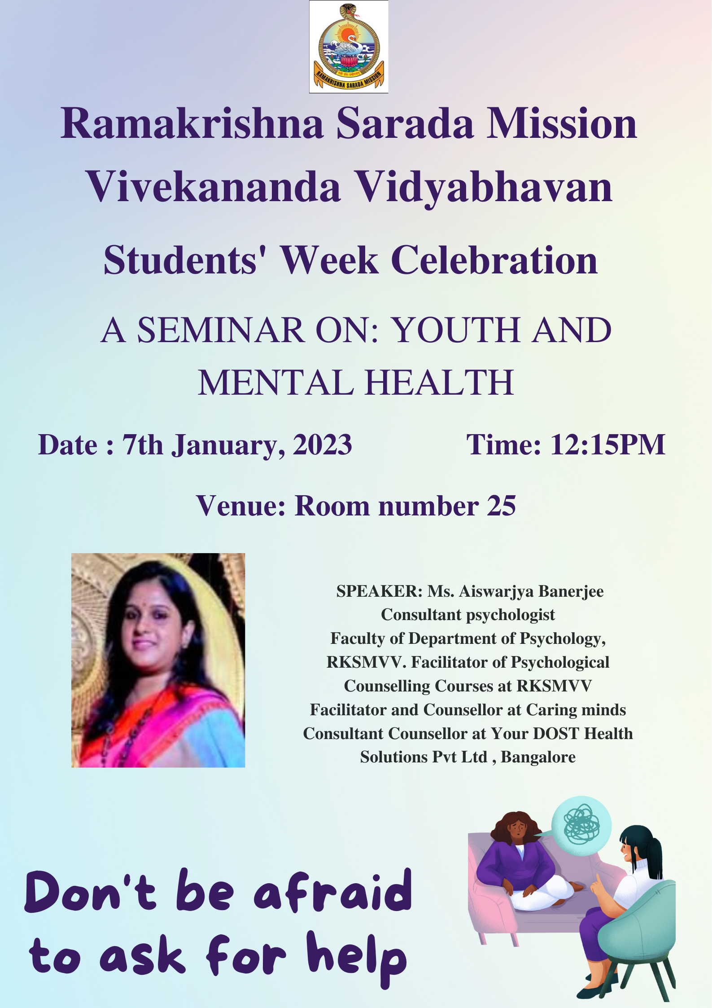
Geo-tagged photos:
